Table of Contents

1. Introduction: What is Full Stack Development?
Full Stack Development refers to the practice of designing, building, and maintaining both the client-facing frontend and the server-side backend of a web application, together with the database layer (Mozilla Foundation, 2024). A Full Stack Developer possesses the competency to construct a complete, functioning web application—from the visual interface rendered in the browser to the underlying data storage and retrieval mechanisms on the server.
The term "full stack" derives from the conceptual model of a web application as a layered technology ecosystem. Unlike specialists who focus exclusively on frontend (HTML, CSS, JavaScript) or backend (servers, databases, APIs), the Full Stack Developer maintains working knowledge across every layer. This versatility proves particularly valuable in agile environments and startup contexts where rapid prototyping and cross-functional problem-solving are essential (World Wide Web Consortium, 2024).

2. The Three-Tier Architecture
Modern web applications typically follow a three-tier architecture, with each tier bearing distinct responsibilities. The portfolio's architecture diagram (Figure 1) illustrates this layering visually, mapping the Client, Server, and Database tiers with their respective technology stacks.

Figure 1: The Three-Tier Architecture Diagram

2.1 The Frontend (Client Layer)
The frontend constitutes everything the user sees and interacts with inside their browser. It is responsible for rendering the User Interface (UI), handling user interactions (clicks, keyboard input, form submissions), communicating with the backend via HTTP requests, and managing client-side state (Mozilla Foundation, 2024). In this portfolio, the frontend was built from scratch using HTML5, CSS3, JavaScript, and Bootstrap 5—deliberately avoiding heavy frameworks like React to demonstrate foundational competency. Key frontend techniques applied include responsive design through Bootstrap's grid system combined with custom CSS media queries, DOM manipulation for real-time element updates, event-driven programming for user interaction handling, and performance optimization using requestAnimationFrame for the game engine's 60 FPS rendering loop.

2.2 The Backend (Server Layer)
The backend operates as the invisible engine of a web application, running on a remote server rather than the user's browser. It processes business logic, manages authentication and authorization, serves data via APIs, and communicates with the database layer (Bootstrap Team, 2024). When a user submits a login form, the frontend sends credentials to the backend, which verifies them against stored records, generates session tokens, and returns appropriate responses. Common backend technologies include Node.js with Express.js for RESTful APIs, Python (Django/Flask) for data-heavy applications, PHP (Laravel) for traditional web applications, and Java (Spring Boot) for enterprise-grade systems.

2.3 The Database Layer
The database serves as the persistent memory of a web application, storing user accounts, content, and transactional data even when servers are offline. SQL databases (MySQL, PostgreSQL) utilize structured tables with defined relationships through foreign keys, making them ideal for consistent, relational data such as banking or e-commerce systems. NoSQL databases (MongoDB, Redis) employ flexible, document-based formats suited for applications with dynamic schemas or requiring high read/write throughput (Mozilla Foundation, 2024).

3. How Data Flows Through the Stack
Understanding the journey of a single data request illuminates the full stack's interconnected nature. The process unfolds as follows: the user initiates input in the frontend (typing a search term); a JavaScript event handler constructs an HTTP request; the request travels across the internet to the backend server; the backend router directs it to the appropriate controller; business logic validates and sanitizes the input before querying the database; the database returns matching records; the backend formats this data as JSON and sends an HTTP 200 response; finally, the frontend parses the JSON and dynamically renders results without page reload (World Wide Web Consortium, 2024).
This cycle—from user interaction through data retrieval and back—represents the fundamental rhythm of full stack development. Each layer depends upon the others, and inefficiency or errors at any stage propagate throughout the system.

4. APIs: The Bridge Between Layers
An Application Programming Interface (API) defines the rules enabling communication between frontend and backend. REST APIs (Representational State Transfer) represent the most common web API architecture, utilizing standard HTTP methods: GET for data retrieval, POST for creation, PUT for updates, and DELETE for removal (Mozilla Foundation, 2024).
The portfolio's interactive request flow demo simulates this API communication. JavaScript listens for button clicks, visually animating the request leaving the client, and uses setTimeout to simulate server processing and database retrieval before updating the console with a simulated response. This demonstration effectively illustrates client-server architecture and the asynchronous nature of web communication.

5. Technology Stacks and Deployment
Industry-standard technology combinations have earned recognizable acronyms: MEAN (MongoDB, Express.js, Angular, Node.js) for full JavaScript stacks; MERN (substituting React for Angular); LAMP (Linux, Apache, MySQL, PHP) as the classic battle-tested configuration; and JAMstack (JavaScript, APIs, Markup) for modern static site generation (Bootstrap Team, 2024).
This portfolio deploys as a static frontend in the JAMstack style, hosted on GitHub Pages. The frontend assets (HTML, CSS, JS) are served directly by GitHub's CDN without a traditional backend server—a valid and increasingly common architecture for portfolios and content-focused sites. Understanding deployment environments (development, staging, production) and hosting options (VPS, PaaS, serverless, static hosting) remains crucial for full stack developers, as architectural decisions directly impact scalability, performance, and cost.

6. Interactive Request Flow Demo
The portfolio incorporates a working demonstration of the request-response cycle (Figure 2). When activated, the simulation visually progresses through six stages: User Request → DNS/Internet → Web Server → App Logic → Database → Response. Each stage illuminates in sequence, with a console output logging the process in real-time. This interactive element transforms abstract architectural concepts into tangible, observable behavior, reinforcing understanding through direct engagement rather than passive reading.
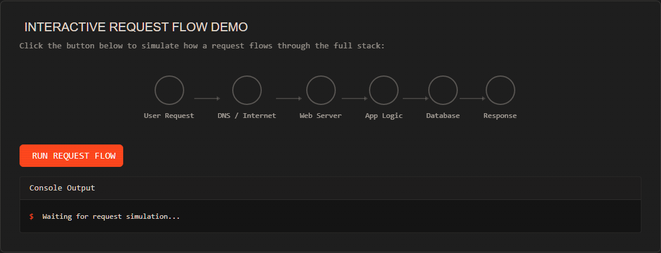
Figure 2: Interactive Request Flow Simulation

7. Reflection
Building this portfolio as a full stack project—from HTML structure through CSS styling to JavaScript interactivity—provided profound appreciation for how every layer depends upon the others. I realized that bugs can originate in the frontend, travel through API calls, be mishandled by the backend, and result in corrupted database data. Only a developer understanding every layer can effectively trace and resolve such issues.
Full stack development transcends mere multi-technology knowledge; it requires understanding how systems integrate at scale. Performance, security, and reliability are not features added retrospectively but architectural principles guiding decisions from project inception. This project transformed theoretical understanding into practical, hands-on experience that will inform future development decisions.

8. References
Bootstrap Team (2024) Bootstrap: The most popular HTML, CSS, and JS library. Available at: https://getbootstrap.com/ (Accessed: 17 June 2026).
Mozilla Foundation (2024) MDN Web Docs. Available at: https://developer.mozilla.org/ (Accessed: 17 June 2026).
World Wide Web Consortium (2024) W3C. Available at: https://www.w3.org/ (Accessed: 17 June 2026).

