Table of Contents

1. Introduction: What is HTML?
HTML (HyperText Markup Language) is the standard markup language for creating and structuring web page content. It is not a programming language—it contains no logic or computational capability—but rather a markup system using elements and tags to instruct browsers how to structure and display content (World Wide Web Consortium, 2024). The term "HyperText" refers to text containing links to other texts, while "Markup" denotes the annotation syntax providing structural meaning.
Invented by Tim Berners-Lee in 1991, HTML has evolved through multiple versions. The current standard, HTML5, finalized in 2014 by the W3C, introduced powerful semantic elements, APIs, and multimedia capabilities that fundamentally transformed browser capabilities (World Wide Web Consortium, 2014).

2. The Anatomy of an HTML Element
Every content piece in HTML wraps within an element comprising three components: an opening tag (`<tagname>`), the content itself, and a closing tag (`</tagname>`). For example, `<h1>Hello World</h1>` creates a level-one heading, while `<p>This is a paragraph.</p>` defines a text paragraph.
Certain elements are self-closing, requiring no separate closing tag because they wrap no content: `<img src="photo.jpg" alt="Description">` embeds images, `<br>` inserts line breaks, and `<input type="text">` creates text fields. Attributes—name-value pairs within opening tags—provide additional element information: `src` specifies file sources, `href` defines hyperlink destinations, `class` assigns CSS styling hooks, `id` provides unique identifiers for JavaScript targeting, and `alt` supplies alternative text critical for accessibility (Mozilla Foundation, 2024).

3. Document Structure and Semantic HTML5
Every valid HTML5 document follows a strict structural template. The portfolio's `index.html` demonstrates this foundation: `<!DOCTYPE html>` declares the HTML5 standard to browsers, activating "standards mode" and preventing inconsistent "quirks mode" rendering; the `<head>` element contains metadata including character encoding (`<meta charset="UTF-8">`), viewport configuration for mobile devices, SEO descriptions, and links to external stylesheets and scripts; the `<body>` element holds all visible content.
HTML5's most significant improvement was introducing semantic elements carrying inherent meaning about content roles. Before HTML5, developers relied on generic `<div>` elements with class names—so-called "div soup"—which provided no structural meaning to browsers, search engines, or assistive technologies. The portfolio's semantic structure comparison (Figure 1) contrasts basic `<div class="header">` approaches against semantic `<header>` tags, dramatically improving clarity.
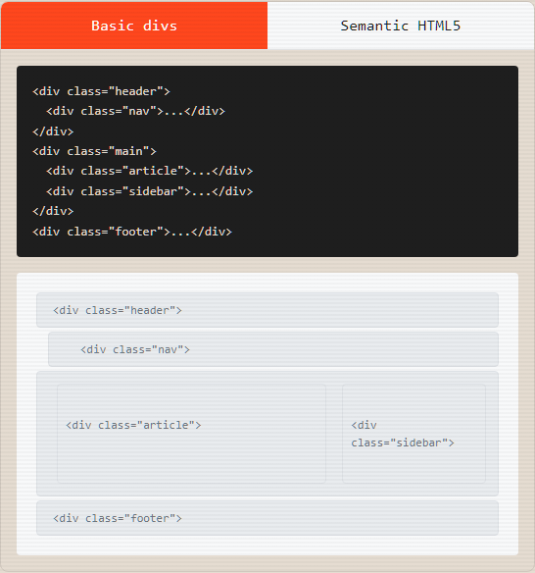
Figure 1: Semantic HTML Structure vs. Non-Semantic Divs
Key semantic elements include: `<header>` for top sections containing logos and navigation; `<nav>` for primary navigation links; `<main>` for the page's unique central content; `<section>` for thematic content blocks with headings; `<article>` for self-contained content pieces; `<aside>` for tangentially related content like sidebars; and `<footer>` for bottom sections containing copyright and contact information (Mozilla Foundation, 2024).
The portfolio structures each content area as `<section id="html">`, `<section id="css">`, etc., enabling smooth scroll navigation where navbar links jump directly to semantic sections. This semantic approach improves accessibility (screen readers announce "navigation" for `<nav>` elements), enhances SEO (search engines weight `<article>` and `<h1>` content more heavily), and increases code maintainability.

4. Common HTML Elements
HTML provides diverse elements for content organization. Headings (`<h1>` through `<h6>`) create hierarchical document outlines, with `<h1>` reserved for the main page title. Text content elements include `<p>` for paragraphs, `<strong>` for important text, `<em>` for emphasis, `<blockquote>` for quotations, `<code>` for inline code snippets, and `<pre>` for preformatted text preserving whitespace.
Lists come in three varieties: unordered (`<ul>`) with bullet points for non-sequential items; ordered (`<ol>`) with numbers for sequential instructions; and definition lists (`<dl>`) pairing terms (`<dt>`) with definitions (`<dd>`). The portfolio's navigation uses nested `<ul>` elements containing `<li><a href="...">` structures.
The anchor element `<a>` creates hyperlinks—the web's fundamental building blocks. Key attributes include `href` for destination URLs (absolute or relative paths, or in-page anchors like `#section-id`), `target="_blank"` for new tab opening, and `rel="noopener noreferrer"` as a security measure preventing newly opened tabs from accessing the original page's window object (World Wide Web Consortium, 2024).

5. Forms, Tables, and Multimedia

5.1 Forms and User Input
HTML forms constitute the primary mechanism for user data submission to servers. The `<form>` element wraps input collections, with `action` specifying the destination URL and `method` defining the HTTP method (GET appends data to URLs; POST sends data in request bodies, preferable for sensitive information). The versatile `<input>` element adapts through its `type` attribute: text, email (with automatic format validation), password (masked), number, range (slider), checkbox, radio, file, date, color, and submit (Mozilla Foundation, 2024).
HTML5 introduced built-in client-side validation without JavaScript: `required` ensures fields contain values; `minlength/maxlength` restricts character counts; `min/max` bounds numeric ranges; and `pattern` validates against regular expressions. The portfolio's interactive form demo (Figure 2) contains various input types with JavaScript capturing `oninput` events to display live JSON data objects, demonstrating how forms serve as data entry points before backend transmission.
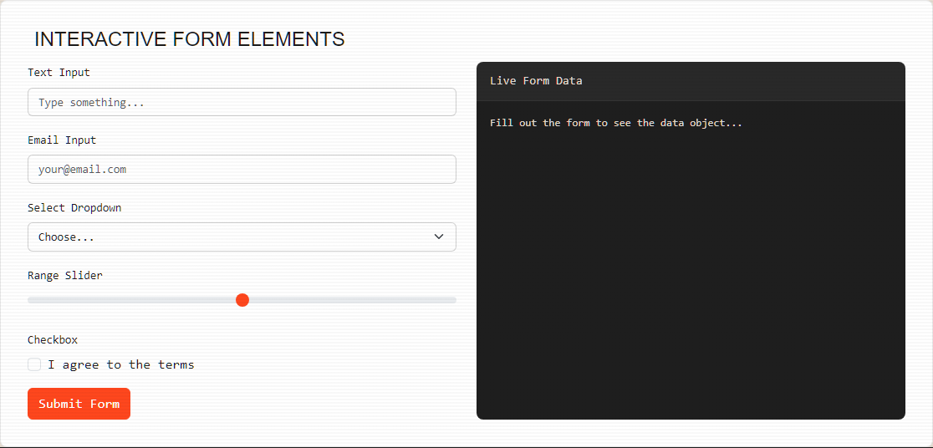
Figure 2: Interactive Form with Live JSON Output

5.2 Tables
The `<table>` element displays two-dimensional tabular data—never for page layout, which remains CSS's domain. Structural elements include `<thead>` for header rows, `<tbody>` for main data, `<tfoot>` for footer rows, `<tr>` for rows, `<th>` for header cells, and `<td>` for standard data cells. Cell spanning via `colspan` and `rowspan` attributes enables complex table layouts.

5.3 Images and Multimedia
The self-closing `<img>` element requires `src` (file path/URL) and `alt` (alternative text for screen readers and failed loads). Additional attributes include `width/height` for space reservation (reducing Cumulative Layout Shift), and `loading="lazy"` for deferred loading until elements approach the viewport. HTML5's `<video>` and `<audio>` elements embed media directly without plugins (World Wide Web Consortium, 2024).

6. Live HTML Editor and Interactive Demonstrations
The portfolio features a working "Live HTML Editor" (Figure 3) where users type HTML code into a `<textarea>` and see instant rendering in an adjacent `<iframe>`. This demonstrates real-time DOM manipulation and cross-frame communication. An event listener detects button clicks within the live preview, automatically focusing the cursor back into the editor and highlighting relevant text via the `postMessage` API—a sophisticated implementation showcasing advanced JavaScript integration with HTML structures.
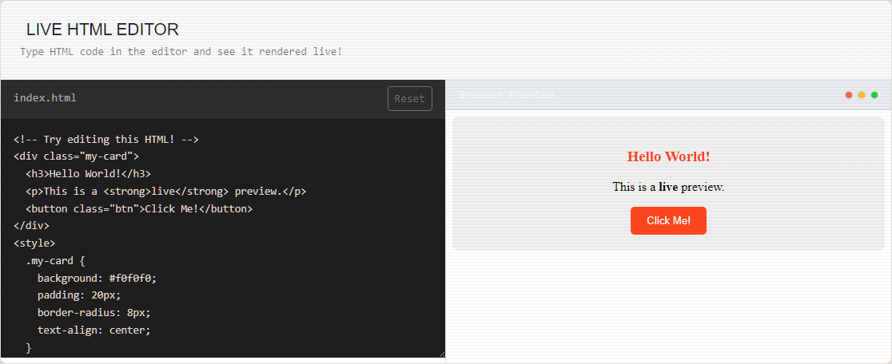
Figure 3: Live HTML Editor Functionality
The semantic HTML comparison (Figure 4) provides toggleable views between basic `<div>` structures and semantic HTML5 equivalents, with visual representations showing how semantic tags create inherently meaningful document outlines. This interactive approach transforms passive reading into active discovery.

Figure 4: Visual Comparison of Semantic vs Non-Semantic Markup

7. Reflection
HTML extends far beyond placing text and images on screens. Through this portfolio, I developed deep appreciation for HTML as the semantic foundation upon which the entire web experience rests. Every tag choice—`<section>` versus `<div>`, `<strong>` versus `<b>`—carries meaning affecting accessibility, SEO, and maintainability. HTML5 significantly expanded browser native capabilities, reducing reliance on third-party plugins for video, audio, and form validation. Strong HTML command is not a prerequisite to rush through but a skill continually revealing new depth.

8. References
Bootstrap Team (2024) Bootstrap: The most popular HTML, CSS, and JS library. Available at: https://getbootstrap.com/ (Accessed: 17 June 2026).
Mozilla Foundation (2024) MDN Web Docs. Available at: https://developer.mozilla.org/ (Accessed: 17 June 2026).
World Wide Web Consortium (2024) W3C. Available at: https://www.w3.org/ (Accessed: 17 June 2026).

