Table of Contents

1. Introduction: What is JavaScript?
JavaScript is a high-level, dynamic programming language that adds interactivity and logic to websites. While HTML structures content and CSS styles presentation, JavaScript enables pages to respond dynamically to user actions, manipulate document structure, handle asynchronous operations, and manage application state (Mozilla Foundation, 2024). As the sole programming language native to web browsers, JavaScript has evolved from simple form validation into a full-featured language capable of powering complex single-page applications, server-side systems (Node.js), and even mobile and desktop applications.
The portfolio's `script.js` demonstrates sophisticated JavaScript patterns including DOM manipulation, event-driven architecture, object-oriented programming with ES6 classes, and game engine physics simulation. This section examines these implementations as evidence of practical JavaScript competency.

2. Advanced DOM Manipulation: Live HTML Editor
The Document Object Model (DOM) represents HTML documents as tree structures accessible through JavaScript. DOM manipulation involves dynamically modifying document structure, content, or styles in response to user interactions or program logic.
The portfolio's Live HTML Editor (Figure 1) listens for user input in a `<textarea>` and instantly injects code into an `<iframe>` via `doc.write()`. This requires careful handling of the iframe's document context, separating editor content from preview execution. A sophisticated enhancement detects button clicks within the live preview, automatically focusing the editor cursor and highlighting relevant text through cross-frame `postMessage` API communication (Mozilla Foundation, 2024).
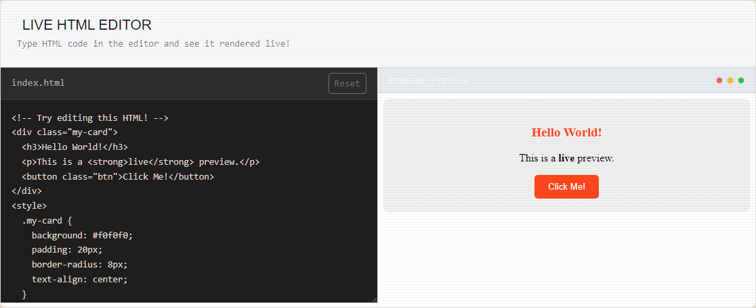
Figure 1: Live HTML Editor Interface with Code Injection
The implementation demonstrates several advanced concepts: cross-origin frame communication, dynamic content injection, text selection manipulation via `setSelectionRange()`, and event delegation within generated content. These techniques extend beyond basic DOM manipulation into the realm of browser API mastery, showing how JavaScript can create self-referential editing environments where the tool itself demonstrates the technology being taught.

3. Interactive Calculator: Logic and State Management
The portfolio features a fully functional calculator (Figure 2) demonstrating variables, functions, and event listeners collaborating to perform arithmetic logic. The implementation maintains three state variables: `currentVal` (active input), `previousVal` (stored operand), and `operator` (pending operation). When users click number buttons, values append to `currentVal`; operator buttons trigger state transitions; and the equals button executes calculation through a `switch` statement handling addition, subtraction, multiplication, and division.
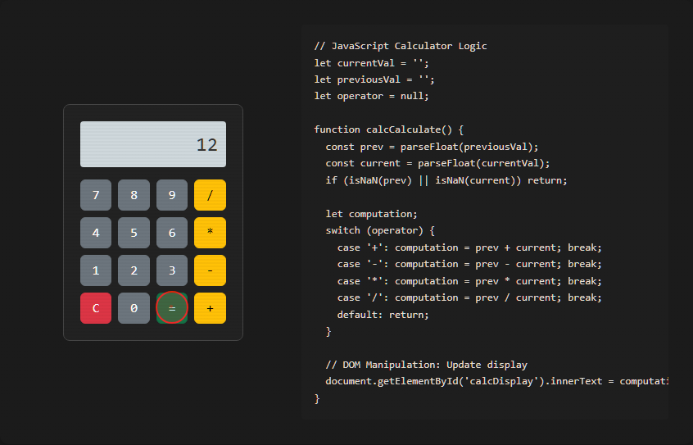
Figure 2: Interactive Calculator Displaying Logic Output
The calculator's CSS Grid layout organizes the numpad responsively, while JavaScript handles edge cases: preventing multiple decimal points, managing consecutive operations, and updating the display DOM element after each interaction. This seemingly simple application encapsulates fundamental programming concepts—state management, conditional logic, function decomposition, and DOM synchronization—that underpin far more complex applications (Mozilla Foundation, 2024).
The accompanying code display (Figure 3) reveals the implementation's clarity: `parseFloat()` converts string inputs to numbers, the `switch` statement selects operations, and `document.getElementById('calcDisplay').innerText` updates the visual output. This direct connection between logic and presentation characterizes JavaScript's role in interactive web development.
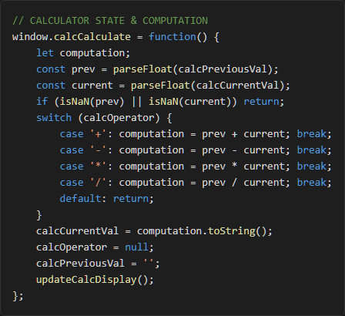
Figure 3: JavaScript Logic for Calculator State Management

4. Object-Oriented Programming: The Runner Game
The portfolio's most sophisticated JavaScript implementation is "The Runner"—an HTML5 Canvas jumping game built entirely from scratch using Object-Oriented Programming (ES6 class `GameEngine`). This exceeds standard portfolio demonstrations (basic calculators or form validators) by implementing a complete game loop with physics simulation, collision detection, and particle effects.
Game Architecture: The `GameEngine` class encapsulates all game functionality: canvas context management, player state (position, velocity, grounded status), obstacle arrays, particle systems, and rendering loops. This OOP structure organizes related data and methods cohesively, making the codebase maintainable and extensible.
Physics Engine: The `updatePhysics()` method applies gravity (`this.player.vy += this.gravity`), handles ground collision detection, and manages obstacle spawning. When the player's vertical position plus height exceeds ground level, velocity resets to zero and `isGrounded` becomes `true`—simple but effective physics simulation.
Game Loop: `requestAnimationFrame` drives the 60 FPS rendering loop, calling `updatePhysics()` followed by `draw` methods (`clear()`, `drawGround()`, `drawPlayer()`, `drawObstacles()`, `drawParticles()`). This pattern—update state then render—represents the standard game development cycle.
Collision Detection: Axis-Aligned Bounding Box (AABB) collision checks compare player and obstacle coordinates each frame. When overlap occurs, the `die()` method triggers: game state halts, particle explosion generates, high scores update via `localStorage`, and the game over overlay appears.
Input Handling: The engine supports multiple input methods—keyboard (`keydown` with Space key), mouse (`mousedown`), and touch (`touchstart`)—ensuring cross-device accessibility. Event listeners attach to both `document` (keyboard) and `canvas` (pointer/touch), with `preventDefault()` preventing unwanted scrolling during mobile play.
The code snippet (Figure 4) shows the physics implementation's elegance: gravity application, ground collision resolution, and state flag management in under ten lines. This conciseness demonstrates how well-structured OOP produces readable, maintainable game logic (Mozilla Foundation, 2024).
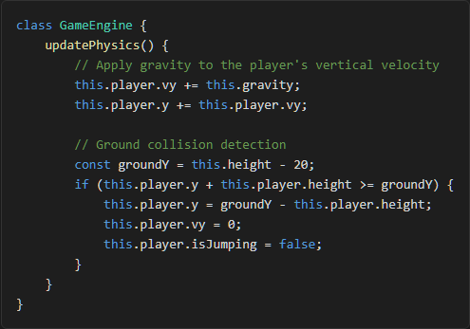
Figure 4: Physics Implementation in The Runner Game

5. Reflection
Writing JavaScript for this portfolio—particularly the Game Engine—solidified my understanding of Object-Oriented Programming and event-driven architecture. I learned to manage application state over time, optimize rendering loops for performance, and structure complex interactions through class-based encapsulation. The calculator taught me about state synchronization between logic and UI; the Live Editor revealed cross-frame communication complexities; and the Runner Game demonstrated how mathematical concepts (gravity, collision detection) translate into playable experiences through code. Seeing my code directly become interactive functionality proved JavaScript's transformative power as a client-side programming language.

6. References
Bootstrap Team (2024) Bootstrap: The most popular HTML, CSS, and JS library. Available at: https://getbootstrap.com/ (Accessed: 17 June 2026).
Mozilla Foundation (2024) MDN Web Docs. Available at: https://developer.mozilla.org/ (Accessed: 17 June 2026).
World Wide Web Consortium (2024) W3C. Available at: https://www.w3.org/ (Accessed: 17 June 2026).

