EMPLOYEE MANAGEMENT

Test API's:

1) get specific Employees:

request URL : 1) http://localhost:2020/SpringRestExample/api/rest/employee-management/employees/10015

Need to pass below 3 headers

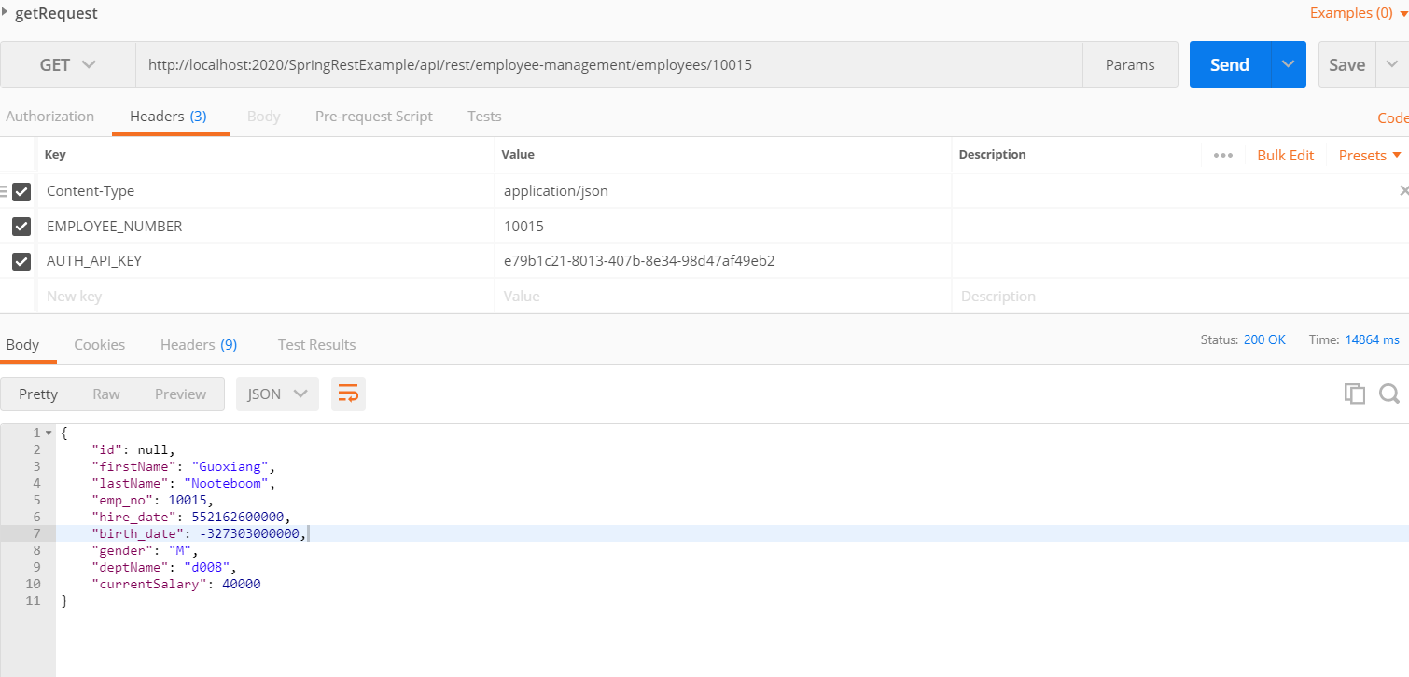

2) List of all employees:

http://localhost:2020/SpringRestExample/api/rest/employee-management/employees

