YEAR | : | III
COLLEGE CODE | : | 207
COLLEGE NAME | : | KING NANDHIVARMAN COLLEGE OF ARTS & SCIENCE
DEPARTMENT | : | COMPUTER SCIENCE
SEMESTER | :  : | V  S.PURUSOTHAMAN  E.SELVEM  P.PRADEEP  P.POOVARASAN  N.RANJITH
  MEMBERS | :

Milestone 1 - Salesforce developer account creation :

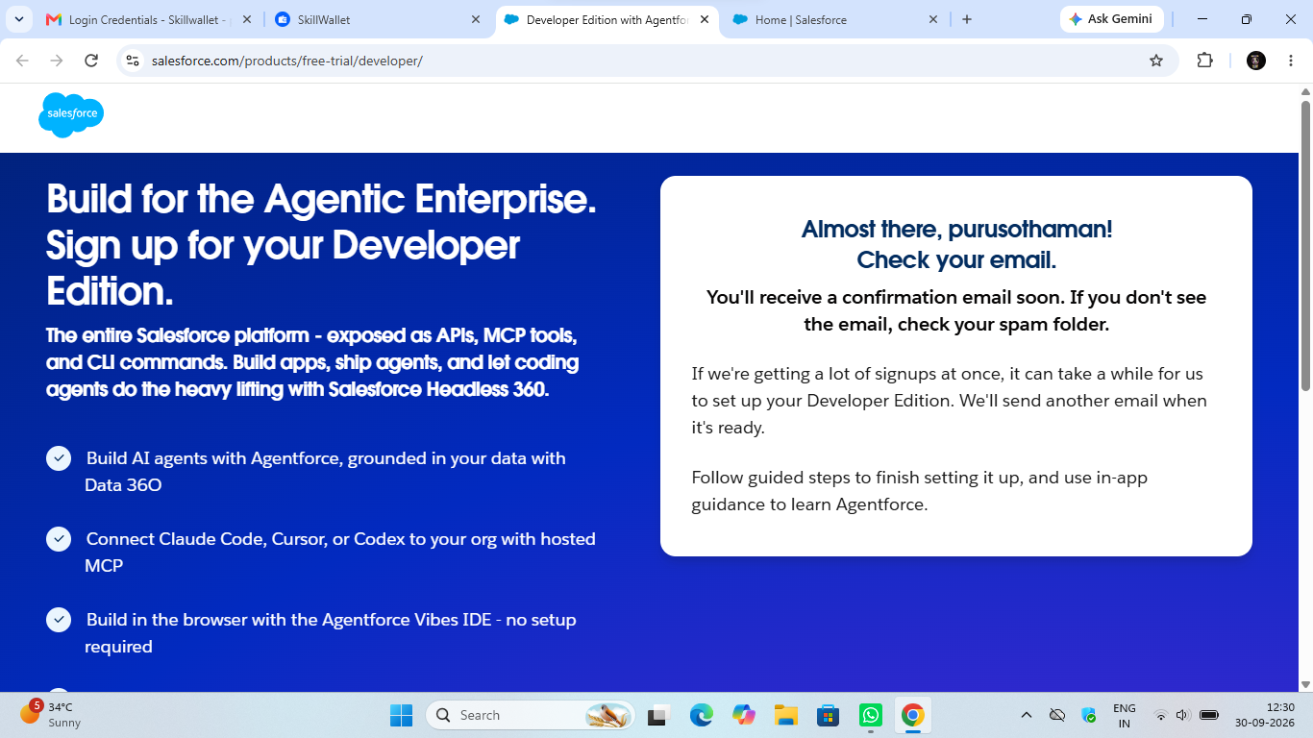
Activity 1: Creating Developer Account:

Creating a developer org in salesforce.
- Go to https://developer.salesforce.com/signup
- On the sign up form, enter the following details :

- First name & Last name
- Email
- Role : Developer
- Company : College or Company Name
- County : India
- Postal Code : pin code
- Username : should be a combination of your name and company
This need not be an actual email id, you can give anything in that format : username@organization.com
Click on sign me up after filling these.

Activity 2: Account Activation :

- Go to the inbox of the email that you used while signing up. Click on the verify account to activate your account. The email may take 5-10mins.

- Click on Verify Account.
- 3.Give a password and answer a security question and click on change password.

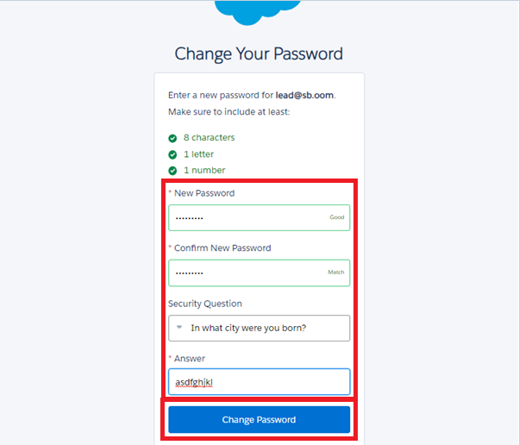

- Then you will redirect to your salesforce setup page.
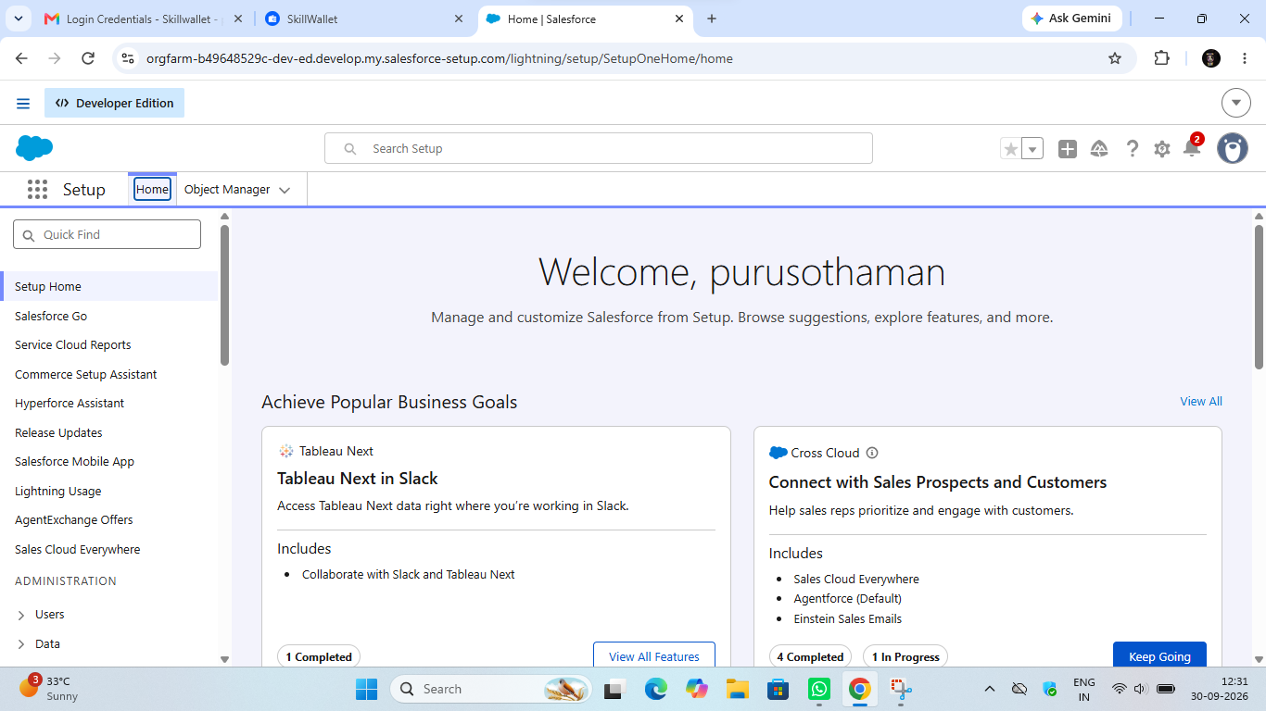

Milestone 2 - Object Creation

Activity 1 : Player Object

- In your Salesforce org, click gear icon on the top left and select Setup to open Setup.
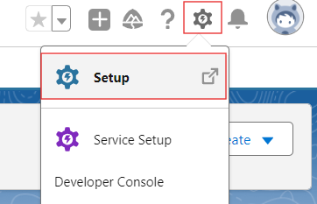

- Click the Object Manager tab. If you don’t see it, enter Object Manager in the Quick Find box.
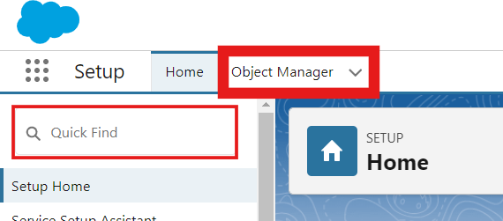

- On the Object Manager page, click Create | Custom Object.

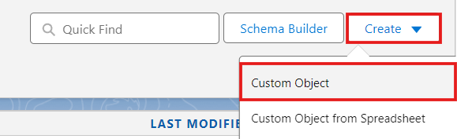
- From the setup page → Click on Object Manager → Click on Create → Click on Custom Object.
- Label : Player
- Plural Label : Players
- Enter Record Name Label and Format
Record Name : Player Name
Data Type : Text
- In Optional features : check the boxes for Allow Reports | Allow Activities | Track Field History.
- Search Status : check the box for Allow Search.
- Save

Activity 2 : Match Performance Object

- From the setup page → Click on Object Manager → Click on Create → Click on Custom Object.
- Label : Match Performance
- Plural Label : Match Performances
- Enter Record Name Label and Format
Record Name : Customer Account Name
Data Type : Text
- In Optional features : check the boxes for Allow Reports | Allow Activities | Track Field History.
- Search Status : check the box for Allow Search.
- Save.

Milestone 3 - Tabs

Activity 1 : Custom tabs creation

- Go to setup page → type Tabs in Quick Find bar → click on tabs → New (under custom object tab)
- Select Object(Player) → Select the tab style → Next (Add to profiles page) keep it as default → Next (Add to Custom App) uncheck the include tab .
- Make sure that the Append tab to users' existing personal customizations is checked.
- Click save.
- Repeat the same steps for Match Performances.
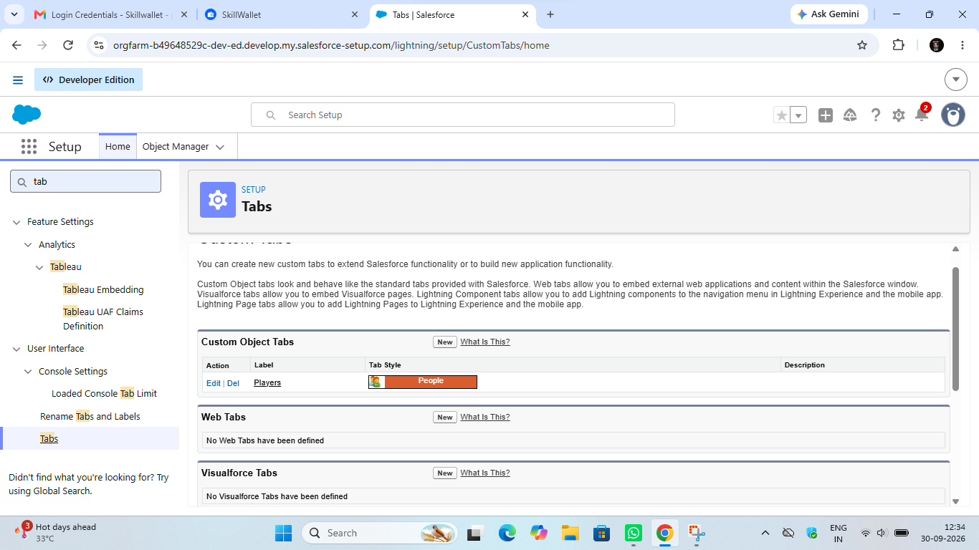

Milestone 4 - The Lightning App

Activity 1 : Create a lightning app

- Go to setup page → search “app manager” in quick find → select “app manager” → click on New lightning App.
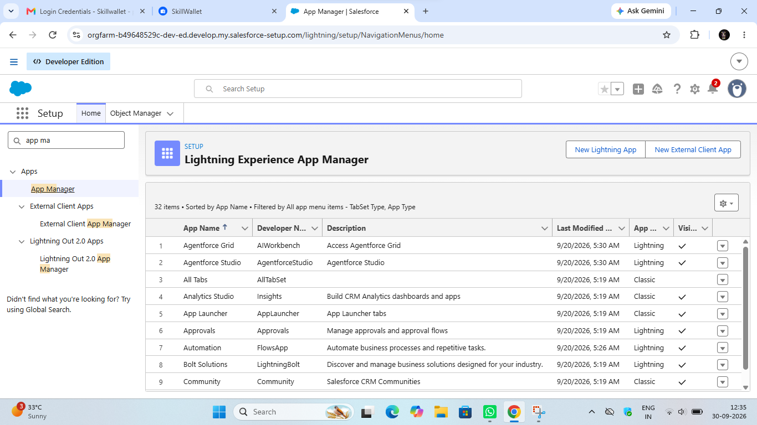
- Fill the app name in app details and branding as follow
App Name : CRICKSTATS
Developer Name : Auto Populates
Add image optional (if you want to give any image you can otherwise not mandatory) - Add Primary color Hex or leave it to default.
Then click Next.

- In App options
Navigation style : Standard navigation
Setup experience : setup
Supporters form factors : Desktop and phone
Then click Next

- In Utility items
Utility Bar alignment : Default
Then click Next.

- Navigation items
Select the created Custom Objects and required standard objects
- Players
Match Performances
Reports
Dashboards
5.To Add User Profiles : System Administrator

6.Click Save & Finish.

Milestone 5 : Fields & Relationships

Activity 1 : Create Custom fields for Player object

- In your Salesforce org, click gear icon on the top left and select Setup to open Setup.
- Click the Object Manager tab. If you don’t see it, enter Object Manager in the Quick Find box.
- From the object manager page, In the Quick Find box, Search for the custom object you just created : Player
- From the sidebar, click Fields & Relationships. Notice that there are already some fields there. Those are the standard fields.
- Click New to create a custom field. Tip: Before creating a new field, do a quick search to make sure a similar one doesn’t already exist.
- Next, choose a data type as Text. Choosing a data type helps you format the field input.
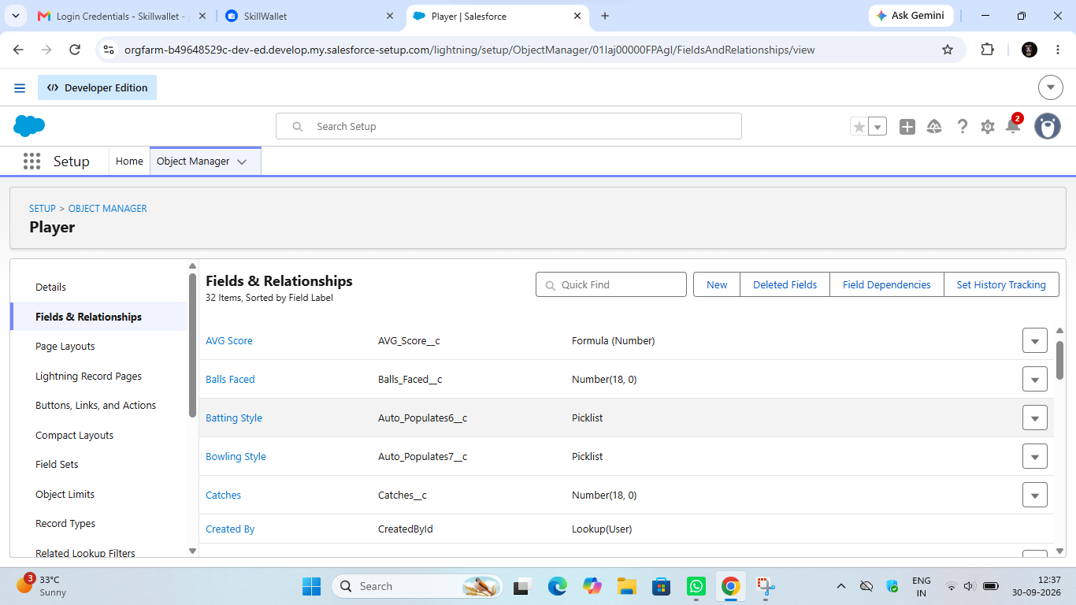

- Data Type : Master - Detail Relationship
Related To : Player
Field Label : Player
Field Name : Auto Populates
Click on Next → Next → Save.

Milestone 6 : Roll-up Summary

Activity 1 : Create Roll-up Summary for Player object.

Note :- Roll-up Summary can only be created on parent object in Master- Detail Relationship.

- In your Salesforce org, click gear icon on the top left and select Setup to open Setup.
- Click the Object Manager tab. If you don’t see it, enter Object Manager in the Quick Find box.
- From the object manager page, In the Quick Find box, Search for the custom object you just created : Player
- From the sidebar, click Fields & Relationships. Notice that there are already some fields there. Those are the standard fields.
- Click New to create a custom field. Tip: Before creating a new field, do a quick search to make sure a similar one doesn’t already exist. Click Next,
- Choose a data type as Roll-up Summary. Click Next.
Field Label: Matches Played
Field Name : Auto Populates
Summarized Object : Match Performances
Select Roll-up Type : COUNT

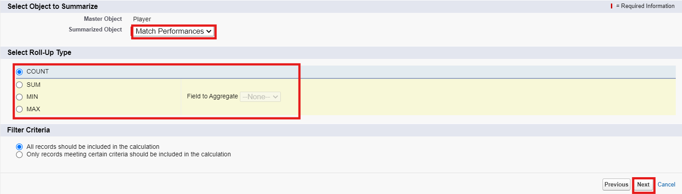

Filter Criteria : All records should be included in the calculation.
Click on Next → Next → Save and new.

- Data Type : Roll-up Summary
Field Label: Number of 50’s
Field Name : Auto Populates
Summarized Object : Match Performances
Select Roll-up Type : COUNT
Filter Criteria : Only records meeting certain criteria should be included in the calculation.
Click on Next → Next → Save and new.
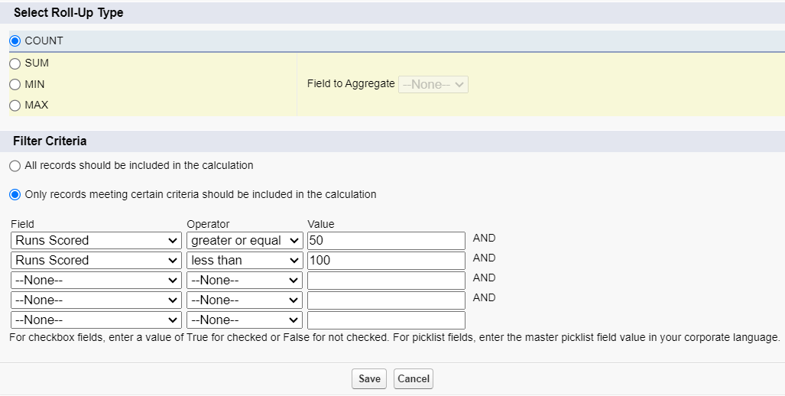

- Data Type : Roll-up Summary
Field Label: Number of 100’s
Field Name : Auto Populates
Summarized Object : Match Performances
Select Roll-up Type : COUNT
Filter Criteria : Only records meeting certain criteria should be included in the calculation.
Click on Next → Next → Save and new.

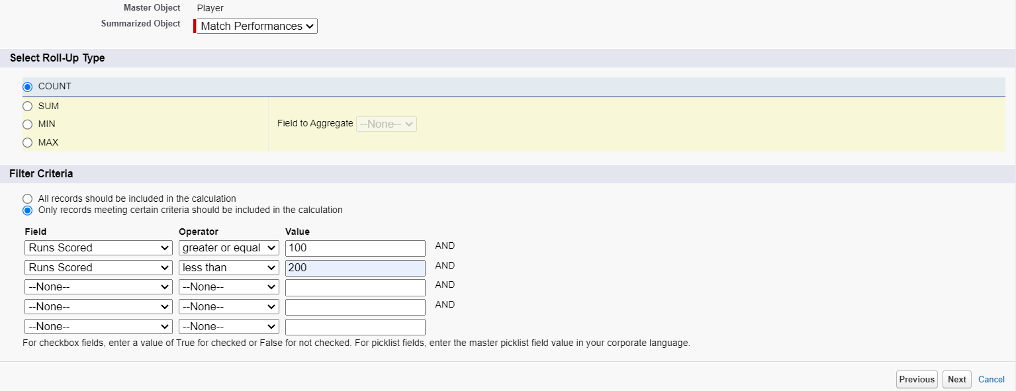

- Data Type : Roll-up Summary
Field Label: Total 4’s
Field Name : Auto Populates
Summarized Object : Match Performances
Select Roll-up Type : SUM
Field To Aggregate : Fours
Filter Criteria : All records should be included in the calculation.
Click on Next → Next → Save and new.

- Data Type : Roll-up Summary
Field Label: Total 6’s
Field Name : Auto Populates
Summarized Object : Match Performances
Select Roll-up Type : SUM
Field To Aggregate : Sixes
Filter Criteria : All records should be included in the calculation.
Click on Next → Next → Save and new.

- Data Type : Roll-up Summary
Field Label: Total Runs
Field Name : Auto Populates
Summarized Object : Match Performances
Select Roll-up Type : SUM
Field To Aggregate : Runs Scored
Filter Criteria : All records should be included in the calculation.
Click on Next → Next → Save and new.

- Data Type : Roll-up Summary
Field Label: Total Overs
Field Name : Auto Populates
Summarized Object : Match Performances
Select Roll-up Type : SUM
Field To Aggregate : Overs Bowled
Filter Criteria : All records should be included in the calculation.
Click on Next → Next → Save and new.

- Data Type : Roll-up Summary
Field Label: Total Wickets
Field Name : Auto Populates
Summarized Object : Match Performances
Select Roll-up Type : SUM
Field To Aggregate : Wickets Taken
Filter Criteria : All records should be included in the calculation.
Click on Next → Next → Save and new.

- Data Type : Roll-up Summary
Field Label: Total Stumpings
Field Name : Auto Populates
Summarized Object : Match Performances
Select Roll-up Type : SUM
Field To Aggregate : Stumpings
Filter Criteria : All records should be included in the calculation.
Click on Next → Next → Save and new.

- Data Type : Roll-up Summary
Field Label: Total Catches
Field Name : Auto Populates
Summarized Object : Match Performances
Select Roll-up Type : SUM
Field To Aggregate : Catches
Filter Criteria : All records should be included in the calculation.
Click on Next → Next → Save and new.

Milestone 7 : Flows

Activity 1 : Screen Flow

- Go to setup, Type Flow in quick find box → Click on the Flow and Select the New Flow.
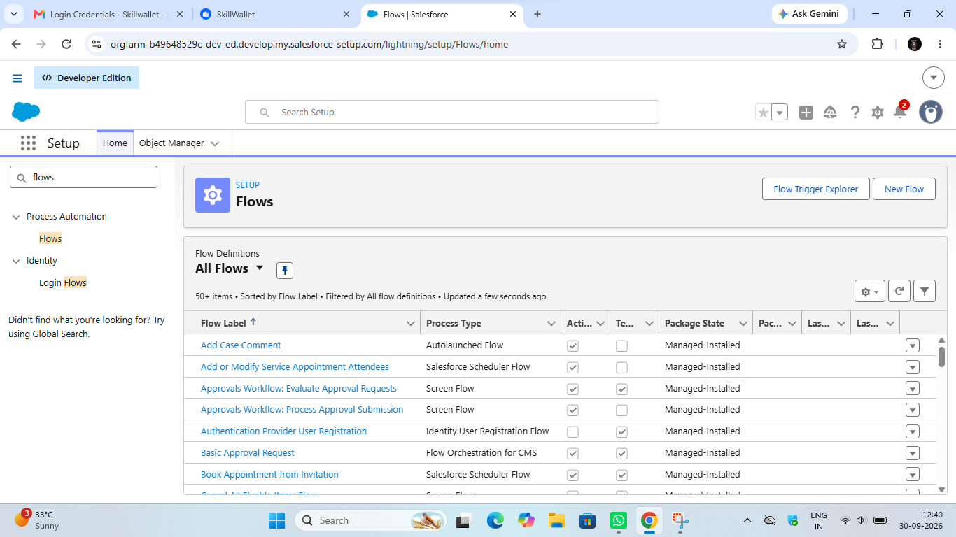

- Select Screen Flow and click Create.

- Click (+) Icon on the flow builder and Select Screen Component.
Label : Players screen
API : Players_screen
Select the Picklist component and place it on the screen.
Label : Team
API : Team
From Component Pane on the left side select Component Type : Picklist
Data Type : Text
Choice : Click New Choice Resources
Resource Type : Picklist Choice Set

API Name : Team
Object : Player
Data Type : Picklist
Field : Team
Click Done.

- Click (+) Icon on the flow builder and Select Get Records Component.
Label : Players
API Name : Players
Object : Player
Filter player records :
Field : Team
Operator : Equals
Value : Click New Resource
Resource Type : Variable
API Name : Dynamic
Data Type : Text
Default Value : Screen component : Team (Picklist)
Click (+) Icon on the flow builder and Select Screen Component.
Label : Player_info
API Name : Player_info
From Component Pane on the left side select Component Type : Data table
API Name : Player_info_table
Label : Data Table
Configure Data Source : Source Collection : Players from players (Player__c)

In Configure Columns : Add all the required Columns
Profile Picture | Player Name | Total Runs | AVG Score | Batting Style | Bowling Style | Matches Played | Number of 50’s | Number of 100’s
Click Done.
Click Save.
Flow Label : Player Flow
Flow API Name : Player_Flow
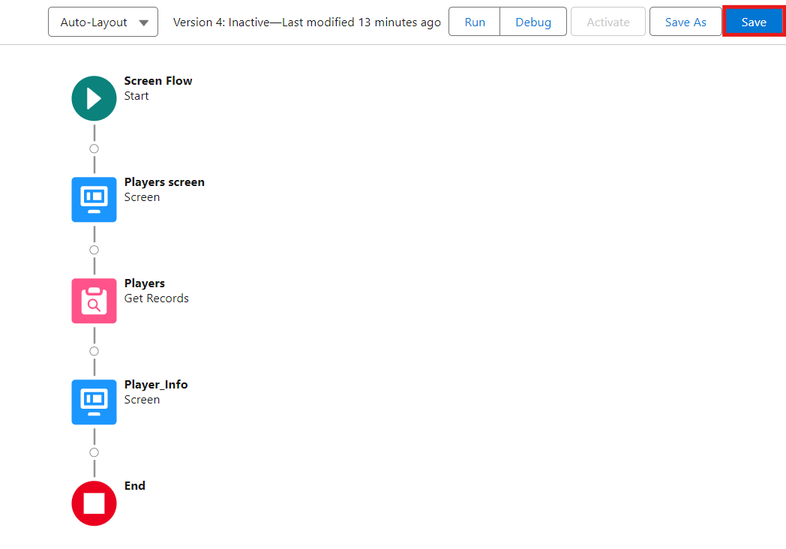
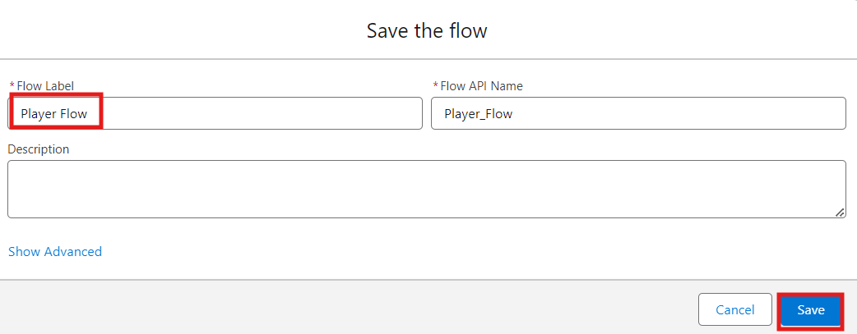

Activity 2 : Flow on Home Page

- On your CRICKSTATS Application on the top right of the Navigation Bar click on Personalize your nav bar icon (Pencil Icon) and Add Home Page and click Save.

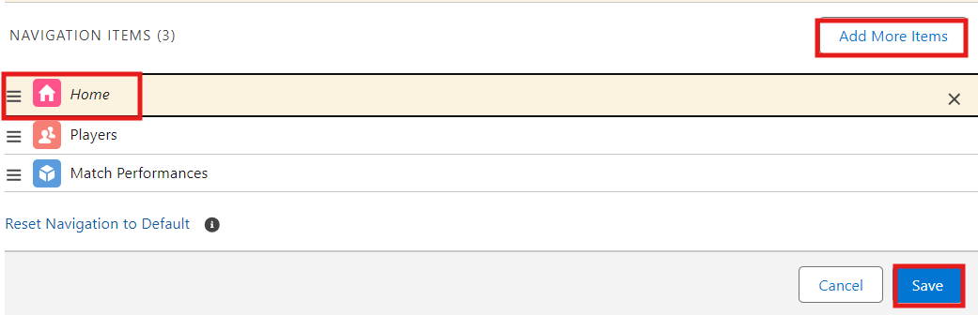

- Remove all other components and Add FLOW component from the standard components on the left side.
- Flow : Players Flow

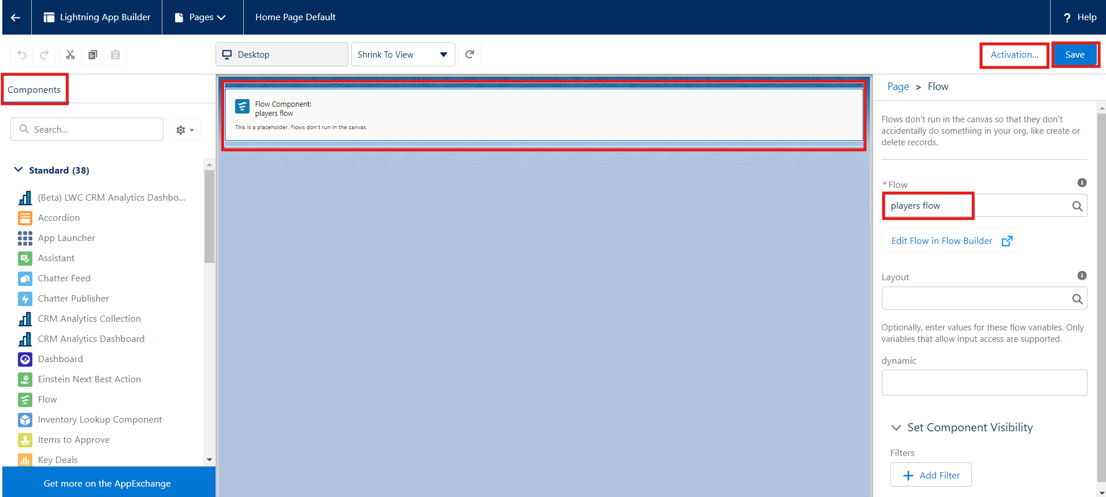

- Click Save and Activation.
- Click on App Default and select Assign to Apps.

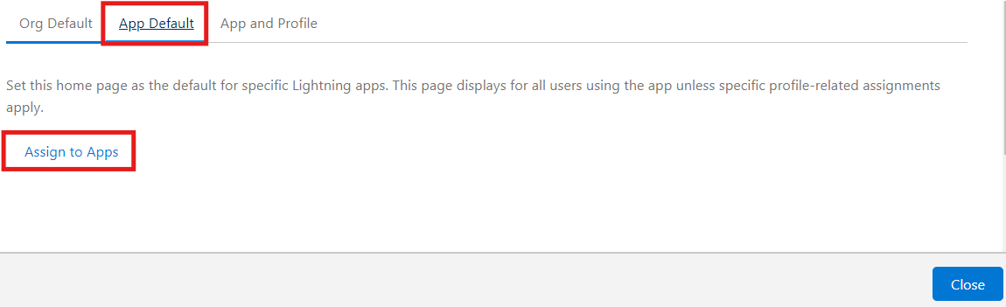
- Select CRICKSTAS App and Click Next and then click Save.

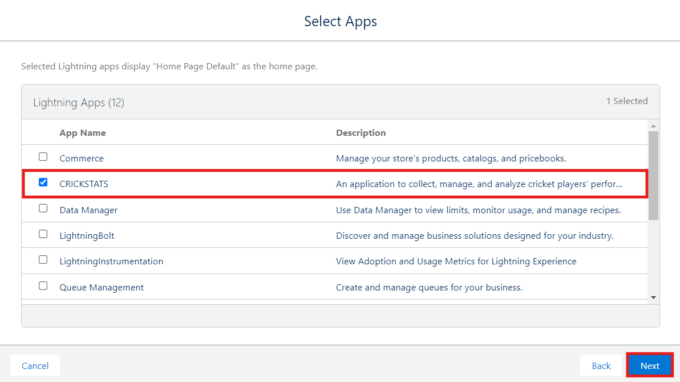

7. FUNCTIONAL & PERFORMANCE TESTING

During the testing phase, screenshots were captured from the Salesforce Lightning user interface to verify the correct functioning of all implemented features in the CRICKSTATS system. These include record creation for Player and Match Performance objects; validation rule checks for mandatory fields, score limits, and input constraints; verification of record type behavior for Domestic and International match categories; and flow execution for automatic updating of player statistics and data consistency. The functionality of roll-up summary fields was also tested to ensure accurate calculation of total runs, wickets, averages, and performance metrics.

In addition, system performance was evaluated by monitoring response time during data entry, report generation, and dashboard loading. The application was tested under multiple user interactions to ensure stable performance without delays. Screenshots of generated reports and interactive dashboards were documented to confirm accurate data visualization, real-time updates, and reliable performance tracking. These testing activities ensured that the CRICKSTATS platform met both functional and performance requirements and was ready for deployment.
NOTE : Enter some records in the Player Object and Match Performance Object to get the results.

- Select one Team from the Picklist and Click Next.

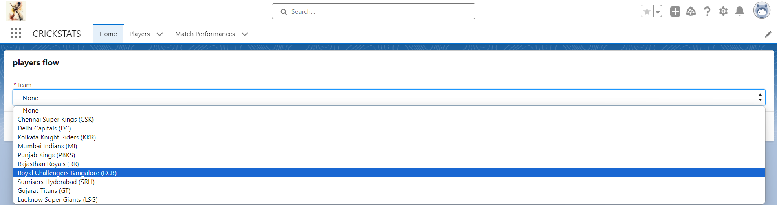

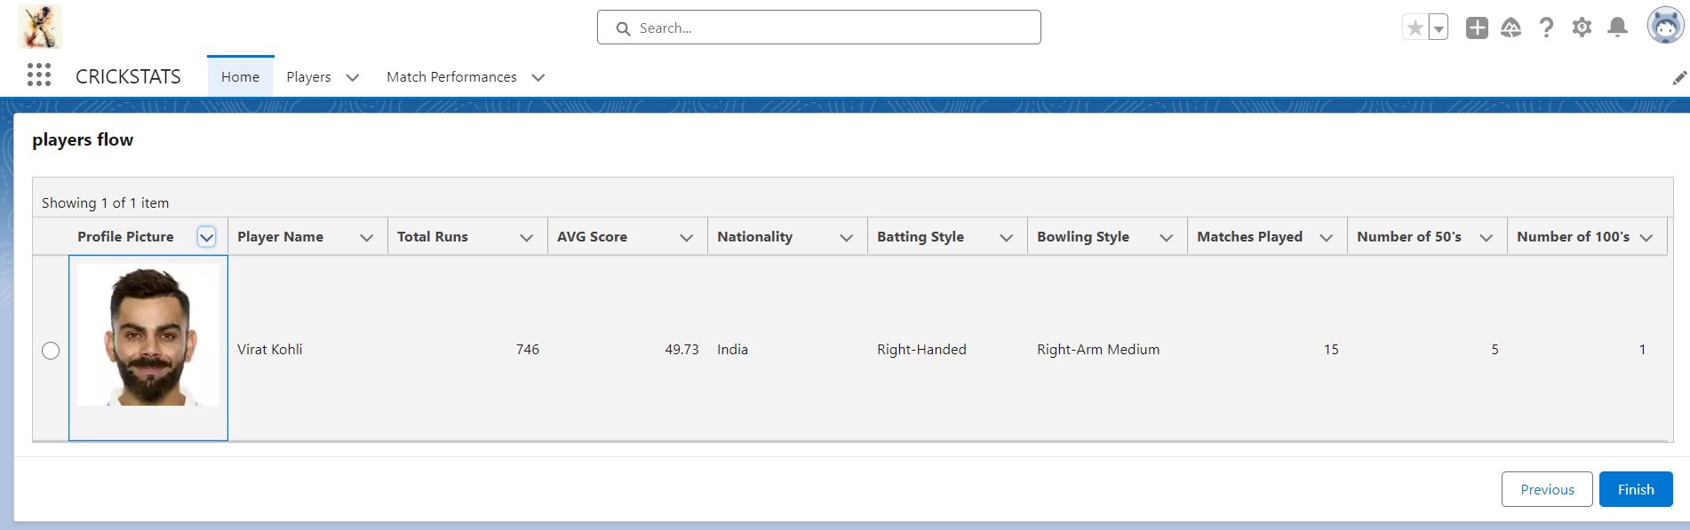
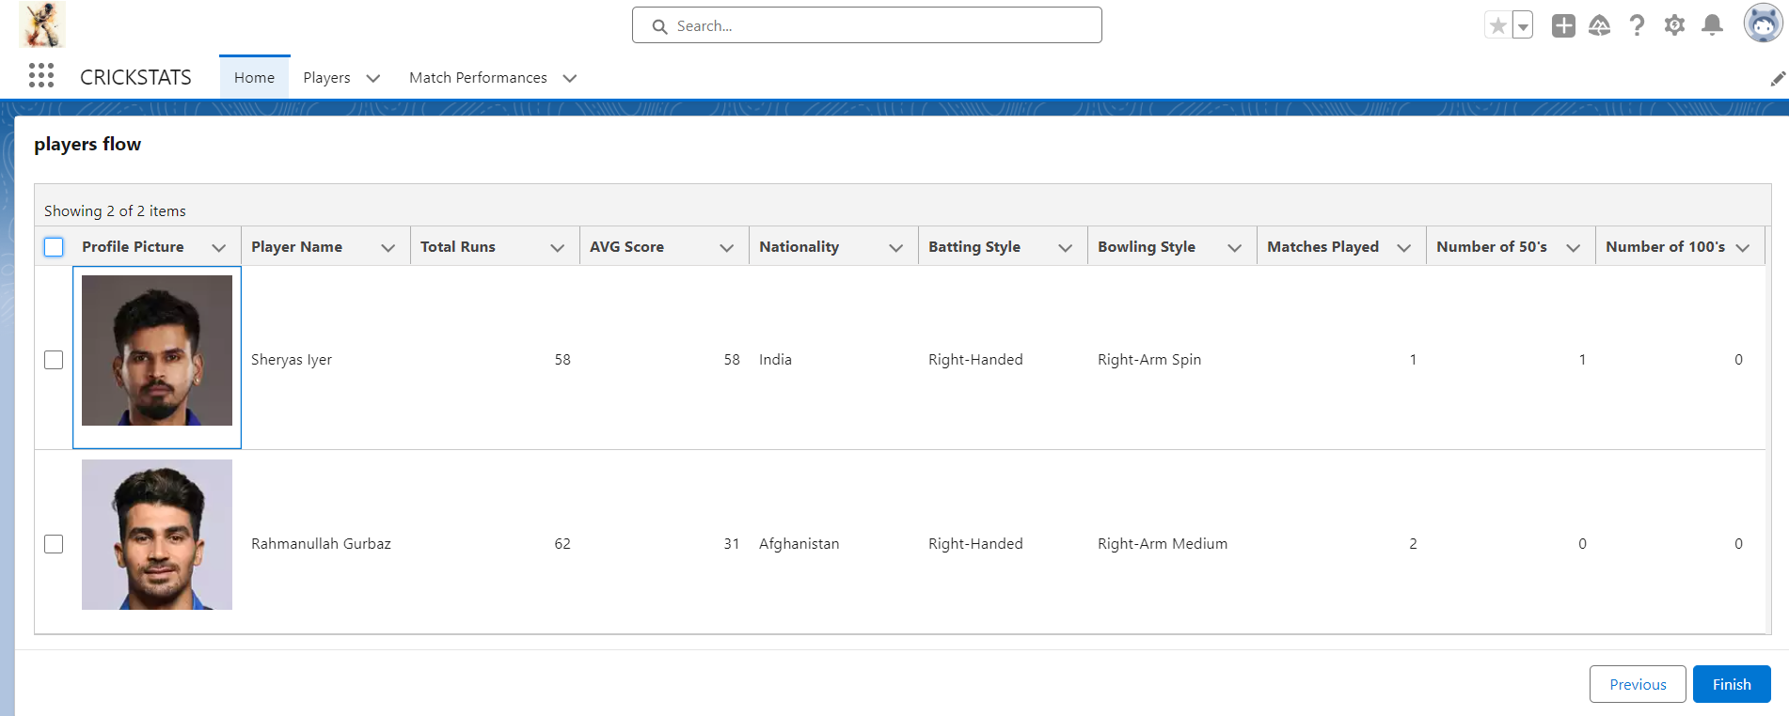

8. ADVANTAGES & DISADVANTAGES

Advantages
- Centralized system
- Real-time analytics
- Secure platform
- Scalable design
- Reduced manual work

Disadvantages
- Requires Salesforce license
- Internet dependency
- Limited offline access

9. Conclusion:

CRICKSTATS successfully implements a cloud-based cricket performance tracking system using Salesforce. The system automates data management, improves reporting accuracy, and supports informed decision-making.
The project demonstrates practical application of SDLC, Agile methodology, and CRM-based development.

10. FUTURE SCOPE
- Mobile application integration
- AI-based performance prediction
- Video analysis integration
- Player ranking system
- Public statistics portal
- Multi-league support

11. APPENDIX
- Salesforce Objects & Fields
- Manual match statistics
- Flow Configurations

Thank You

