Assignment Submission – Project 05: Use Cases & Version Control
Course: IS 699 – Information Systems Project
Project: Sign Language Recognition
Under guidance of: Dr. Abraham Asher
Team Members: Purv Savalia, Purav Rawal, and Dhruti Dedhia

1. Functional Requirements
1. Gesture Detection and Frame Extraction – The system automatically extracts frames from video input and normalizes them for consistent preprocessing and analysis.

2. Human Segmentation and Hand Detection – The model isolates hand regions from the background using segmentation (via Sapiens Lite) to enhance gesture clarity.

3. Feature Extraction and Classification – The system extracts spatial features using ResNet50 and interprets temporal sequences with Transformer and Bi-LSTM models to recognize gestures accurately.

4. Output Translation and Real-Time Prediction – The system provides real-time gesture-to-text translation, displaying recognized signs at an accuracy level of at least 80% on standard datasets.

2. High-Level Use Case Diagram

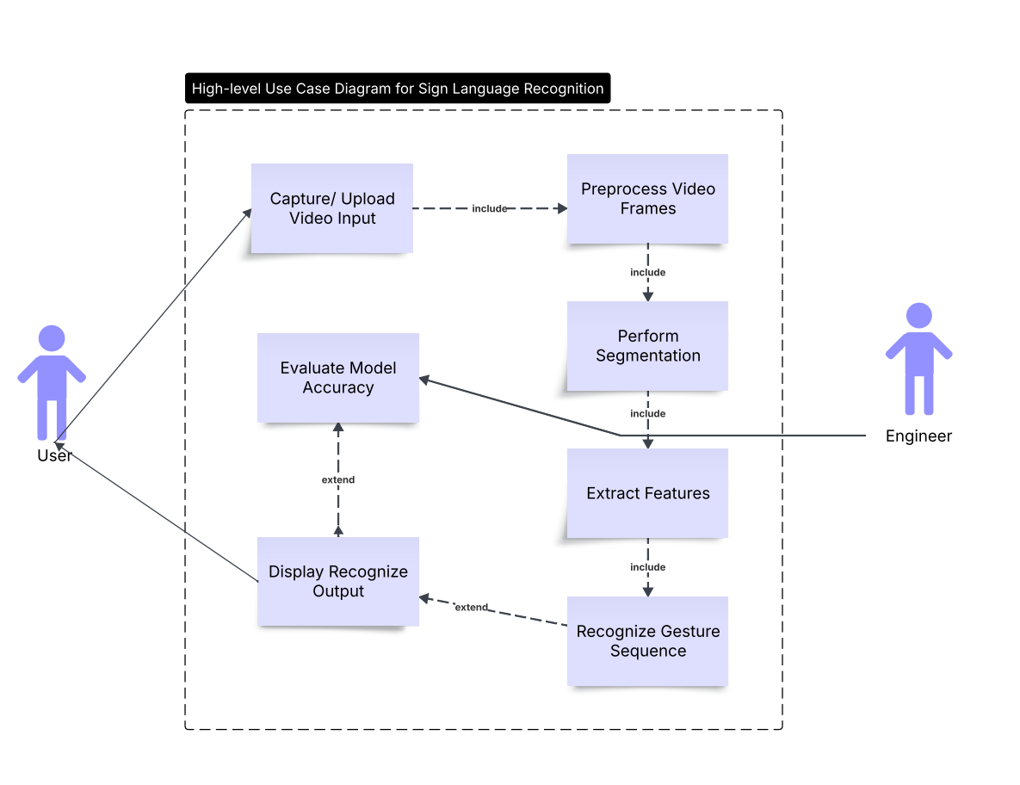

3. Azure Link: https://dev.azure.com/DhrutiDedhia01/IS699_SLR_Project

4. GitHub Repository Link: https://github.com/purv2219/IS699-project

