CASE STUDY
Retail Store Inventory Analysis
Finding out which stores are running low on stock, and when they need to reorder

Prepared by | Business Analyst / Data Analyst
Tools used | MySQL, Power BI, Claude AI
Data covers | 5 retail stores, 2 years of daily records
Data source | retail_store_inventory_data.csv

Table of Contents
1. What This Project Is About 1
2. The Data I Worked With 1
3. How I Approached It 1
4. Checking Stock Health 1
5. Working Out When to Reorder 1
6. Fast-Moving vs Slow-Moving Products 1
7. The Power BI Dashboard 1
Page 1 — Retail Inventory Optimization Dashboard 1
Page 2 — Key Insights 1
8. What I Found 1
9. Files in This Project 1
10. Tools Used 1
11. What Could Be Done Next 1

Executive Summary

This project analyzes inventory data across 5 retail locations to optimize stock levels, identifying where products are overstocked or at risk of running out.

Using MySQL for data processing and Power BI for clear, user-friendly visualization, the project delivers actionable insights to prevent lost sales and improve cash flow.

2. Dataset Details
The main file, retail_store_inventory_data.csv, has one row for every store, product category, and day, over a 2-year period. Here's a quick snapshot:
Detail | Value
Total rows | 73,100
Date range | 1 Jan 2022 to 9 Sep 2023 (731 days)
Stores | S001, S002, S003, S004, S005
Categories | Clothing, Electronics, Furniture, Groceries, Toys
Regions | North, South, East, West
Main columns | Inventory Level, Units Sold, Units Ordered, Demand Forecast, Price, Discount, Weather, Holiday/Promotion

In plain terms: every row tells us, for one store and one product category on one day, how much stock was on the shelf, how much got sold, and how much was expected to be sold.

3. Project Approach
I kept the process simple and broke it into 5 steps:
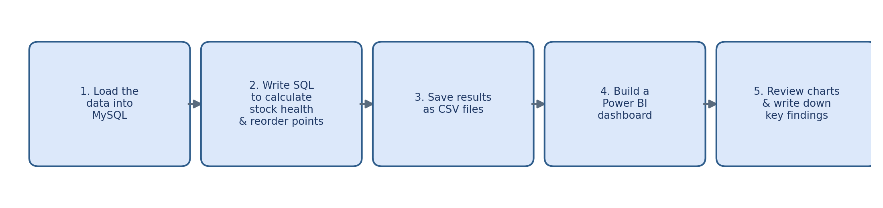

4. Checking Stock Health
For every day, I compared how much stock a store had against how much it was expected to sell (the demand forecast). Based on that, I put each day into one of three simple buckets:
Status | Simple Rule | What It Means
Critical Understock | Stock covers less than 3 days of expected sales | Very risky — could run out any day
Reorder Warning | Stock covers less than 7 days of expected sales | Getting low — should reorder soon
Healthy Stock | Stock covers 7 or more days of expected sales | No action needed right now

Then, for every store + category + region combination, I worked out what percentage of days fell into each bucket. Here's what that looks like across all stores:
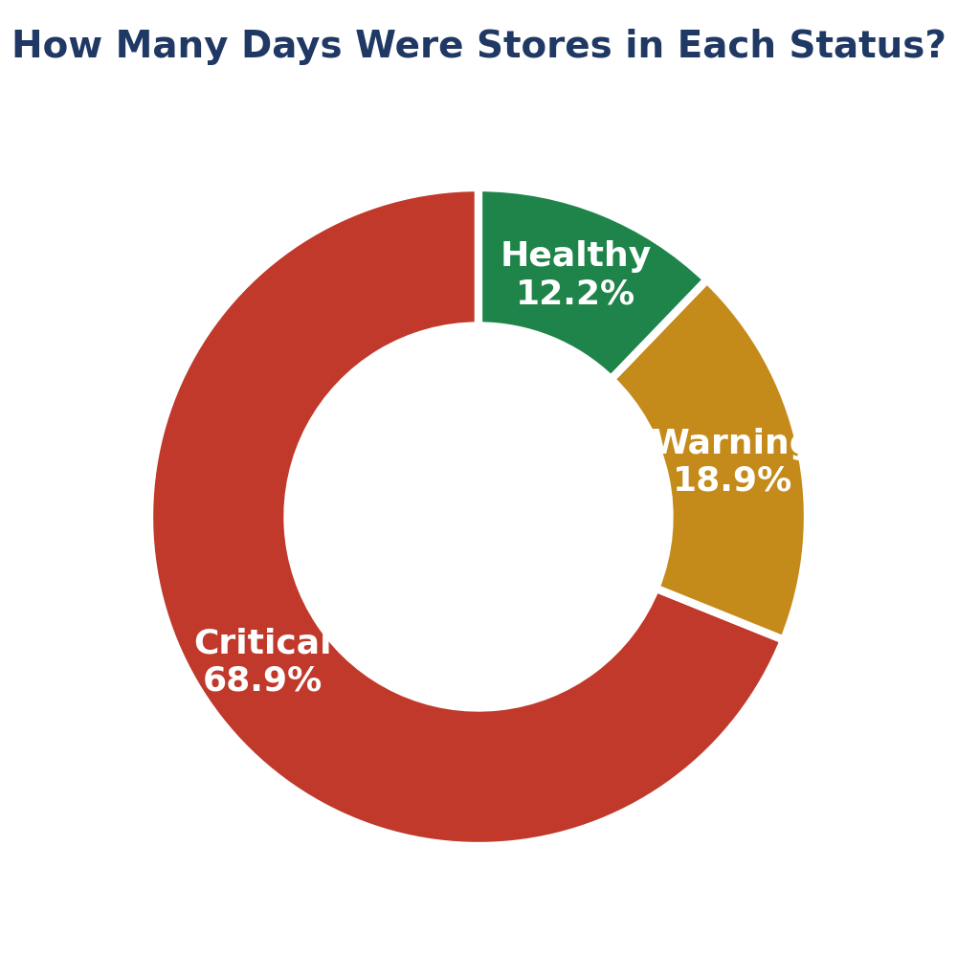
On average, stores were in Critical status 68.9% of the time — this is the norm, not the exception.

5. Stock Reorder Analysis
Next, I worked out a few numbers for each store/category/region to figure out exactly when stock should be reordered:
- Sales Velocity — how many units are sold per day, on average
- Safety Stock — a small buffer to keep on hand (3 days of sales)
- Reorder Point — the stock level at which a new order should go in (10 days of sales)
- Stock Gap — current stock minus the Reorder Point. A negative number means the store already has less stock than it should

I then ranked every store/category/region combination from the biggest gap to the smallest, so the most urgent cases float to the top. Here's how the categories compare:
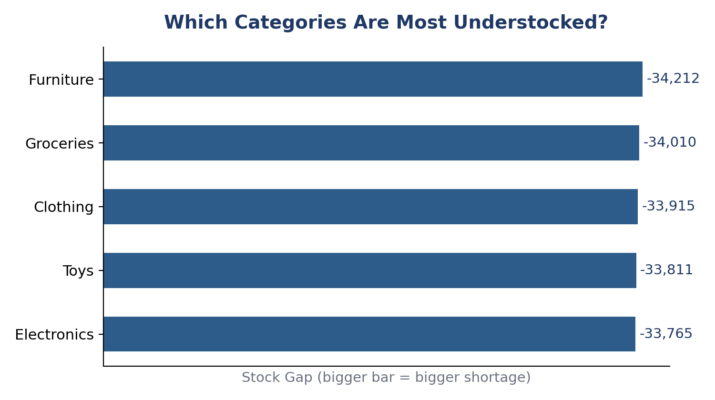
Furniture, Groceries, and Clothing have the biggest shortages overall. The most urgent individual cases right now are Clothing in the South region (Store S003), Furniture in the East region (Store S002), and Clothing in the South region (Store S004) these three need attention first.

6. Fast-Moving vs Slow-Moving Products
Not every product sells at the same speed, so I grouped each store/category/region combo into Fast, Medium, or Slow-Moving, based on average daily sales.
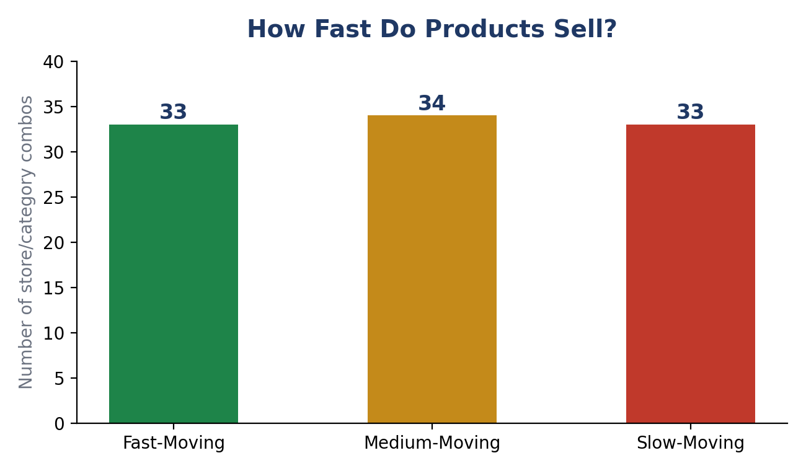
Products are split almost evenly across the three groups. That's an important finding on its own. It means a single reorder rule for every product won't work well. Fast movers need to be restocked more often, while slow movers don't.

7. The Power BI Dashboard
All of this comes together in a 2-page Power BI dashboard, Inventory_Analysis.pbix:

Page 1 — Retail Inventory Optimization Dashboard
- 4 summary cards at the top: Total Units Sold, Inventory Turnover Ratio, Total Stock Gap, and Average % of Days in Critical Stock
- Filters (slicers) to view the dashboard by Category and Region
- A bar chart showing which categories have the biggest reorder problem
- A table showing the stock gap and number of urgent reorders for each store
- A chart comparing % Healthy Stock vs % Critical Stock across categories

Page 2 — Key Insights
- A summary of the main findings (see Section 8)
- A donut chart showing the overall Critical / Warning / Healthy split

8. Key Findings
- Stores are in Critical stock status on 68.9% of tracked days, on average this is a regular, ongoing problem, not a one-off.
- Only 12.2% of days are in Healthy status, and 18.9% are in Warning status.
- Furniture and Groceries have the biggest stock gaps, they are the most under-stocked compared to what they should have.
- A small number of store + category combinations account for most of the high-urgency reorders, so fixing those first would have the biggest impact.
- Products are split almost evenly between Fast, Medium, and Slow-Moving, so a single reorder rule won't suit every product.

9. Files in This Project
File Name | What It Is
retail_store_inventory_data.csv | The raw, original data
Inventory_Analysis.sql | All SQL queries used to calculate stock health, reorder points, and fast/slow movers
stock_health.csv | Output: % of Critical / Warning / Healthy days per store/category/region
reorder_suggestions.csv | Output: reorder point, stock gap, and urgency rank per store/category/region
fast_and_slow_movers.csv | Output: sales speed and movement group per store/category/region
Inventory_Analysis.pbix | The Power BI dashboard file

10. Tools Used
- MySQL — to store the data and write queries (using CASE statements, GROUP BY, and window functions like RANK)
- Power BI — to build the dashboard, cards, charts, and filters
- CSV files — to move data between MySQL and Power BI

11. Recommendations
- Set up an automatic alert or email when a store/category goes into Critical status
- Dig into why Furniture and Groceries have bigger stock gaps than other categories
- Connect the dashboard directly to the live database instead of CSV files, so it updates on its own
- Look at whether Price, Discount, and Promotion are affecting stock-outs

