Loan Default Risk Segmentation
Finding high-risk loan applicants using SQL and Power BI
Prepared by: Purva Vinod Patil
Tools used: SQL Server (SSMS), Excel, Power BI
Data source: Loan Prediction dataset (Kaggle – Analytics Vidhya), 614 applications

Table of Contents
Table of Contents 2
Executive Summary 3
Understanding the Problem & Goal 3
Data Collection 3
Data Cleaning (in SQL) 4
Table Structure & Risk Segmentation Logic 4
Exporting Data & Building the Dashboard 5
Key Findings 6
Conclusion & What Could Be Done Next 7
Appendix 7
Files in This Project 7
Tools Used 8

Executive Summary
Before giving out a loan, a bank needs to know how likely the applicant is to pay it back. This project looks at loan applicant data and sorts each applicant into a risk group — Low, High, or Unknown — mainly based on their credit history. The cleaned data was turned into a Power BI dashboard so a loan manager can quickly see which applicants need a closer look before approval.
The project was carried out in clear phases: collecting the data, cleaning it in SQL, creating a risk label for each applicant, and finally building a dashboard in Power BI. Each phase is explained below, like steps in a case study.
PHASE 1

Understanding the Problem & Goal
Before starting, the goal of the project was kept simple:
- Find out which loan applicants are high-risk (likely to default / not repay).
- Group applicants by risk using clean, well-organised data.
- Look at income and loan amount patterns to understand risk better.
- Give loan managers an easy-to-read dashboard so they can act faster.

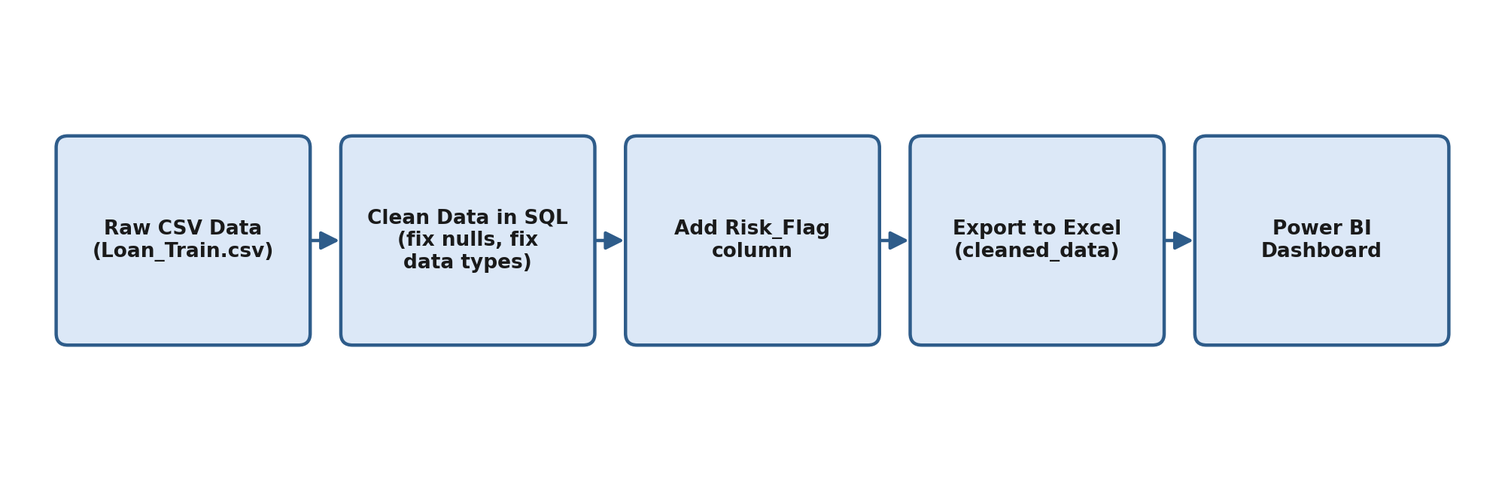
Diagram 1: The overall project flow, from raw data to final dashboard
PHASE 2

Data Collection
The data used for this project is the well-known Loan Prediction dataset from Kaggle (by Analytics Vidhya). It has loan applications with details about each applicant and whether their loan was approved.
Detail | Value
File name | Loan_Train.csv
Total applications | 614
Main columns | Gender, Married, Dependents, Education, Self_Employed, ApplicantIncome, CoapplicantIncome, LoanAmount, Loan_Amount_Term, Credit_History, Property_Area, Loan_Status
Format | CSV, imported into SQL Server
PHASE 3

Data Cleaning (in SQL)
The raw data had a few missing (null) values in some columns. These were checked and fixed using simple SQL UPDATE statements before doing any analysis:
Column | Missing Values | How It Was Fixed
Gender | 13 | Filled with the most common value, 'Male'
Married | 3 | Filled with 'Yes'
Dependents | 15 | Filled with '0'
Self_Employed | 32 | Filled with 'No'
LoanAmount | 22 | Filled with the average loan amount
Loan_Amount_Term | 14 | Filled with 360 (the most common loan term)
Credit_History | 50 | Left as is — used later to mark 'Unknown' risk

Duplicate rows (based on Loan_ID) were also removed using a ROW_NUMBER() window function, keeping only the first record for each Loan_ID.
PHASE 4

Table Structure & Risk Segmentation Logic
After cleaning, this is what the main data table looks like, including the new Risk_Flag column that was added:
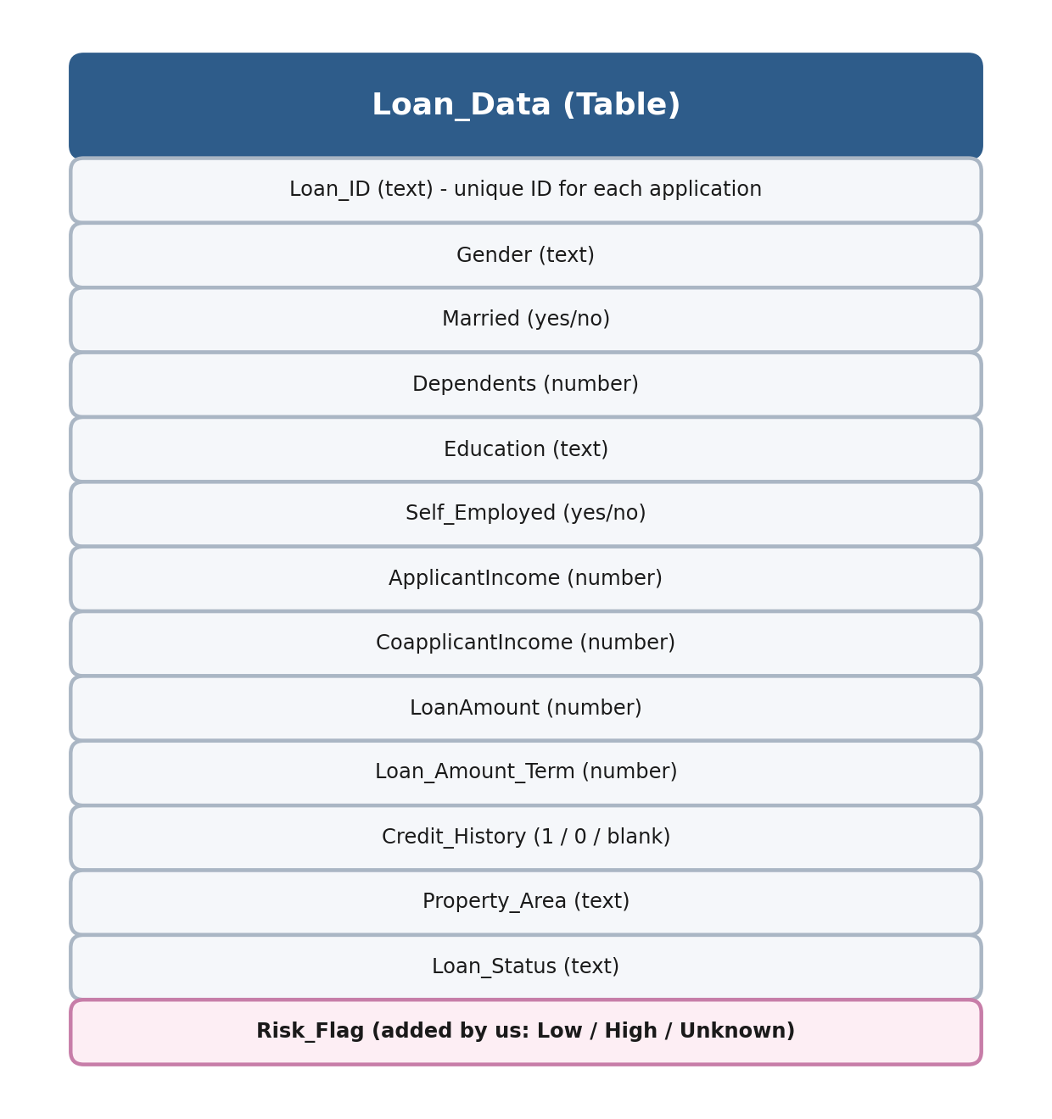
Diagram 2: Simple structure of the Loan_Data table
Risk_Flag is the most important addition. It labels each applicant's risk in one word, based on the Credit_History column, since a good credit history is usually the strongest sign that someone will repay a loan.
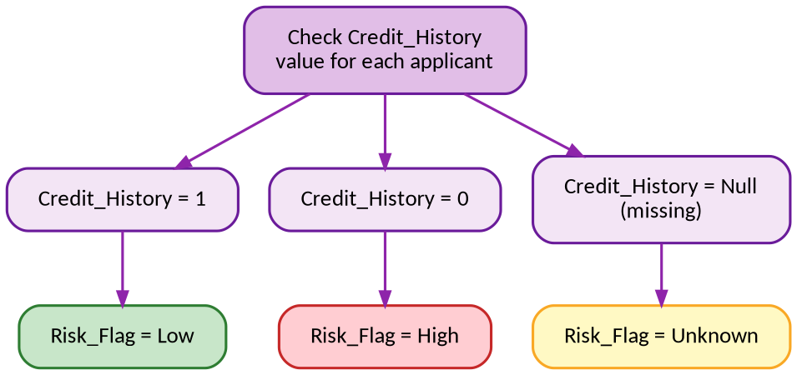
Diagram 3: How each applicant's Risk_Flag is decided
Credit_History Value | Risk_Flag | What It Means
1 | Low | Good credit history — safer to approve
0 | High | Poor credit history — needs a closer look
Null (missing) | Unknown | No credit history on record — not enough info to judge
PHASE 5

Exporting Data & Building the Dashboard
Once the data was cleaned and Risk_Flag was ready, the table was exported from SQL Server into Excel (cleaned_data.xls / new_data.csv), and loaded into Power BI to build the dashboard.
The Power BI dashboard includes:
- A card showing the total number of loan applications (614).
- A table breaking down Risk_Flag with total Applicant Income and Loan Amount.
- A column chart showing total Loan Amount by Risk_Flag.
- A column chart showing number of applications by Property Area (Urban / Semiurban / Rural).
- A column chart comparing total Applicant Income across Risk_Flag groups.
- A pie chart showing the % share of applications in each Risk_Flag group.
- A funnel chart showing applications by Risk_Flag and Property Area.

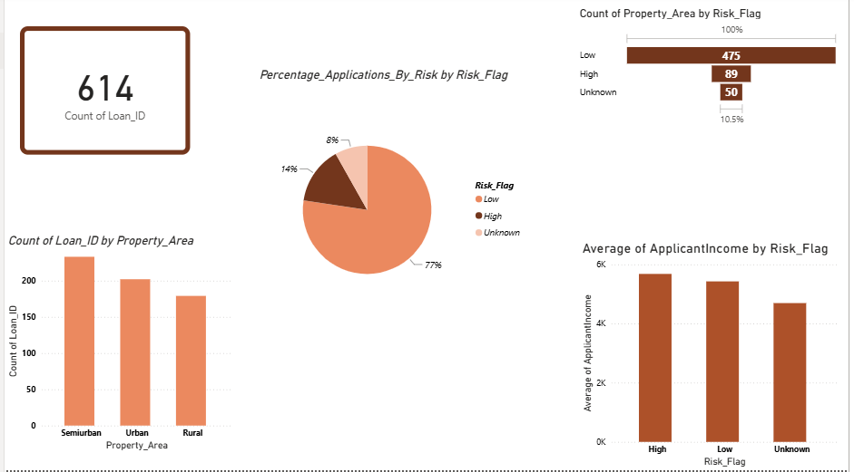
Screenshot: Power BI dashboard showing risk distribution and applicant patterns
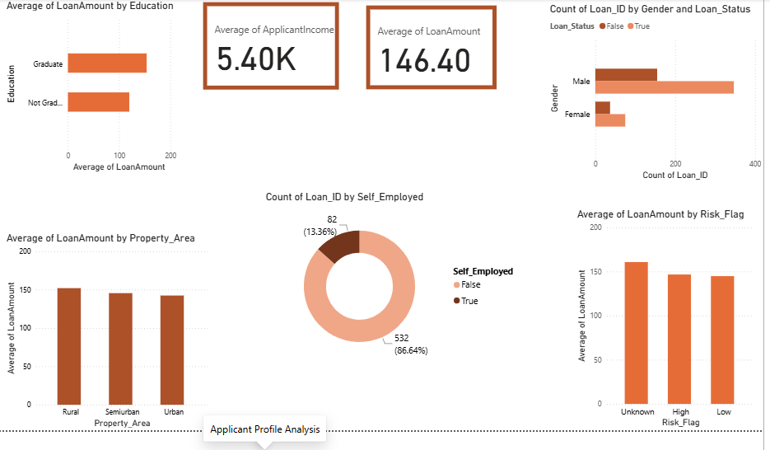
Screenshot: Power BI dashboard showing Applicant Profile Analysis

PHASE 6

Key Findings
Out of all 614 applicants, here is how the risk groups broke down:
Risk Group | Applicants | % of Total | Avg. Income | Avg. Loan Amount
Low Risk | 475 | 77.4% | 5,427 | 145
High Risk | 89 | 14.5% | 5,679 | 147
Unknown Risk | 50 | 8.1% | 4,693 | 161

- Most applicants (about 77%) fall into the Low Risk group, mainly because they have a good credit history (Credit_History = 1).
- Applicants with no credit history (Credit_History = 0) were always marked High Risk , a clear link between credit history and default risk.
- High Risk applicants had a slightly higher average income than Low Risk applicants, but also a slightly higher average loan amount — worth watching for future approvals.
- The Unknown Risk group (50 applicants, 8.1%) had lower average income and the highest average loan amount of all 3 groups, and no credit history on file, this group needs extra information before a decision can be made.
- Out of 614 applicants, 502 were Male and 112 were Female. Among High Risk applicants, 72 were Male and 17 were Female.
- Semiurban areas had the most applications (233), followed by Urban (202) and Rural (179), with risk fairly spread across all three.
PHASE 7

Conclusion
This project shows that a simple, credit-history-based risk label can already separate loan applicants into useful groups. The Power BI dashboard makes it easy for a loan manager to see, at a glance, who is Low, High, or Unknown risk, and to dig into the income and loan amount patterns behind that.
A few ideas for taking this further:
- Collect credit history for the 'Unknown' group instead of leaving it unclassified.
- Add an income-to-loan ratio as its own column, since it's a strong warning sign on its own.
- Connect the dashboard to live data instead of a fixed CSV, so it always shows the latest applications.
- Try a proper prediction model (like logistic regression) later, using Risk_Flag as a starting point.

Appendix

Files in This Project
File Name | What It Is
Loan_Train.csv | Raw / original data (input file), 614 applications
loandata.sql | SQL steps used to clean data and create Risk_Flag
cleaned_data.xls | Cleaned data exported from SQL Server to Excel
new_data.csv | Final cleaned data with Risk_Flag, used in Power BI
loan.pbix | The Power BI dashboard file
loan_risk_analysis.pdf | Project presentation with summary and dashboard screenshots

Tools Used
- SQL Server Management Studio (SSMS) -- for cleaning data and creating the Risk_Flag column.
- Excel – for handling the data between SQL and Power BI.
- Power BI – for building the dashboard and visuals.
- Kaggle (Analytics Vidhya) – source of the original Loan Prediction dataset.
- Claude AI – Leveraged to streamline workflows using dedicated MCP connectors:
- Power BI Connector
- Figma Connector
- Lucid Connector

End of Document

