BUSINESS REQUIREMENTS DOCUMENT
SaveIT
Your Finance Buddy

Document | Business Requirements Document (BRD)
Version | 1.0
Prepared by | Business Analyst
Date | 16 July 2026
Status | Draft

Table of Contents
1. Document Control 1
1.1 Revision History 1
1.2 Approval Status 1
2. Introduction 1
2.1 Project Overview 1
2.2 Project Stakeholders 1
3. Business Objectives 1
3.1 Project Objective 1
3.2 Business Goals 1
3.3 Success Criteria 1
4. Project Scope 1
4.1 In Scope 1
4.2 Out of Scope 1
5. Functional Requirements 1
5.1 Login & Account 1
5.2 Dashboard 1
5.3 Expense Management 1
5.4 Budget Planning 1
5.5 Financial Goals 1
5.6 AI Financial Insights 1
5.7 Advisor Consultation 1
5.8 Subscription Management 1
5.9 Notifications & Reminders 1
6. Non-Functional Requirements 1
7. Business Rules 1
8. Assumptions 1
9. Constraints 1

1. Document Control

1.1 Revision History
Version | Date | Description | Author
1.0 | 16 Jul 2026 | First version of the BRD for the SaveIT project. | Business Analyst

1.2 Approval Status
Role | Status
Project Sponsor (Founder) | Pending
Business Analyst | Prepared

2. Introduction

2.1 Project Overview

SaveIT is a personal finance management application that helps users track expenses, create budgets, set financial goals, and receive AI-powered financial insights. The platform also allows users to connect with verified financial advisors for professional financial guidance. SaveIT follows a freemium model, offering essential features for free while providing additional features through Plus and Pro subscription plans.
2.2 Project Stakeholders
- Project Sponsor
- Product Owner
- Business Analyst
- UI/UX Designer
- Software Development Team
- Quality Assurance (QA) Team
- Project Manager
- Financial Advisors
- End Users

3. Business Objectives

3.1 Project Objective
Build a personal finance management application that helps users track expenses, create budgets, set financial goals, receive AI-based financial insights, and connect with verified financial advisors through a single platform.

3.2 Business Goals
- Help users effectively manage their income, expenses, and budgets.
- Encourage better budgeting and saving habits through goals and personalized tips
- Bring in recurring revenue through the freemium subscription model
- Earn extra revenue through advisor consultation fees
- Build something reliable enough that people keep coming back to
- Make SaveIT a name people trust for financial literacy and planning

3.3 Success Criteria
- Users are actively logging expenses and tracking monthly budgets
- Users are creating and following through on financial goals
- Increase in the conversion of free users to paid subscriptions.
- Users are booking advisor consultations through the app
- Feedback shows people find the app easy to use and genuinely helpful
- Engagement and retention improve as people keep using the app over time

4. Project Scope

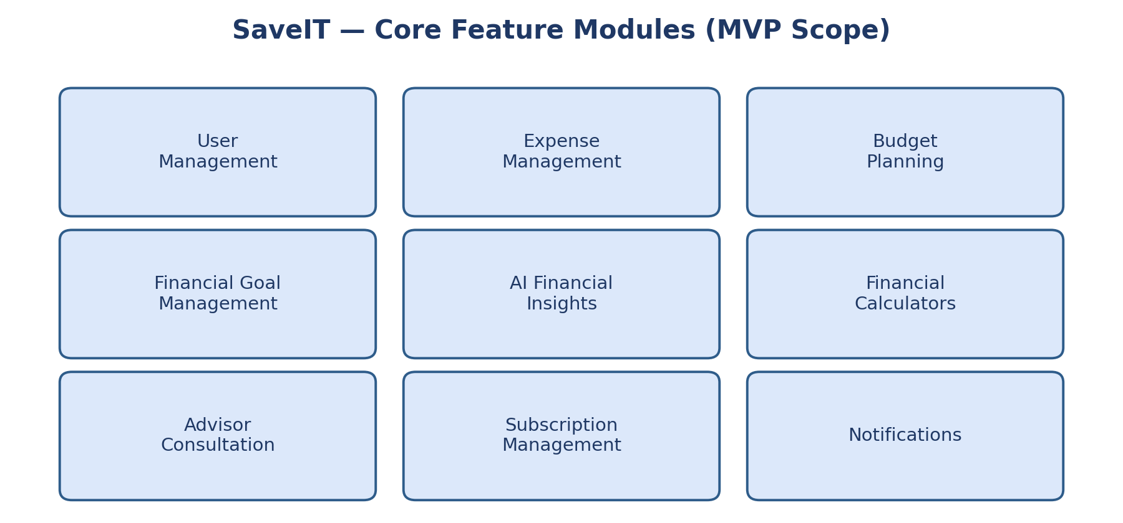

4.1 In Scope
- User Management — registration, login, profile, password reset
- Expense Management — add/edit/delete expenses, categorize, view history and trends
- Budget Planning — create monthly budgets, track usage, visualize progress
- Financial Goal Management — create goals, track progress, plan-based goal limits
- AI Financial Insights — spending analysis, budget tips, personalized reports (plan-based)
- Financial Calculators — EMI, SIP, Compound Interest, Budget calculator
- Advisor Consultation — browse advisors, AI matching, book, pay, video call, AI meeting summary
- Subscription Management — view/upgrade/downgrade plans, plan-based feature access
- Notifications — budget alerts, goal reminders, appointment and payment reminders

4.2 Out of Scope
- Direct stock or mutual fund investing
- Loan applications or approvals
- Tax filing or tax consultancy
- Cryptocurrency trading
- UPI payments
- Insurance purchase or management
- Automatic bank account syncing
- Business or corporate finance tools
- Multiple language support

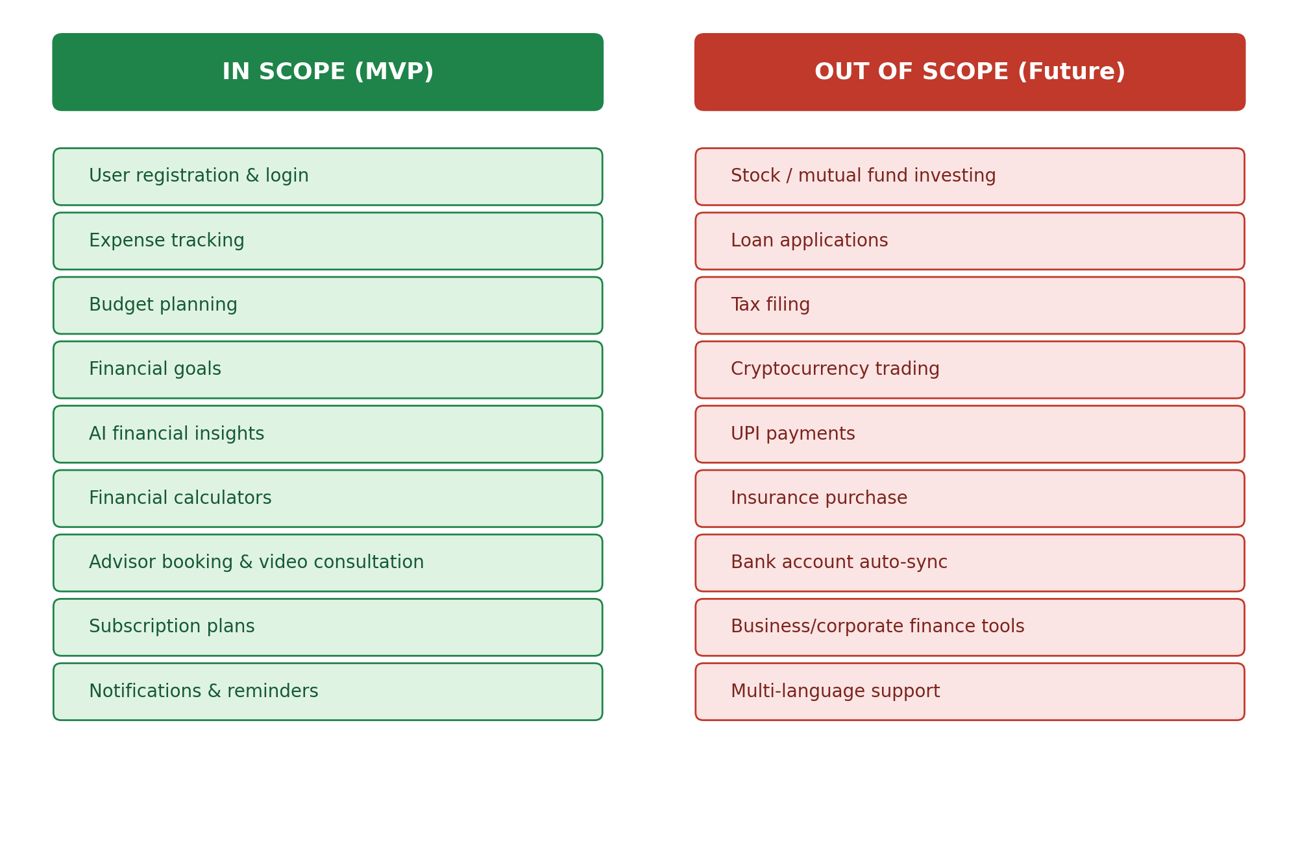

5. Functional Requirements

5.1 Login & Account
ID | Requirement | Priority
FR-001 | Users can register using their email address or mobile number. | High
FR-002 | Registered users can log in securely with valid credentials. | High
FR-003 | Users can reset their password using an OTP. | High
FR-004 | Users can update their profile information. | Medium
FR-005 | Users can securely log out of the app. | High

5.2 Dashboard
ID | Requirement | Priority
FR-006 | The app shows a financial dashboard right after login. | High
FR-007 | The dashboard shows total income, expenses, savings, and remaining budget. | High
FR-008 | The dashboard shows progress on active financial goals. | High
FR-009 | The dashboard shows recent transactions and a spending summary. | Medium

5.3 Expense Management
ID | Requirement | Priority
FR-010 | Users can add daily expenses manually. | High
FR-011 | Users can edit existing expense entries. | High
FR-012 | Users can delete expense entries. | Medium
FR-013 | Users can sort expenses into set or custom categories. | High
FR-014 | The app generates daily, weekly, and monthly expense summaries. | High
FR-015 | The app shows expense trends using simple charts. | High

5.4 Budget Planning
ID | Requirement | Priority
FR-016 | Users can create a monthly budget. | High
FR-017 | Users can edit an existing budget. | Medium
FR-018 | The app compares actual spending against the planned budget. | High
FR-019 | The app warns users when spending is close to or over budget. | High

5.5 Financial Goals
ID | Requirement | Priority
FR-020 | Users can create a goal with a name, target amount, target date, and category. | High
FR-021 | Users can track progress on each goal. | High
FR-022 | Users can edit or delete a goal. | Medium
FR-023 | The app shows what percentage of a goal is complete. | High
FR-024 | The number of active goals a user can have depends on their subscription plan. | High
FR-025 | The app notifies users when they hit a goal. | Medium

5.6 AI Financial Insights
ID | Requirement | Priority
FR-026 | The app analyzes income, expenses, savings, and goals to generate AI insights. | High
FR-027 | The app flags top spending categories and suggests ways to cut back. | High
FR-028 | The app recommends budgeting approaches based on the user's habits. | High
FR-029 | Free users get basic AI tips; premium users get deeper, personalized ones. | High
FR-030 | The app generates periodic financial health reports for eligible plans. | Medium
FR-031 | The app keeps a history of past AI reports for reference. | Medium

5.7 Advisor Consultation
ID | Requirement | Priority
FR-032 | Users can describe their financial concern before booking a consultation. | High
FR-033 | The app suggests suitable advisors based on that concern. | High
FR-034 | Users can view advisor profiles, specialty, experience, ratings, fees, available slots. | High
FR-035 | Users can book a consultation by picking a date and time. | High
FR-036 | Users pay securely online before the consultation is confirmed. | High
FR-037 | Users get access to a video call at the scheduled time. | High
FR-038 | The app generates an AI summary of the consultation with key points and next steps. | High

5.8 Subscription Management
ID | Requirement | Priority
FR-039 | The app shows the available subscription plans and what's included in each. | High
FR-040 | Users can upgrade or downgrade their plan. | High
FR-041 | Premium features unlock right after payment goes through. | High
FR-042 | Feature access is limited according to the user's active plan. | High
FR-043 | Users can view their plan status, renewal date, and payment history. | Medium

5.9 Notifications & Reminders
ID | Requirement | Priority
FR-044 | The app sends reminders to log daily expenses. | Medium
FR-045 | The app warns users when they're close to or over their monthly budget. | High
FR-046 | The app reminds users about upcoming advisor consultations. | Medium
FR-047 | The app confirms successful subscription payments and renewals. | Medium
FR-048 | The app notifies users when a new AI report is ready. | Low

6. Non-Functional Requirements
ID | Category | Requirement
NFR-001 | Performance | Dashboard should load within 3 seconds under normal network conditions.
NFR-002 | Performance | The app should handle multiple users at once without slowing down.
NFR-003 | Security | Passwords must be encrypted before they're stored.
NFR-004 | Security | Sensitive data must be sent over secure HTTPS connections.
NFR-005 | Availability | The app should be up and running 99% of the time (excluding maintenance).
NFR-006 | Reliability | Users shouldn't lose financial data due to an unexpected app failure.
NFR-007 | Usability | The interface should be simple enough for users with basic tech skills.
NFR-008 | Compatibility | The app should work on the latest Android, iOS, and modern web browsers.
NFR-009 | Scalability | The system should handle future features without a major rebuild.
NFR-010 | Maintainability | New features and bug fixes should be easy to add without breaking existing ones.
NFR-011 | Privacy | Financial data should only be visible to the user and authorized system processes.
NFR-012 | Backup & Recovery | Data should be backed up regularly so it can be recovered if something goes wrong.

7. Business Rules
.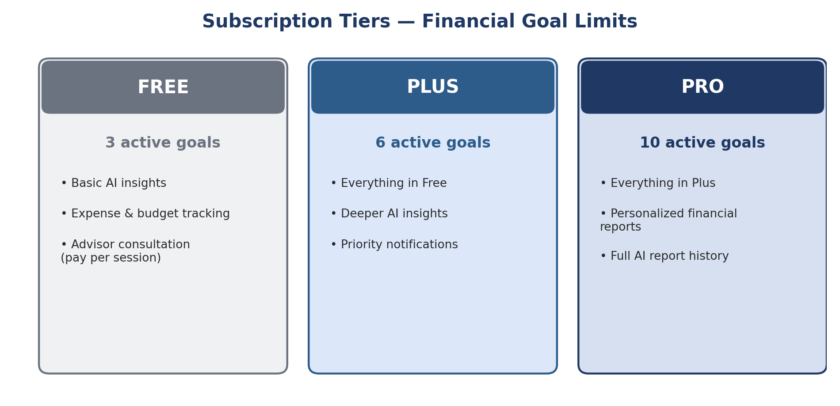
ID | Rule
BR-001 | Users must register before accessing any personalized features.
BR-002 | Each user can have only one account, tied to a unique email or mobile number.
BR-003 | Free plan users can have up to 3 active financial goals.
BR-004 | Plus plan users can have up to 6 active financial goals.
BR-005 | Pro plan users can have up to 10 active financial goals.
BR-006 | Free users get limited AI insights.
BR-007 | Deeper AI insights and personalized reports are only for Plus/Pro users.
BR-008 | Advisor consultations are charged separately, unless a promotion says otherwise.
BR-009 | Payment must be completed before a consultation is confirmed.
BR-010 | Advisor suggestions are based on the concern the user describes.
BR-011 | An AI summary is generated after every completed consultation.
BR-012 | Premium features unlock immediately after successful payment.
BR-013 | If a subscription lapses, premium access is removed but the user's data stays safe.
BR-014 | Users keep access to their past financial data regardless of their plan.
BR-015 | The app sends reminders for pending goals, consultations, and budget updates.
BR-016 | All financial data stays private ,visible only to the user and authorized processes.
BR-017 | Users can upgrade or downgrade their plan anytime, per the subscription policy.

8. Assumptions
- Users enter accurate financial information so insights are actually useful
- Advisors on the platform are verified before they can offer consultations
- Third-party services (payments, AI, video calls) are up and working
- The app supports English at launch, with more languages later
- The MVP only includes what's defined in this document's scope

9. Constraints
- The application will be developed as a Minimum Viable Product (MVP).
- Automatic bank account integration is not included in Version 1.
- AI-generated financial insights are provided for informational purposes only and do not replace professional financial advice.
- Advisor consultations depend on the availability of verified financial advisors.
- Features outside the approved project scope will be considered for future releases.

