BUSINESS ANALYST PORTFOLIO CASE STUDY
SaveIT
Your Finance Buddy
~ by Purva Patil

Project type | Conceptual Business Analyst portfolio project
My role | Business Analyst
Methodology | SDLC, Agile Scrum, MVP approach
Tools used | Word, Excel, Lucidchart

Table of Contents
1. Executive Summary 1
2. Business Problem 1
3. Proposed Solution 1
4. My Role 1
5. SDLC & Agile Methodology 1
6. Project Deliverables 1
7. Key Features 1
8. How the System Works 1
9. Challenges & Assumptions 1
10. Future Enhancements 1
11. Key Learnings 1

1. Executive Summary
SaveIT is a Business Analyst portfolio project based on the idea of a personal finance management application. The goal of the project was to understand how a Business Analyst contributes throughout a project from identifying a business problem and gathering requirements to preparing documentation that helps the development team build the product.
The application is designed to help users manage their finances by tracking expenses, planning budgets, setting financial goals, receiving AI-powered financial insights, and consulting verified financial advisors through a single platform.
Throughout this project, I prepared key Business Analyst deliverables including the Project Charter, BRD, User Personas, Process Flows, Product Backlog, User Stories, Sprint Planning, RTM, and UAT documents to simulate a real project environment.

2. Business Problem
Managing personal finances is difficult for many people due to poor budgeting habits, limited financial knowledge, and the lack of reliable financial guidance. While many finance applications help users track expenses or investments, most focus on only one area of personal finance.
Users often need multiple applications for budgeting, financial planning, investment tracking, and professional advice. This creates an opportunity to build a single platform that brings these services together in one place.

3. Proposed Solution
SaveIT gives users one place to:
- Track daily expenses
- Create monthly budgets
- Monitor financial goals
- Get AI-powered financial insights
- Generate personalized financial reports
- Use financial calculators
- Connect with verified financial advisors
- Book online consultations
- Get AI-generated meeting summaries
SaveIT follows a freemium model where core features are available free of charge, while premium plans provide additional AI insights, advanced reports, and higher financial goal limits.

4. My Role
As the Business Analyst on this project, I was responsible for:
- Understanding the business problem
- Defining business objectives
- Identifying project stakeholders
- Gathering and documenting business requirements
- Preparing the Business Requirements Document (BRD)
- Creating process flow diagrams in Lucidchart
- Preparing Agile documentation Product Backlog, User Stories, and Sprint Planning
- Writing User Acceptance Test Cases and a Requirement Traceability Matrix
- Helping prioritize requirements for the Minimum Viable Product (MVP)

5. SDLC & Agile Methodology
The project follows the Software Development Life Cycle (SDLC) from requirement gathering to testing. Agile Scrum was chosen as the development methodology so the product could be built in smaller iterations instead of developing everything at once.
Business requirements were first documented in the BRD and then converted into Product Backlog items, User Stories, Sprint Plans, and User Acceptance Test cases. This helped organize the work into manageable sprints while ensuring every requirement could be tracked throughout the project.

6. Project Deliverables
Here's what I prepared as part of this project:
Deliverable | What It Covers
Project Charter | The project's purpose, sponsor, and high-level plan
Stakeholder Matrix | Who's involved, and what they need from the project
Business Requirements Document (BRD) | Business objectives, scope, requirements, and rules
User Personas | Profiles representing SaveIT's key user types
User Journey | How a user moves through the app, stage by stage
Process Flow Diagrams | Visuals of how the system and users interact
Product Backlog | The full feature list, ranked by priority
User Stories | Requirements written from the user's point of view
Sprint Planning | How the backlog was broken into Agile sprints
User Acceptance Test Cases | Scenarios used to confirm the app works as expected
Requirement Traceability Matrix (RTM) | Links each requirement to its test case

7. Key Features
- Expense Tracking
- Budget Planning
- Financial Goal Management
- AI Financial Insights
- Financial Calculators
- Advisor Consultation
- Video Consultation Booking
- AI Meeting Summary
- Subscription Management

8. How the System Works
The following diagrams illustrate the application's workflows, user interactions, and core data model.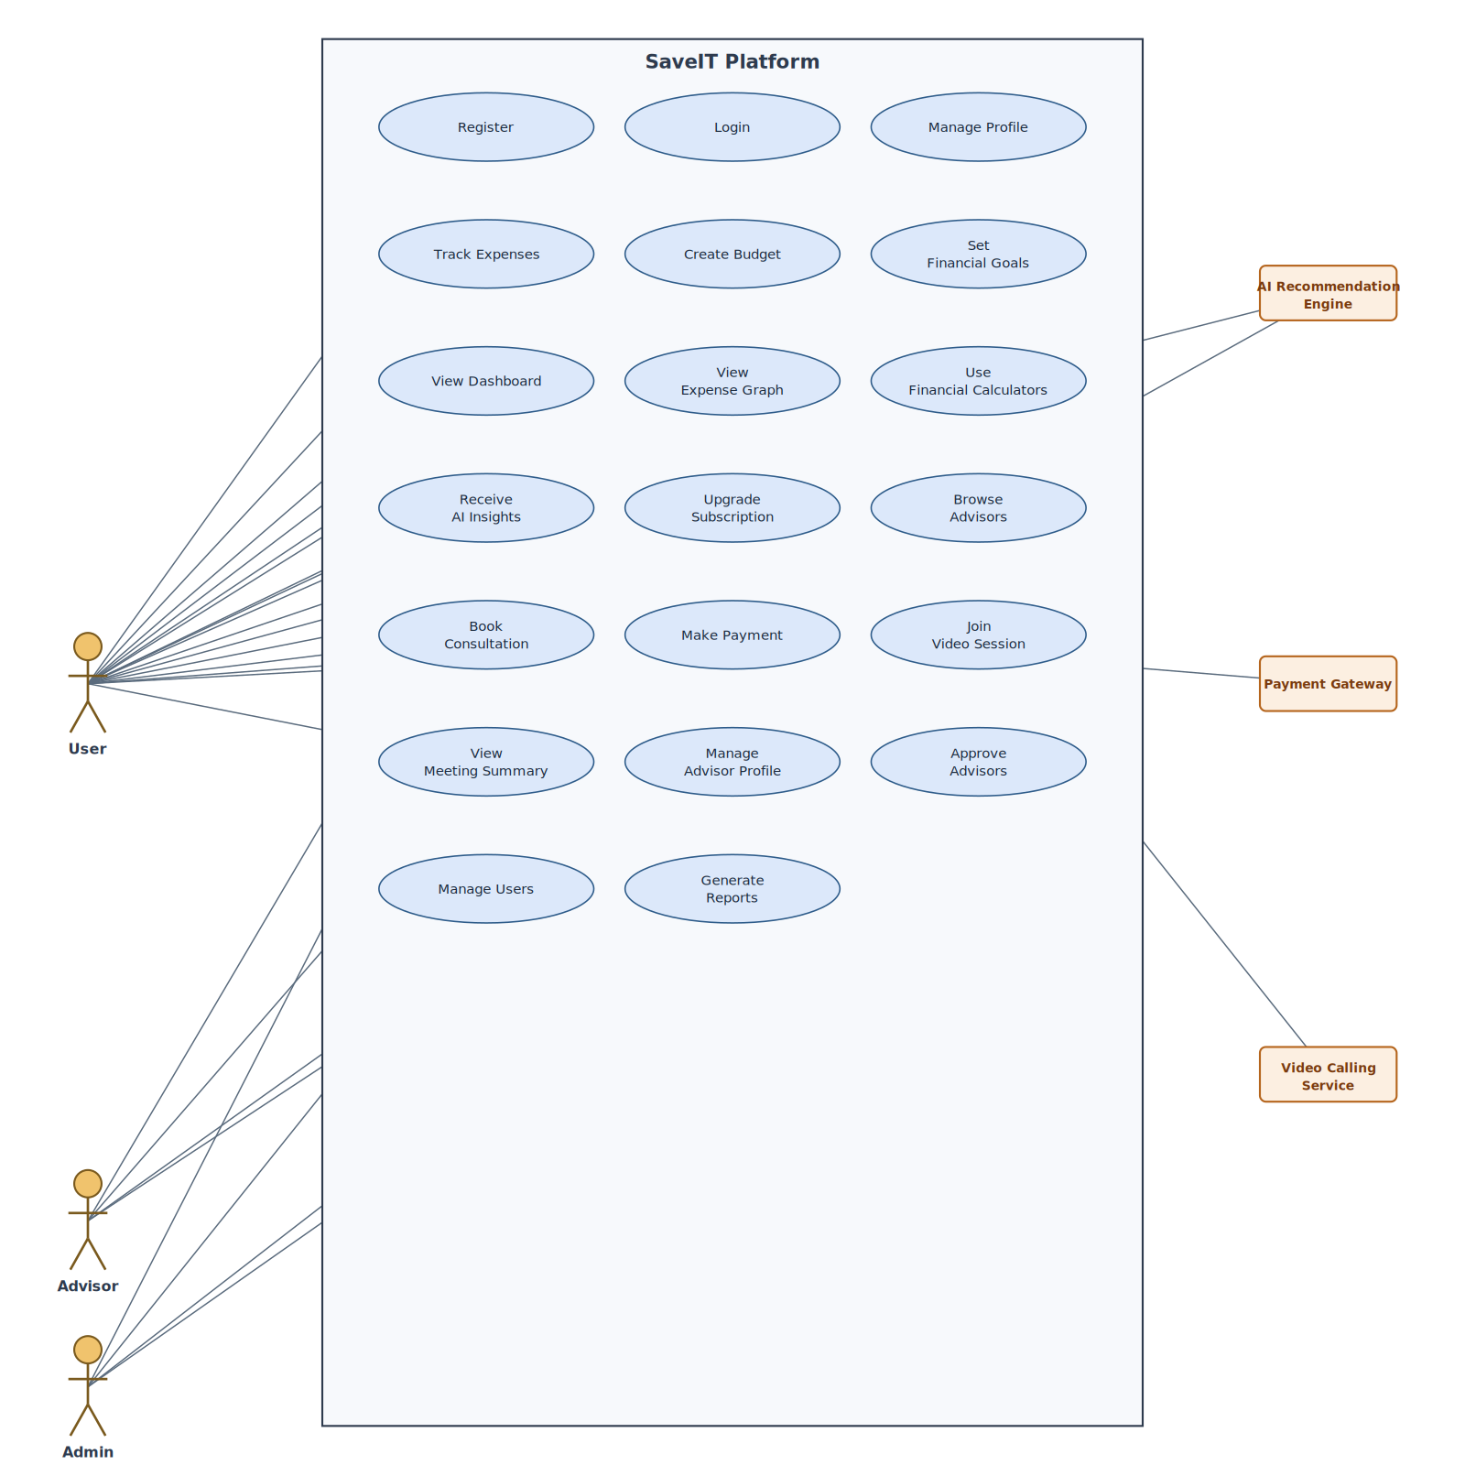
Use Case Diagram (UML) User, Advisor, Admin, and supporting systems and what each one can do in SaveIT.

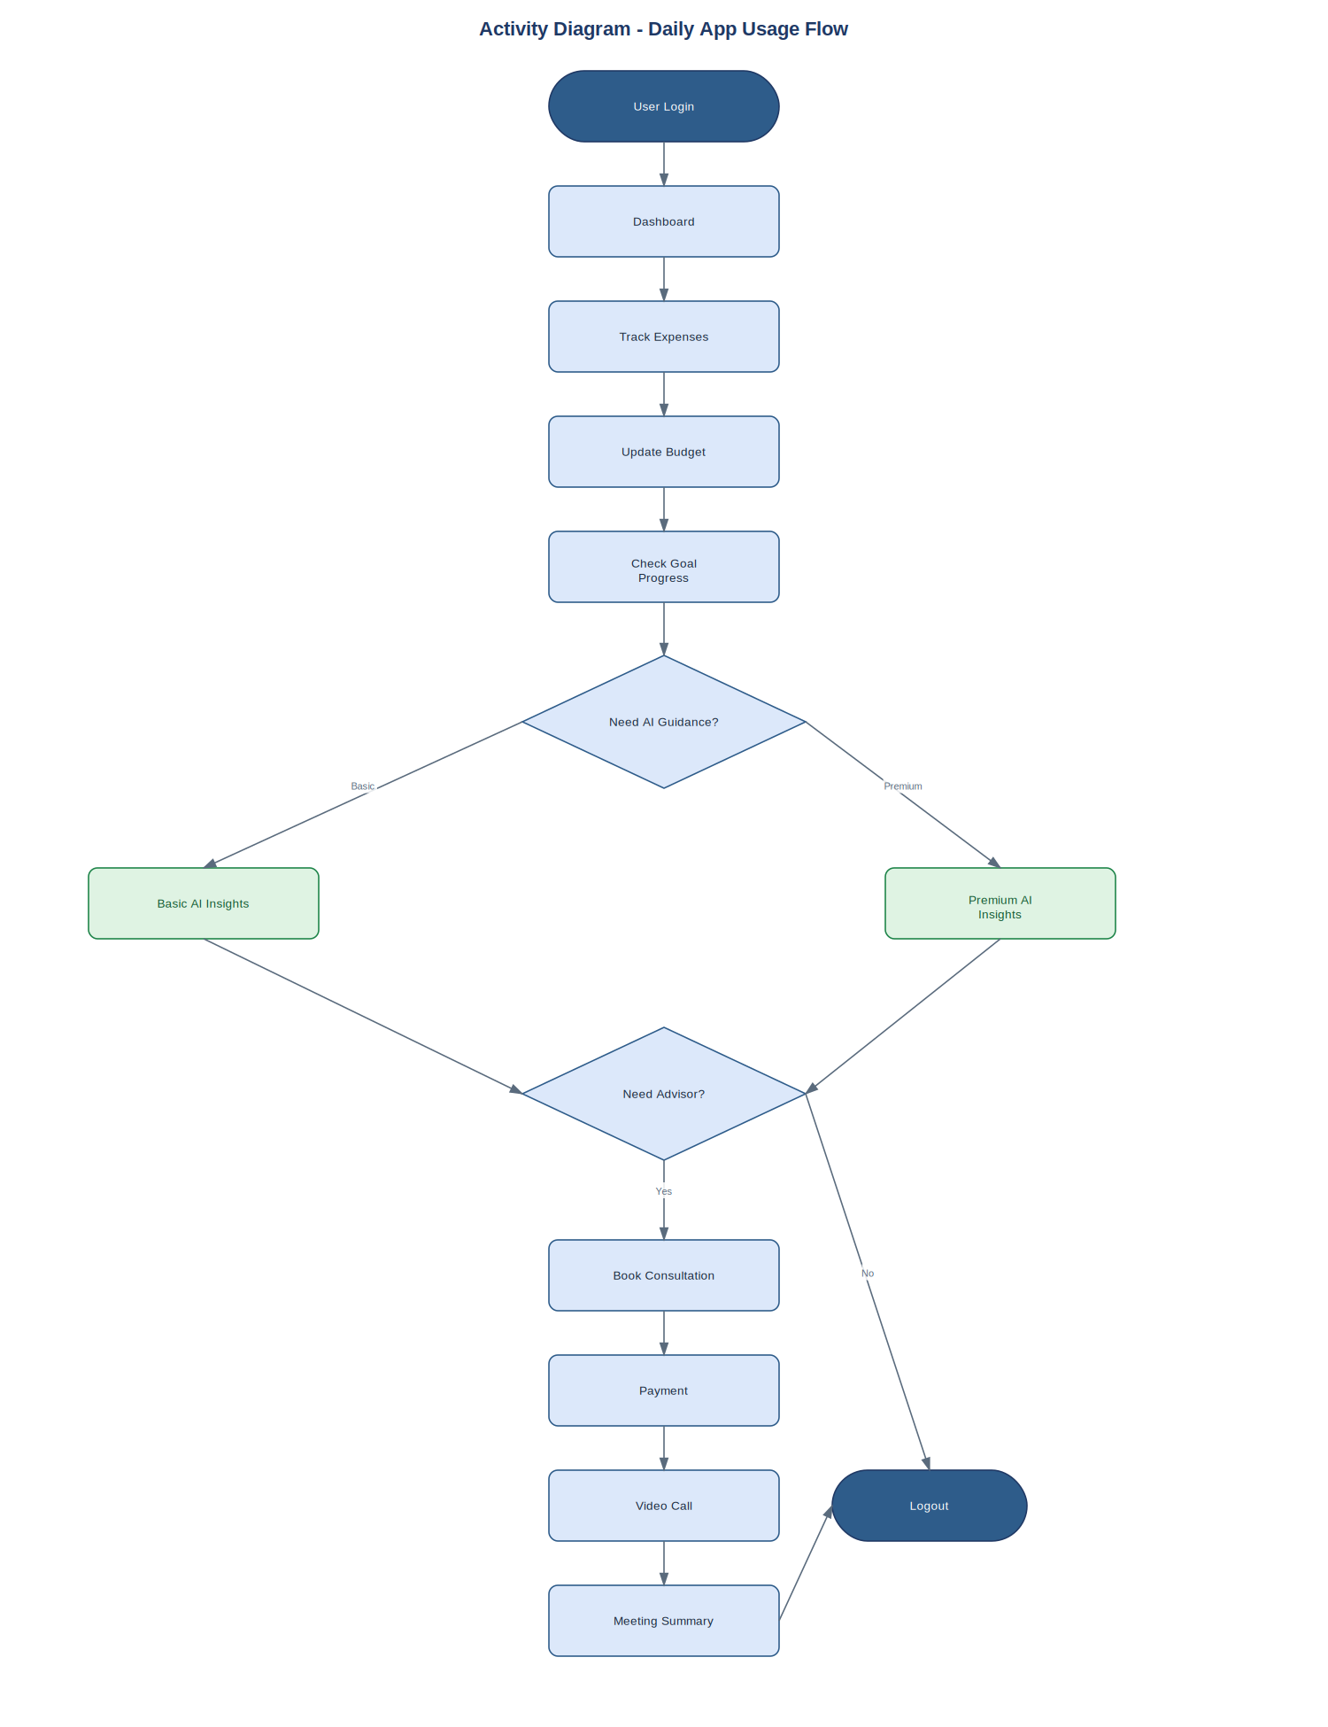

Activity Diagram (UML) the day-to-day flow a user follows, from login to a booked advisor consultation.

To support the features above, the app needs to keep track of users, their expenses, budgets, goals, subscriptions, and advisor bookings. The diagram below is a simplified view of how that data connects.
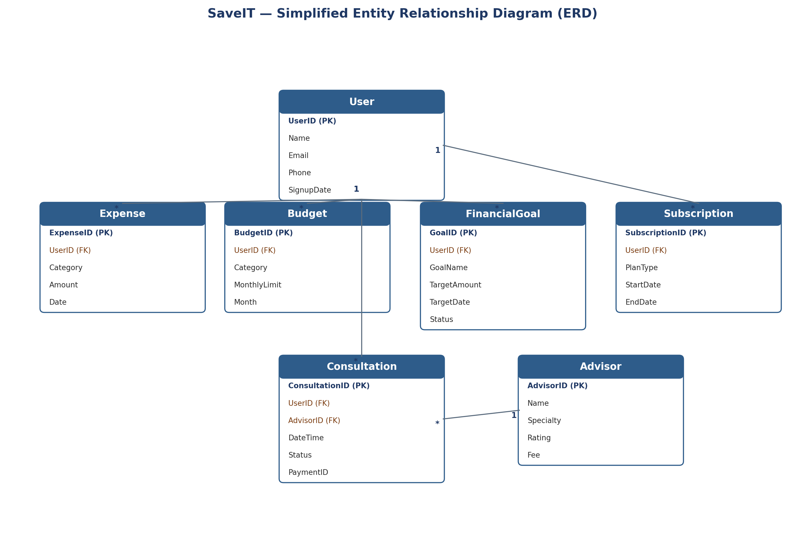
Entity Relationship Diagram (ERD) a simplified view of SaveIT's core data model.

9. Challenges & Assumptions
Since SaveIT is a conceptual portfolio project, the business requirements and workflows were developed through research on existing finance applications, business analysis practices, and logical assumptions. AI tools such as ChatGPT and Claude were used to review ideas, refine documentation, and validate the completeness and consistency of the proposed solution.

10. Future Enhancements
Some ideas for where this could go next, beyond the MVP:
- Bank account integration
- Automatic transaction syncing
- Investment portfolio tracking
- Tax planning assistance
- Multi-language support
- Family finance management
- Financial community forums

11. Key Learnings
Working through this project gave me hands-on practice in:
- Business Analysis fundamentals
- Requirement gathering and documentation
- Agile Scrum practices
- Product Backlog creation
- User Story writing
- Sprint Planning
- Requirement Traceability
- User Acceptance Testing
- Process modeling using Lucid chart
This project strengthened my understanding of how a Business Analyst translates business needs into clear, structured requirements for development teams.

