**Movie Ticket Management System**

**Step 1: Set Up Your Java Project**

* Open Eclipse or IntelliJ IDEA.
* Create a Dynamic Web Project (if using Eclipse) or a Maven Web App (if using IntelliJ).
* Name the project " Railway Reservation System**".**

**Step 2: Configure Tomcat Server**

Download and install Apache Tomcat (if not already installed).

In Eclipse, go to:

* Pgsql

Window → Preferences → Server → Runtime Environments → Add → Apache Tomcat

**Step 3: Set Up the Project Structure**

Create the following directories in your project:

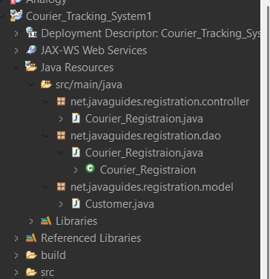

**Step 4: Create the Database**

Open MySQL Workbench or any database tool and create a database.

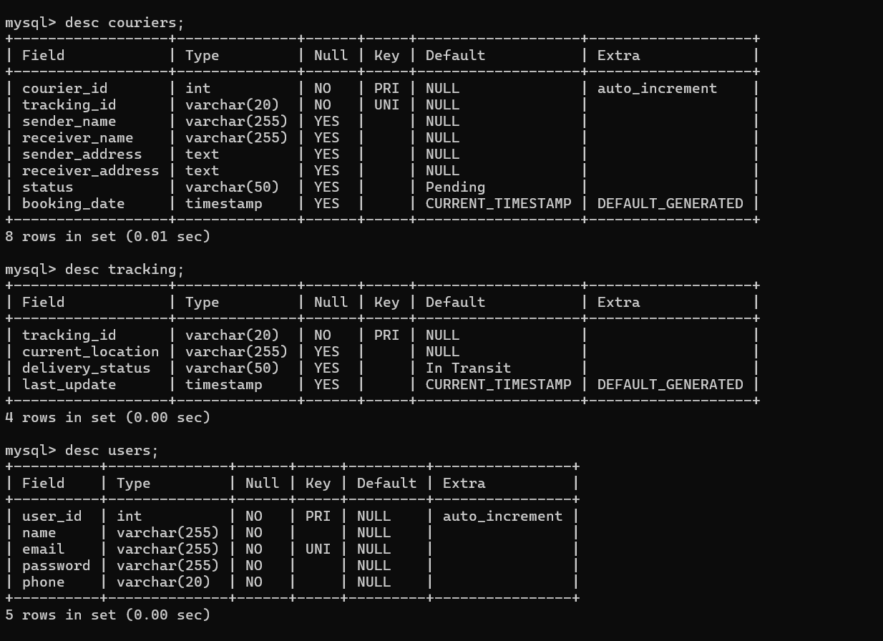

package net.javaguides.movieticket.dao;

import java.sql.Connection;

import java.sql.DriverManager;

import java.sql.PreparedStatement;

import java.sql.SQLException;

import net.javaguides.movieticket.model.Ticket;

public class TicketDAO {

public int saveTicket(Ticket ticket) throws ClassNotFoundException {

String INSERT_TICKET_SQL = "INSERT INTO tickets (movie_name, customer_name, seat_number, show_time) VALUES (?, ?, ?, ?)";

int result = 0;

Class.forName("com.mysql.cj.jdbc.Driver");

try (Connection cn = DriverManager.getConnection("jdbc:mysql://localhost:3306/moviedb", "root", "Harshal@25");

PreparedStatement preparedStatement = cn.prepareStatement(INSERT_TICKET_SQL)) {

preparedStatement.setString(1, ticket.getMovieName());

preparedStatement.setString(2, ticket.getCustomerName());

preparedStatement.setString(3, ticket.getSeatNumber());

preparedStatement.setString(4, ticket.getShowTime());

System.out.println(preparedStatement); // Debug log

result = preparedStatement.executeUpdate();

} catch (SQLException e) {

printSQLException(e);

}

return result;

}

private void printSQLException(SQLException ex) {

for (Throwable e : ex) {

if (e instanceof SQLException) {

e.printStackTrace(System.err);

}

}

}

}

Step 6: Create the Model Classes

Create a file named Ticket.java inside the model/ package.

package net.javaguides.registration.model;

public class Passenger Details {

private int user_Id;

private int phone;

private String name;

private String email;

private String password;

public int getUser_Id() {

return user_Id;

}

public void setUser_Id(int user_Id) {

this.user_Id = user_Id;

}

public int getPhone() {

return phone;

}

public void setPhone(int phone) {

this.phone = phone;

}

public String getName() {

return name;

}

public void setName(String name) {

this.name = name;

}

public String getEmail() {

return email;

}

public void setEmail(String email) {

this.email = email;

}

public String getPassword() {

return password;

}

public void setPassword(String password) {

this.password = password;

}

}

package net.javaguides.movieticket.model;

public class Ticket {

private int id;

private String movieName;

private String customerName;

private String seatNumber;

private String showTime;

public int getId() {

return id;

}

public void setId(int id) {

this.id = id;

}

public String getMovieName() {

return movieName;

}

public void setMovieName(String movieName) {

this.movieName = movieName;

}

public String getCustomerName() {

return customerName;

}

public void setCustomerName(String customerName) {

this.customerName = customerName;

}

public String getSeatNumber() {

return seatNumber;

}

public void setSeatNumber(String seatNumber) {

this.seatNumber = seatNumber;

}

public String getShowTime() {

return showTime;

}

public void setShowTime(String showTime) {

this.showTime = showTime;

}

}

**Step 7: Create the Servlets (Controllers)**

**Create a file named TicketBookingServlet.java inside the controller/ package.**

package net.javaguides.movieticket.controller;

import java.io.IOException;

import jakarta.servlet.ServletException;

import jakarta.servlet.annotation.WebServlet;

import jakarta.servlet.http.HttpServlet;

import jakarta.servlet.http.HttpServletRequest;

import jakarta.servlet.http.HttpServletResponse;

import net.javaguides.movieticket.dao.TicketDAO;

import net.javaguides.movieticket.model.Ticket;

@WebServlet("/bookTicket")

public class TicketBookingServlet extends HttpServlet {

private static final long serialVersionUID = 1L;

public TicketBookingServlet() {

super();

}

protected void doPost(HttpServletRequest request, HttpServletResponse response) throws ServletException, IOException {

try {

// Get form data

String movieName = request.getParameter("movieName");

String customerName = request.getParameter("customerName");

String seatNumber = request.getParameter("seatNumber");

String showTime = request.getParameter("showTime");

// Create Ticket object

Ticket ticket = new Ticket();

ticket.setMovieName(movieName);

ticket.setCustomerName(customerName);

ticket.setSeatNumber(seatNumber);

ticket.setShowTime(showTime);

// Save ticket using DAO

TicketDAO dao = new TicketDAO();

int result = dao.saveTicket(ticket);

if (result > 0) {

request.setAttribute("message", "Ticket booked successfully!");

} else {

request.setAttribute("error", "Failed to book ticket.");

}

} catch (Exception e) {

request.setAttribute("error", "Error: " + e.getMessage());

}

// Forward to confirmation or form JSP

request.getRequestDispatcher("ticket_form.jsp").forward(request, response);

}

}<%@ **page** language=*"java"* contentType=*"text/html; charset=UTF-8"* pageEncoding=*"UTF-8"*%>

<!**DOCTYPE** html>

<**html**>

<**head**>

<**meta** charset=*"UTF-8"*>

<**title**> Passenger Details Registration</**title**>

</**head**>

<**body**>

<**h2**> Passenger Details Registration Form</**h2**>

<**form** action=*" Passenger Details"* method=*"post"*>

<**label** for=*"User_id"*>User ID:</**label**>

<**input** type=*"number"* id=*"user_id"* name=*"user_id"* required><**br**><**br**>

<**label** for=*"name"*>Name:</**label**>

<**input** type=*"text"* id=*"name"* name=*"name"* required><**br**><**br**>

<**label** for=*"email"*>Email:</**label**>

<**input** type=*"email"* id=*"email"* name=*"email"* required><**br**><**br**>

<**label** for=*"password"*>Password:</**label**>

<**input** type=*"password"* id=*"password"* name=*"password"* required><**br**><**br**>

<**label** for=*"phone"*>Phone:</**label**>

<**input** type=*"number"* id=*"phone"* name=*"phone"* required><**br**><**br**>

<**button** type=*"submit"*>Register</**button**>

</**form**>

</**body**>

</**html**>

**Step 11: Run the Project**

**Movie Ticket Management System**

**Step 1: Set Up Your Java Project**

* Open Eclipse or IntelliJ IDEA.
* Create a Dynamic Web Project (if using Eclipse) or a Maven Web App (if using IntelliJ).
* Name the project " Railway Reservation System**".**

**Step 2: Configure Tomcat Server**

Download and install Apache Tomcat (if not already installed).

In Eclipse, go to:

* Pgsql

Window → Preferences → Server → Runtime Environments → Add → Apache Tomcat

**Step 3: Set Up the Project Structure**

Create the following directories in your project:



**Step 4: Create the Database**

Open MySQL Workbench or any database tool and create a database.



package net.javaguides.movieticket.dao;

import java.sql.Connection;

import java.sql.DriverManager;

import java.sql.PreparedStatement;

import java.sql.SQLException;

import net.javaguides.movieticket.model.Ticket;

public class TicketDAO {

public int saveTicket(Ticket ticket) throws ClassNotFoundException {

String INSERT_TICKET_SQL = "INSERT INTO tickets (movie_name, customer_name, seat_number, show_time) VALUES (?, ?, ?, ?)";

int result = 0;

Class.forName("com.mysql.cj.jdbc.Driver");

try (Connection cn = DriverManager.getConnection("jdbc:mysql://localhost:3306/moviedb", "root", "Harshal@25");

PreparedStatement preparedStatement = cn.prepareStatement(INSERT_TICKET_SQL)) {

preparedStatement.setString(1, ticket.getMovieName());

preparedStatement.setString(2, ticket.getCustomerName());

preparedStatement.setString(3, ticket.getSeatNumber());

preparedStatement.setString(4, ticket.getShowTime());

System.out.println(preparedStatement); // Debug log

result = preparedStatement.executeUpdate();

} catch (SQLException e) {

printSQLException(e);

}

return result;

}

private void printSQLException(SQLException ex) {

for (Throwable e : ex) {

if (e instanceof SQLException) {

e.printStackTrace(System.err);

}

}

}

}

Step 6: Create the Model Classes

Create a file named Ticket.java inside the model/ package.

package net.javaguides.registration.model;

public class Passenger Details {

private int user_Id;

private int phone;

private String name;

private String email;

private String password;

public int getUser_Id() {

return user_Id;

}

public void setUser_Id(int user_Id) {

this.user_Id = user_Id;

}

public int getPhone() {

return phone;

}

public void setPhone(int phone) {

this.phone = phone;

}

public String getName() {

return name;

}

public void setName(String name) {

this.name = name;

}

public String getEmail() {

return email;

}

public void setEmail(String email) {

this.email = email;

}

public String getPassword() {

return password;

}

public void setPassword(String password) {

this.password = password;

}

}

package net.javaguides.movieticket.model;

public class Ticket {

private int id;

private String movieName;

private String customerName;

private String seatNumber;

private String showTime;

public int getId() {

return id;

}

public void setId(int id) {

this.id = id;

}

public String getMovieName() {

return movieName;

}

public void setMovieName(String movieName) {

this.movieName = movieName;

}

public String getCustomerName() {

return customerName;

}

public void setCustomerName(String customerName) {

this.customerName = customerName;

}

public String getSeatNumber() {

return seatNumber;

}

public void setSeatNumber(String seatNumber) {

this.seatNumber = seatNumber;

}

public String getShowTime() {

return showTime;

}

public void setShowTime(String showTime) {

this.showTime = showTime;

}

}

**Step 7: Create the Servlets (Controllers)**

**Create a file named TicketBookingServlet.java inside the controller/ package.**

package net.javaguides.movieticket.controller;

import java.io.IOException;

import jakarta.servlet.ServletException;

import jakarta.servlet.annotation.WebServlet;

import jakarta.servlet.http.HttpServlet;

import jakarta.servlet.http.HttpServletRequest;

import jakarta.servlet.http.HttpServletResponse;

import net.javaguides.movieticket.dao.TicketDAO;

import net.javaguides.movieticket.model.Ticket;

@WebServlet("/bookTicket")

public class TicketBookingServlet extends HttpServlet {

private static final long serialVersionUID = 1L;

public TicketBookingServlet() {

super();

}

protected void doPost(HttpServletRequest request, HttpServletResponse response) throws ServletException, IOException {

try {

// Get form data

String movieName = request.getParameter("movieName");

String customerName = request.getParameter("customerName");

String seatNumber = request.getParameter("seatNumber");

String showTime = request.getParameter("showTime");

// Create Ticket object

Ticket ticket = new Ticket();

ticket.setMovieName(movieName);

ticket.setCustomerName(customerName);

ticket.setSeatNumber(seatNumber);

ticket.setShowTime(showTime);

// Save ticket using DAO

TicketDAO dao = new TicketDAO();

int result = dao.saveTicket(ticket);

if (result > 0) {

request.setAttribute("message", "Ticket booked successfully!");

} else {

request.setAttribute("error", "Failed to book ticket.");

}

} catch (Exception e) {

request.setAttribute("error", "Error: " + e.getMessage());

}

// Forward to confirmation or form JSP

request.getRequestDispatcher("ticket_form.jsp").forward(request, response);

}

}<%@ **page** language=*"java"* contentType=*"text/html; charset=UTF-8"* pageEncoding=*"UTF-8"*%>

<!**DOCTYPE** html>

<**html**>

<**head**>

<**meta** charset=*"UTF-8"*>

<**title**> Passenger Details Registration</**title**>

</**head**>

<**body**>

<**h2**> Passenger Details Registration Form</**h2**>

<**form** action=*" Passenger Details"* method=*"post"*>

<**label** for=*"User_id"*>User ID:</**label**>

<**input** type=*"number"* id=*"user_id"* name=*"user_id"* required><**br**><**br**>

<**label** for=*"name"*>Name:</**label**>

<**input** type=*"text"* id=*"name"* name=*"name"* required><**br**><**br**>

<**label** for=*"email"*>Email:</**label**>

<**input** type=*"email"* id=*"email"* name=*"email"* required><**br**><**br**>

<**label** for=*"password"*>Password:</**label**>

<**input** type=*"password"* id=*"password"* name=*"password"* required><**br**><**br**>

<**label** for=*"phone"*>Phone:</**label**>

<**input** type=*"number"* id=*"phone"* name=*"phone"* required><**br**><**br**>

<**button** type=*"submit"*>Register</**button**>

</**form**>

</**body**>

</**html**>

**Step 11: Run the Project**

**Right-click the project → Run As → Run on Server (Eclipse) or Deploy to Tomcat (IntelliJ).**  
Open [**http://localhost:8080/MovieTicketManagementSystem/ticket_form.jsp**](http://localhost:8080/MovieTicketManagementSystem/ticket_form.jsp).  
Fill out the ticket booking form with movie details, customer name, seat number, and show time, then submit to book a ticket.