1. **Create at least three different types of visualizations (e.g., bar chart, line chart, scatter plot) to analyze different aspects of the data**

## **1. Bar Charts-**

Bar charts are visual tools used to represent categorical data using rectangular bars. Each bar's length or height corresponds to the value it represents, making it easy to compare categories. Bars can be displayed vertically or horizontally, with the x-axis typically representing categories and the y-axis showing numerical values. They are useful for showing trends, differences, or distributions in data across discrete groups. For example, bar charts can illustrate sales by region, population by country, or test scores by grade level. Variations include grouped or stacked bars to show subcategories. Bar charts are simple yet effective for summarizing and communicating data.

### **Steps**:

1. **Load Data into Tableau**:
   * Open Tableau and connect to your data source (Excel, CSV, database, etc.).
   * Drag and drop your dataset into the Data pane.
2. **Identify the Fields**:
   * Choose a **categorical variable** for the bars (e.g., product, region) and a **numerical variable** for the bar heights (e.g., sales, frequency).
3. **Build the Bar Chart**:
   * Drag the **categorical variable** (e.g., "Category") to the **Columns** shelf.
   * Drag the **numerical variable** (e.g., "Sales") to the **Rows** shelf.
   * Tableau will automatically create a vertical bar chart.

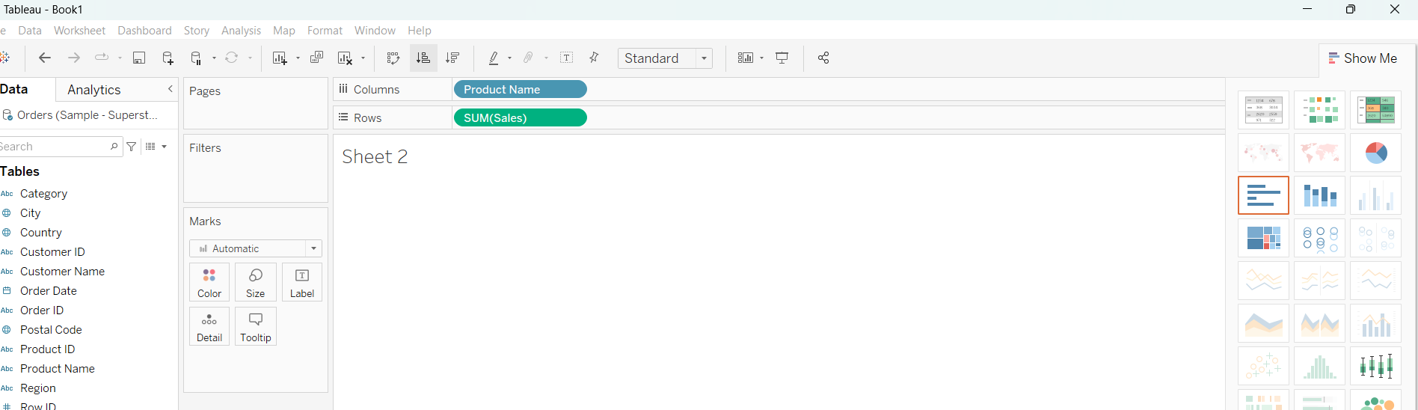

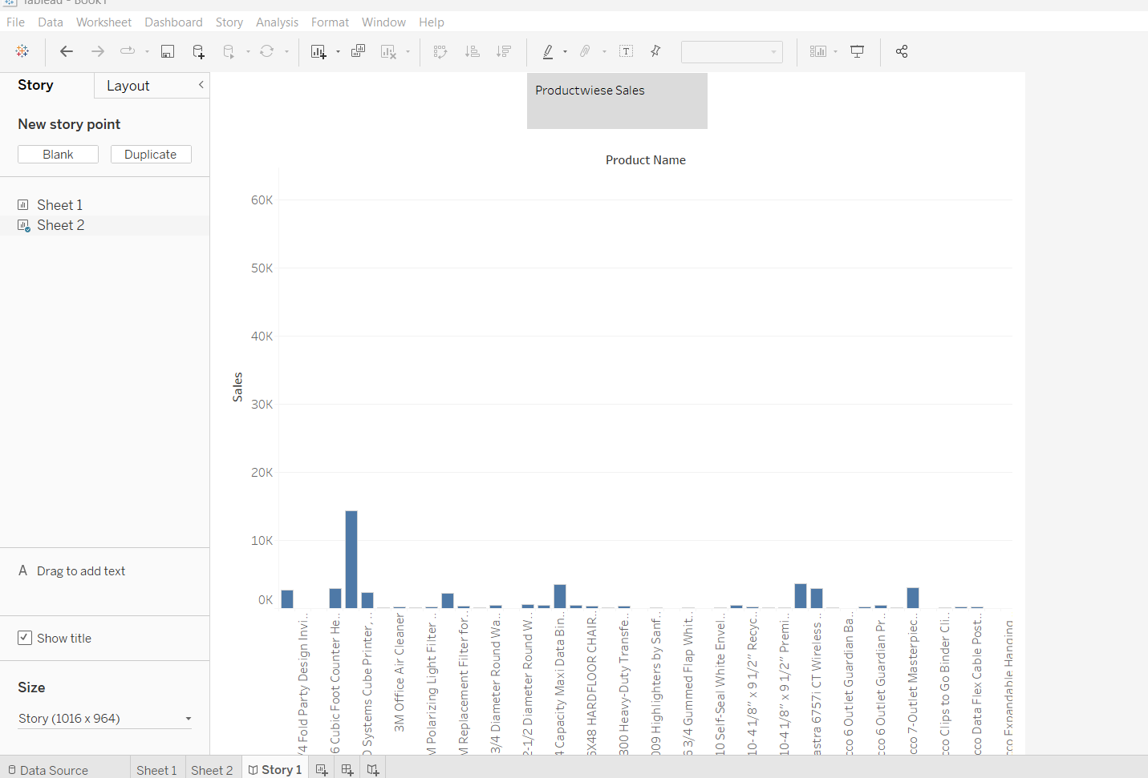

## **Line Charts-**

Line charts are graphical representations used to show trends, changes, or relationships in data over time or continuous intervals. They consist of points connected by lines, where the x-axis typically represents the independent variable (e.g., time) and the y-axis shows the dependent variable (e.g., sales, temperature). Line charts are ideal for visualizing patterns, such as growth, decline, or fluctuations, making it easy to compare data sets by plotting multiple lines. Commonly used in business, science, and finance, they help identify trends, outliers, or cyclic behaviors. Their simplicity and clarity make line charts a versatile tool for analyzing continuous data.

### **Steps**:

1. **Load Data into Tableau**:
   * Ensure your dataset contains a **time-based dimension** (e.g., date, week, year) and a **numerical variable** to plot.
2. **Identify the Fields**:
   * Use a time-based field for the x-axis and a numerical field for the y-axis.
3. **Build the Line Chart**:
   * Drag the **time-based field** (e.g., "Date") to the **Columns** shelf. Tableau automatically aggregates dates.
   * Drag the **numerical field** (e.g., "Sales") to the **Rows** shelf.
   * Tableau will generate a line chart.

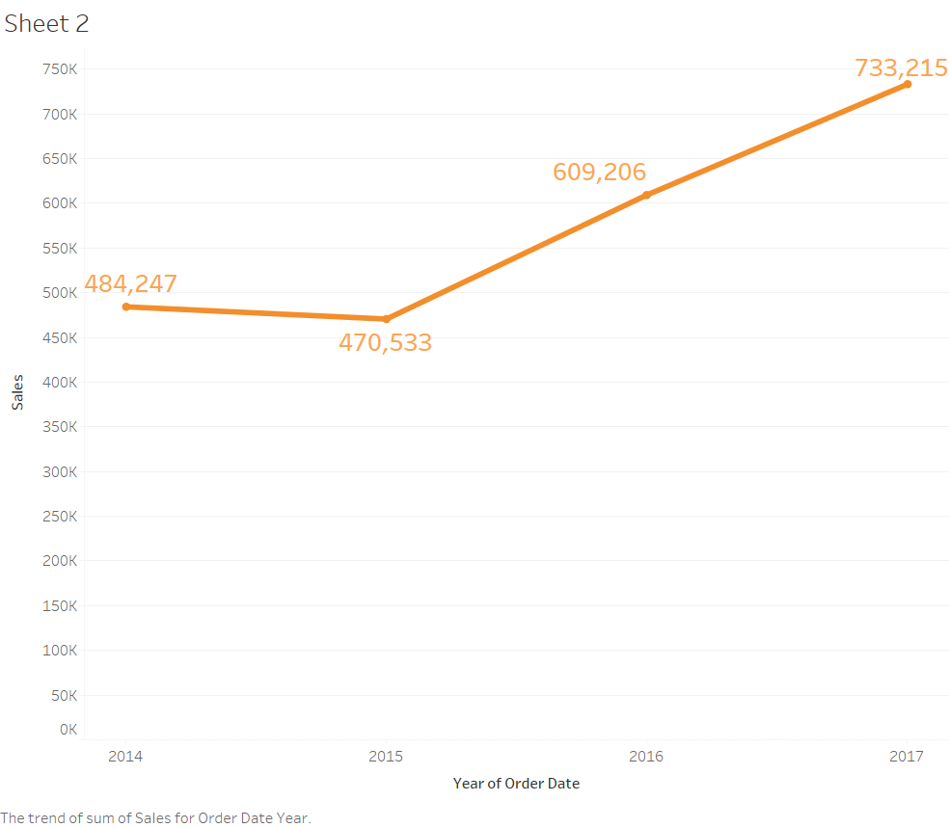

## **Scatter Plots-**

A scatter graph (or scatter plot) is a visual tool used to display relationships between two numerical variables. Each data point is represented by a dot, plotted on an x-y axis, where the x-axis shows the independent variable and the y-axis shows the dependent variable. Scatter graphs are effective for identifying patterns, trends, correlations, or outliers. For example, they can reveal positive, negative, or no correlation between variables, such as age and income or study time and test scores. They are widely used in statistics, science, and business to analyze relationships and predict trends, providing a clear snapshot of data distribution.

### **Steps**:

1. **Load Data into Tableau**:
   * Ensure your dataset contains two **numerical variables** for the x and y axes.
2. **Identify the Fields**:
   * Choose one numerical variable for the x-axis (e.g., "Profit") and another for the y-axis (e.g., "Sales").
3. **Build the Scatter Plot**:
   * Drag the first **numerical variable** (e.g., "Profit") to the **Columns** shelf.
   * Drag the second **numerical variable** (e.g., "Sales") to the **Rows** shelf.
   * Tableau will display a scatter plot.

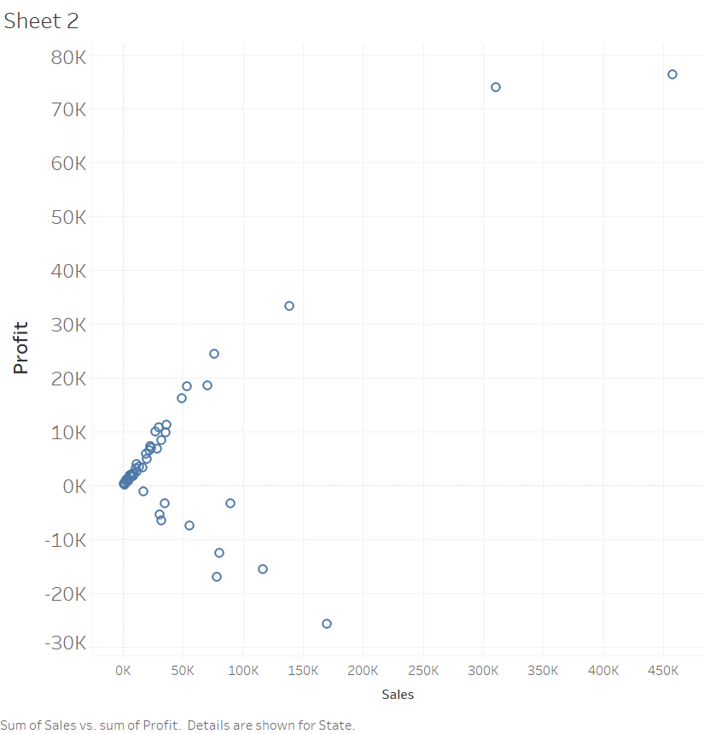

**2. To demonstrate different data source connections and extracts data from .csv / SQL etc**

* **Data Connection with Data Sources(.csv, .txt, SQL, Excel)**

Tableau's ability to connect to various data sources is one of its most powerful features. It supports a wide range of data types, including flat files (e.g., CSV, TXT), relational databases (e.g., SQL), and spreadsheets (e.g., Excel). Here, we will detail the steps to connect Tableau to different types of data sources.

## **General Steps for Connecting to Data in Tableau**

1. **Launch Tableau Desktop**:

Open Tableau Desktop on your computer. You'll see the **Start Page**, which provides a range of connection options.

1. **Select Your Data Source Type**:
   * On the left-hand side, under the "Connect" menu, Tableau displays supported data sources.
   * Options are categorized as **File** (e.g., CSV, Excel) or **Server** (e.g., SQL databases).

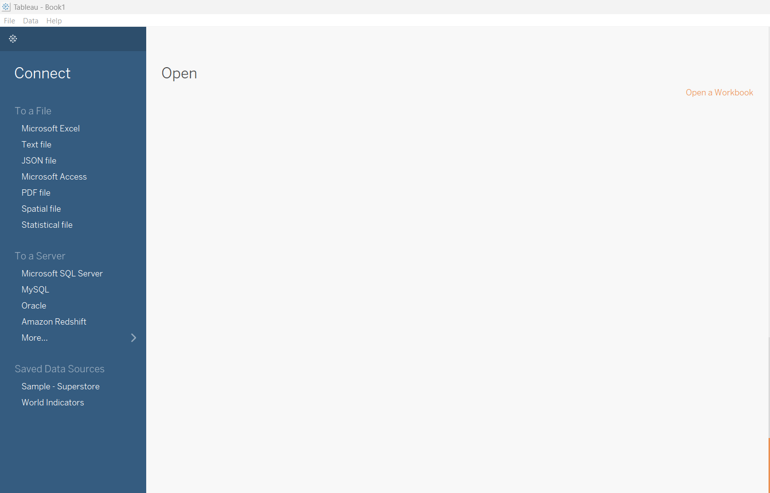

1. **Locate and Connect to Your Data Source**:
   * For files, browse to the file’s location on your computer.

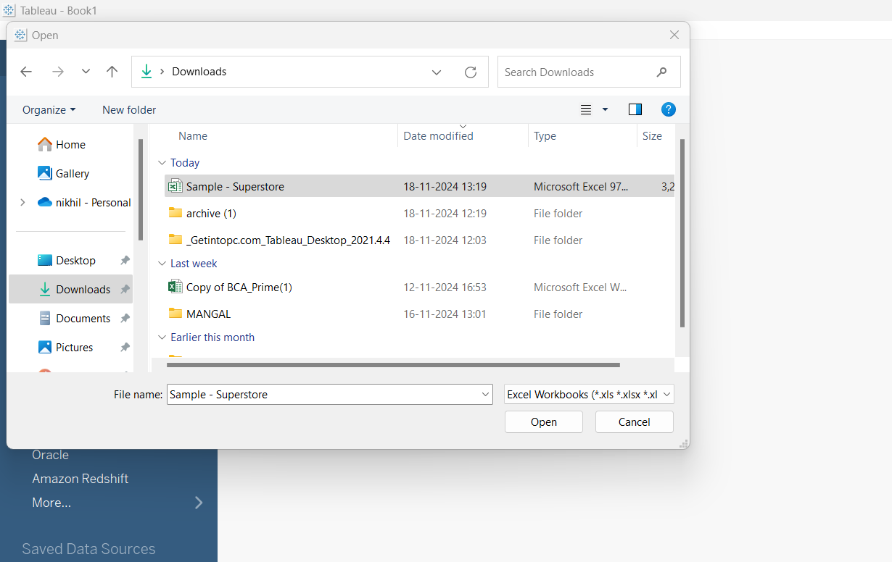

* + For databases, provide connection credentials (username, password, server address, etc.).

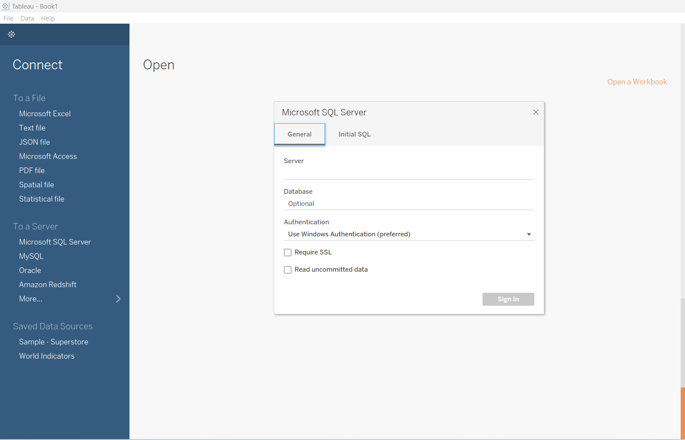

1. **Review and Modify Data in the Data Pane**:
   * Once connected, Tableau imports the metadata of your data source.
   * You can preview the data, join tables, or create relationships before proceeding to the visualization workspace.
   * 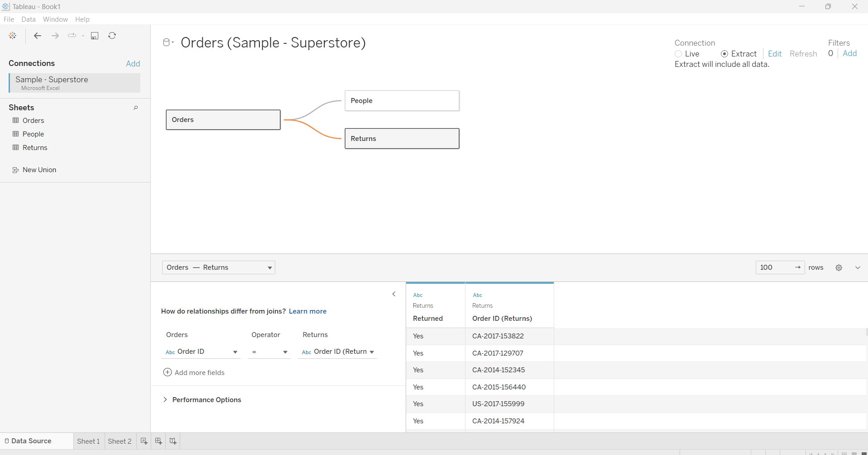
2. **Start Building Visualizations**:

Drag fields from the Data Pane into the Rows, Columns, and Marks sections to create visualizations.

**3. Data Blending and Joins**

* **Tableau working on data (Joining, Blending & Sorting)-**

1**. Data Joining -**

Joining is used to combine data from multiple tables based on a related column (common field). Both tables need to come from the same data source.

**Steps to Join Data:**

1. Connect to Data Source:
   * Open Tableau → Go to File > New.
   * Select the desired Data Source (e.g., Excel, SQL Server, CSV).
2. Drag Tables into the Data Pane:
   * In the Data Source tab, drag the first table into the canvas.
   * Drag the second table and drop it next to the first.
   * 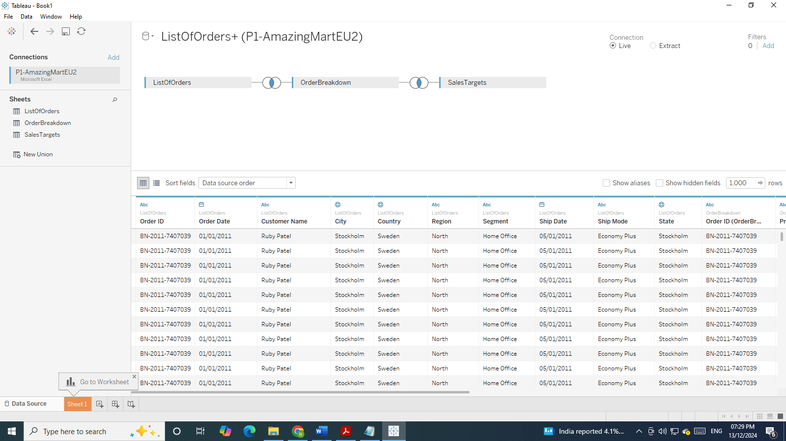
3. Define the Join Relationship:
   * Tableau automatically shows a venn diagram to represent the Join.
   * Choose the type of join:
     + Inner Join (only matching rows).
     + Left Join (all rows from the left table + matching rows from the right).
     + Right Join (all rows from the right table + matching rows from the left).
     + Full Outer Join (all rows from both tables).
   * Select the common field (key column) that links both tables.
4. Verify Join Results:
   * Preview the combined data in the Data Grid at the bottom.
   * Adjust the join type or fields if needed.

**4. Creating maps and geographic visualizations**

**Working with Spatial Data in Tableau – Simple Steps**

Step 1: Get Your Spatial Data

You can use spatial data formats like:

* Shapefiles (.shp)
* GeoJSON files (.geojson)
* KML files
* Excel/CSV files with latitude and longitude columns

📂 Open Tableau → Click "Connect" → Choose your file type and load your spatial data.

Step 2: Understand the Geometry Field

When you load spatial data (like a shapefile), Tableau will automatically detect a Geometry field 🧩.

* This field represents your shapes or locations on the map.
* It might be named “Geometry” or something else, depending on your file.

Step 3: Drag the Geometry Field into the View

* Go to a new worksheet.
* Drag the Geometry field into the view area.
* Tableau will automatically generate a map! 🌍

Step 4: Customize Your Map

You can:

* Color by category (e.g., country, region)
* Label places with names or values
* Add filters to interact with the map

Just drag and drop fields into the Color, Label, or Filter areas on the Marks card.

Step 5: Use Latitude & Longitude (If Needed)

If your data doesn't have a Geometry field but has latitude and longitude, do this:

* Drag Latitude to Rows
* Drag Longitude to Columns
* Tableau creates a map based on those coordinates 📍

Step 6: Layer or Join Spatial Data (Optional)

You can:

* Join two spatial files based on location
* Use dual-axis maps to overlay two data layers

For dual-axis: Duplicate the Latitude field, synchronize axes, and customize each layer.

Step 7: Save & Share

* Design your dashboard 📊
* Save your workbook

Publish to Tableau Public or Tableau Server to share with others

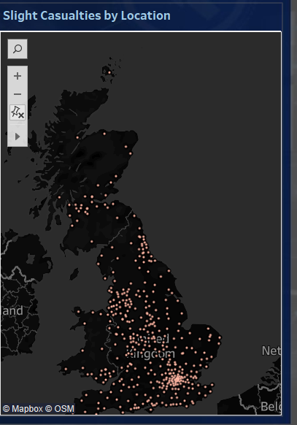

* + 1. **Interactive Sales Dashboard**

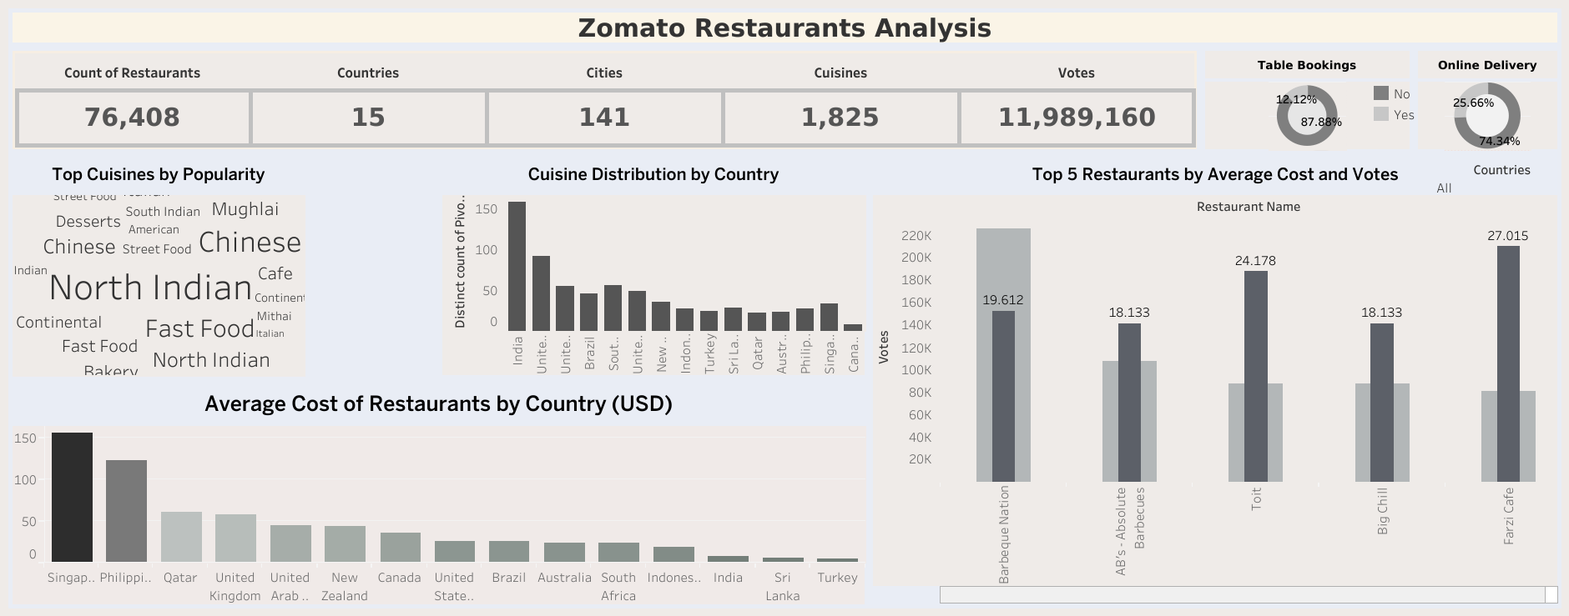

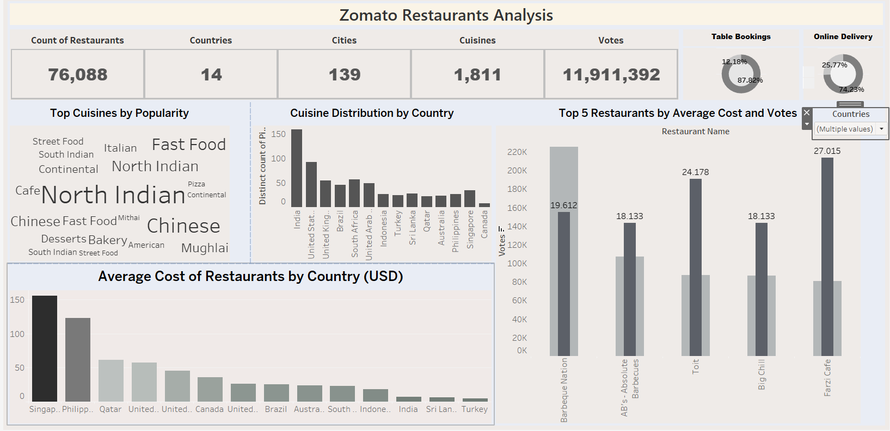

* + 1. **Interactive HR Dashboard**

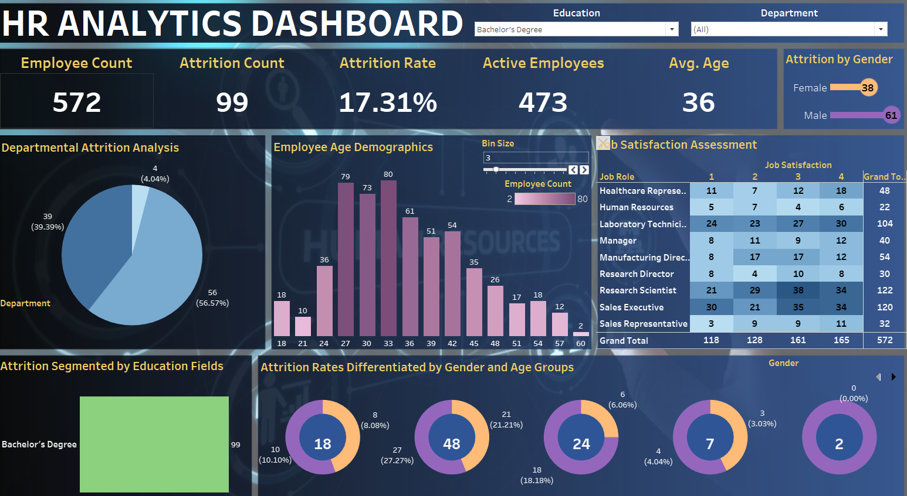

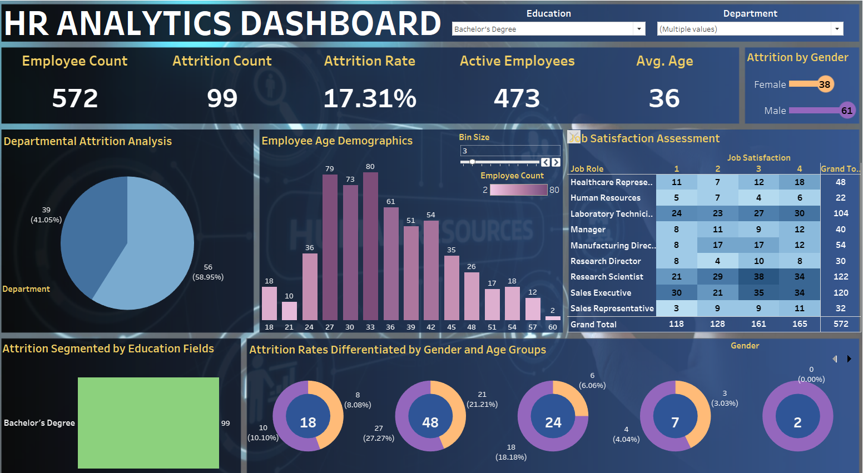

13. Techniques for effective data storytelling using dashboards

