DATA COMMUNICATION & COMPUTER NETWORKS (DCN)
Experimental Analysis of Error Detection Techniques
Comparative Empirical Evaluation of VRC/Parity, LRC, Internet Checksum, and CRC
Across Multi-Model Channel Perturbations
―――――――――――――――――――――――――――――――――――――――――――――
PROJECT DOMAIN  Data Communication (DCN) | TECHNIQUES  VRC, LRC, Checksum, CRC | INTERFACES  Web Interface & CLI | SIMULATION  Monte Carlo Pipeline

1. Executive Summary & Project Objective
In modern data communication systems, physical transmission media (copper cabling, optical fiber, wireless RF) suffer from inherent physical channel impairments such as thermal Gaussian noise, electromagnetic interference (EMI), signal attenuation, and multipath fading. These physical impairments cause transmitted binary voltage levels to invert, corrupting raw payload frames before they reach the receiver.
This project provides an end-to-end experimental simulation and analytical benchmarking laboratory to evaluate the four canonical error detection techniques used across Layer 2 (Data Link) and Layer 4 (Transport) of the OSI model: Vertical Redundancy Check (VRC / Parity), Longitudinal Redundancy Check (LRC), Internet Checksum (1's complement), and Cyclic Redundancy Check (CRC).
[PRIMARY OBJECTIVE] Primary Engineering Goal: Quantify the trade-offs between mathematical detection reliability (error detection rate), computational processing latency (microseconds), and transmission bandwidth penalty (redundancy overhead percentage) across controlled Monte Carlo empirical simulations.

2. System Architecture & Code Logic by File
The project follows a clean separation of concerns: core mathematical algorithms and Monte Carlo runners are isolated in native Python modules, while a lightweight Flask integration layer exposes the backend to a browser-based user interface.

A. Three-Stage Communication Pipeline
Every simulation executes through a strict sequential 3-stage communication pipeline:
1. Stage 1 - Transmitter (Sender): Ingests the original raw binary data and computes redundant check bits according to the chosen algorithm, forming the protected frame.
2. Stage 2 - Physical Transmission Channel: Corrupts the protected frame by inverting specific bits according to realistic physical channel models (single-bit, multiple-bit, burst, consecutive burst, multiple burst, or manual).
3. Stage 3 - Receiver (Verification): Strips or recalculates check bits from the received frame. If the syndrome/remainder matches expectations, the frame passes; otherwise, an error is detected.

B. Project Structure & File-by-File Logic
Directory & File | Core Functional Purpose | Key Methods / Logic Implemented
algorithms/parity.py | Vertical Redundancy Check (VRC) | add_vrc(), check_vrc(). Computes 1-bit even parity. Validates count of '1's modulo 2.
algorithms/lrc.py | Longitudinal Redundancy Check | add_lrc(), check_lrc(). Partitions data into 8-bit blocks, computes vertical column XOR vector, appends 8-bit LRC byte.
algorithms/checksum.py | Internet Checksum (RFC 1071) | add_checksum(), verify_checksum_detailed(). Sums 8/16-bit binary words, performs end-around carry addition, inverts bits via 1's complement.
algorithms/crc.py | Cyclic Redundancy Check | crc_encode(), crc_check_detailed(). Polynomial modulo-2 binary division using XOR. Zero-padding of degree k, remainder verification.
simulation/error_generator.py | Physical Channel Modeling | single_bit_error(), multiple_bit_error(), burst_error(), consecutive_burst_error(), multiple_burst_error(), manual_error(). Inverts bits at target indices.
simulation/simulator.py | End-to-End Orchestrator | simulate(), compare_all_techniques(). Manages Transmitter -> Channel -> Receiver pipeline, measures latency via time.perf_counter(), determines physical cause.
experiments/experiment_runner.py | Monte Carlo Benchmark Suite | run_all_experiments(). Executes parametric sweeps over payload sizes (32-512 bits), error amounts (1-8), burst spans, and trials.
experiments/metrics.py | Empirical Metrics Aggregator | compute_and_save_metrics(). Computes detection rate (%), average processing time (µs), and overhead ratio (%) per configuration.
visualization/plot_results.py | Analytical Graph Plotter | generate_all_plots(). Generates 4 publication-quality charts at 300 DPI using Matplotlib.
web_integration/adapter.py | Typed Integration Layer | run_simulation(), run_comparison(), get_algorithm_working(). Sanitizes JSON, validates binary input, bridges UI to backend.
web_integration/experiment_service.py | Thread-Safe Service | run_benchmark(), apply_staged_results(). Thread lock protection, staging directory isolation, atomic baseline synchronization.
web/app.py | Flask REST Application | Routes for /, /api/simulate, /api/compare, /api/algorithm-working, /api/experiments/run, /api/graphs/<filename>, /api/metrics.
web/static/js/app.js | Frontend Logic & UI Controller | Manages session payload, bitstream rendering with flip highlights, comparison tables, async API calls, and prompt confirmations.
web/static/css/style.css | Academic UI Styling | Warm off-white palette (#f7f5f0), Oxford Navy accents (#1d3557), clean typography, responsive layout.
run_web.py / main.py | Dual Entry Points | run_web.py launches local web server and auto-opens default browser. main.py runs the interactive CLI terminal application.

3. Error Detection Techniques & Worked Examples

A. Vertical Redundancy Check (VRC / Parity)
VRC is the simplest error detection technique. In Even Parity mode, a single redundant bit is appended to the payload such that the total number of '1' bits in the protected frame becomes even.
• Redundancy Formula: P = b_0 ⊕ b_1 ⊕ b_2 ⊕ ... ⊕ b_{n-1}
• Receiver Rule: If (Count of '1's in received frame) mod 2 == 0, Valid. Else, Error Detected.
[VRC STEP-BY-STEP WORKED TRACE] Worked Example:
• Original Payload: 1011001 (Seven bits; contains 4 ones, an even number).
• Generated Parity Bit: '0' (to maintain even count).
• Transmitted Frame: 10110010 (Total ones: 4).
• Scenario 1 (Single-bit flip): Channel flips index 2 -> 10010010 (Total ones: 3). Receiver detects error because 3 mod 2 != 0.
• Scenario 2 (Two-bit flip): Channel flips indices 2 and 4 -> 10011010 (Total ones: 4). Receiver verifies 4 mod 2 == 0 and passes corrupted frame!
• Inherent Limitation: VRC detects 100% of odd-bit flips, but 0% of even-bit flips.

B. Longitudinal Redundancy Check (LRC)
LRC treats data as a two-dimensional matrix. The bit sequence is partitioned into blocks of $k$ bits (typically 8-bit bytes). A parity bit is computed longitudinally along each bit column, producing an entire parity block (byte) appended to the frame.
[LRC STEP-BY-STEP WORKED TRACE] Worked Example (Two 8-bit Words):
• Word 1: 1 0 1 1 0 0 1 1
• Word 2: 1 1 0 0 1 0 1 0
• Column Parity (XOR):
Bit 7 (1⊕1=0), Bit 6 (0⊕1=1), Bit 5 (1⊕0=1), Bit 4 (1⊕0=1),
Bit 3 (0⊕1=1), Bit 2 (0⊕0=0), Bit 1 (1⊕1=0), Bit 0 (1⊕0=1)
• LRC Parity Byte: 0 1 1 1 1 0 0 1
• Transmitted Frame: [Word 1] + [Word 2] + [LRC Byte] (24 bits total).
• Strengths: Detects all burst errors of length <= k. Detects any odd number of bit errors in any column.

C. Internet Checksum (RFC 1071 / 1's Complement)
Used extensively at the Internet layer (IPv4) and Transport layer (TCP, UDP). The data payload is treated as a sequence of 16-bit (or 8-bit) binary integers. All words are added together using 1's complement arithmetic, where carry-out bits from the most significant position are added back to the least significant bit (end-around carry). Finally, the sum is inverted (complemented).
[CHECKSUM STEP-BY-STEP WORKED TRACE] Worked Example (8-bit Word Mode):
• Byte 1: 11001010 (Hex CA = Dec 202)
• Byte 2: 10101111 (Hex AF = Dec 175)
• Binary Addition: 11001010 + 10101111 = 1 01111001 (9-bit result, carry = 1)
• End-Around Carry Addition: 01111001 + 1 = 01111010 (Hex 7A)
• 1's Complement Inversion: ~01111010 = 10000101 (Hex 85) -> Checksum Byte!
• Receiver Verification: Receiver sums [Byte 1] + [Byte 2] + [Checksum Byte]:
01111010 + 10000101 = 11111111 (All 1's). 1's complement of 11111111 = 00000000 (0 -> Valid Frame!).

D. Cyclic Redundancy Check (CRC)
CRC provides the highest mathematical rigor and is standard in Layer 2 protocols (Ethernet IEEE 802.3, Wi-Fi 802.11, HDLC). It treats bit strings as polynomial coefficients over the Galois Field GF(2). Modulo-2 binary division is performed using XOR subtraction (no borrows or carries).
Standard Generator Polynomials supported in the project:
• CRC-8: X^8 + X^2 + X + 1 (Binary: 100000111, 8 check bits)
• CRC-16-IBM: X^16 + X^15 + X^2 + 1 (Binary: 11000000000000101, 16 check bits)
• CRC-16-CCITT: X^16 + X^12 + X^5 + 1 (Binary: 10001000000100001, 16 check bits)
• CRC-32-IEEE: 32 check bits (used in Ethernet and ZIP archives).
[CRC POLYNOMIAL DIVISION TRACE] Worked Modulo-2 Division Example:
• Payload: 11010011101100
• Generator Polynomial G(X): 1011 (Degree r = 3 check bits)
• Step 1: Append r=3 zeros to payload: 11010011101100 000
• Step 2: Modulo-2 binary long division (XOR subtraction where leftmost bit is 1):
Divide 11010011101100000 by 1011 -> Quotient: 11110101011000, Remainder: 100
• Step 3: Append remainder to original payload: 11010011101100 100 (Protected Frame).
• Receiver Check: Divide received frame by 1011. If remainder == 000 -> Valid! If remainder != 0 -> Error detected!

4. Physical Channel Error Models & Channel Etiology
To test detection limits under authentic transmission conditions, the simulation engine implements 7 distinct error models. Each error model corresponds to specific physical hardware phenomena and introduces errors via precise mathematical mechanisms:
Error Model Name | Physical Channel Cause (Etiology) | Introduction Mechanism & Behavior
1. Clean Transmission | Ideal high-SNR physical medium with zero interference. | 0 bits flipped. Injected indices: []. Validates false-positive rate.
2. Single-Bit Error | Thermal Gaussian noise (AWGN) or microscopic voltage fluctuation crossing decision threshold. | Exactly 1 randomly selected bit position is inverted across the frame.
3. Multiple-Bit Error | Sustained high noise, cross-talk coupling from adjacent unshielded twisted pairs. | N independent random bit positions are flipped anywhere across the frame.
4. Textbook Burst Error | Transient lightning strike, power supply transient, electrostatic discharge (ESD). | Corrupts a contiguous window of length L. The 1st and last bits of the span are guaranteed to flip; bits inside flip with 50% probability.
5. Consecutive Burst Corruption | Sustained severe EMI pulse, mechanical cable vibration, deep wireless fade dip, clock sync slip. | 100% solid contiguous corruption: Every single bit from index S to S+L-1 is inverted continuously.
6. Multiple Burst Errors | Periodic impulse noise, recurring motor commutator arcing, multipath reflection echoes. | Injects K distinct, separated burst episodes across the frame, each having an uncorrupted interval between them.
7. Manual Error Injection | Deterministic boundary testing and algorithm verification. | User specifies exact 0-indexed bit positions (e.g., [2, 5, 11]) to observe specific corner-case behavior.

5. Web Application & User Interface Features
The web interface is accessed locally at http://127.0.0.1:5000 and features an academic off-white interface with Oxford Navy branding. It organizes functionality into four dedicated tabs:
UI Feature / Tab | Capabilities and Interactive Workflow
Active Session Payload Bar | Global persistent data bar across all tabs. Supports raw binary, one-click 16-bit random generation, ASCII-to-binary text conversion, and 8/16/32-bit sample presets.
Tab 1: Transmission Simulator | Live 3-stage communication pipeline visualization. Shows payload, protected frame, corrupted frame with red-highlighted flipped bits, physical cause cards, metric pills (Overhead, Latency in µs, Detection Status), and analytical explanations.
Tab 2: Compare Techniques | Executes VRC, LRC, Checksum, and CRC simultaneously on the identical corrupted frame. Displays side-by-side comparison table, status badges ([VALID], [DETECTED], [MISSED]), and individual diagnostic cards.
Tab 3: Algorithm Working | Educational mathematical trace engine. Shows raw bit calculations: parity count for VRC, column matrices for LRC, word additions for Checksum, and modulo-2 division polynomial traces for CRC.
Tab 4: Experiments & Analytical Graphs | Batch Monte Carlo benchmark suite. Center-aligned benchmark configuration card. Prompts user confirmation before updating, then executes trials, automatically applies results, and reloads the 4 analytical graphs and metrics table.

6. Empirical Benchmark Analysis & Visualizations
The experiment suite executes controlled Monte Carlo sweeps across a parametric grid:
• Data Payload Sizes: 32, 64, 128, 256, 512 bits
• Error Magnitudes: 1, 2, 3, 4, 5, 8 bit flips
• Burst Spans: 2, 4, 8, 16 bits
• Trial Counts: 30 to 50 trials per configuration (thousands of total frames recorded in experiment_results.csv and aggregated in metrics_results.csv).

Graph 1: Detection Rate by Error Type and Technique
Significance: Evaluates overall reliability across Clean, Single-Bit, Multiple-Bit, and Burst error conditions. Key Finding: CRC achieves 100% detection across all non-clean error types. Internet Checksum achieves ~99.9% detection. LRC achieves ~98-100% depending on burst alignment. VRC (Parity) drops dramatically to ~50% on multiple-bit errors because random multiple errors have an equal 50% probability of having an even number of bit flips.

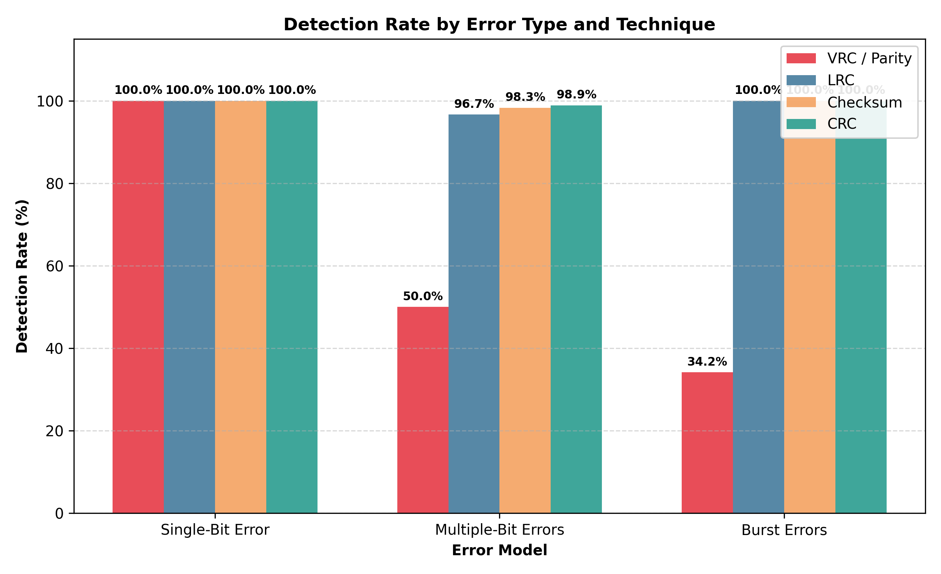
Figure 1: Detection Rate (%) grouped by error category across all four techniques.

Graph 2: Detection Rate vs. Error Magnitude (Bit Flips)
Significance: Examines detection rate as the number of injected bit errors increases from 1 to 8 bits. Key Finding: Demonstrates the classical saw-tooth oscillation of VRC Parity: exactly 100% detection for odd numbers of errors (1, 3, 5, 7 bits) and exactly 0% detection for even numbers of errors (2, 4, 6, 8 bits). In stark contrast, CRC and LRC maintain a flat, invariant line at 100% detection.

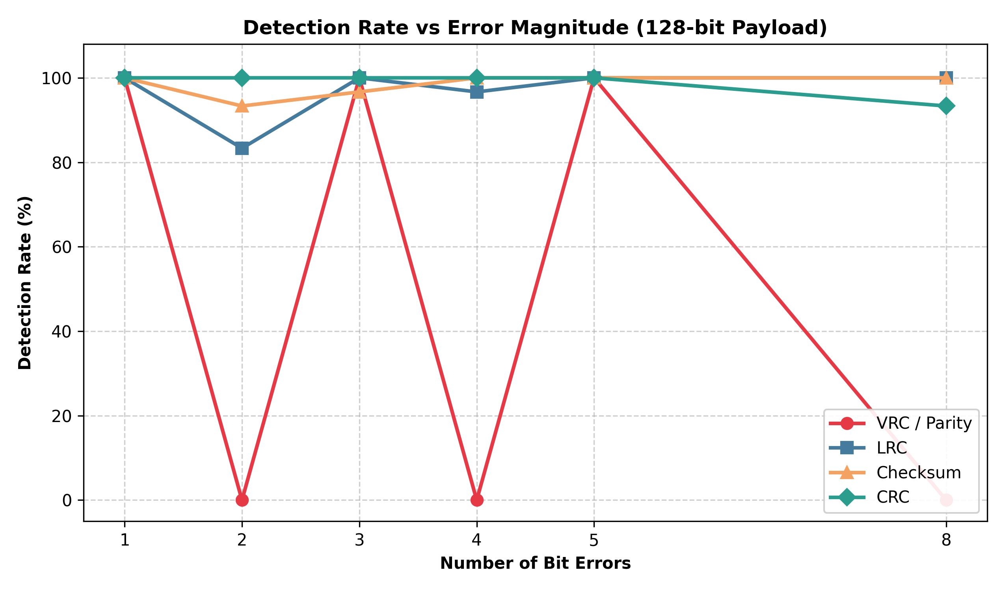
Figure 2: Parity saw-tooth curve (100% odd vs 0% even) contrasted with CRC resilience.

Graph 3: Processing Time vs. Data Size (Microseconds)
Significance: Compares computational latency and algorithm execution time as payload size scales from 32 to 512 bits. Key Finding: All techniques exhibit linear O(N) algorithmic scaling. VRC is computationally fastest (~3-6 µs) due to simple bitwise parity. Checksum requires integer additions and carry folding (~8-15 µs). CRC requires modulo-2 polynomial bit shifts (~20-40 µs in software). This clearly illustrates why hardware CRC accelerators or simplified checksums are preferred in high-throughput network adapters.

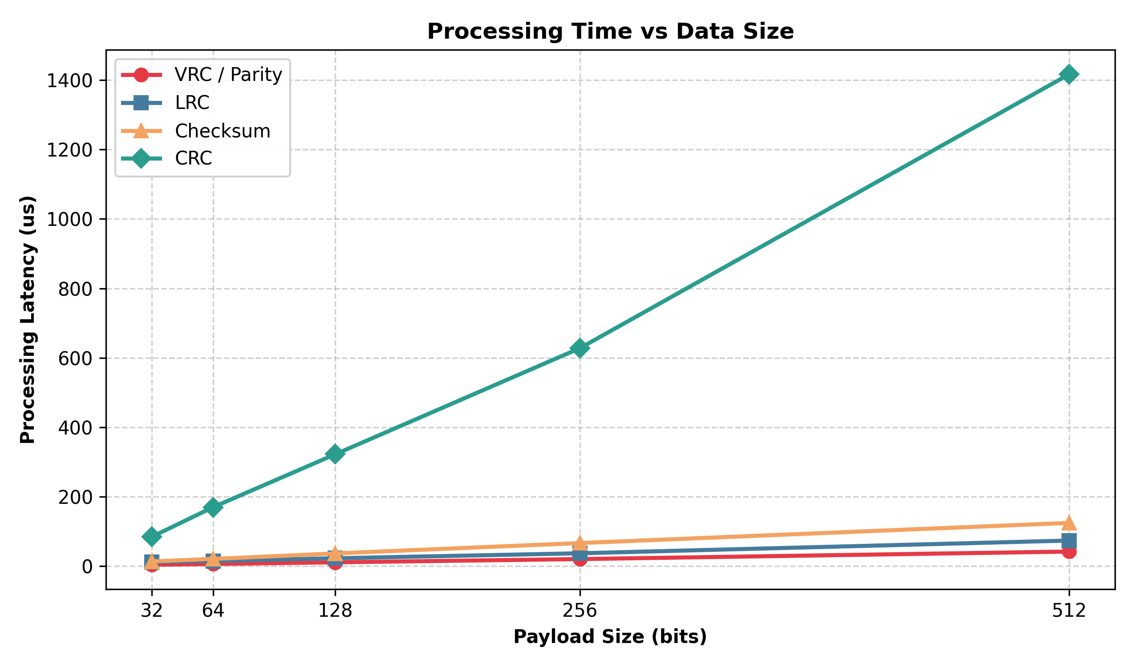
Figure 3: Computational latency scaling linearly with transmission frame length.

Graph 4: Transmission Overhead vs. Data Size (%)
Significance: Plots the channel bandwidth penalty: (Redundancy Bits / Total Transmitted Bits) * 100%. Key Finding: Redundancy bits are fixed regardless of payload size (1 bit for VRC, 8 bits for CRC-8/LRC, 16 bits for Checksum/CRC-16). Consequently, overhead drops hyperbolicly as payload scales: for 32-bit payloads, CRC-8 imposes 20.0% overhead; for 512-bit payloads, CRC-8 overhead drops to just 1.54%. This demonstrates why larger Maximum Transmission Units (MTUs) significantly improve channel efficiency.

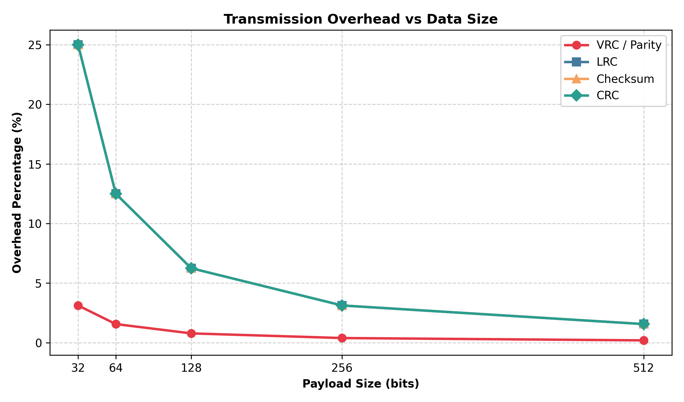
Figure 4: Redundancy overhead percentage decreasing asymptotically as payload size expands.

7. Viva & Examination Quick-Reference Guide
Frequently Asked Exam / Viva Question | Concise Engineering Answer
Why can't Parity detect even-bit errors? | Because inverting any two bits leaves the total count of 1s with the exact same parity (odd/even). Parity arithmetic is mod 2.
Why is CRC preferred over Checksum at Layer 2? | CRC uses polynomial division that detects 100% of single, double, odd, and burst errors up to degree r. Checksum uses integer addition, which fails if two errors cancel each other out or if bytes are transposed.
What is 'End-Around Carry' in Checksum? | In 1's complement arithmetic, adding two numbers can generate a carry out of the MSB. That carry must be added back to the LSB to ensure mathematical closure.
How does generator polynomial choice affect CRC? | The length of the generator determines burst error protection: a polynomial of degree r detects all burst errors of length <= r, and a fraction (1 - 2^-r) of longer bursts.
What is the difference between Burst Error and Consecutive Burst? | In textbook burst error, only the first and last bits of the span are guaranteed to flip; bits in between flip randomly with 50% probability. In consecutive burst corruption, 100% of contiguous bits in the span are inverted.

