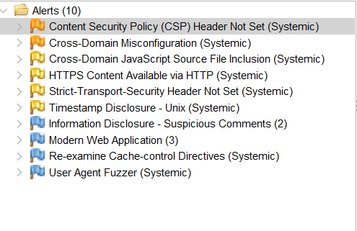
OWASP ZAP scan alerts

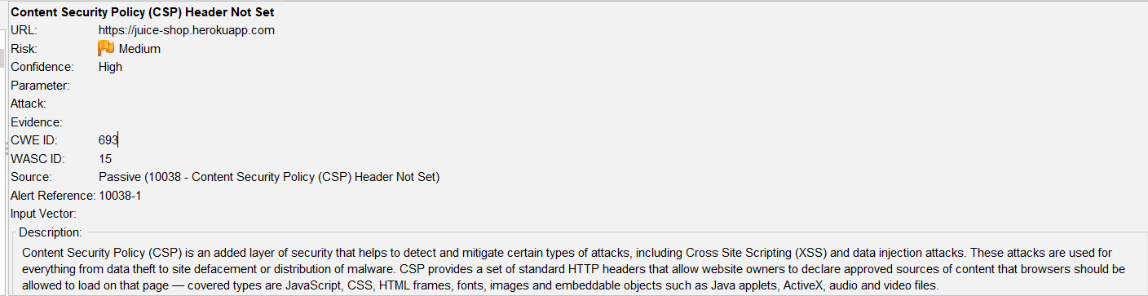

CSP Header Not Set alert

