PROJECT DESIGN PHASE-I
Solution Architecture

Date | March 2026
Team ID | 699d5f8ac40b5ad0e9ee598f
Project Name | PlantCare AI
Maximum Marks | 4 Marks

Solution Architecture Overview
PlantCare AI employs a layered web application architecture that bridges the user-facing interface with a powerful AI inference engine. The architecture is designed for simplicity, scalability, and low-latency prediction.

Architecture Components

1. Frontend Layer (Presentation Tier)
- Technology: HTML5, CSS3, JavaScript
- Pages: index.html (Home), upload.html (Upload), result.html (Prediction Result), about.html (About)
- Static assets served from /static directory (CSS, JS, images)
- Responsive UI for desktop and mobile browsers
- Form-based image upload with file type validation (PNG, JPG, JPEG)

2. Backend Layer (Application Tier)
- Framework: Flask (Python)
- Entry point: app.py
- Routes: GET / (Home), GET /upload (Upload page), POST /predict (Prediction), GET /about (About)
- Image handling: Receives uploaded image, saves to static/images/uploads/
- Preprocessing: utils/preprocessing.py - resizes to 224x224, normalizes pixel values
- Calls ML model inference and returns predicted class name and confidence

3. AI/ML Layer (Model Tier)
- Base Model: MobileNetV2 (pretrained on ImageNet) - Transfer Learning
- Fine-tuned on Plant Disease Dataset (38 disease categories)
- Model files: model/model.py, model/train_model.py, model/evaluate_model.py
- Trained model stored as plant_disease_model.h5
- Class labels stored in class_names.json (38 disease categories)
- Inference: Preprocessed image passed to model, softmax output gives disease class probabilities

4. Data Flow
Step | Action | Component
1 | User accesses the web app via browser | Browser -> Flask (app.py)
2 | User uploads plant leaf image on /upload page | upload.html -> POST /predict
3 | Flask saves image to uploads folder | app.py -> static/images/uploads/
4 | Image preprocessed (resize, normalize) | utils/preprocessing.py
5 | Preprocessed array passed to loaded ML model | model.py -> MobileNetV2
6 | Model outputs probabilities for 38 classes | TensorFlow/Keras inference
7 | Highest probability class mapped to disease name | class_names.json
8 | Result rendered on result.html | Flask -> result.html

Solution Architecture Diagram

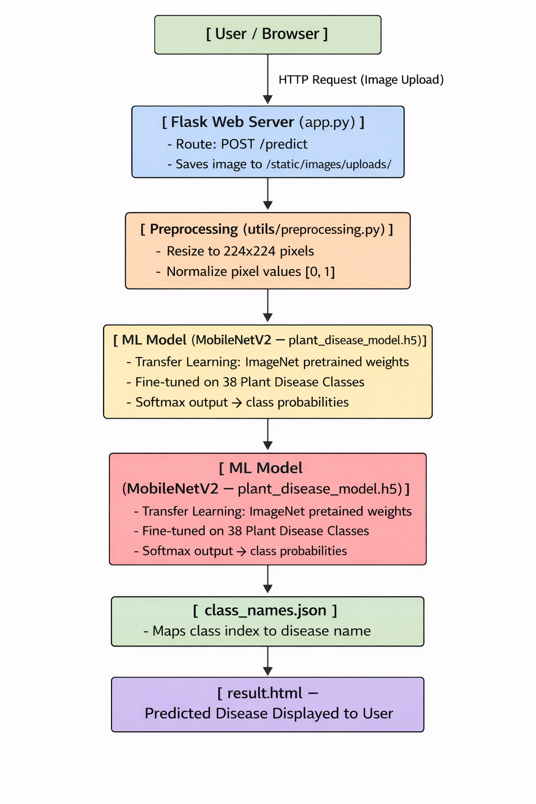

Technology Stack
Layer | Technology | Purpose
Frontend | HTML5, CSS3, JavaScript | User interface and image upload
Backend | Python, Flask | Web server, routing, request handling
ML Model | TensorFlow, Keras, MobileNetV2 | Disease classification via transfer learning
Data Processing | NumPy, Pillow (PIL) | Image preprocessing and array manipulation
Model Storage | HDF5 (.h5 file) | Storing trained model weights
Config | JSON (class_names.json) | Disease class label mapping
Static Assets | CSS/JS files | Styling and interactivity

Deployment Architecture
- The Flask application can be deployed locally (python app.py) on port 5000
- For cloud deployment: Dockerize using Docker, deploy on AWS EC2, Heroku, or Google Cloud Run
- Model (.h5 file) stored separately due to size; loaded at runtime
- Static files served by Flask in development; Nginx in production
- Future: Integrate with cloud storage (S3) for uploaded image management

