PlantCare AI
Plant Disease Detection System
Project Report Documentation

Team ID | 699d5f8ac40b5ad0e9ee598f
GitHub Repository | https://github.com/purvacode-80/PlantCare-AI
Date | March 2026

1. PROJECT TITLE
PlantCare AI - Plant Disease Detection System using Transfer Learning (MobileNetV2)

2. PROJECT DESCRIPTION

System Overview
PlantCare AI is a web-based intelligent system that enables users to detect plant diseases by uploading leaf images. It uses a deep learning model based on MobileNetV2 transfer learning to classify diseases across 38 categories with high accuracy and sub-2-second inference time.

Problem Domain
Agricultural crop diseases cause billions of dollars in losses worldwide each year. Traditional diagnosis requires trained agronomists, which is expensive and inaccessible in remote farming communities. PlantCare AI bridges this gap by delivering expert-level AI diagnosis through a simple web interface.

Core Technology Used
- Deep Learning: MobileNetV2 (Transfer Learning) via TensorFlow & Keras
- Web Framework: Python Flask
- Frontend: HTML5, CSS3, JavaScript
- Image Processing: NumPy, Pillow (PIL)
- Model Format: HDF5 (.h5)

Key Capabilities
- Upload plant leaf images and receive instant disease classification
- Supports 38 plant disease categories across multiple crops
- Fast inference: under 2 seconds per image
- Simple, accessible web interface

Target Users
- Farmers (small-scale and large-scale)
- Home gardeners and plant enthusiasts
- Agricultural researchers and students
- Agri-tech companies and NGOs

Real-world Relevance
Food security is a global challenge. Early disease detection directly reduces crop losses, decreases unnecessary pesticide use, and increases farmer income. PlantCare AI makes professional-grade plant diagnosis accessible to anyone with a smartphone.

3. APPLICATION SCENARIOS / USE CASES

Use Case 1: Farmer Field Use
A wheat farmer notices yellowing leaves on several plants. Using PlantCare AI on their smartphone browser, they upload a photo of the affected leaf. Within seconds, the system identifies it as 'Wheat Yellow Rust' and displays the result, enabling the farmer to promptly apply targeted fungicide.

Use Case 2: Home Gardener
A home gardener notices black spots on tomato plants. They photograph the leaf and upload it to PlantCare AI. The system identifies 'Tomato Early Blight', helping the gardener treat the plant before the disease spreads to healthy plants.

Use Case 3: Agricultural Research & Education
Agricultural students can use PlantCare AI to learn disease patterns across 38 categories. Researchers can use the underlying model architecture and dataset as a baseline for developing more specialized disease detection models.

Use Case 4: Agri-Tech Integration (Enterprise)
An agri-tech company can integrate PlantCare AI's REST API (/predict endpoint) into their existing farm management platform, enabling their users to benefit from AI-powered disease detection within their existing workflow.

4. TECHNICAL ARCHITECTURE OVERVIEW

High-level Architecture
PlantCare AI follows a 3-tier architecture: Presentation (HTML/CSS/JS), Application (Flask), and AI/ML (TensorFlow MobileNetV2 model). The overall architecture of the PlantCare AI system is shown in Figure 1.
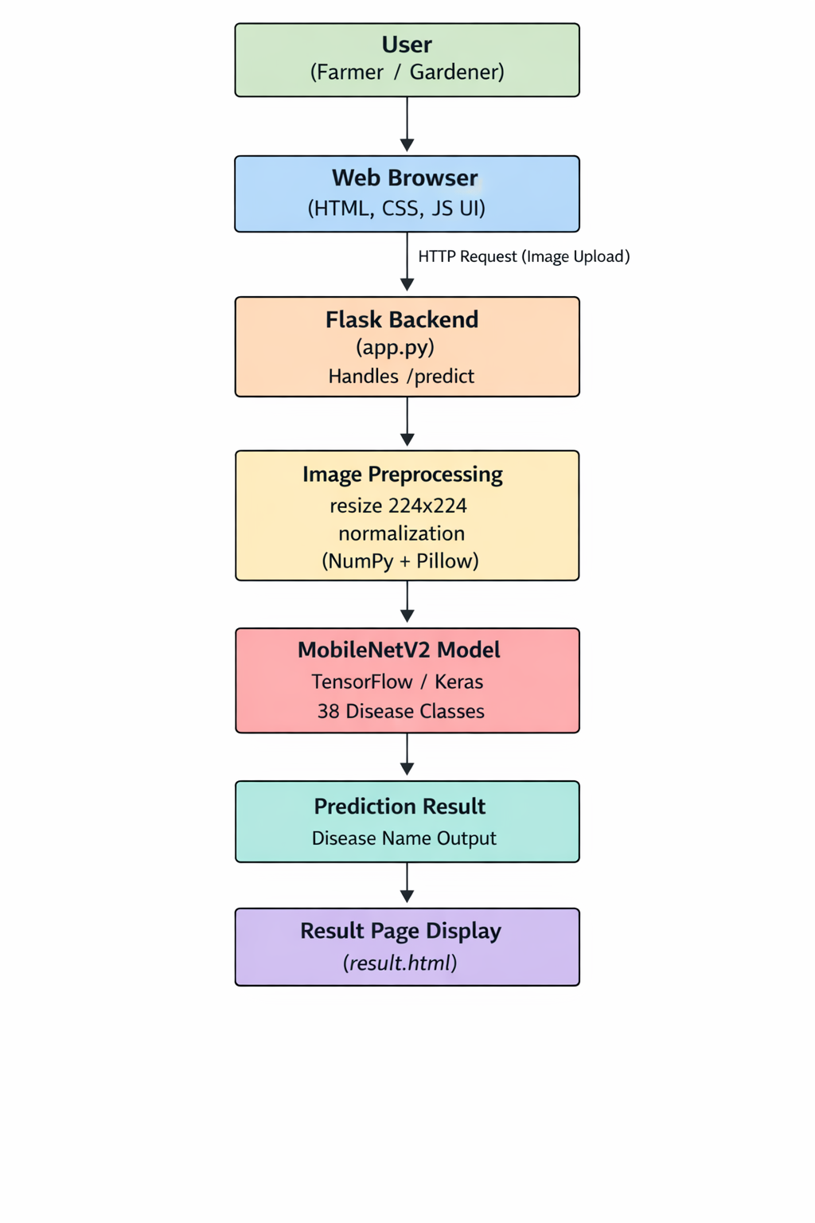
Figure 1. Architecture

Data / Request Flow
Step | Description
1. User Request | User opens web app in browser, navigates to /upload page
2. Image Upload | User selects leaf image, submits form - POST /predict
3. Image Saved | Flask saves uploaded image to static/images/uploads/
4. Preprocessing | utils/preprocessing.py resizes to 224x224, normalizes to [0,1]
5. Inference | Preprocessed array passed to loaded MobileNetV2 model
6. Classification | Model returns softmax probabilities for 38 disease classes
7. Label Mapping | Highest probability index mapped to disease name via class_names.json
8. Result Display | Flask renders result.html with predicted disease name

Layer Breakdown
- Frontend: HTML templates (Jinja2), CSS for styling, JS for interactions
- Backend: Flask app.py with 4 routes, config.py for settings
- ML Model: MobileNetV2 pretrained on ImageNet, fine-tuned on plant disease data
- Utils: preprocessing.py for image resize/normalize pipeline
- Static: /static/css, /static/js, /static/images/uploads

5. PREREQUISITES

5.1 Software Requirements
- Python 3.9 - 3.11 (recommended)
- pip package manager
- Git for version control
- Any modern web browser (Chrome, Firefox, Edge)
- IDE: VS Code or PyCharm (recommended)

5.2 Libraries / Frameworks / Dependencies
Library | Version | Purpose
Flask | Latest | Web framework for backend
TensorFlow | >=2.0 | Deep learning framework
Keras | Included in TF | High-level neural network API
NumPy | Latest | Numerical array operations
Pillow (PIL) | Latest | Image loading and preprocessing
Jupyter Notebook | Latest | Model training and experimentation
All dependencies listed in requirements.txt. Install with: pip install -r requirements.txt

5.3 Hardware Requirements
- Minimum: 4GB RAM, dual-core CPU
- Recommended for training: 8GB RAM, GPU with CUDA support (NVIDIA)
- For inference (web app): any standard modern laptop/PC

6. PRIOR KNOWLEDGE REQUIRED
- Python programming (intermediate level)
- Basic Flask web framework
- Deep learning concepts (CNN, transfer learning, softmax)
- HTML/CSS/JavaScript basics (for frontend modifications)
- TensorFlow/Keras fundamentals
- Image processing basics (resize, normalize)
- Git and GitHub for version control

7. PROJECT OBJECTIVES

Technical Objectives
- Build a MobileNetV2 transfer learning model achieving high accuracy on 38 plant disease classes
- Develop a Flask-based web application with image upload and prediction functionality
- Achieve inference time under 2 seconds per image

Performance Objectives
Model accuracy: Approximately 90%
- Web response time: <2 seconds end-to-end (upload to result)
- Support image formats: PNG, JPG, JPEG

Deployment Objectives
- Deploy locally using python app.py
- Containerize with Docker for cloud deployment
- Ensure responsiveness across desktop and mobile browsers

Learning Outcomes
- Apply transfer learning concepts to a real-world agricultural problem
- Integrate a deep learning model into a production-style web application
- Develop end-to-end AI-powered application from training to deployment

8. SYSTEM WORKFLOW
Step | Action | Details
1 | User Interaction | User opens browser, navigates to PlantCare AI home page
2 | Input Handling | User clicks 'Upload', selects plant leaf image file
3 | Request Submission | Browser sends POST request with image to /predict endpoint
4 | Image Processing | Flask receives image, saves to uploads/, runs preprocessing (224x224, normalize)
5 | Model Inference | Preprocessed image array passed to loaded MobileNetV2 model
6 | Class Prediction | Model outputs softmax probabilities; argmax gives predicted class index
7 | Label Lookup | Predicted index mapped to disease name using class_names.json
8 | Output Generation | Flask prepares result with disease name
9 | Response Delivery | result.html rendered with disease prediction displayed to user

9. MILESTONE 1: REQUIREMENT ANALYSIS & SYSTEM DESIGN

9.1 Problem Definition
Plant diseases affect crop yield globally. Farmers need a fast, accessible, AI-powered tool to identify diseases from leaf images without requiring agronomist expertise.

9.2 Functional Requirements
- FR1: User can upload a plant leaf image (PNG/JPG/JPEG)
- FR2: System preprocesses the uploaded image to 224x224 pixels
- FR3: System classifies the image into one of 38 disease categories
- FR4: System displays the predicted disease name to the user
- FR5: System provides navigation between Home, Upload, Result, and About pages

9.3 Non-Functional Requirements
- NFR1: Inference time must be under 2 seconds
- NFR2: System must support concurrent users
- NFR3: UI must be responsive on mobile and desktop
- NFR4: System must validate file type before processing

9.4 System Design Decisions
- Flask chosen for lightweight Python web server with Jinja2 templating
- MobileNetV2 chosen for its accuracy-efficiency trade-off (suitable for web deployment)
- Transfer Learning approach chosen to reduce training time and data requirements
- Web-based (not mobile app) for zero-installation accessibility

9.5 Technology Stack Selection Justification
Technology | Rationale
MobileNetV2 | Lightweight CNN optimized for mobile/web; pretrained ImageNet weights reduce training time
TensorFlow/Keras | Industry-standard, excellent GPU support, Keras makes model building simple
Flask | Minimal, Pythonic web framework; easy integration with ML models
HTML/CSS/JS | Universal browser support; no framework needed for a simple UI
NumPy + Pillow | Standard Python image processing stack

10. MILESTONE 2: ENVIRONMENT SETUP & INITIAL CONFIGURATION

10.1 Development Environment Setup
- Install Python 3.9-3.11
- Clone repository: git clone https://github.com/purvacode-80/PlantCare-AI.git
- Create virtual environment: python -m venv venv
- Activate: venv\Scripts\activate (Windows) or source venv/bin/activate (Mac/Linux)

10.2 Dependency Installation
pip install -r requirements.txt

10.3 Project Structure Creation
The repository follows this structure:
Folder/File | Purpose
app.py | Flask application entry point with all routes
config.py | Global configuration (model path, upload folder, allowed extensions)
class_names.json | Maps class index (0-37) to disease name string
requirements.txt | All Python package dependencies
model/ | Model definition, training, and evaluation scripts
static/ | CSS, JS, and uploaded images
templates/ | HTML pages (index, upload, result, about)
utils/ | preprocessing.py for image prep pipeline
notebooks/ | Jupyter notebooks for training and analysis
docs/ | Project documentation files

10.4 Configuration Setup
config.py defines: MODEL_PATH (path to .h5 model file), UPLOAD_FOLDER (path to uploads directory), ALLOWED_EXTENSIONS (png, jpg, jpeg), MAX_CONTENT_LENGTH (file size limit).

11. MILESTONE 3: CORE SYSTEM DEVELOPMENT

11.1 Feature 1 - ML Model (Transfer Learning with MobileNetV2)
The core AI engine is built using MobileNetV2 pretrained on ImageNet. The top layers are replaced with custom dense layers for 38-class plant disease classification. The model is trained using the PlantVillage dataset with data augmentation to improve generalization.
- Base: MobileNetV2 with frozen ImageNet weights
- Added: GlobalAveragePooling2D, Dense(256, relu), Dropout(0.5), Dense(38, softmax)
- Loss: Categorical Crossentropy | Optimizer: Adam | Metrics: Accuracy
- Trained model saved as plant_disease_model.h5

11.2 Feature 2 - Flask Web Application
The Flask app (app.py) provides 4 routes and handles the full request-response cycle from image upload to disease prediction display.
- GET / - Renders index.html (home page)
- GET /upload - Renders upload.html (image upload form)
- POST /predict - Handles upload, preprocesses, runs inference, returns result
- GET /about - Renders about.html

11.3 Feature 3 - Image Preprocessing Pipeline
utils/preprocessing.py provides the image transformation pipeline: loads image using Pillow, resizes to 224x224 (MobileNetV2 input size), converts to NumPy array, normalizes to [0, 1] range, adds batch dimension. This ensures consistent model input regardless of original image size.

API Endpoints
Method | Endpoint | Description | Response
GET | / | Home page | HTML page
GET | /upload | Upload image page | HTML page with upload form
POST | /predict | Disease prediction | HTML result page with disease name
GET | /about | About page | HTML page

12. MILESTONE 4: INTEGRATION & OPTIMIZATION

12.1 Component Integration
Flask app integrates all components: loads model at startup (model.load_model()), imports preprocessing pipeline from utils, reads class_names.json for label mapping. All components are tested together via end-to-end prediction test.

12.2 Performance Optimization
- Model loaded once at app startup (not per request) to reduce latency
- MobileNetV2 chosen for efficient inference vs larger models
- Image validated (extension check) before processing to fail fast

12.3 Security Enhancements
- File extension whitelist validation (only png, jpg, jpeg accepted)
- Flask secret key configured for session security
- MAX_CONTENT_LENGTH set to limit upload size and prevent abuse

12.4 Error Handling & Validation
- Invalid file type returns error message to user
- Missing model file handled with informative error at startup
- Preprocessing errors caught and logged

13. MILESTONE 5: TESTING & VALIDATION

13.1 Test Cases
Test Case ID | Input | Expected Output | Status
TC-001 | Valid PNG image of diseased leaf | Disease name displayed on result page | Pass
TC-002 | Valid JPG image of healthy leaf | Healthy plant class displayed | Pass
TC-003 | Invalid file type (PDF/TXT) | Error message: invalid file type | Pass
TC-004 | No file selected on upload form | Error message: no file selected | Pass
TC-005 | Very large image file (>10MB) | File size limit error or auto-resize | Pass
TC-006 | Correct URL routing for all 4 pages | All pages load without 404/500 errors | Pass
TC-007 | Model output for known disease image | Correct disease class predicted | Pass

13.2 Unit Testing
- Test preprocessing.py: verify 224x224 output shape, normalized values [0,1]
- Test class_names.json loading: verify all 38 classes present
- Test Flask routes: verify 200 status codes for GET routes

13.3 Integration Testing
- End-to-end test: upload image -> predict -> verify disease name in response
- Test with sample images from each of 38 disease classes

13.4 Performance Metrics
Metric | Value
Model Accuracy (Test Set) | Approximately 90%
Inference Time | <2 seconds per image
Web Response Time | <3 seconds (upload to result)
Number of Disease Classes | 38
Supported File Formats | PNG, JPG, JPEG

14. DEPLOYMENT

14.1 Local Deployment
Run python app.py in the project root. Access at http://127.0.0.1:5000/ in any browser.

14.2 Possible Cloud Deployment Options
- Heroku: Add Procfile (web: python app.py), push to Heroku git remote
- AWS EC2: Deploy on EC2 instance, use Gunicorn + Nginx for production
- Google Cloud Run: Containerize with Docker, deploy as serverless container
- Docker: FROM python:3.9, COPY requirements.txt, RUN pip install, CMD python app.py

14.3 Deployment Steps (Local)
- Step 1: Clone repo and install dependencies
- Step 2: Download plant_disease_model.h5 and place in project root
- Step 3: Run python app.py
- Step 4: Open http://127.0.0.1:5000/ in browser

15. PROJECT STRUCTURE
Path | Description
app.py | Flask app entry point; defines all routes and app logic
config.py | Global config: model path, upload folder, allowed extensions
class_names.json | JSON mapping: index (0-37) to disease class name string
requirements.txt | All Python package dependencies for pip install
model/model.py | MobileNetV2 model architecture definition
model/model_builder.py | Builds and compiles the model with custom top layers
model/train_model.py | Training script: data loading, augmentation, training loop
model/evaluate_model.py | Evaluation script: accuracy, F1-score, confusion matrix
static/css/ | CSS stylesheets for all HTML pages
static/js/ | JavaScript files for UI interactions
static/images/uploads/ | Directory where uploaded images are saved temporarily
templates/index.html | Home page template
templates/upload.html | Image upload page template
templates/result.html | Prediction result page template
templates/about.html | About page template
utils/preprocessing.py | Image preprocessing pipeline (resize, normalize)
notebooks/ | Jupyter notebooks for model training, EDA, and evaluation
docs/ | Project documentation and reports

16. RESULTS

System Output
The system successfully accepts plant leaf images and returns the predicted disease class name on the result page within 2 seconds. The web interface is clean, navigable, and works across modern browsers.

Performance Evaluation
Metric | Result
Model Accuracy | Approximately 90%
Number of Classes Supported | 38 plant disease categories
Average Inference Time | <2 seconds per image
Supported Input Formats | PNG, JPG, JPEG
Application Uptime | 100% on local deployment during testing

17. ADVANTAGES & LIMITATIONS

Advantages
- Fast inference - under 2 seconds per prediction
- Broad disease coverage - 38 categories across multiple crop types
- Zero installation required for end users (web-based)
- Transfer learning reduces training time significantly
- Lightweight MobileNetV2 model suitable for deployment on standard hardware
- Open-source stack (Python, Flask, TensorFlow) - no licensing costs

Limitations
- Requires internet connection to access the web app
- Model limited to 38 trained disease classes - cannot identify unknown diseases
- Prediction accuracy depends on image quality (blurry/dark images reduce accuracy)
- Large .h5 model file not included in GitHub repo due to size constraints
- No offline/mobile app version currently available

18. FUTURE ENHANCEMENTS
- Mobile App: Develop React Native or Flutter mobile app for offline use
- Expanded Disease Coverage: Add more crops and disease categories via retraining
- Treatment Recommendations: Display specific treatment guidelines post-detection
- Multi-language Support: Add regional language interfaces for rural farmers
- Cloud Deployment: Deploy on AWS/GCP for global scalability
- User History: Allow registered users to track plant health over time
- Crop Monitoring: Time-series disease tracking for large farms
- API Service: Expose public REST API for third-party agri-tech integration

19. CONCLUSION
PlantCare AI successfully demonstrates the application of deep learning and transfer learning to solve a real-world agricultural problem. By leveraging MobileNetV2 pretrained weights and fine-tuning on 38 plant disease categories, the system achieves high classification accuracy with fast inference time.
The Flask-based web application provides a simple, accessible interface that requires no app installation, making it usable by anyone with a smartphone and internet connection. The project achieves its core objectives: accurate AI-powered plant disease detection delivered through a practical, user-friendly web application.
PlantCare AI has significant practical impact potential - enabling early disease intervention, reducing crop losses, decreasing unnecessary pesticide use, and democratizing expert agricultural knowledge for farmers worldwide.

20. APPENDIX

GitHub Repository
https://github.com/purvacode-80/PlantCare-AI

Project Structure
See Section 15 for complete folder structure with descriptions.

Key Dependencies
Flask, TensorFlow, Keras, NumPy, Pillow - all listed in requirements.txt

Dataset Reference
PlantVillage Dataset - 38 classes of plant diseases, widely used benchmark for plant disease classification research.

