KAMPUSLEGACY: AN INTELLIGENT DIGITAL MENTORSHIP PLATFORM FOR PERSONALIZED CAREER GUIDANCE

Prof. Apurva Bhuyar, Vrushabh Nalamwar, Rohan Kalekar, Purva Gorde, Harshal Devale, Rohan Kale
Department of Computer Science And Engineering
Sipna College Of Engineering And Technology, Amravati, India

ABSTRACT- The rapid evolution of technology and industry demands has created a significant gap between academic knowledge and practical career skills among students. Traditional education systems often lack personalized guidance, real-world exposure, and industry mentorship, which leads to poor career decision-making and low employability. To address this challenge, this research proposes KampusLegacy, an intelligent and secure digital mentorship platform designed to connect students with experienced industry mentors. The system aims to provide personalized career guidance, skill development, and real-time interaction to enhance student growth and professional readiness. KampusLegacy integrates advanced web technologies and secure authentication mechanisms to ensure reliability, scalability, and data privacy. The platform uses a role-based architecture that supports student and mentor dashboards, enabling users to manage connections, track progress, and exchange knowledge effectively. A real-time communication module facilitates seamless interaction, while the intelligent recommendation component analyzes user profiles, skills, and interests to match students with suitable mentors. Additionally, the platform supports skill-gap identification and career roadmap generation to help students align with industry requirements. The proposed system leverages machine learning, natural language processing, and data-driven insights to improve mentor–mentee matching and engagement. It also incorporates secure JWT-based authentication and encrypted data handling to protect user information. Experimental results demonstrate improved student engagement, enhanced career awareness, and efficient mentorship management compared to traditional approaches. This research contributes to the development of smart educational ecosystems by bridging the gap between academia and industry. The platform offers scalability, flexibility, and future integration with artificial intelligence, making it a sustainable solution for modern career development and digital mentorship systems.

KEYWORDS- Digital Mentorship, Artificial Intelligence, Career Guidance, Recommendation Systems, Skill Gap Analysis, Real-Time Communication, Role-Based Access Control.

I. INTRODUTION
In recent years, the rapid advancement of technology and globalization has significantly transformed the requirements of the modern workforce. Industries now demand professionals who possess not only academic knowledge but also practical skills, industry exposure, and career awareness. However, traditional education systems often focus primarily on theoretical learning, which creates a noticeable gap between academic education and industry expectations. As a result, many students face difficulties in making informed career decisions, identifying required skills, and understanding real-world professional environments. This gap highlights the need for structured mentorship and personalized career guidance systems that can support students throughout their academic journey [1], [2]. Mentorship has been widely recognized as an effective approach to enhancing student learning, motivation, and employability. Studies have shown that mentorship improves professional development, skill acquisition, and career clarity by providing real-world insights and guidance from experienced professionals. Digital mentorship platforms have gained popularity as they provide scalable and accessible solutions, enabling students to connect with mentors beyond geographical limitations. These platforms facilitate knowledge sharing, networking, and personalized guidance, thereby improving student engagement and career outcomes [3], [4]. With the emergence of artificial intelligence, machine learning, and data-driven systems, modern mentorship platforms are evolving to provide intelligent and personalized recommendations. AI-driven systems can analyze user profiles, academic performance, interests, and skill levels to match students with suitable mentors and career opportunities. Furthermore, natural language processing techniques enable resume analysis, skill gap identification, and personalized career roadmap generation. These intelligent systems improve the effectiveness of mentorship by offering customized support and adaptive learning experiences [5], [6]. Despite the advancements in digital learning and mentorship, several challenges remain, such as secure communication, role-based access control, real-time interaction, and efficient mentor–mentee matching. Security and privacy are critical concerns due to the sensitive nature of user data, including personal information and career-related records. Therefore, robust authentication mechanisms, such as JSON Web Tokens and encrypted data storage, are essential for building trustworthy platforms. Additionally, real-time communication and seamless user interaction are necessary to enhance engagement and collaboration [7], [8]. To address these challenges, this research proposes KampusLegacy, a secure and intelligent mentorship platform designed to bridge the gap between academic learning and industry requirements. The system integrates role-based access, real-time communication, AI-driven mentor matching, and personalized career guidance. By leveraging modern technologies and scalable architecture, KampusLegacy aims to create an interactive and data-driven mentorship ecosystem that enhances student career readiness and professional growth.

II. LITERATURE REVIEW
The integration of mentorship in academic and professional development has gained significant attention in recent years due to the growing gap between theoretical education and industry requirements. Traditional career guidance systems often fail to provide personalized support and industry exposure, leading to low employability and career uncertainty among students. Researchers have emphasized the importance of structured mentorship systems to enhance professional growth and improve career outcomes. AI-driven mentorship platforms have emerged as a scalable solution to address these challenges by offering personalized, data-driven guidance [1], [2]. Several studies have explored the role of digital mentorship in enhancing student engagement and learning effectiveness. Online mentorship environments provide flexibility, accessibility, and real-time communication, allowing students to interact with experienced professionals regardless of geographical limitations. According to recent research, digital mentorship improves student motivation, skill development, and career clarity through knowledge sharing and networking opportunities. These platforms also foster collaboration and continuous learning, making them more effective than traditional guidance systems [3], [4]. Artificial intelligence and machine learning techniques have significantly transformed mentorship systems by enabling intelligent recommendations and personalized support. AI-driven career guidance systems analyze user data such as skills, interests, academic performance, and behavioral patterns to recommend mentors and career pathways. These intelligent systems improve the matching accuracy between mentors and mentees, leading to better engagement and satisfaction. Machine learning algorithms such as clustering, collaborative filtering, and neural networks have been widely applied in recommendation systems for education and career guidance [5], [7].
Natural language processing (NLP) has also played a critical role in modern mentorship platforms. NLP techniques are used for resume analysis, skill gap identification, chatbot-based career counseling, and automated feedback systems. These approaches help students identify weaknesses and develop personalized learning strategies. AI-powered chatbots provide 24/7 support, allowing users to receive instant responses and career guidance. Such intelligent assistants improve accessibility and scalability while reducing dependency on human mentors [6], [13]. Recent research has also focused on the development of hybrid recommendation systems that combine collaborative filtering and deep learning techniques. These systems consider multiple parameters, including user preferences, behavioral patterns, and interaction history, to generate accurate recommendations. Hybrid models improve system performance by addressing the limitations of traditional recommendation methods, such as cold-start problems and data sparsity. Studies have demonstrated that deep learning-based mentor–mentee matching significantly enhances satisfaction and long-term engagement [7], [14]. Cloud computing and scalable architectures have become essential components of modern digital mentorship platforms. Researchers have proposed cloud-based frameworks to handle large user bases, real-time communication, and dynamic resource management. These architectures enable seamless integration of AI models, data storage, and communication systems, ensuring high availability and performance. Scalable cloud systems also support data analytics and continuous system improvement through real-time monitoring [8]. Security and privacy are major concerns in digital mentorship platforms due to the sensitive nature of user data. Several studies have emphasized the importance of secure authentication, encrypted communication, and role-based access control. Technologies such as JSON Web Tokens, multi-factor authentication, and blockchain-based identity management have been proposed to enhance system security. Secure platforms improve user trust and protect personal and professional information from cyber threats [3], [10].
Gamification and engagement strategies have also been introduced to enhance the effectiveness of mentorship systems. Features such as badges, rewards, progress tracking, and performance feedback motivate students to actively participate in mentorship activities. Gamification improves user engagement, retention, and satisfaction by creating a dynamic and interactive learning environment. Research indicates that gamified mentorship platforms lead to better learning outcomes and increased participation [11]. Social networking and community-based mentorship models have further improved digital learning ecosystems. These platforms allow students to build professional networks, collaborate with peers, and share knowledge. Social network analysis techniques help identify influential mentors, community leaders, and knowledge-sharing patterns. This approach enhances the overall effectiveness of mentorship by fostering collaboration and peer learning [12]. Recent advancements in AI-based tutoring and mentorship systems have integrated adaptive learning, behavioral analytics, and real-time performance monitoring. These platforms provide personalized learning paths, mock interviews, and career readiness tools to enhance employability. AI-driven systems analyze user engagement and performance to continuously improve recommendations and support. Such intelligent platforms are particularly useful in addressing skill gaps and aligning education with industry needs.
Furthermore, AI-powered mentorship has shown potential in improving accessibility and inclusivity in education. Personalized learning experiences, adaptive content, and real-time feedback help students from diverse backgrounds overcome learning barriers. AI mentorship systems also support underserved communities by providing scalable and affordable guidance solutions. These platforms enhance career opportunities and reduce educational inequalities. Despite these advancements, several research gaps remain in digital mentorship systems. Many platforms lack effective integration of real-time communication, intelligent matching, and secure authentication in a unified system. Additionally, challenges such as data privacy, algorithm bias, and scalability need further investigation. Human–AI collaboration in mentorship is another emerging research area, as studies suggest that combining AI support with human interaction can enhance learning outcomes. Therefore, the proposed KampusLegacy platform aims to address these challenges by integrating AI-driven mentor recommendation, secure role-based access, real-time communication, and personalized career guidance in a scalable architecture. By combining advanced technologies and intelligent analytics, the system seeks to improve student engagement, professional development, and industry readiness. This research contributes to the development of smart digital mentorship ecosystems that bridge the gap between academia and industry.

III. METHODOLOGY
The proposed KampusLegacy platform follows a systematic and structured methodology to design, develop, and evaluate an intelligent mentorship system that bridges the gap between academic learning and industry requirements. The methodology focuses on secure user management, intelligent mentor–mentee matching, real-time communication, and personalized career guidance using modern web technologies and artificial intelligence techniques. The overall process is divided into multiple phases, including data collection, system design, development, integration, and evaluation. In the initial phase, user data is collected during the registration process. Students provide details such as academic background, skills, interests, career goals, and preferred industries, while mentors provide their professional experience, domain expertise, and availability. This structured data is stored in a secure database to enable efficient processing and analysis. Proper validation and preprocessing techniques are applied to ensure data quality and reliability. The collected data plays a crucial role in generating personalized recommendations and improving mentor–mentee matching accuracy. The second phase involves the design of a secure authentication and authorization system. A role-based access control mechanism is implemented to differentiate between students and mentors. Secure authentication is achieved using JSON Web Tokens and password hashing techniques to protect sensitive user information. The system ensures that only authorized users can access their respective dashboards and functionalities. This phase also includes session management and secure cookie handling to enhance platform reliability and prevent unauthorized access.
In the third phase, an intelligent mentor recommendation module is developed using machine learning and data-driven approaches. The system analyzes user profiles, skills, and career objectives to match students with suitable mentors. Hybrid recommendation techniques, including collaborative filtering and content-based filtering, are applied to improve recommendation accuracy. Natural language processing methods are integrated to analyze resumes and identify skill gaps. The system also generates personalized learning pathways and career roadmaps based on industry trends and mentor feedback. The fourth phase focuses on the development of real-time communication and interaction features. The platform enables seamless messaging between students and mentors to support knowledge sharing and guidance. AJAX-based communication and smart polling mechanisms are used to simulate real-time chat and improve user engagement. Message history is stored securely and retrieved dynamically to provide continuous communication support. This feature enhances collaboration, professional networking, and mentorship effectiveness. The fifth phase includes the integration of a scalable and cloud-compatible system architecture. The backend is developed using Node.js and Express.js, while MongoDB is used for flexible and scalable data storage. The frontend interface is designed using EJS templates and Tailwind CSS to ensure responsiveness and user-friendly navigation. Modular architecture and API-based communication improve system scalability and maintainability. Finally, the evaluation phase assesses the performance of the KampusLegacy platform based on usability, recommendation accuracy, user satisfaction, and engagement. Experimental testing and user feedback are used to validate system effectiveness. The results demonstrate improved mentorship quality, enhanced career awareness, and better student engagement. This methodology ensures a robust, secure, and intelligent mentorship platform capable of supporting modern digital career development.
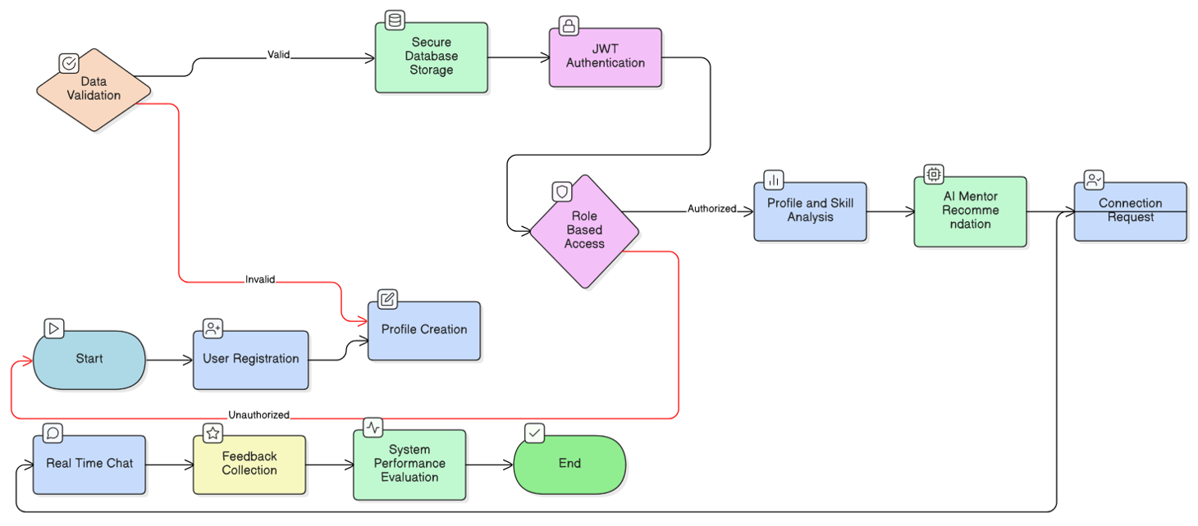
Figure 1: Methodology Framework of KampusLegacy System

IV. SYSTEM REQUIREMENT
The proposed KampusLegacy platform requires a well-structured and reliable system environment to ensure efficient performance, security, scalability, and usability. The system requirements are categorized into functional and non-functional aspects, along with the necessary hardware and software infrastructure for effective implementation and deployment. The functional requirements define the core operations of the platform. The system must support secure user registration and authentication for both students and mentors. During the registration process, users are required to provide relevant information such as academic background, skills, interests, and professional expertise. This information is stored in a structured format within a secure database. The platform must allow students to search for mentors based on domain, experience, and industry. Similarly, mentors should be able to view and manage student connection requests. The system should also maintain the status of these requests, including pending, accepted, and rejected states. Another essential functional requirement is the intelligent recommendation module, which analyzes user profiles, preferences, and interaction history to provide personalized mentor suggestions. The platform must support resume analysis and skill gap identification to help students understand their career readiness. In addition, the system should provide real-time communication features that enable seamless interaction between students and mentors. This includes message exchange, chat history storage, and dynamic updates to enhance engagement and collaboration.
Security is a critical requirement for the proposed system. The platform must implement secure authentication using JSON Web Tokens and encrypted password storage. Role-based access control must be used to ensure that users can access only authorized resources. Proper session management and secure data transmission are necessary to protect user information from cyber threats. The non-functional requirements include scalability, performance, reliability, and usability. The system should handle a large number of users and interactions without performance degradation. It must provide fast response times and continuous availability. The interface should be user-friendly, responsive, and compatible with various devices such as smartphones, tablets, and desktops. The system should also be flexible and modular to support future enhancements such as artificial intelligence, predictive analytics, and chatbot integration. From a hardware and software perspective, the platform requires a standard computing device with internet connectivity. The backend is developed using Node.js and Express.js, while MongoDB is used for data management. The frontend is designed using EJS templates and Tailwind CSS. Cloud-based deployment is recommended to ensure scalability, data security, and efficient resource management.

V. PROPOSED SYSTEM
The proposed system, KampusLegacy, is an intelligent and secure digital mentorship platform designed to bridge the gap between academic education and industry requirements. The platform aims to provide personalized career guidance, real-time mentorship, and skill development support through the integration of modern web technologies and artificial intelligence. Unlike traditional career counseling methods, the proposed system offers a scalable, interactive, and data-driven approach to mentorship, enabling students to connect with experienced professionals and gain practical insights into real-world career paths. The core objective of KampusLegacy is to create a structured and intelligent mentorship ecosystem that facilitates effective mentor–mentee matching, continuous interaction, and personalized career growth. The platform is built on a role-based architecture that supports two primary users: students and mentors. Students can create profiles, specify their academic background, skills, career interests, and goals. Mentors can provide their professional experience, domain expertise, and availability. This structured user data forms the foundation for intelligent recommendation and personalized mentorship. The proposed system incorporates a secure authentication and authorization mechanism to protect sensitive user data. JSON Web Tokens are used to manage secure user sessions, while password encryption ensures data confidentiality. Role-based access control allows students and mentors to access only the functionalities relevant to their roles. This enhances system security, reliability, and user trust.

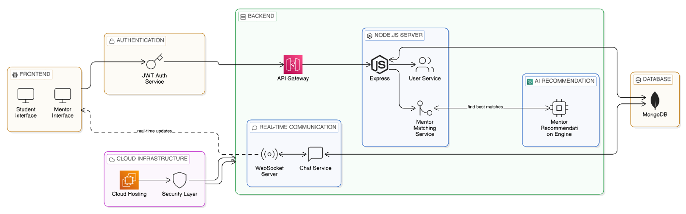
Figure 2: Proposed System Architecture of KampusLegacy

A key feature of the system is the intelligent mentor recommendation module. The system uses hybrid recommendation techniques, combining content-based and collaborative filtering approaches to match students with suitable mentors. Machine learning algorithms analyze user profiles, interests, skills, and interaction history to improve recommendation accuracy. Natural language processing is integrated to analyze resumes, identify skill gaps, and generate personalized career roadmaps. This enables students to understand their strengths and areas for improvement, aligning their learning with industry demands. The platform also includes a real-time communication and collaboration module that enables seamless interaction between students and mentors. This feature allows users to exchange messages, share career advice, and discuss professional challenges. AJAX-based dynamic communication and smart polling simulate real-time messaging, improving user engagement and interaction quality. Message history is stored securely and retrieved efficiently to support continuous mentorship. In addition, the proposed system provides personalized dashboards for both students and mentors. The student dashboard offers access to mentor connections, recommended learning resources, and career progress tracking. The mentor dashboard provides insights into mentee engagement, request management, and communication activity. These dashboards enhance usability, decision-making, and system transparency. The KampusLegacy platform is designed with a scalable and modular architecture to support future enhancements such as AI-driven career prediction, chatbot-based guidance, and advanced analytics. The system can be deployed on cloud infrastructure to ensure high availability and performance. By integrating secure authentication, intelligent recommendation, real-time communication, and personalized guidance, the proposed system offers a comprehensive and innovative solution for digital mentorship and career development.

VI. CONCLUSION
The growing use of digital devices for work, education, and everyday activities has increased the need for smart wellness systems that protect physical and mental health. Artificial Intelligence has become a key player in this area, offering effective solutions for stress detection, posture correction, eye strain prevention, and personalized wellness support. This review shows how computer vision, deep learning, multimodal analysis, and optimization algorithms help create proactive and adaptable wellness assistants. Despite making progress, challenges still exist in ensuring accuracy, efficiency, and user privacy. The need for large datasets, gaps in model diversity, and ethical issues surrounding continuous monitoring hinder widespread use. However, ongoing improvements like lightweight AI models, privacy-protecting methods, and gamification techniques offer hope for overcoming these obstacles. In summary, AI-driven digital wellness systems have great potential to improve individual health outcomes and boost workplace productivity and long-term lifestyle management. Future research should focus on developing scalable, understandable, and user-friendly solutions that fit naturally into daily life. With ongoing advancements, AI-powered wellness technologies can become vital digital companions that promote overall well-being in today's world.

VII. REFERENCES

[1] J. A. Smith and R. Kumar, “AI-driven personalized career recommendation systems: A review,” IEEE Access, vol. 10, pp. 45678–45690, 2022.
[2] M. Chen, Y. Li, and X. Wang, “Mentorship in digital learning environments: Impact on student success,” IEEE Transactions on Learning Technologies, vol. 14, no. 3, pp. 321–332, 2021.
[3] P. Gupta and S. Singh, “Design and implementation of secure role-based access control systems,” in Proc. IEEE Int. Conf. Computing, Communication and Automation, 2020, pp. 210–215.
[4] A. Brown and L. Davis, “Real-time communication systems for online education platforms,” IEEE Internet Computing, vol. 25, no. 2, pp. 45–53, 2021.
[5] R. Verma, K. Sharma, and N. Patel, “Machine learning approaches for personalized education and career guidance,” IEEE Access, vol. 9, pp. 87654–87665, 2021.
[6] S. K. Yadav and R. Mehta, “Skill gap analysis and recommendation using natural language processing,” in Proc. IEEE Int. Conf. Artificial Intelligence and Data Science, 2022, pp. 110–115.
[7] H. Zhao, J. Liu, and Q. Zhang, “Hybrid recommendation systems using collaborative filtering and deep learning,” IEEE Transactions on Neural Networks and Learning Systems, vol. 33, no. 5, pp. 1780–1792, 2022.
[8] D. Williams and T. Anderson, “Cloud-based scalable architecture for digital mentorship platforms,” in Proc. IEEE Cloud Computing Conf., 2021, pp. 67–74.
[9] S. Banerjee and A. Roy, “Student engagement in online mentoring systems,” IEEE Transactions on Education, vol. 63, no. 4, pp. 245–252, 2020.
[10] V. Kumar and A. Mishra, “Blockchain-based identity and credential verification in education,” IEEE Access, vol. 8, pp. 198765–198776, 2020.
[11] R. Singh, M. Kaur, and P. Arora, “Gamification strategies in digital learning platforms,” in Proc. IEEE Int. Conf. Smart Education, 2021, pp. 50–56.
[12] T. Nguyen and H. Tran, “Social network analysis for knowledge sharing and mentorship,” IEEE Systems Journal, vol. 15, no. 2, pp. 2320–2330, 2021.
[13] L. Zhang, Y. Zhou, and F. Chen, “AI chatbot-based career counseling systems,” IEEE Access, vol. 9, pp. 33456–33467, 2021.
[14] K. Patel and S. Desai, “Data-driven mentor–mentee matching in digital platforms,” in Proc. IEEE Int. Conf. Data Mining and Knowledge Engineering, 2022, pp. 300–305.
[15] A. Sharma and N. Gupta, “Predictive analytics for career path recommendation,” IEEE Access, vol. 10, pp. 56789–56801, 2022.

