**High Performance Computing Lab**

**Practical No. 6**

**PRN : 22510089**

**Name: Purva Rajendra Markam**

**Batch : B1**

**GitHub : https://github.com/Vru01/HPC_22510092**

**Title of practical:**

Installation of MPI & Implementation of basic functions of MPI

**Problem Statement 1:**

Implement a simple hello world program by setting number of processes equal to 10

**Screenshots:**

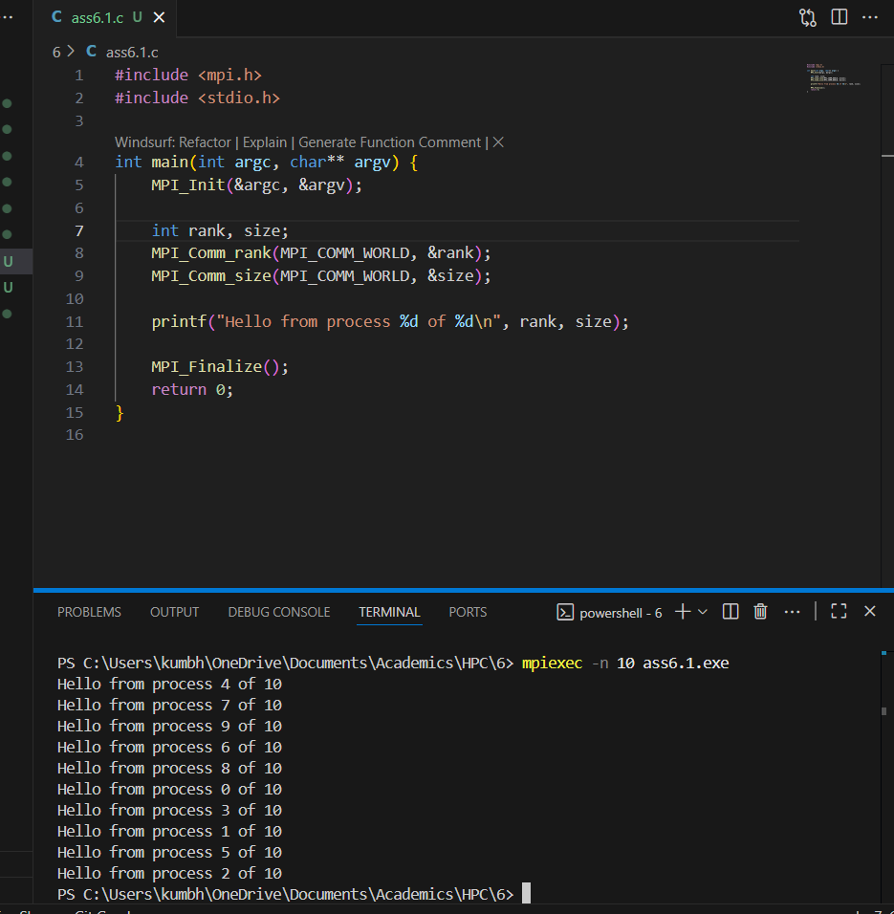

**Information 1:**This is the simplest example of parallel programming with MPI. It teaches you how to start, identify, and finish multiple processes working together, which is the foundation for more complex distributed computing tasks

**Problem Statement 2:**

Implement a program to display rank and communicator group of five processes

**Screenshots:**

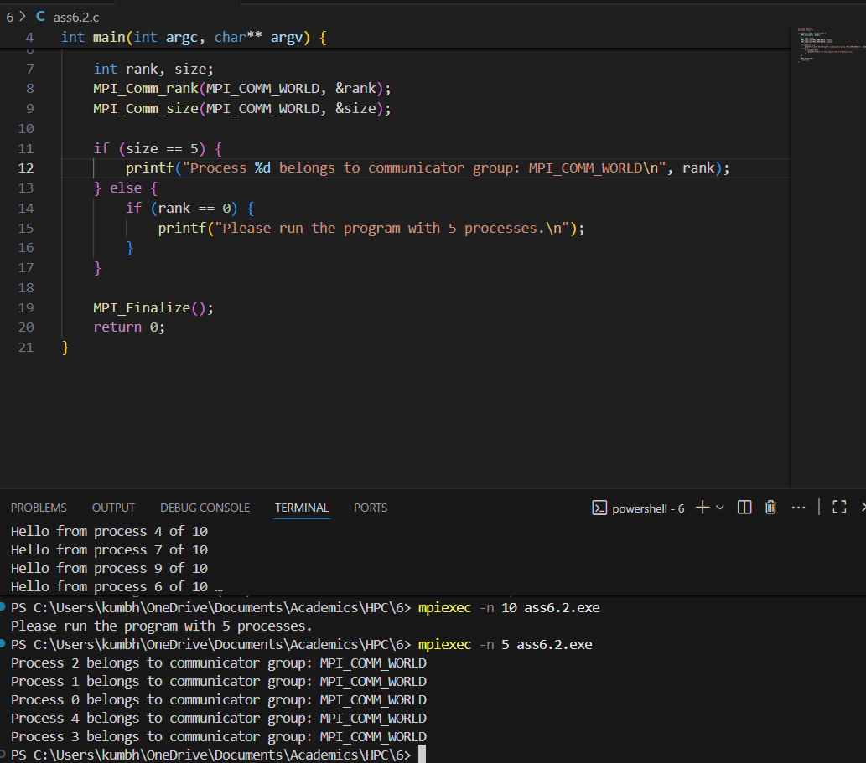

**Q3: Implement a MPI program to give an example of Deadlock.**

**Program and screenshots**

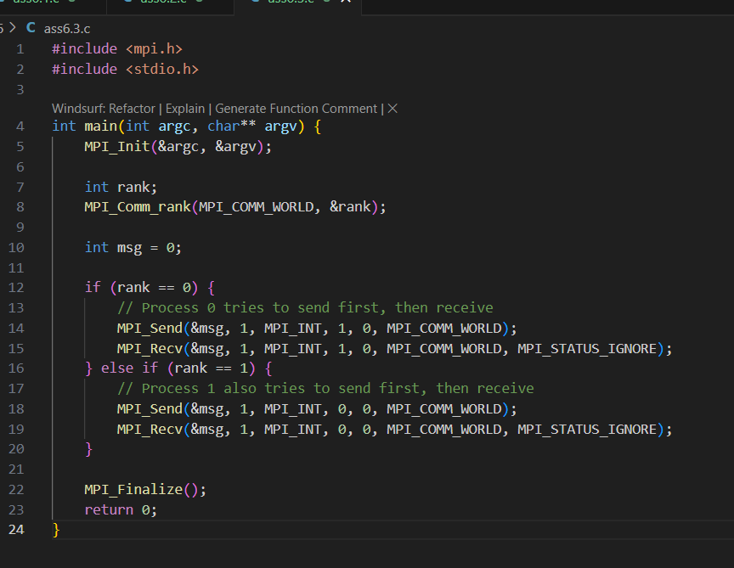

**Q4. Implement blocking MPI send & receive to demonstrate Nearest neighbor exchange of data in a ring topology.**

**Program and screenshots**

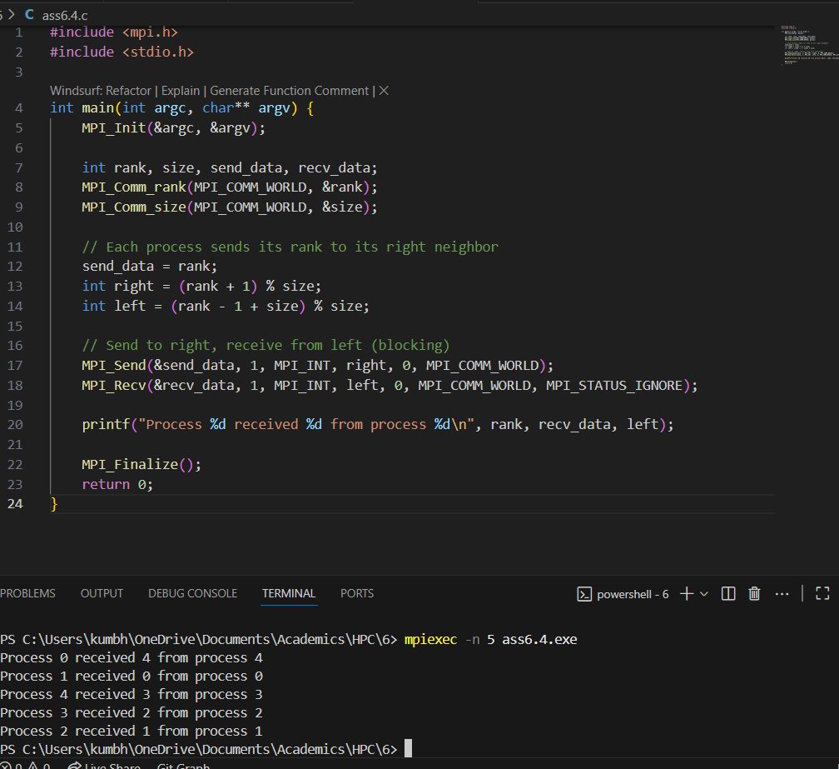

**Q5. Write a MPI program to find the sum of all the elements of an array A of size**

**n. Elements of an array can be divided into two equals groups. The first [n/2]**

**elements are added by the first process, P0, and last [n/2] elements the by second process, P1. The two sums then are added to get the final result.**

**Program and screenshots**

