Performance of the Indian Corporate Debt Market
FY 2021-22 to FY 2025-26
Assignment on the corporate bond market, based on SEBI reports and RBI publications

1. Introduction
Companies in India can borrow from banks, raise equity or issue bonds. For a long time banks did most of the lending, so the corporate bond market stayed small. In this report I look at how the market did over the last five financial years (FY2021-22 to FY2025-26). I cover five things: how big the market is and how fast it is growing, how much of the money raised from the primary market comes from debt, how many new bonds were issued each year, how much trading happens in the secondary market, and what foreign portfolio investors (FPIs) have been doing. At the end I give my view on whether the market is dominated by private placements and AAA-rated issuers.
All years are financial years running from April to March. The numbers for FY2025-26 are provisional, so they may change when final data come out. The tables are in the Excel workbook and the sources are listed at the end.

2. Market size, growth and share of GDP
The outstanding corporate bonds rose from Rs 40.2 lakh crore in FY22 to Rs 58.2 lakh crore in FY26. This works out to a compound annual growth rate of about 9.7% over the four years.
Year | Outstanding (Rs lakh cr) | YoY growth | Nominal GDP (Rs lakh cr) | % of GDP
2021-22 | 40.2 | 11.2% | 236.65 | 17.0%
2022-23 | 42.0 | 4.5% | 272.41 | 15.4%
2023-24 | 47.3 | 12.6% | 295.36 | 16.0%
2024-25 | 53.3 | 12.7% | 322.00 | 16.6%
2025-26 | 58.2 | 9.2% | 355.00 | 16.4%
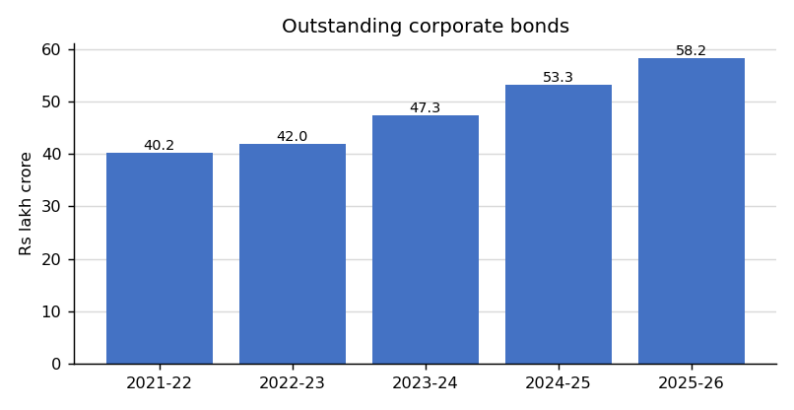
Figure 1: Outstanding corporate bonds
Growth was weakest in FY23 at 4.5%, which was a year of rising interest rates. It was strongest in FY24 and FY25 at around 12.6% to 12.7%. What I find interesting is that the share of GDP has stayed between 15% and 17% in all five years. So the bond market has mostly grown at the same speed as the economy, and it has not become much deeper relative to GDP.

3. Primary market resource mobilisation
If we add up the money raised through equity and debt in the primary market, debt was the bigger part in every year.
Year | Equity (Rs crore) | Debt (Rs crore) | Total (Rs crore) | Debt share
2021-22 | 2,13,361 | 5,99,626 | 8,12,987 | 73.8%
2022-23 | 83,256 | 7,63,688 | 8,46,944 | 90.2%
2023-24 | 1,71,230 | 8,56,924 | 10,28,154 | 83.4%
2024-25 | 4,29,871 | 9,94,884 | 14,24,755 | 69.8%
2025-26 | 4,50,000 | 9,10,000 | 13,60,000 | 66.9%
Total | 13,47,718 | 41,25,122 | 54,72,840 | 75.4%
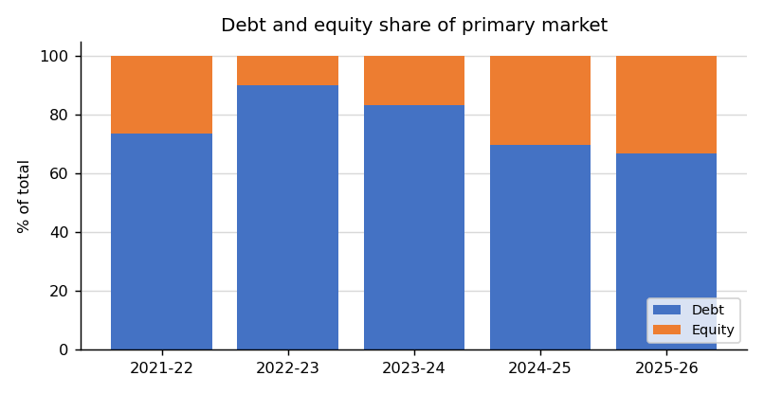
Figure 2: Debt and equity share in primary market
The debt share was highest in FY23 at about 90%. In that year the equity market was weak and only Rs 0.83 lakh crore was raised through equity. After that equity picked up again because of IPOs, QIPs and preferential issues, and the debt share came down to about 70% in FY25 and 67% in FY26. Over the whole five years debt was roughly three-fourths (75%) of the total.

4. Fresh issuance of corporate bonds
Year | Private placement (Rs cr) | Public issue (Rs cr) | Total (Rs lakh cr) | YoY growth
2021-22 | 5,88,037 | 11,589 | 6.00 | NA
2022-23 | 7,54,467 | 9,221 | 7.64 | 27.4%
2023-24 | 8,37,756 | 19,168 | 8.57 | 12.2%
2024-25 | 9,86,735 | 8,149 | 9.95 | 16.1%
2025-26 | 9,00,900 | 9,100 | 9.10 | -8.5%
Total | 40,67,895 | 57,227 | 41.25
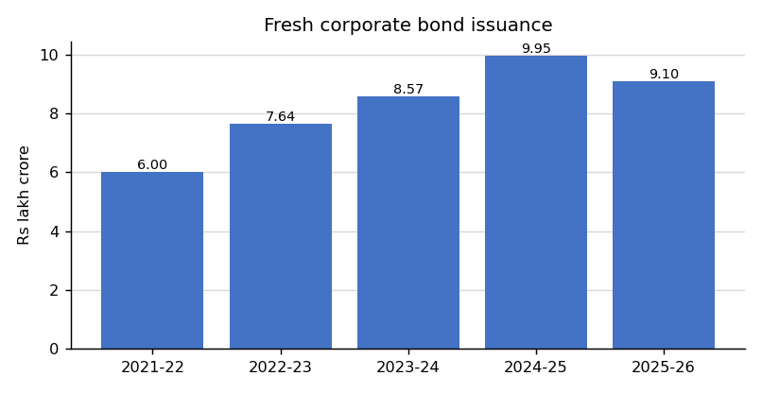
Figure 3: Fresh corporate bond issuance
New bond issuance went up every year till FY25, when it reached a record of about Rs 9.95 lakh crore. Yields were lower and there was a lot of liquidity in the system, which made borrowing through bonds attractive. In FY26 issuance fell by about 8.5% to around Rs 9.1 lakh crore because yields went up and some companies preferred bank loans. In total about Rs 41.3 lakh crore of bonds were issued in the five years.

5. Secondary market trading
Year | Avg daily turnover (Rs cr) | Settled trades (Rs lakh cr) | RFQ volume (Rs cr) | RFQ share
2021-22 | 7,358 | 14.30 | 1,85,000 | 12.9%
2022-23 | 5,549 | 13.44 | 2,48,000 | 18.5%
2023-24 | 5,718 | 13.26 | 3,40,525 | 25.7%
2024-25 | 7,645 | 16.56 | 5,29,147 | 32.0%
2025-26 | 7,100 | 17.50 | 6,10,000 | 34.9%
Average | 6,674 | 15.01 | 3,82,534 | 24.8%
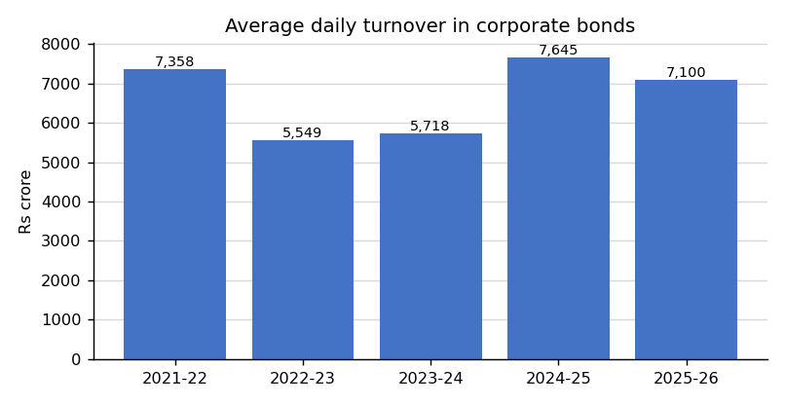
Figure 4: Average daily turnover in corporate bonds
Average daily turnover was Rs 7,358 crore in FY22. It fell to around Rs 5,500 to 5,700 crore in FY23 and FY24 and then went back up to Rs 7,645 crore in FY25 and Rs 7,100 crore in FY26. The five-year average is about Rs 6,674 crore a day. This looks small when we compare it with a market of more than Rs 50 lakh crore. One reason is that large buyers like insurance companies, pension funds and banks mostly hold the bonds till maturity, so there is not much trading. On the positive side, trading on the RFQ (Request for Quote) platform has increased every year and is now about one-third of settled trades.

6. Foreign portfolio investor (FPI) flows
Year | FPI corp. holding (Rs lakh cr) | Limit (Rs lakh cr) | Utilisation | Net FPI debt flow, all routes (Rs cr)
2021-22 | 1.20 | 6.03 | 19.9% | -15,048
2022-23 | 1.04 | 6.70 | 15.5% | 6,408
2023-24 | 1.08 | 6.68 | 16.2% | 1,20,000
2024-25 | 1.21 | 7.64 | 15.8% | 1,40,000
2025-26 | 1.25 | 8.33 | 15.0% | 16,100
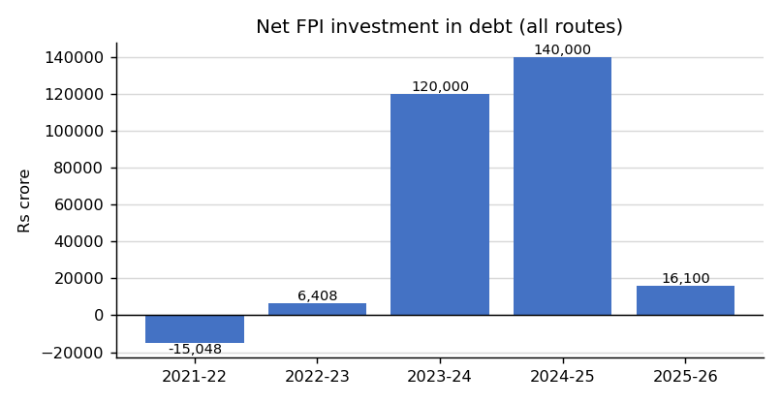
Figure 5: Net FPI flows into debt (all routes)
FPIs sold more debt than they bought in FY22 and bought only a little in FY23, when global interest rates were going up. Flows jumped in FY24 and FY25 after Indian government bonds were included in global indices (JP Morgan GBI-EM from June 2024 and Bloomberg indices from January 2025). But most of this money went into government securities through the Fully Accessible Route and not into corporate bonds. FPI holdings of corporate bonds stayed between Rs 1.04 and Rs 1.25 lakh crore, which is only about 15% to 20% of the approved limit.
One limitation: the yearly flow numbers are for all debt together, and I could not get a separate yearly series for corporate bonds only. So I also looked at the change in corporate holdings, which was about -0.16, +0.04, +0.13 and +0.04 lakh crore in FY23 to FY26. This gives a better idea for corporate debt, but it also includes price changes.

7. Is the market dominated by private placements and AAA-rated issuers?
Year | Total debt raised (Rs cr) | Private placement (Rs cr) | Private placement share | Public issue share
2021-22 | 5,99,626 | 5,88,037 | 98.1% | 1.9%
2022-23 | 7,63,688 | 7,54,467 | 98.8% | 1.2%
2023-24 | 8,56,924 | 8,37,756 | 97.8% | 2.2%
2024-25 | 9,94,884 | 9,86,735 | 99.2% | 0.8%
2025-26 | 9,10,000 | 9,00,900 | 99.0% | 1.0%
Total | 41,25,122 | 40,67,895 | 98.6% | 1.4%

My view is that I agree with this statement, for the following reasons.
- Private placements: they were between 97.8% and 99.2% of all bond issuance in every year, and about 98.6% over the five years. Public issues were never more than Rs 20,000 crore in a year.
- Rating concentration: most of the issuance is in top-rated paper, roughly 85% to 88% in AAA/AA+ and above. The issuers are mainly public sector companies, banks, financial institutions and big NBFCs. Companies with lower ratings find it difficult to raise money. I could only find a combined AAA/AA+ figure, so the AAA-only share still needs to be checked from a rating-wise source.
- Reasons: private placement is cheaper and faster and needs fewer documents. The buyers are mostly institutions, and the minimum investment is high, so retail investors stay out. Investors also prefer high-rated bonds because it is hard to sell weaker bonds in the secondary market.
- What is being done: SEBI has reduced the face value of privately placed debt to Rs 10,000, encouraged the RFQ platform and launched the Bond Central database. These steps should bring in more investors and issuers, but so far the effect on the numbers is small.

8. Conclusion
Over the five years the corporate bond market grew from Rs 40.2 lakh crore to Rs 58.2 lakh crore, and debt supplied about 75% of the money raised in the primary market. Still, the market is only about 16% of GDP, trading is thin, foreign investors hold few corporate bonds, and almost all issuance is through private placement by highly rated companies. To make the market deeper, secondary market liquidity has to improve, more investors (including retail and foreign investors) have to come in, and mid-rated companies should find it easier to borrow through bonds.

References
- SEBI Annual Reports, 2021-22 to 2024-25.
- RBI Annual Reports, 2021-22 to 2025-26.
- RBI Financial Stability Report, June 2025.
- RBI Bulletin and Handbook of Statistics on the Indian Economy.
- Economic Survey statistical appendix, Table 3.9: Resource Mobilization in Corporate Bond Market (source: SEBI).
- NSDL FPI Monitor, FPI investment in debt.
- Ministry of Statistics and Programme Implementation (MoSPI), national accounts, nominal GDP.

