**Homework 4**

Purva Patel

SDEV400

Professor Poma

11 October 2022

|  |  |  |  |  |
| --- | --- | --- | --- | --- |
| **Test Case** | **Input** | **Expected Output** | **Actual Output** | **Pass? (Y or N)** |
| #1 Enter invalid menu option | Choose one of the following options:  a. Take quiz  b. View scoreboard  c. Download all questions  d. Delete a user from the leaderboard  e. View user guide  f. Exit  **g** | *******Invalid choice! Please try again******  Choose one of the following options:  a. Take quiz  b. View scoreboard  c. Download all questions  d. Delete a user from the leaderboard  e. View user guide  f. Exit |  | **Y** |
| #2 Take quiz and get full score | Answer quiz questions | Your total score: 10  Great job! |  | **Y** |
| #3 Enter incorrect quiz answer | Enter incorrect answers | Your total score: 8 |  |  |
| #4 Enter invalid answer choice | 8. How many chromosomes do humans have? A. 46 B. 23 C. 28 D. 48  Enter your answer: **G** | Please enter valid option!  8. How many chromosomes do humans have? A. 46 B. 23 C. 28 D. 48  Enter your answer: |  |  |
| #5 Create username | Choose one of the following options:  a. Take quiz  b. View scoreboard  c. Download all questions  d. Delete a user from the leaderboard  e. View user guide  f. Exit  a  Create your username: **purva123** | Username 'purva123' was successfully created! |  | **Y** |
| #6 Delete a username | Choose one of the following options:  a. Take quiz  b. View scoreboard  c. Download all questions  d. Delete a user from the leaderboard  e. View user guide  f. Exit  **d**  Enter the username you would like to delete: **purva123** | purva123 was successfully deleted from the table |  |  |
| #7 Display leaderboard | Choose one of the following options:  a. Take quiz  b. View scoreboard  c. Download all questions  d. Delete a user from the leaderboard  e. View user guide  f. Exit  **b** | SCOREBOARD  {'Score': Decimal('7'), 'Username': 'newuser1'}  {'Score': Decimal('0'), 'Username': 'Purva'}  {'Score': Decimal('10'), 'Username': 'purva123'} |  | **Y** |
| #8 Download quiz.txt | Choose one of the following options:  a. Take quiz  b. View scoreboard  c. Download all questions  d. Delete a user from the leaderboard  e. View user guide  f. Exit  **c** | **** quiz.txt was downloaded successfully! **** |  | **Y** |
| #9 View user guide | Choose one of the following options:  a. Take quiz  b. View scoreboard  c. Download all questions  d. Delete a user from the leaderboard  e. View user guide  f. Exit  **e** | Display user guide file contents of “userguide.txt” from S3 bucket |  | **Y** |
| #10 Exit | Choose one of the following options:  a. Take quiz  b. View scoreboard  c. Download all questions  d. Delete a user from the leaderboard  e. View user guide  f. Exit  **f** | Thank you for using the quiz program! |  | **Y** |
| #11 Check log file | Open logfile.txt | Logfile containing username creations, deletions, and quiz.txt downloads |  | **Y** |

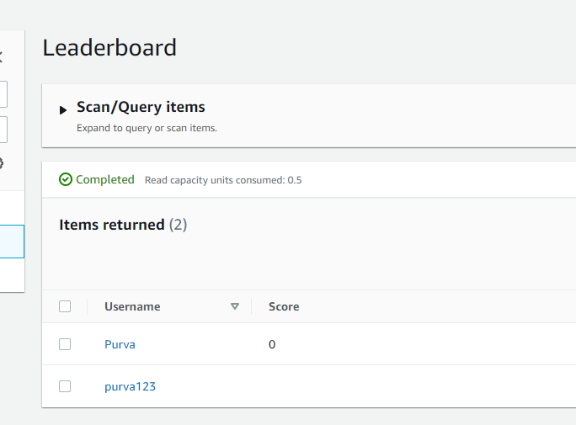

Figure 1: Username created on Leaderboard table in DynamoDB

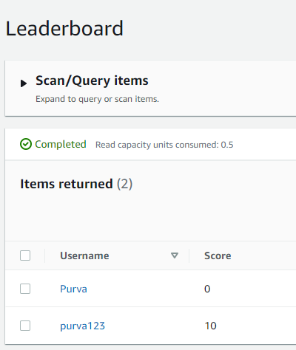

Figure 2: Updated score on Leaderboard table

Pylint score:

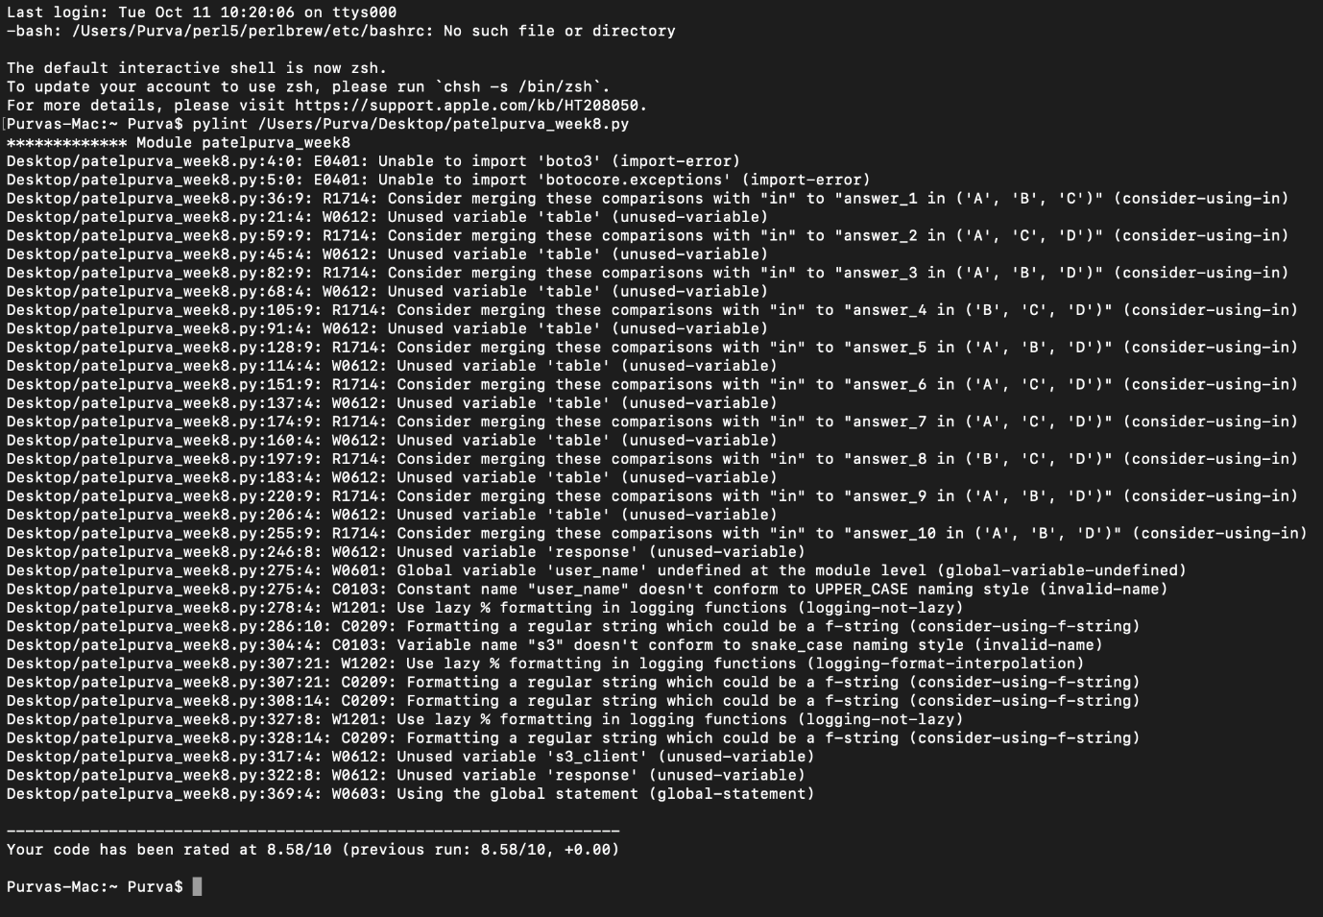

8.58/10