**PRACTICAL -2**

1. **Write a CSS that sets an element to occupy 60% of the screen width and that is centered horizontally.**

**CODE:-**

<!DOCTYPE html>

<html>

<head>

<style type="text/css">

.class

{

text-align:center;

text-align:justify;

margin:auto;

width:60%;

}

</style>

</head>

<body>

<p class="class"> Write a CSS that sets an element to occupy 60% of the screen width and that is centered horizontally. Write a CSS that sets an element to occupy 60% of the screen width and that is centered horizontally. Write a CSS that sets an element to occupy 60% of the screen width and that is centered horizontally. Write a CSS that sets an element to occupy 60% of the screen width and that is centered horizontally. Write a CSS that sets an element to occupy 60% of the screen width and that is centered horizontally. Write a CSS that sets an element to occupy 60% of the screen width and that is centered horizontally. Write a CSS that sets an element to occupy 60% of the screen width and that is centered horizontally. Write a CSS that sets an element to occupy 60% of the screen width and that is centered horizontally. Write a CSS that sets an element to occupy 60% of the screen width and that is centered horizontally. Write a CSS that sets an element to occupy 60% of the screen width and that is centered horizontally. Write a CSS that sets an element to occupy 60% of the screen width and that is centered horizontally.Write a CSS that sets an element to occupy 60% of the screen width and that is centered horizontally. Write a CSS that sets an element to occupy 60% of the screen width and that is centered horizontally. Write a CSS that sets an element to occupy 60% of the screen width and that is centered horizontally. Write a CSS that sets an element to occupy 60% of the screen width and that is centered horizontally. Write a CSS that sets an element to occupy 60% of the screen width and that is centered horizontally. </p>

</body>

</html>

**OUTPUT:-**

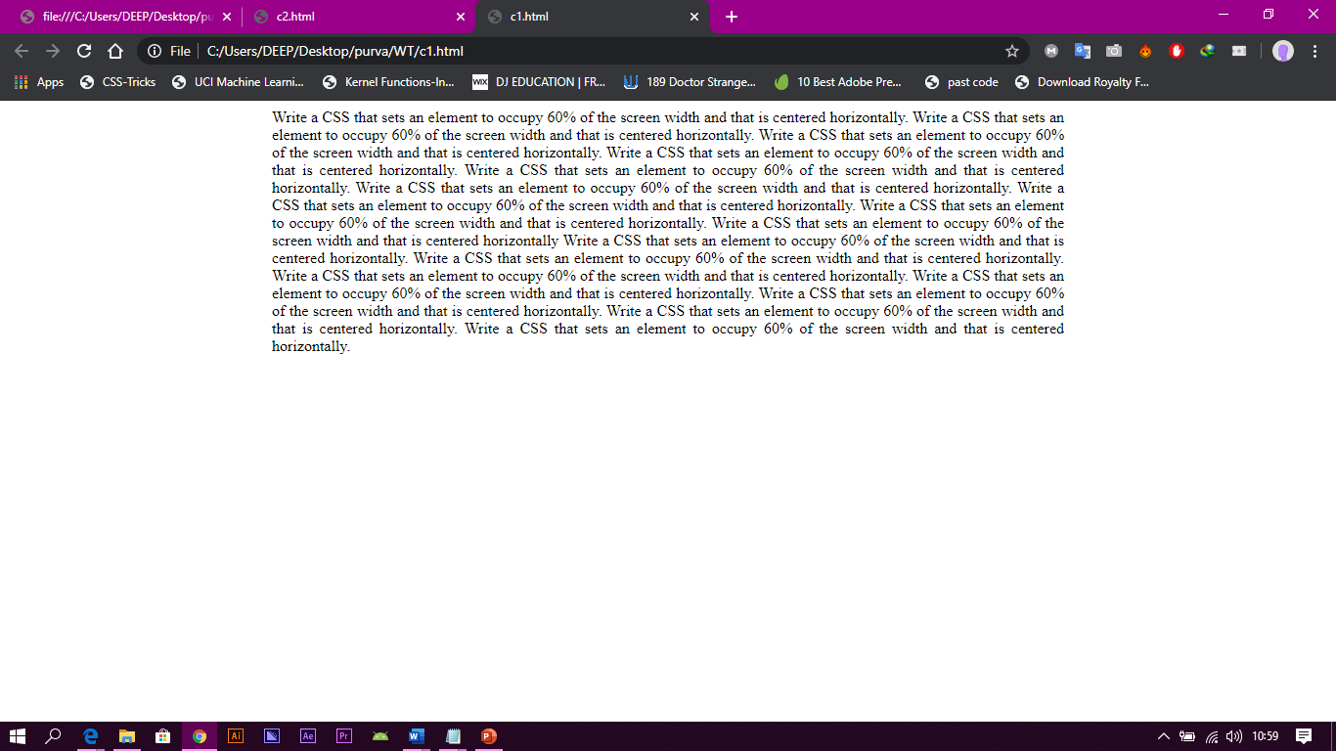

**2. Write an Internal CSS with following rules.**

**i) Paragraph with font-family times new roman, size 150%.**

**ii) Text capitalized and underline with indent of 1 cm.**

**Make its use in body part of your sample html page.**

**CODE:-**

<!DOCTYPE html>

<html>

<head>

<style type= "text/css">

p.red

{

text-align:justify;

margin:auto;

font-family:Times new roman;

font-weight:150%;

text-indent:1cm;

text-transform:capitalize;

text-decoration:underline;

}

</style>

</head>

<body>

<p class="red"> Write an Internal CSS. Write an Internal CSS. Write an Internal CSS. Write an Internal CSS. Write an Internal CSS. Write an Internal CSS. Write an Internal CSS. Write an Internal CSS. Write an Internal CSS. Write an Internal CSS. Write an Internal CSS. Write an Internal CSS.

</p>

</body>

</html>

**OUTPUT:-**



**3. Write the following styles in separate CSS file and also show how to link this CSS file in HTML file and show use of styles.**

**(i) The headings should have normal font style and font’s size should be 120%.**

**(ii) Define a class arial for paragraph which defines font family arial and font style bold.**

**(iii) Apply a background color “yellow”.**

**CODE:-**

<!DOCTYPE html>

<head>

<title>css3</title>

<link rel="stylesheet" type="text/CSS" href="c3.css">

</head>

<body>

<p>

The headings should have normal font style and font’s size should be 120%. Define a class arial for paragraph which defines font family arial and font style bold.Apply a background color “yellow” The headings should have normal font style and font’s size should be 120% . Define a class arial for paragraph which defines font family arial and font style bold. Apply a background color “yellow”. The headings should have normal font style and font’s size should be 120% (ii) Define a class arial for paragraph which defines font family arial and font style bold. (iii) Apply a background color “yellow”.

</p>

</body>

</html>

**c3.css**

p{

font-weight:120%;

font-family:Arial;

font-style:bold;

background-color:yellow;

}

**OUTPUT:-**

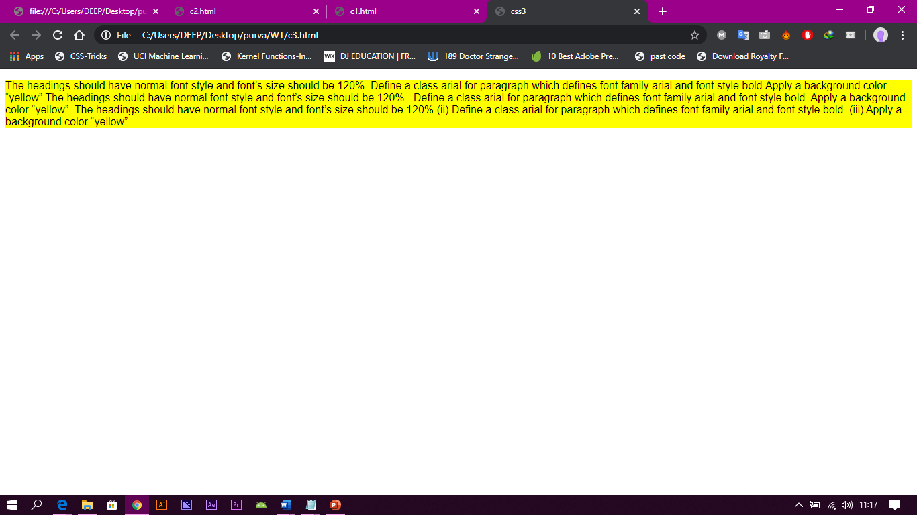

**4. Write a HTML program to draw table shown below. Also write CSS rules so that**

**1. table background is of RED color.**

**2. Cell data is center aligned.**



**CODE:-**

<!DOCTYPE html>

<html>

<head>

<head>

<body style="text/CSS" >

<p>

<TABLE border="1" cellspaning="0" celpadding="0" width="450" height="90" bgcolor="red">

<tr>

<td align="center">A</td>

<td align="center">B</td>

<td align="center">C</td>

<td align="center" rowspan="3">D</td>

</tr>

<tr>

<td align="center">E</td>

<td align="center" colspan="2">F</td>

</tr>

<tr>

<td align="center">G</td>

<td align="center">H</td>

<td align="center">I</td>

</tr>

</TABLE>

</p>

</body>

</html>

**OUTPUT:-**

