**PRACTICAL -1**

1. **Write HTML Code for given list.**

◦ Chapter-1 Web Design

▪ Web Site structure

▪ Web design planning

◦ Chapter-2 HTML

▪ HTML tag

▪ List

• ordered list

- arrange items in order.

• Unordered list

- arrange items without order

▪ Table

◦ Chapter-3 CSS

1. Inline Stylesheet

2. External Stylesheet

<!DOCTYPE html>

<html>

<head>

<title> html unordered list</title>

</head>

<body>

<ul type = "circle">

<li> Chapter-1 Web Design</li>

<ul type = "square">

<li>Web Site structure</li>

<li>Web design planning</li>

</ul>

</ul>

<ul type = "circle">

<li> Chapter-2 HTML</li>

<ul type = "square">

<li>HTML tag</li>

<li>List</li>

<ul type = "disc">

<li>ordered list </li>

<dl>- arrange items in order.</dl>

</ul>

<ul type = "disc">

<li>Unordered list </li>

</ul>

<ul>

<dl>- arrange items without order.</dl>

</ul>

</ul>

<ul type = "square">

<li>Table</li>

</ul>

</ul>

<ul type = "circle">

<li> Chapter-3 CSS</li>

<ol>

<li> Inline Stylesheet</li>

<li> External Stylesheet</li>

</ol>

</ul>

</body>

</html>

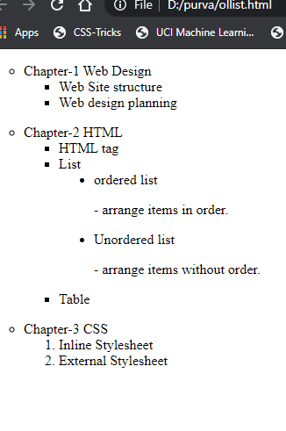**OUTPUT :-**

**2. Write a HTML program to draw table shown below.**

**1. table background is of RED color.**

**2. Cell data is center aligned.**

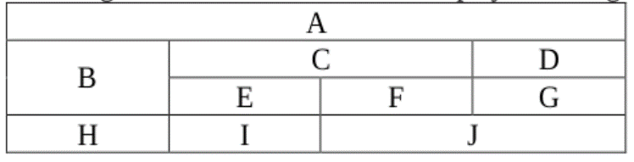

**CODE:-**

<!DOCTYPE html>

<html>

<head>

<title>html table</title>

</head>

<body>

<table border = "1" width = "40%" table align = "center" bgcolor = "red">

<tr align = "center">

<td colspan = "4" > A </td>

</tr>

<tr align = "center">

<td rowspan = "2"> B </td>

<td colspan ="2"> C</td>

<td> D </td>

</tr>

<tr align = "center">

<td>E</td>

<td>F</td>

<td>G</td>

</tr>

<tr align = "center">

<td>H</td>

<td>I</td>

<td colspan = "2">J </td>

</tr>

</table>

</body>

</html>

**OUTPUT :-**

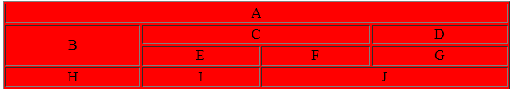

**3. Write a HTML program for given form.**



**CODE:-**

<!DOCTYPE html>

<html>

<head>

<title> My feedback form</title>

</head>

<body>

<h1> My feedback form</h1>

<form>

<ul type = "disc">

<li>Name: <input type="text" name="name" /><br></li>

<li> Email: <input type=" " Email="email" /><br></li>

<li>Password: <input type="password" name="password" /><br></li>

<li>Please check all the emotions that apply to you:</li>

<ul type = "disc">

<li>Angry <input type="checkbox" name="emotions" value="Angry"><br></li>

<li>Sad <input type="checkbox" name="emotions" value="Sad"><br></li>

<li>Happy <input type="checkbox" name="emotions" value="Happy"><br></li>

<li>Ambivalent<input type="checkbox" name="emotions" value="Ambivalent"><br> </li>

</ul>

<li> How satisfied were you with our service? </li>

<ul type = "disc">

<li>Very satisfied<input type="radio" name="feedback" value="Very satisfied"><br> </li>

<li>Satisfied<input type="radio" name="feedback" value="satisfied"><br></li>

<li>Didn't care<input type="radio" name="feedback" value="Didn't care"><br></li>

<li>Dissatisfied<input type="radio" name="feedback" value="Dissatisfied"><br></li>

<li>Very Dissatisfied<input type="radio" name="feedback" value="Very Dissatisfied"><br></li>

</ul>

<li>Further comments: <textarea rows="2" cols="25" name=" " /></textarea> <br></li>

</ul>

<ul type="disc">

<li>Bio photo:<input type="text" name=" " ><input type="file" name="pic" accept="image/*"><br></li>

</ul>

<ul type="disc">

<li>Location visited: <select>

<option selected="selected" >select location</option>

<option value="ahmedabad">Ahmedabad</option>

<option value="gandhinagar">Gandhinagar</option>

<option value="surat">Surat</option>

</select>

</ul>

<li><input type="submit" name="submit" value="Submit" /></li><br>

</form>

</body>

</html>

**OUTPUT:-**

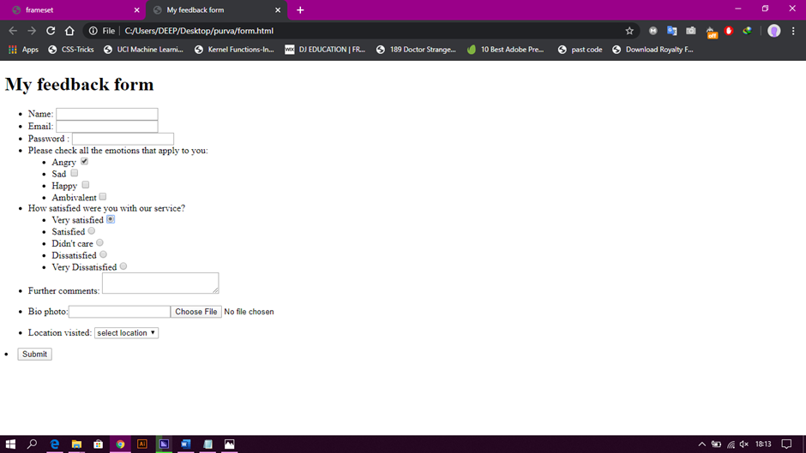

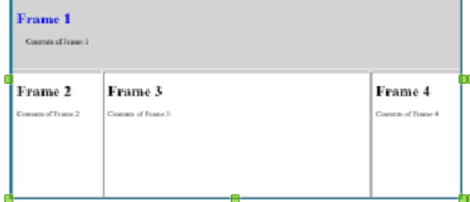**4. Write HTML code for given frames**

**CODE:-**

**Frameset :**

<!DOCTYPE html>

<html>

<head>

<title> frameset</title>

</head>

<frameset rows="25%,75%">

<frame src="frame_1.htm">

<h2> Frame 1</h2>

<frameset cols="25%,50%,25%">

<frame src="frame_2.htm">

<body>

<div>

<h2>contents of frame 2</h2>

</div>

</body>

<frame src="frame_3.htm">

<body>

<div>

<h2>contents of frame 3</h2>

</div>

</body>

<frame src="frame_4.htm">

<body>

<div>

<h2>contents of frame 4</h2>

</div>

</body>

</frameset>

</frameset>

</html>

**Frame_1:**

<html>

<title>Frame 1 </title>

<body style = "background-color :#cdc1c5;">

<h2 style="color:#0000ff">Frame 1</h2>

<h3>contents of frame 1</h3>

</div>

</body>

</html>

**Frame_2:**

<html>

<title>Frame 2 </title>

<body>

<style>

div{ }

</style>

<h2>Frame 2</h2>

<h3>contents of frame 2</h3>

</div>

</body>

</html>

**Frame_3:**

<html>

<title>Frame 3 </title>

<body>

<style>

div{ }

</style>

<h2>Frame 3</h2>

<h3>contents of frame 3</h3>

</div>

</body>

</html>

**Frame_4:**

<html>

<title>Frame 4 </title>

<body>

<h2>Frame 4</h2><b>

<h3>contents of frame 4</h3>

</div>

</body>

</html>

**OUTPUT:-**

