**PRACTICAL -3**

**1. Write a JavaScript program to find the area of circle, rectangle and triangle.**

**CODE:-**

Write a JavaScript program to find the area of circle, rectangle and triangle.

<html>

<head>

<script language="javascript">

function calculatetriangle()

{

var base=parseInt(prompt("Type the width of triangle:"));

var height=parseInt(prompt("Type the height of triangle:"));

document.write("<p>The area of triangle: "+(base*height*0.5)+"</p>");

}

function calculatecircle()

{

var radious=parseInt(prompt("Type the radious of circle:"));

document.write("<p>The area of circle: "+(3.14*radious*radious)+"</p>");

}

function calculaterectangle()

{

var length=parseInt(prompt("Type the length of rectangle:"));

var width=parseInt(prompt("Type the width of rectangle:"));

document.write("<p>The area of rectangle: "+(length*width)+"</p>");

}

</script>

<body>

<form name=form1>

Enter the width and height of triangle:

<input type="button" value="calculate" onClick='calculatetriangle();'><br/>

Enter the radious of circle:

<input type="button" value="calculate" onClick='calculatecircle();'></br>

Enter the length and width of rectangle:

<input type="button" value="calculate" onClick='calculaterectangle();'>

</form>

</body>

</html>

**OUTPUT:-**

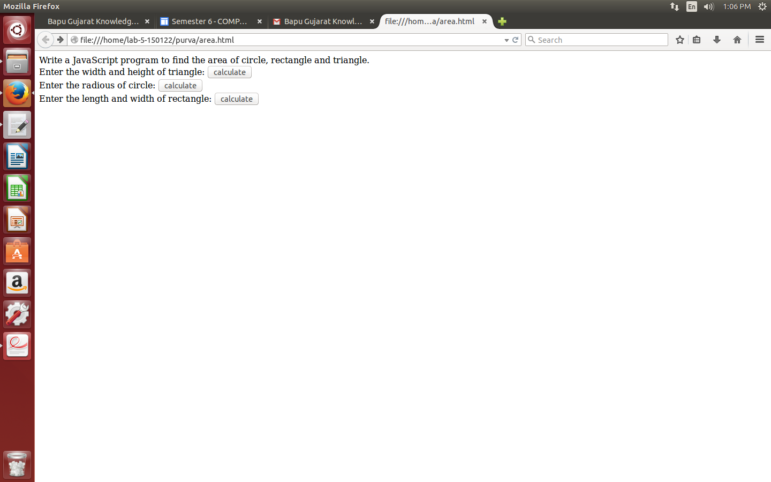

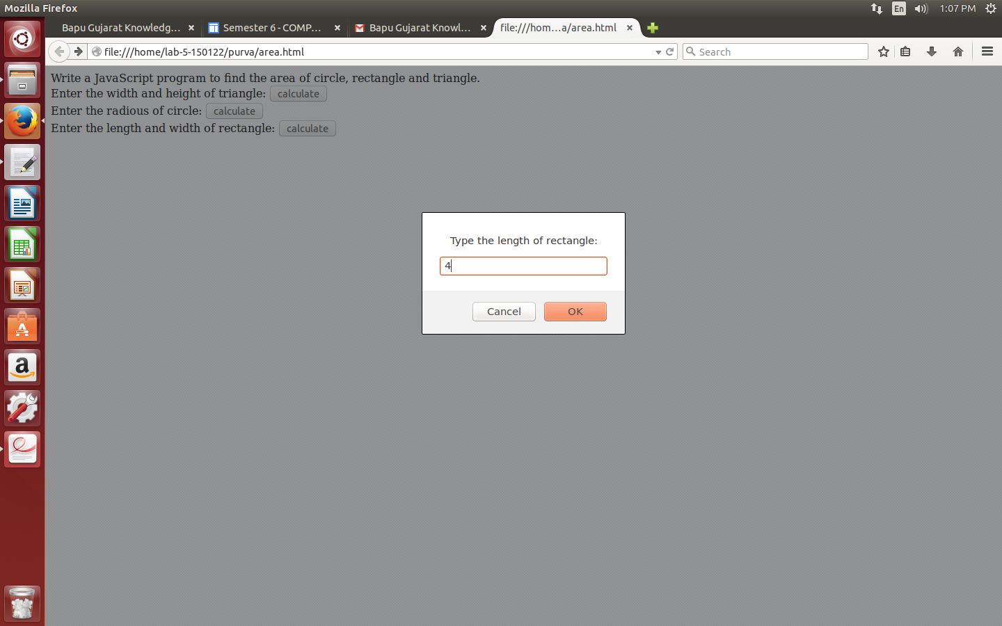

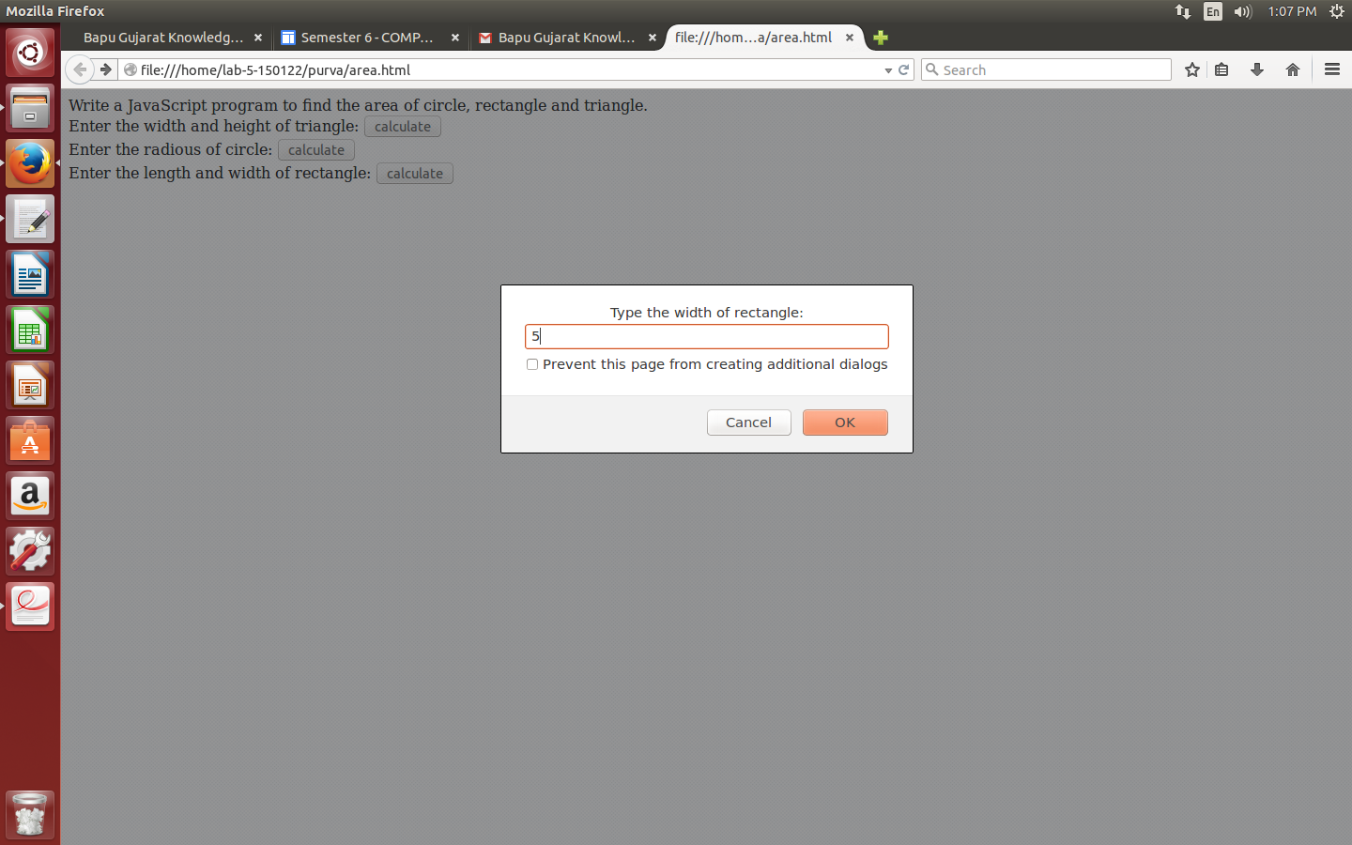

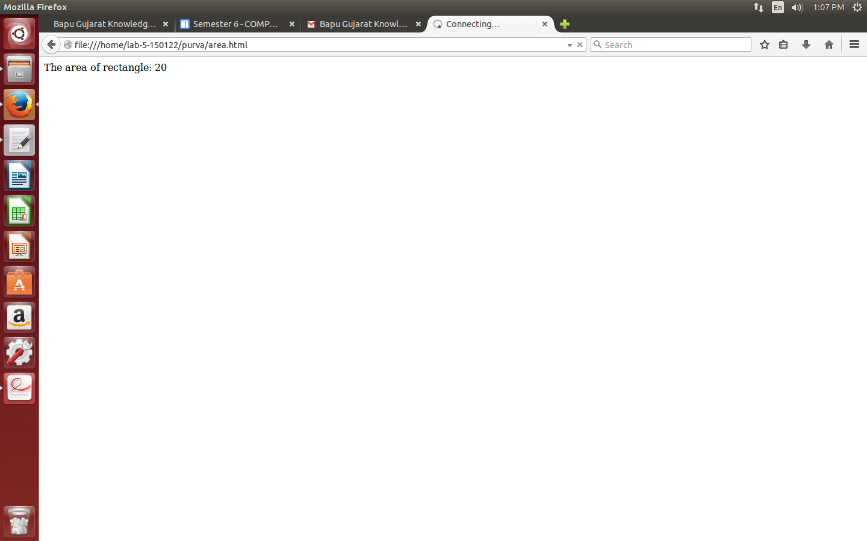

**2. Write a JavaScript program to perform form validation.**

**CODE:-**

<html>

<head>

<title>validation</title>

<script language="javascript">

function check(){

if(frmlogin.login.value==""){

alert('please provide login name');

return false;

}

if(frmlogin.password.value==""){

alert('please provide password');

return false;

}

}

</script>

</head>

<body>

<form name="frmlogin" action="" method="post" onsubmit="return check()">

Login: <input type="text" name="login"><br>

Password: <input type="password" name="password"><br>

<input type="submit" name="submit" value="Submit">

<input type="reset" name="reset" value="Reset">

</form>

</body>

</html>

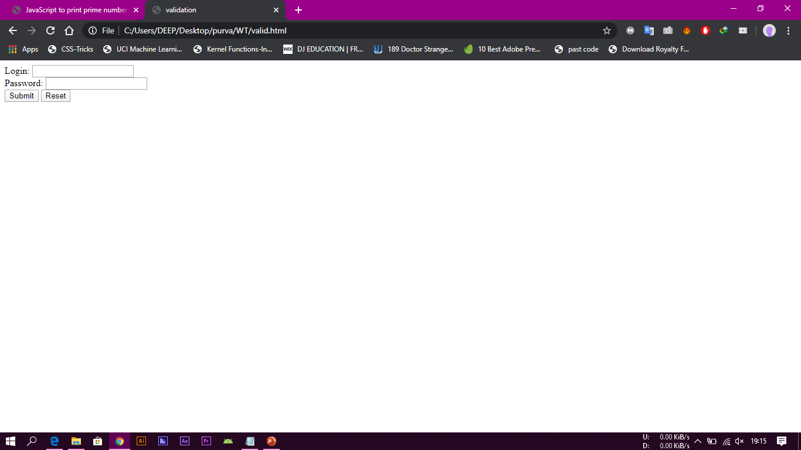**OUTPUT:-**

**3. Write a JavaScript to display person detail using object.**

**CODE:-**

<!DOCTYPE html>

<html>

<body>

<p>Creating a JavaScript Object.</p>

<p id="demo"></p>

<script>

var person = {firstName:"Joy", lastName:"Patel", age:10, eyeColor:"blue"};

document.getElementById("demo").innerHTML =

person.firstName + " is " + person.age + " years old.";

</script>

</body>

</html>

**OUTPUT:-**

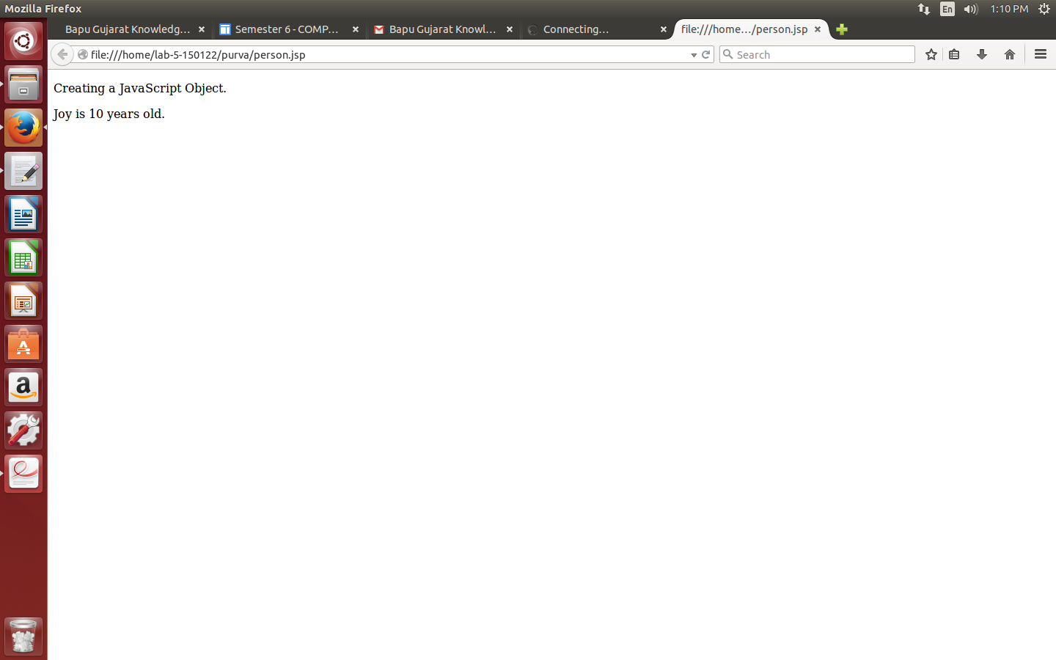

**4. Write a JavaScript to find first 10 prime numbers.**

**CODE:-**

<html>

<head>

<title>JavaScript to print prime numbers!</title>

<script>

function printPrime() {

var i = 0;

var j = 0;

for (i = 1; i <= 25; i++) {

c = 0;

for (j = 1; j <= i; j++) {

if (i % j == 0) {

c++;

}

}

if (c == 2) {

document.getElementById("result").insertAdjacentHTML('beforeend', i + '<br>');

}

}

}

</script>

</head>

<body>

<h2>JavaScript to print Prime numbers!</h2>

first 10 prime numbers::<input type="submit" value="Print Prime Numbers" onclick="printPrime()" name="print" />

<div id="result"></div>

</body>

</html>

**OUTPUT:-**

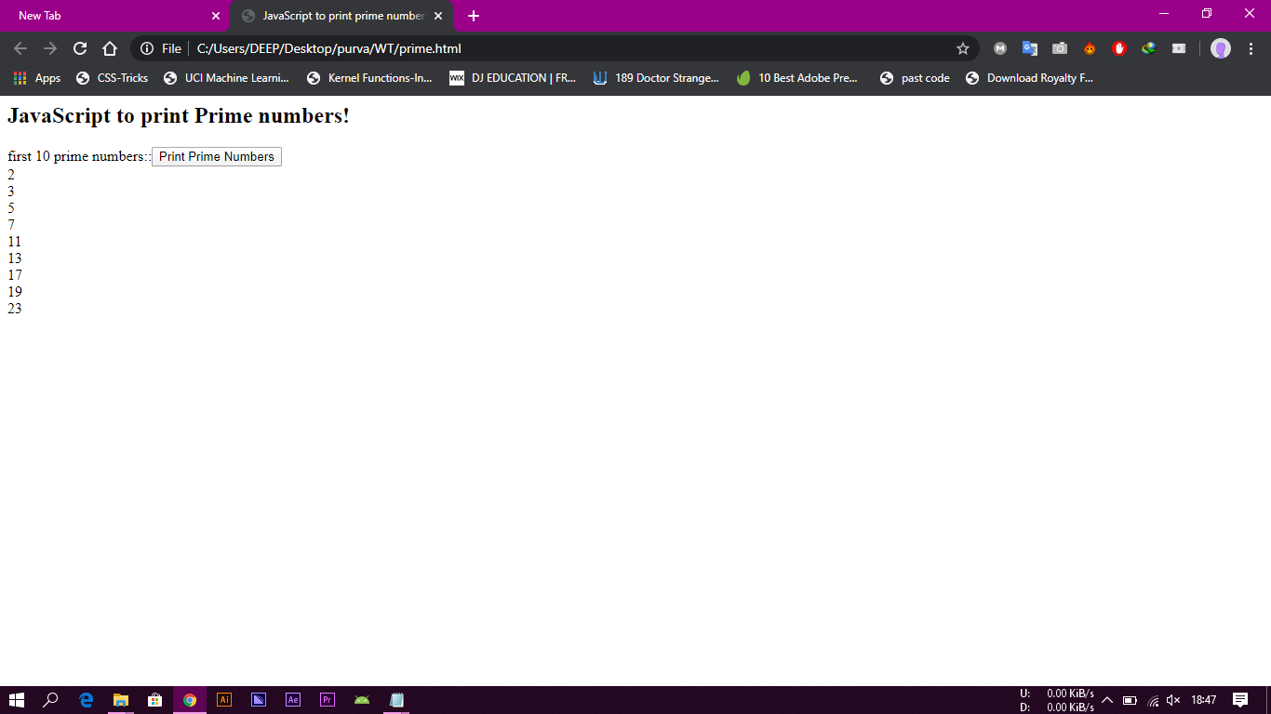

**5. Write a JavaScript to check input string is palindrome or not.**

**CODE:-**

<!DOCTYPE html>

<html>

<head>

<title>Palindrome </title>

<script type="text/javascript">

function checkPalindrome() {

var revStr = "";

var str = document.getElementById("str").value;

var i = str.length;

for(var j=i; j>=0; j--) {

revStr = revStr+str.charAt(j);

}

if(str == revStr) {

alert(str+" -is Palindrome");

} else {

alert(str+" -is not a Palindrome");

}

}

</script>

</head>

<body>

<form>

Enter a String/Number: <input type="text" id="str" name="string" /><br />

<input type="submit" value="Check" onclick="checkPalindrome();"/>

</form>

</body>

</html>

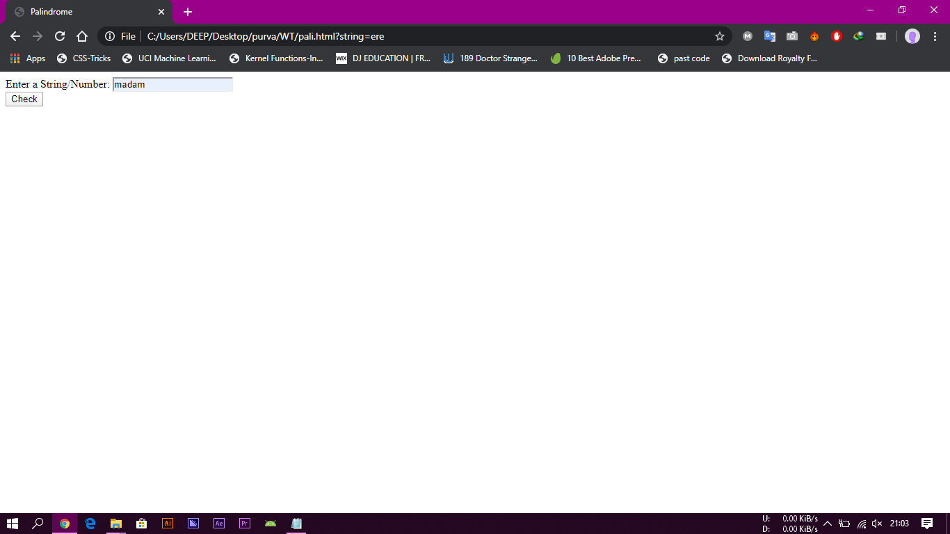**OUTPUT:-**

