**2. Write a HTML program to draw table shown below.**

**1. table background is of RED color.**

**2. Cell data is center aligned.**

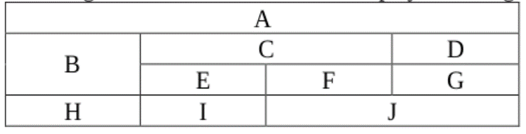

<!DOCTYPE html>

<html>

<head>

<title>html table</title>

</head>

<body>

<table border = "1" width = "40%" table align = "center" bgcolor = "red">

<tr align = "center">

<td colspan = "4" > A </td>

</tr>

<tr align = "center">

<td rowspan = "2"> B </td>

<td colspan ="2"> C</td>

<td> D </td>

</tr>

<tr align = "center">

<td>E</td>

<td>F</td>

<td>G</td>

</tr>

<tr align = "center">

<td>H</td>

<td>I</td>

<td colspan = "2">J </td>

</tr>

</table>

</body>

</html>

**Output :-**

