**Biztechnosys Infotech Pvt Ltd.**

**Address**: #3773 Howard Hughes,

PKWY-Suite 500S, LAS Vegas,

NV 89169-6014

**June 17, 2021**

**Mike Straeter,**

**Solar Cam,**

1268 E 100 S

Rochester, Indiana

United States

**Contact:**(574) 224-8324

Dear Mike,

Greetings!!!

We thank you for taking time to see the CRM demo. We enjoy the company of passionate entrepreneurs and would be enthused to partner with you.

In our proposal, we try to ensure that each of your needs is met with a solution. From our discussions, these are the points seem to have emerged and are the most important to solve your requirement:

**Objectives:**

The Solar CAM Solar System is a patented, ground-mount system designed by Jim Straeter with Ag Technologies, Inc

**The Following are the main Objectives:**

1. Implementing a CRM system for Solar Cam
2. CRM would simplify the workload and reduce the manual work that Solar Cam has been following.
3. Implementing a CRM which can cover Inventory Management, Parts Management, Vendor Management, Leads Management, Projects Management, Quotes Management and Support Management
4. To keep the proper records of Clients. The information once saved in CRM will help Solar Cam to have quick follow-up whenever required.

**Business Workflow**

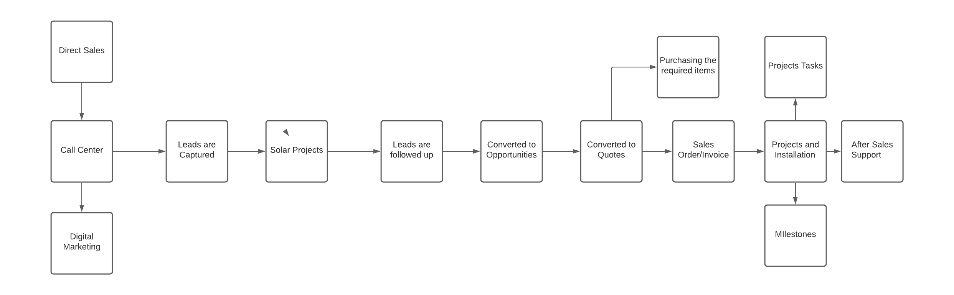

**User Workflow:**

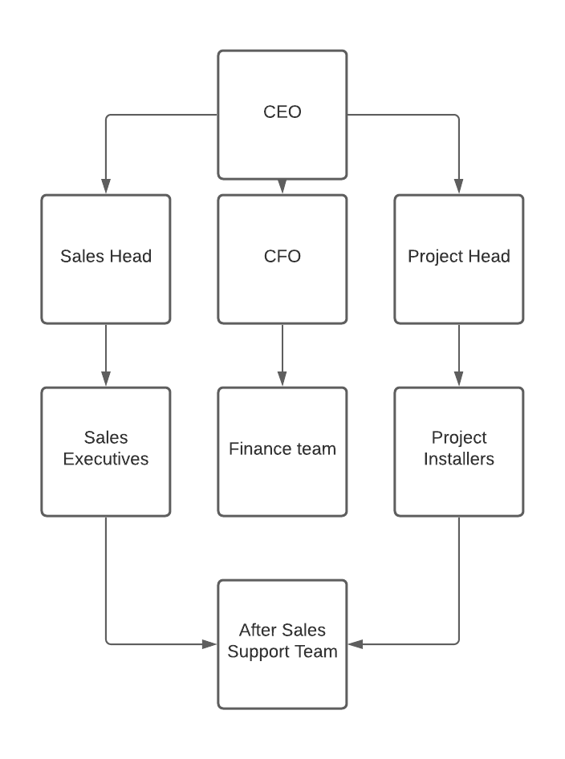

**PROJECT SCOPE OF WORK & DELIVERABLES**

|  |  |  |
| --- | --- | --- |
| **BRD ID #** | **Component/Heading** | **Rules/Exceptions** |
| BTS 21.1.1 | User-Management | * Login * Retrieve password * Users’ Dashboard * User Profile management * Create Users * Manage Users * User Access Management * User Role Management |
| BTS 21.1.2 | Lead Management**:** | * Create, Update, Delete Leads - Manually and import using excel sheet * Lead Capturing website and social media Integrations (Customization) * Users’ Dashboard * Mange Leads * Change leads status * Lead Report |
| BTS 21.1.3 | Contacts Management | * All the Customers who are enrolled for the GYM programmes can be maintained * Description of the contacts * Contact Summary |
| BTS 21.1.4 | Products/Parts and Inventory Management | * All the Parts can be managed * All the inventories can be managed * Vendors can be managed * Dealers can be managed * All the services can be managed |
| BTS 21.1.5 | Calendar Module | * Calendar for task and meeting invite * Add task and events in calendar |
| BTS 21.1.6 | Tasks Management | * Creation of Tasks * Reminders on the tasks scheduled |
| BTS 21.1.7 | Quotation Management | * Creation of Quotes * Downloading quoted in the PDF Format * Sending the Quotes as an email to the Clients |
| BTS 21.1.8 | Project management | * Creation of Projects * Managing Project tasks * Project Summary View * Milestones management * Project related Reports |
| BTS 21.1.9 | Invoice/Billing Management: | * Users can generate and invoice. * Create invoice * Invoice status update according to payment. * Create report |
| BTS 21.1.10 | Payment Management: | * Manage payment using various payment option. * Create report |
| BTS 21.1.11 | Support and Service Management | * After Sales Support can be managed in this module * Support related issues are saved as Tickets * Service contracts can be created |
| BTS 21.1.12 | SMS and Email Alerts | * Sending automatic SMSs/emails to the Leads, Contacts and Opportunities * Email tool Integration with the CRM |
| BTS 21.1.13 | Reports | * Customized reports can be designed for the above-mentioned modules. |

**Project Schedule:**

|  |  |  |
| --- | --- | --- |
| **Sl. No** | **Activity Name** | **Time Frame** |
| 1 | **CRM Setup, Configuration, and Data Migration** | **1 Week** |
| 2 | **Training** | **1 Week** |
|  | **Total** | **2 weeks** |

**Payment Terms:**

|  |  |  |  |  |
| --- | --- | --- | --- | --- |
| **Sl Nos.** | **Deliverables** | **Per User**  **Monthly USD** | **Total User’s** | **Amount (USD)** |
| 1 | **All the above-mentioned modules** | **50 $** | **6** | **300$** |
| 2 | **One time Set Up Cost:**   1. **Migrating the data** 2. **Setting Up and Configuring** 3. **Training** |  |  | **500$** |

**Note: Advance payment of the Next QTR payment to be released 1 Week of the Quarter start.** Additional Training is chargeable

**Payment Terms:**

1. Billing is done quarterly in advance, So the billing for **6** users is **900$ /quarter+250$ (Implementation Cost) = 1150$ in advance** which has to be paid **before the start of the quarter**, the remaining **250$** should be paid immediately **after** **installation**.

2. Payments should be made in the favour of "Biztechnosys Infotech Pvt ltd.".

**ADDITIONAL BILLABLE**

Any Unplanned components, ideas, revisions, and project scope happen - when there is an unexpected event that will incur a cost, we will notify you ahead of time and will not produce unless we receive clear approval for increased budget and timeline.

**OUR TEAM & ABOUT US**

Biztechnosys Infotech is a global digital solution provider specializing in **VTiger CRM**,Odoo ERP, Sitecore, etc. Biztechnosys is a business Leader in the field of IT Services and Enterprise Business Structures around the globe. Being IT specialists, we have built, upgraded, migrated, and maintained well over 100+ projects for industries like **Solar,** Project and Services, E Commerce, Finance, Marketing, Automotive, Real Estate etc. with 99.2% success rate.

**METHODOLOGY**

**How it Works**

Let’s start off by looking at the steps we'll be taking to get your project from start to finish.

1. **Discovery** - Through a process of surveys and meetings we'll gather all the information we need to have the best understanding of your business and goals.
2. **Architecture** - VTiger CRM needs a solid blueprint. Together we'll determine the best way to organize the CRM and sketch out a rough outline.
3. **Content** - with a solid blueprint in place it will be your job to collect, organize, edit, and deliver to

us content for each page.

1. **Design** - at the same time you are working on content our team will be creating non-functioning

comprehensive layouts showing possible design directions.

1. **Development** - with all the necessary architecture, content, and design elements in hand we'll

create the first working version of your website.

1. **Test & Trial** - Trial and error is a method of solving the problem, recorrecting, fine - tuning, or obtaining knowledge to give ourselves an opportunity to analyse that failure, make those changes, and then try again to provide the appropriate solution.
2. **Launch** - To get your CRM "going live" ready will inevitably require several rounds of revisions and polish. Once it is ready, we'll go through the final launch checklist.
3. **Warranty** - Once your CRM is now live! Over the next several weeks our team will be training you on how to manage and use the solution and also help you to solve any issues coming across during the usage. Thereafter as per the Support Package our team will help you over remotely through the emails, calls or any other feasible mode of communication.

**Communicating Effectively**

During your project communication will be non-stop with emails, phone calls, and online meetings. Here is how we make it happen?

* Email - [support@biztechnosys.com] is the only email you need to remember. Everyone here regularly checks this account and the person best suited to reply will always do so quickly.
* Phone - +91 7760097778 is the direct line of your project manager, [Kalpesh Vaza].

Your calls are always welcome between 10am and 7pm IST, Monday through Friday.

* Meetings - we use Google Meet, Skype or any other feasible tool for online meetings to review milestones and deliverables. Make sure you have the software installed before our first meeting.

**TECHNOLOGY & HOSTING PLATFORM**

With Odoo solution you can spend much less, and get much more features to streamline your business process. We offer an integrated system that runs all of your Online Business in one place while growing your database automatically.

|  |  |
| --- | --- |
| **Edition** | Community  Edition |
| **Management Tools** | VTiger |
| **Version** | Ver.7.3 |
| **Language** | Php |
| **Data base** | Mysql |
| **Cloud** | AWS |

**HELPDESK & EDUCATION**

We want you to get the most out of the Odoo solution. For this to happen, you must be asking questions and continually learning. We offer an assortment of different training, education, support, & helpdesk products and agreements.

**[OPTIONAL] PHONE HELPDESK**

|  |  |
| --- | --- |
| TERMS | We will provide one (1) user with unlimited helpdesk support. Helpdesk allows for direct email and phone support for our Platform. Helpdesk does not include design or development labour.  Helpdesk services are offered Monday through Friday from 10am and 7pm Indian Standard Time. |

**PROJECT AGREEMENT**

|  |  |
| --- | --- |
| We,  **Biztechnosys Infotech Pvt Ltd**  **Address:** :  #3773 Howard Hughes,  PKWY-Suite 500S,  LAS Vegas, NV 89169-6014  **Name**: **Kalpesh Vaza**  **Email: kalpesh@biztechnosys.com** | You,  **Solar Cam,**  1268 E 100 S  Rochester, Indiana  United States  **Contact:**(574) 224-8324 |

**INVOICES**

Payment is due upon receipt of invoice. You may not withhold any amounts due and we reserve the right to cease work without prejudice if amounts are not paid when due.

**ENTIRE AGREEMENT**

This document together with any attachments, as well as any new, different or additional terms, conditions or policies which we may establish from time to time, and any agreement that we are currently bound by or will be bound by in the future, constitutes the complete and exclusive agreement between you and us concerning your engagement of us on this project, and supersede and govern all prior written and verbal communications.

**SIGNATURE**

By signing this document, you represent to us that you are a duly authorized representative of your organization and upon its behalf agree to be legally bound by its terms and conditions. You hereby accept and authorize the commencement and payment for the project described above.

BY: _________________________ TITLE: ________________________

NAME: _________________________ DATE: ________________________