SQL Developer Task 2 Report

# Introduction

This document summarizes the execution and results of the SQL Developer Task 2. The task involved working with a student management system database to perform various queries using SQL on Students, Courses, and Enrollments tables.

# Task 1: List all students and the courses they are enrolled in

SQL Query:

SELECT s.Name AS StudentName, c.CourseName  
FROM Students s  
INNER JOIN Enrollments e ON s.StudentID = e.StudentID  
INNER JOIN Courses c ON e.CourseID = c.CourseID;

This query uses INNER JOIN to list student names along with the courses they are enrolled in.

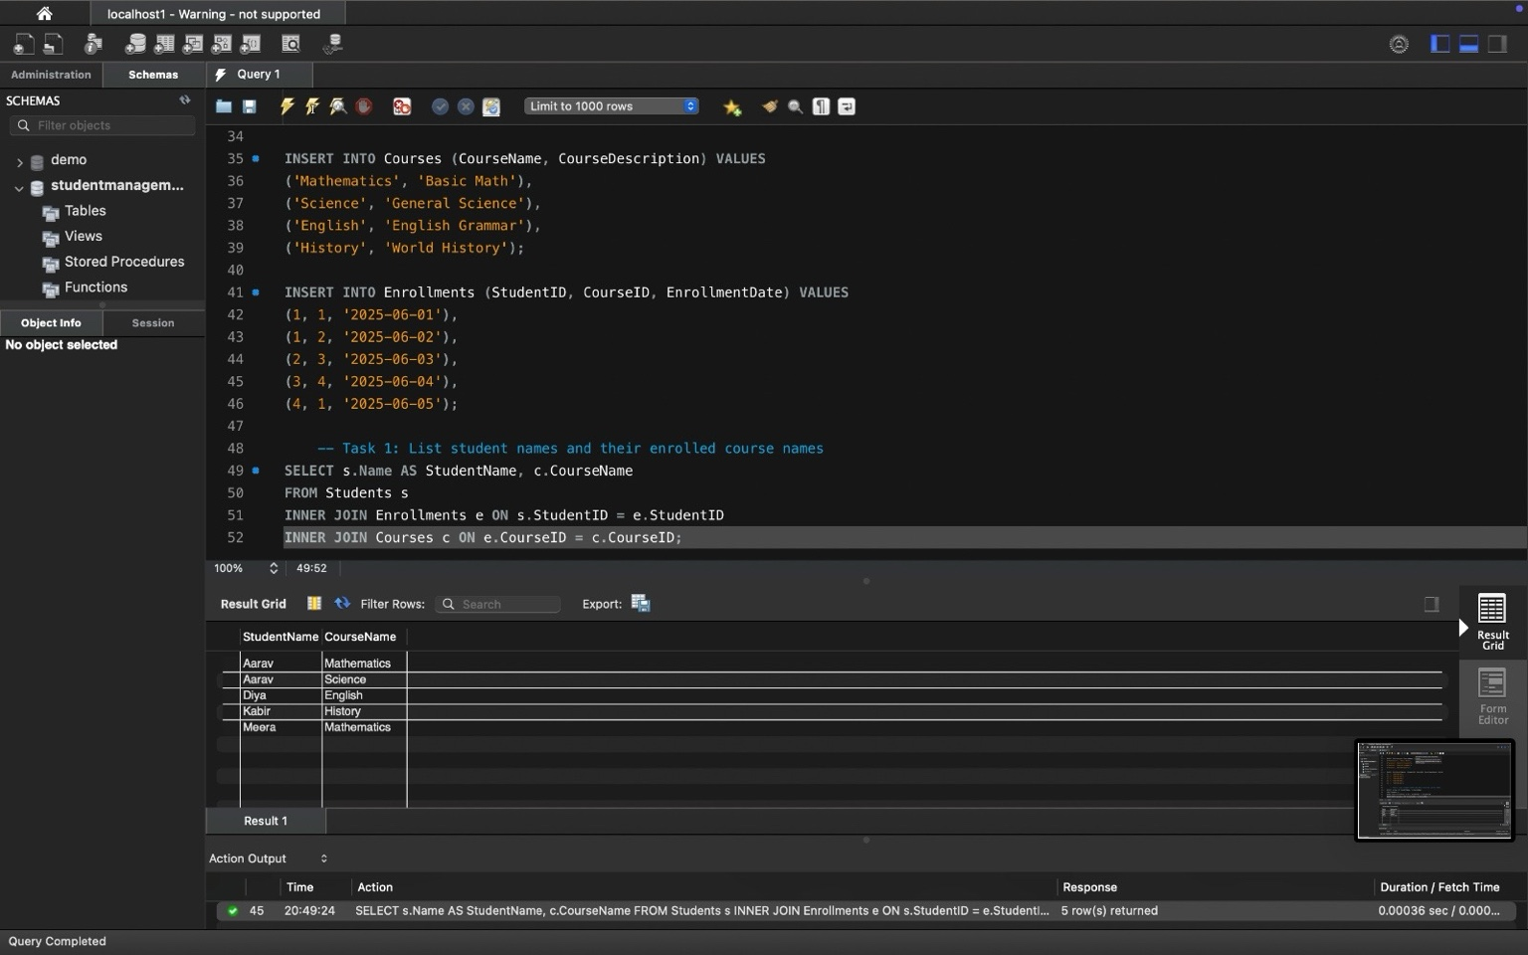

# Task 2: Find the number of students enrolled in each course

SQL Query:

SELECT c.CourseID, c.CourseName, COUNT(e.StudentID) AS StudentCount  
FROM Courses c  
LEFT JOIN Enrollments e ON c.CourseID = e.CourseID  
GROUP BY c.CourseID, c.CourseName;

This query uses LEFT JOIN and COUNT to find how many students are enrolled in each course, including courses with 0 students.

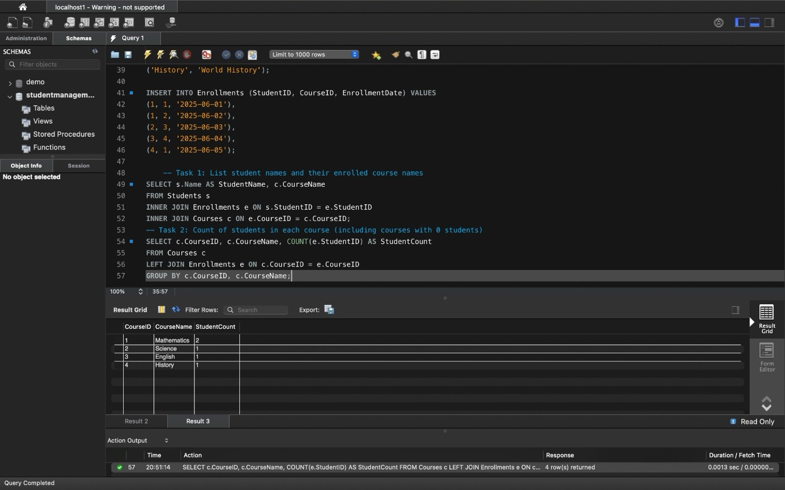

# Task 3: List students who have enrolled in more than one course

SQL Query:

SELECT StudentID, COUNT(CourseID) AS CourseCount  
FROM Enrollments  
GROUP BY StudentID  
HAVING COUNT(CourseID) > 1;

This query counts how many courses each student is enrolled in and filters those with more than one.

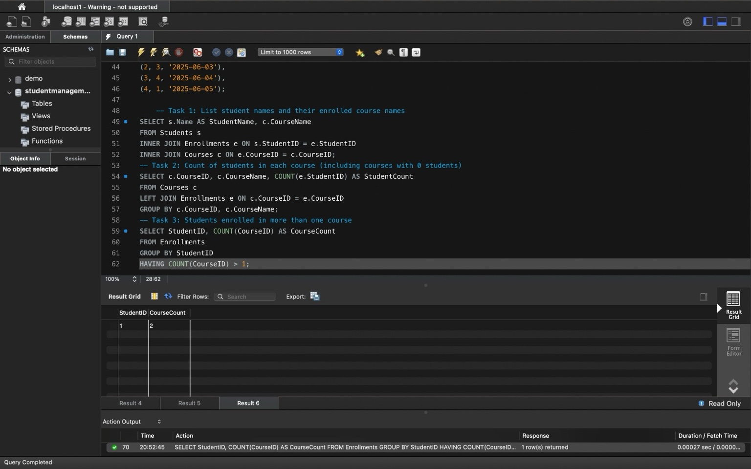

# Task 4: Find courses with no enrolled students

SQL Query:

SELECT c.CourseID, c.CourseName  
FROM Courses c  
LEFT JOIN Enrollments e ON c.CourseID = e.CourseID  
WHERE e.EnrollmentID IS NULL;

This query finds all courses that do not have any associated records in the Enrollments table.

