
Hackthon Identity 2026
Project – Ajmer Goes live
Topic – Shree Ram Coaching center

Submitted by :- Payal Jain
BCA Batch – A
Semester – 1st

PROCESS SHEET
1. Client Details
- Business Name - Shree Ram Coaching Classes
- Business Type - Coaching centre
- Director’s Name – Mr. Ashish Parashar & Mr. Susheel Parashar
- Website Purpose: To provide information about the coaching centre, its courses, faculty, and contact details.
- Target Audience: Students preparing for exams and seeking coaching classes.
- Client Requirements:
  - Information about the coaching centre.
  - Courses and subjects offered.
  - Faculty details.
  - Contact information.
  - Admission or enquiry details.

2. 5 questions you asked and their answers
Question 1: What is the main reason you want this website?
Answer-We want an online identity for Shree Ram Coaching Classes. It will make it easy for students to check about our institute.
Question 2: What pages and information do you want on the website?
Answer-The website should clearly show an introduction about our coaching centre, a list of subjects we teach and a way for students to ask about admissions.
Question 3: How do you want students to contact you through the website?
Answer-We need our phone number and address listed clearly, along with a simple enquiry section where students can check for admission details or message us.
Question 4: Do you have a logo or any specific colour preference for the design?
Answer-We will share our official logo with you. For colours, we prefer something professional and educational, like blue and white, which looks clean.
Question 5: Do you want to show the fee structure of the courses on the website?
Answer- No, we don't want to put exact fees online because they change based on subjects.

3. Sitemap

Registration form
Contact Details
Primary
Middle
Secondary
Senior Secondary

About Coaching Centre
Class 10th Board Results
Class 12th Board Results
(Science ,Commerce ,Arts)
REGISTRATION PAGE
RESULT SECTION
CLASSES SECTION
HOME PAGE
Sitemap Of My Coaching Centre Website
4. Hand-drawn Wireframe
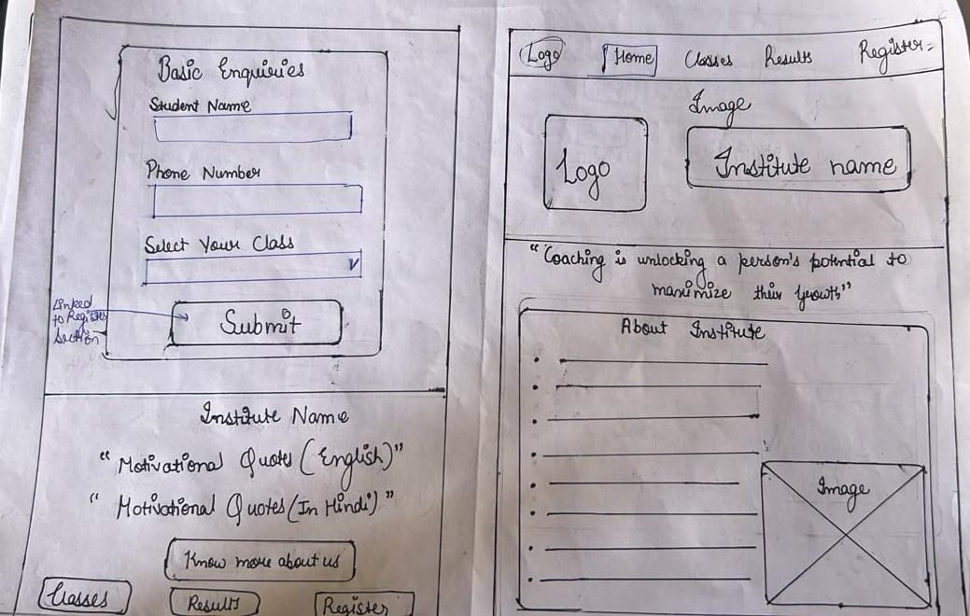

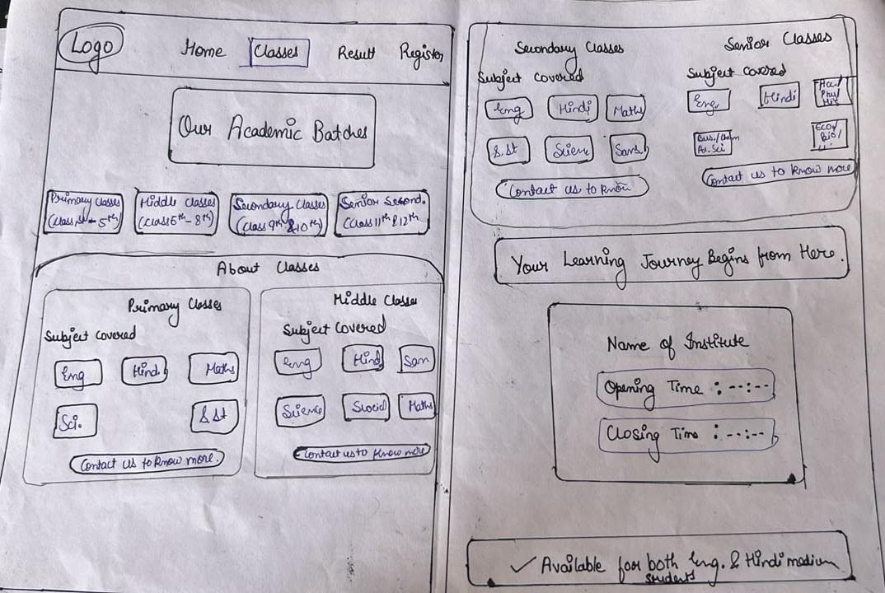
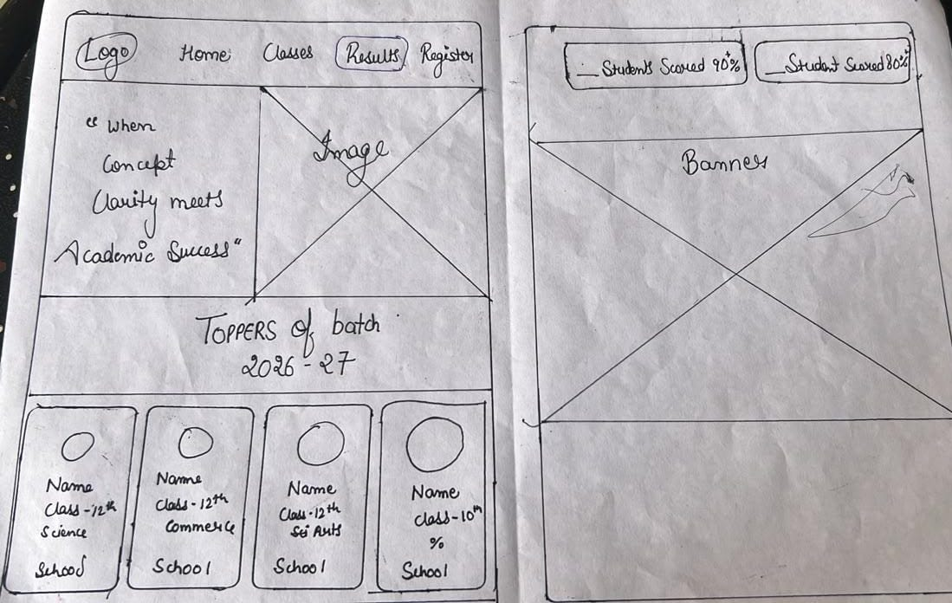

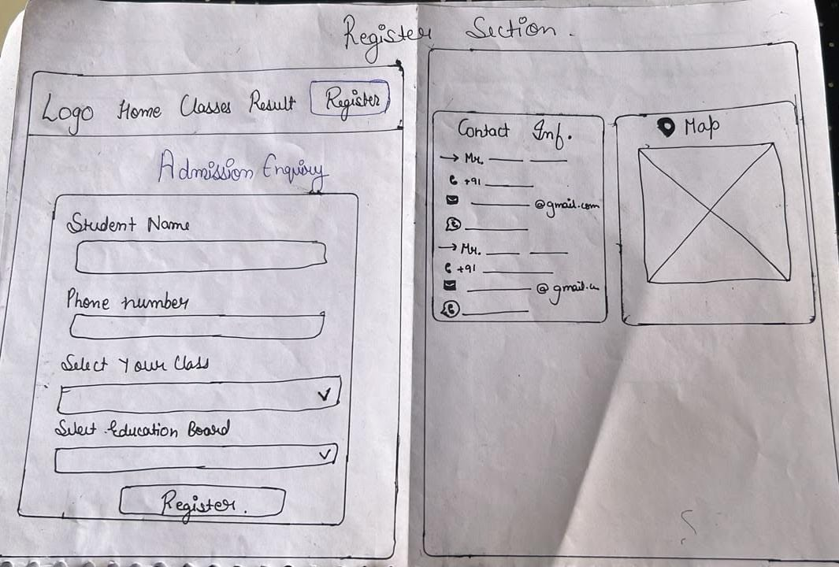

5. Reason for choosing colour and font style
1. Reason for Choosing the Color Combo (Blue and White)
- Professional & Trustworthy (Blue): Blue colour represents trust, intelligence, and wisdom. Since this is an educational website for a coaching center, blue creates a feeling of security and reliability for both parents and students.
- Clean & Readable (White): White provides a clean background with excellent contrast. It reduces eye strain, makes the text highly readable, and gives the website a modern, clutter-free look.
- Academic Appeal: The combination of Royal Blue and White is globally recognized as the standard academic colour palette, making the platform look highly official.
2. Reason for Choosing Font Style (Arial, Helvetica, sans-serif)
- High Readability for All Age Groups
- Professional and Formal Appearance
- Excellent Text Alignment & Spacing

6. Validator And Lighthouse Screenshots
- HOME PAGE
Validator :-
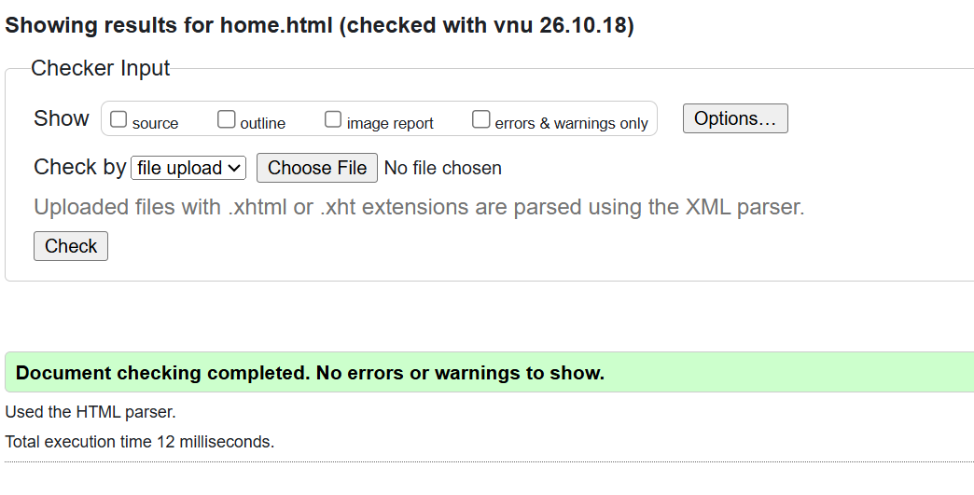

Lighthouse :-
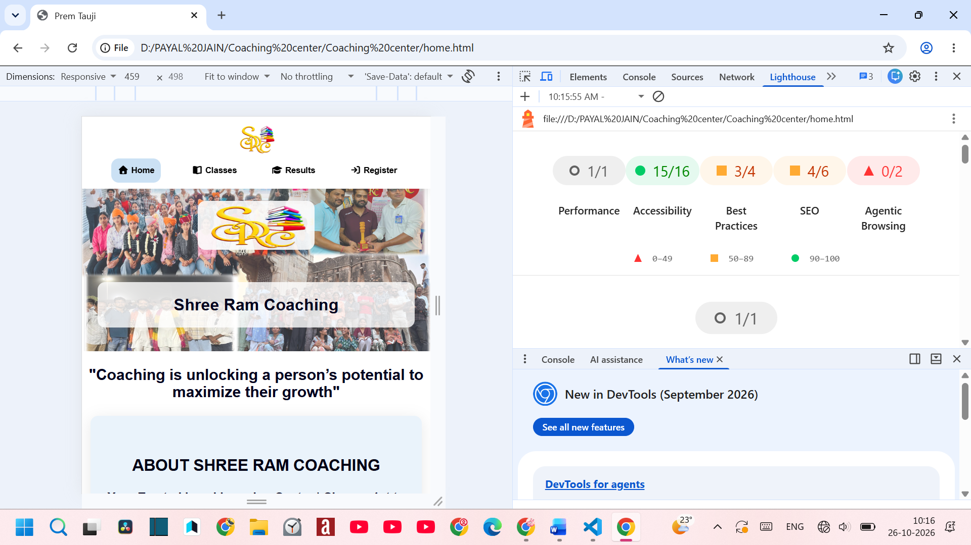

- CLASESS SECTION
Validator :-
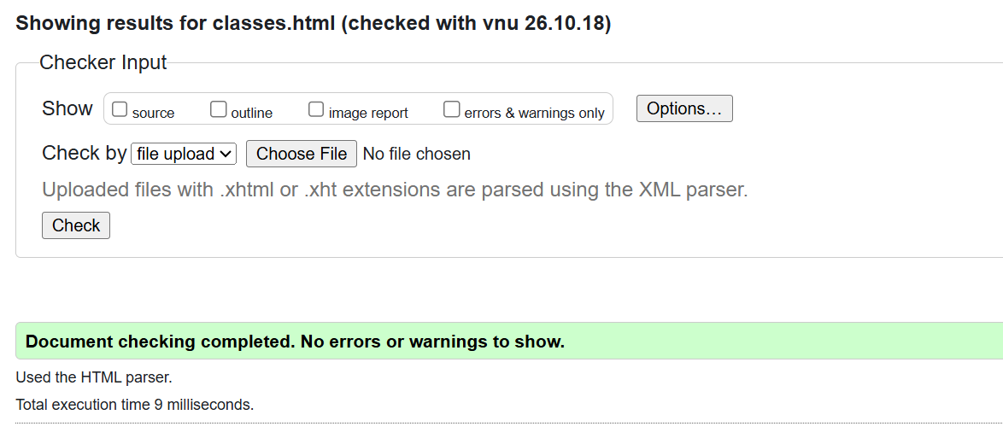

Lighthouse :-
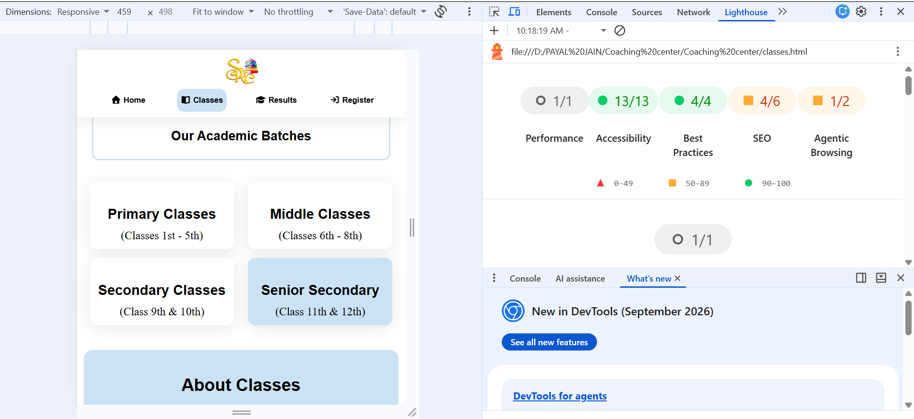

- RESULT SECTION
Validator :-
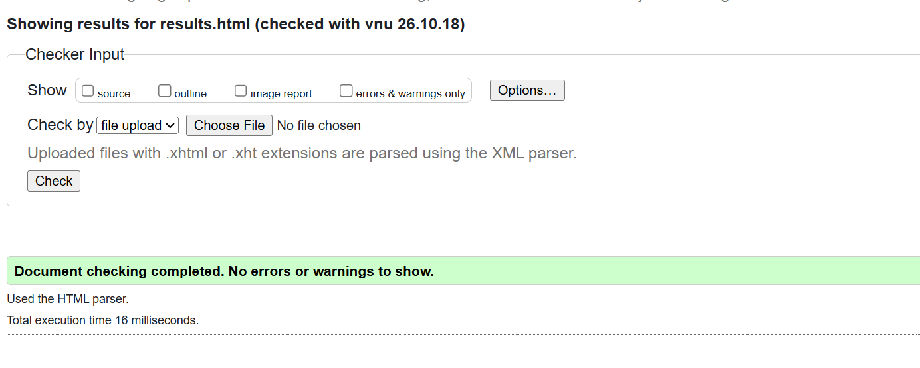

Lighthouse :-
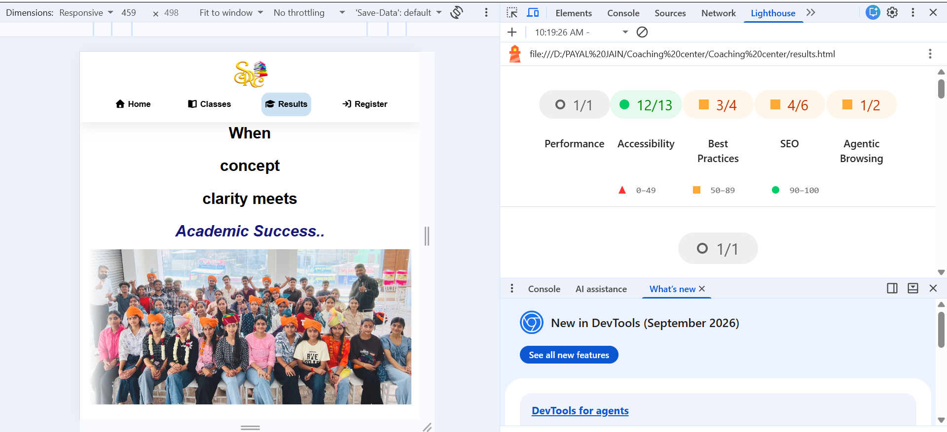

- REGISTRATION SECTION
Validator :-
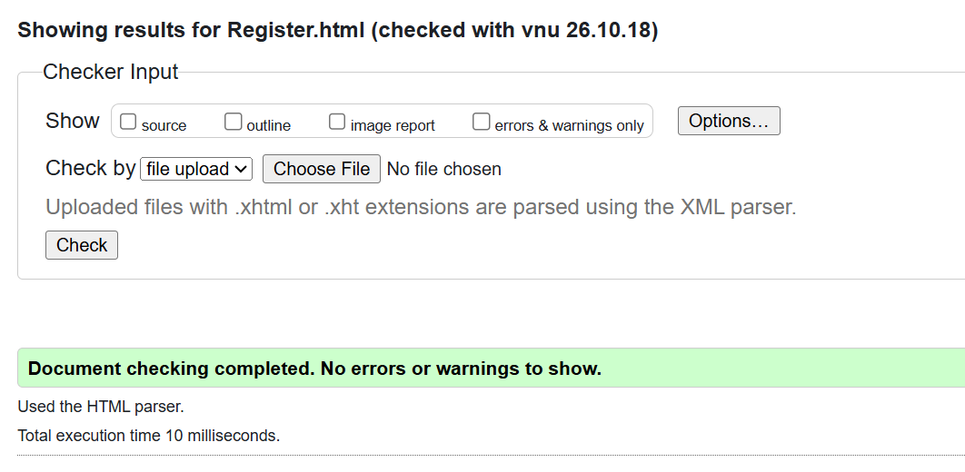

Lighthouse :-
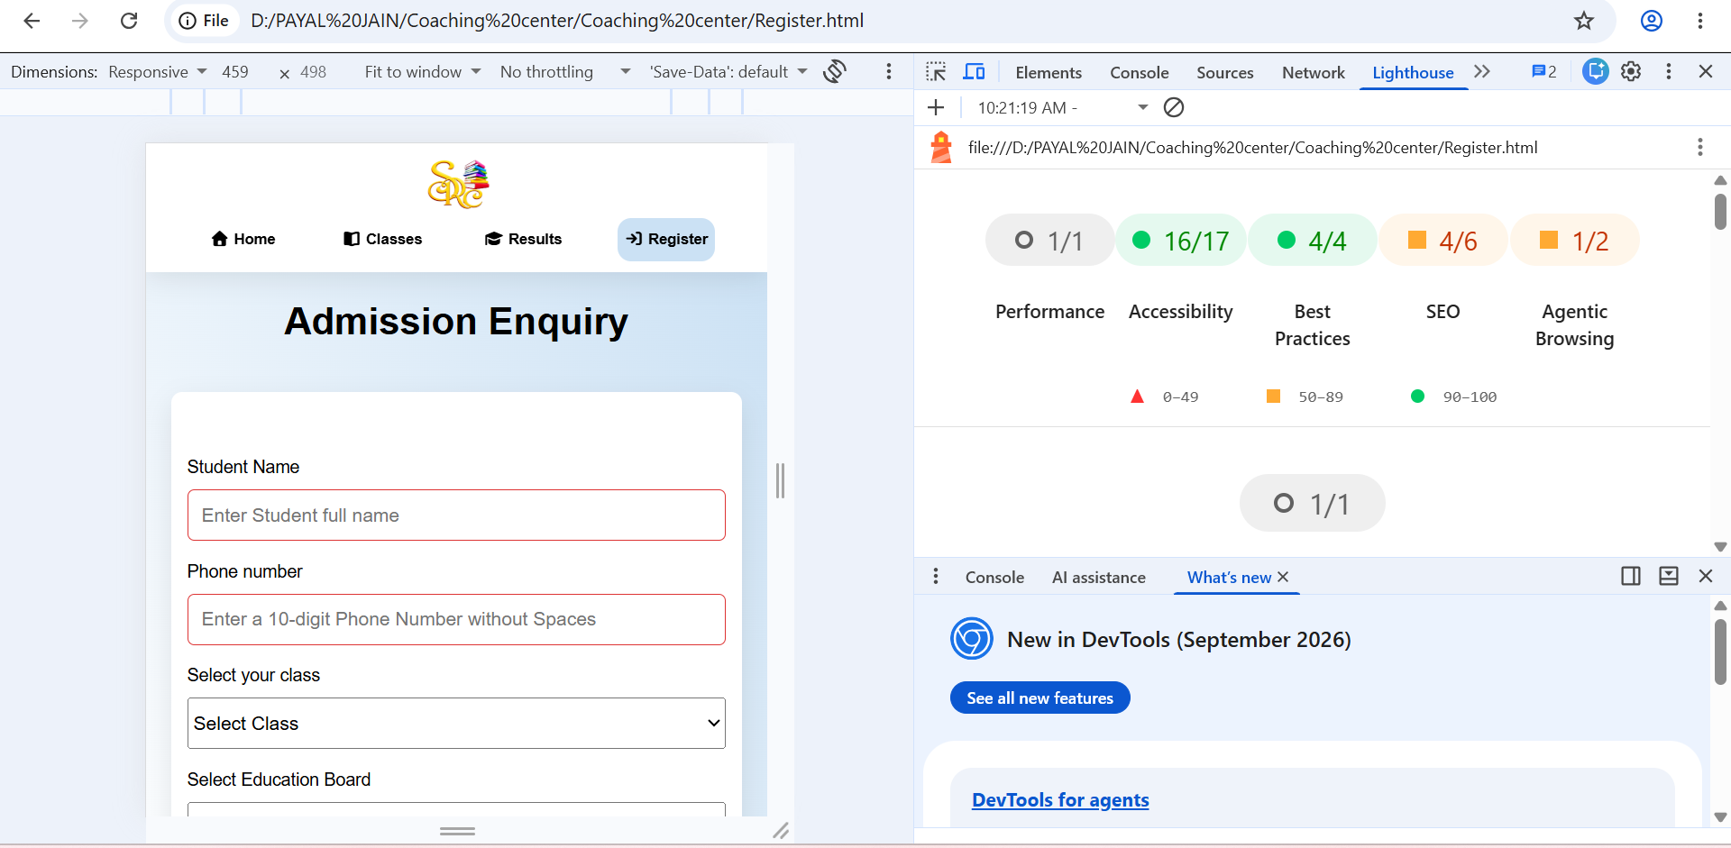

- STYLE SECTION
Validator :-
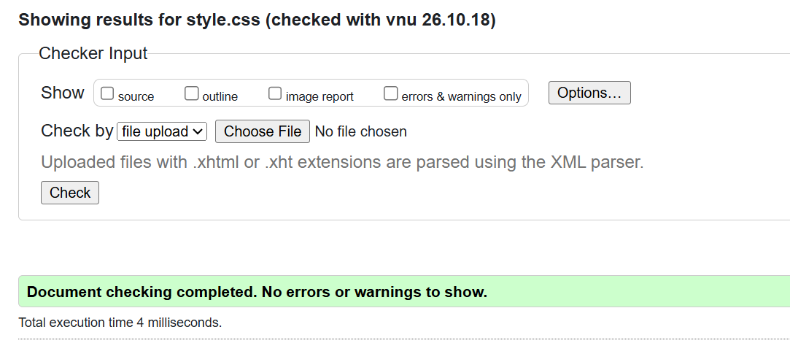

- Permission of the client

