One of the main strategic decisions within Stratego is whether to attack or not. This decision is keyed off two main important factors: first, whether you are sure that you are stronger than the opponent, and second, whether the information to be gained is worth the risk of facing

an unknown enemy piece.

For gathering information around the first question - we have implemented a function *spy at (row, column)* which maintains the joint probability distribution for every enemy piece. This function works in conjunction with an update function which provides all the necessary state information for recalculating the distribution on every move. We have also added additional information about the game into the update function to allow for some primitive deduction. For instance, once a piece is moved, we now know for certain that the moved piece is *not* a flag or a bomb. Furthermore, we also know that any *other* piece is now more likely to be a flag or bomb because the set of possible pieces which are flags/bombs has been reduced by one. Likewise, the minute an enemy player moves more than one position, we now know that it is definitely a scout. This once again affects the probabilities of all remaining pieces and is reflected in the updated distributions. Here’s a small diagram to demonstrate the logic:

Let’s assume that there are 4 remaining pieces - and we know that there is one marshal, one bomb, the flag, and one scout. Since no pieces have moved yet, every piece has an equal opportunity 25% chance of being any of the four pieces.

**Step 1.**

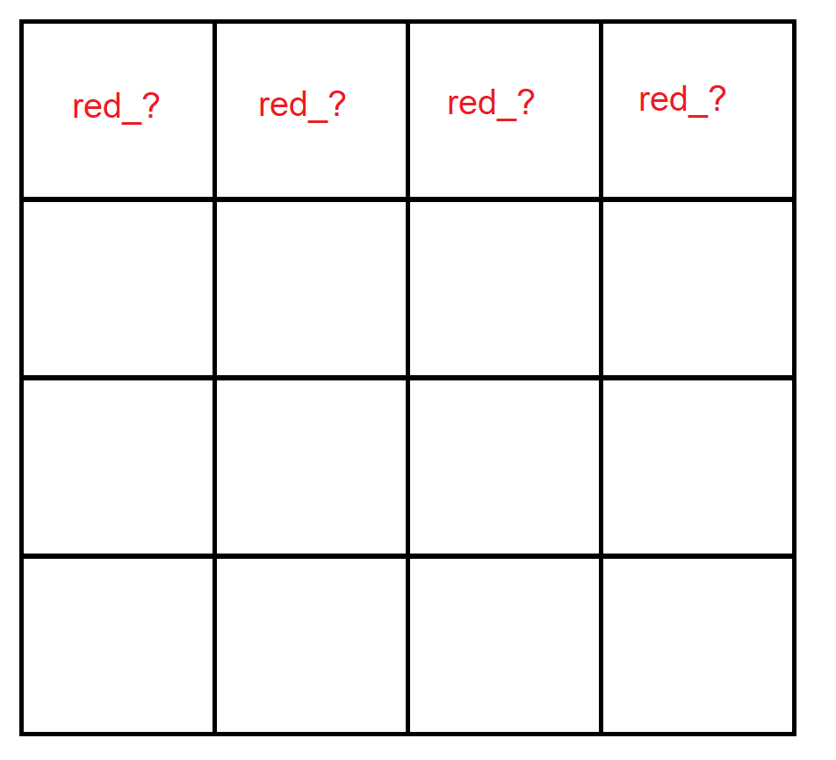

JDP:

|  |  |  |  |  |
| --- | --- | --- | --- | --- |
|  | (0,0) | (0,1) | (0,2) | (0,3) |
| Flag | 0.25 | 0.25 | 0.25 | 0.25 |
| Bomb | 0.25 | 0.25 | 0.25 | 0.25 |
| Marshal | 0.25 | 0.25 | 0.25 | 0.25 |
| Scout | 0.25 | 0.25 | 0.25 | 0.25 |

However, once the piece at (0,2) moves forward 2 spaces we are able to deduce its identity, as well as update the identity probabilities of the surrounding pieces.

**Step 2.**

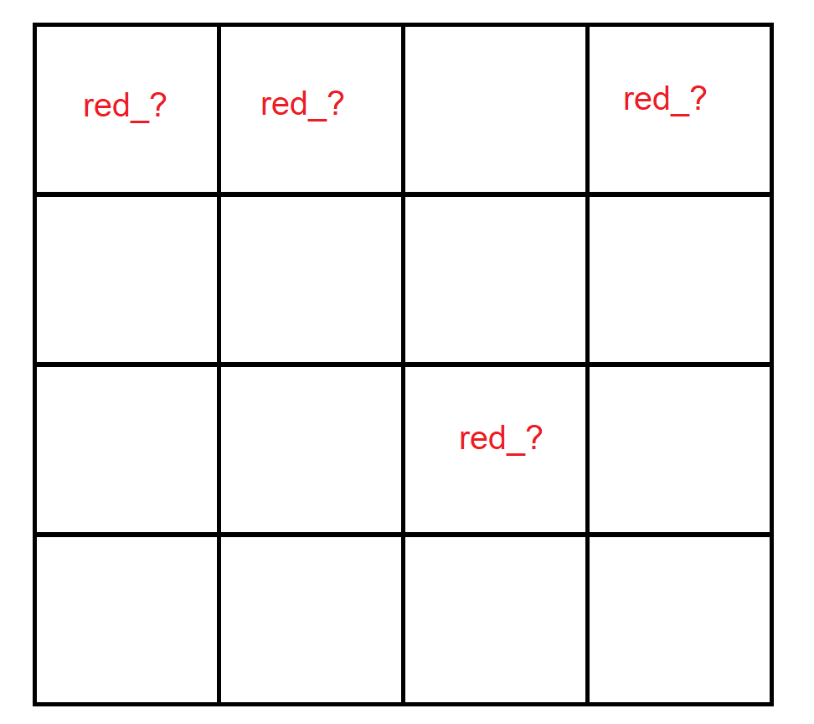

JDP:

|  |  |  |  |  |
| --- | --- | --- | --- | --- |
|  | (0,0) | (0,1) | (0,2) | (0,3) |
| Flag | 0.33 | 0.33 | 0 | 0.33 |
| Bomb | 0.33 | 0.33 | 0 | 0.33 |
| Marshal | 0.33 | 0.33 | 0 | 0.33 |
| Scout | 0 | 0 | 1 | 0 |

Regarding the second point, with this running joint probability distribution we can make educated guesses about the identity of a given location and use that information to decide whether to attack or run from an unknown piece. As a further note, this distribution provides the raw probabilities which could be used with observations about attacking/running behavior can then be used as input into Bayes equation to provide a probability about the likelihood of an unknown piece being stronger or weaker than another piece.