|  |  |
| --- | --- |
| **Full Name** | Asmita Shinde |
| **Batch** | **MS FSD DEC 2021 Cohort** |
| **Project Title** | Learner’s Academy |
| **Project Submission Date** | 22/03/2022 |

|  |
| --- |
| **Screenshots:** |

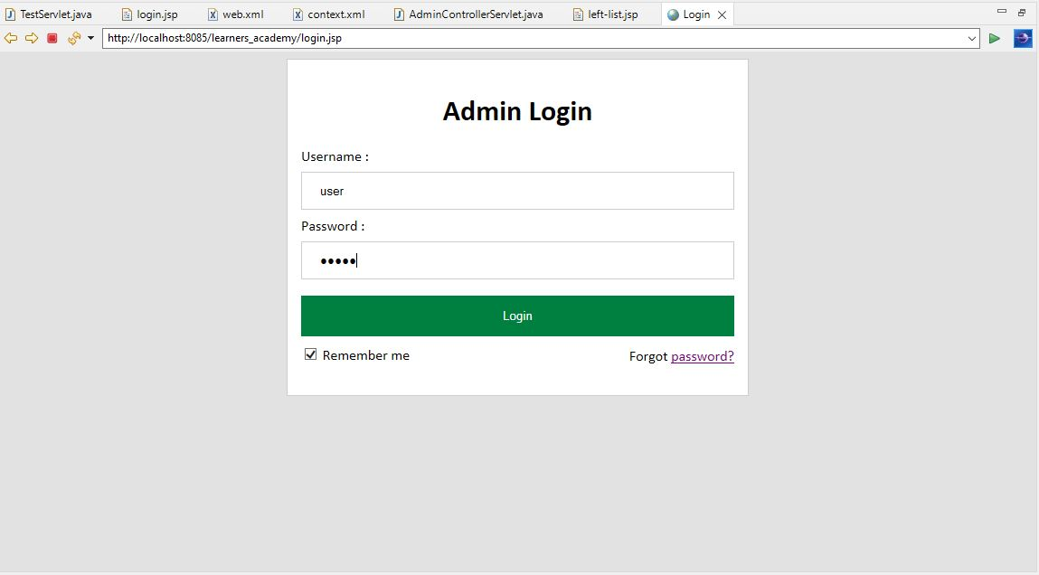

Login page

List of classes

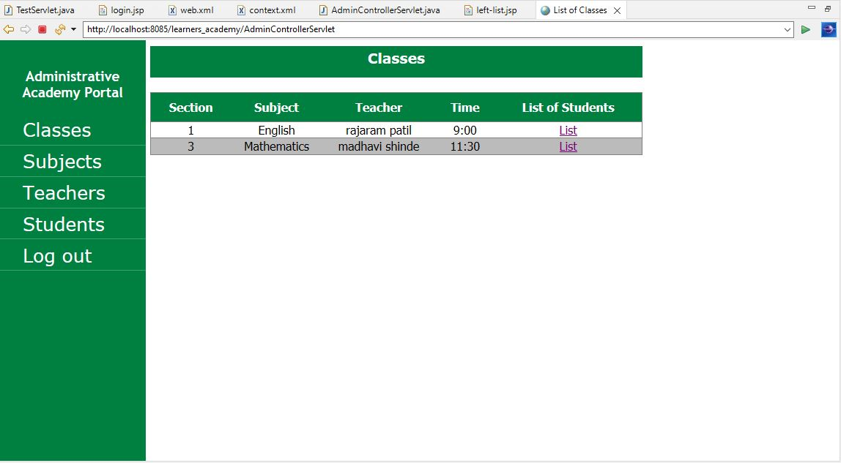

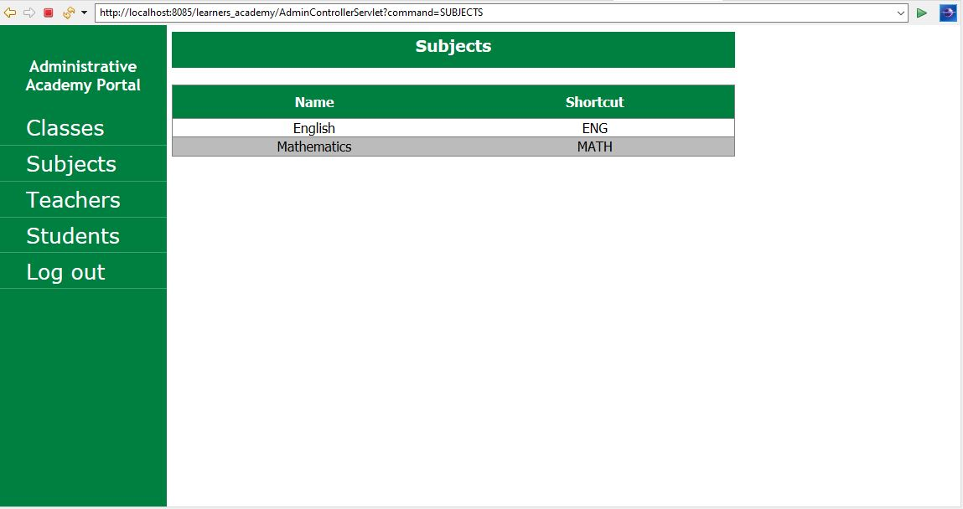List of subjects

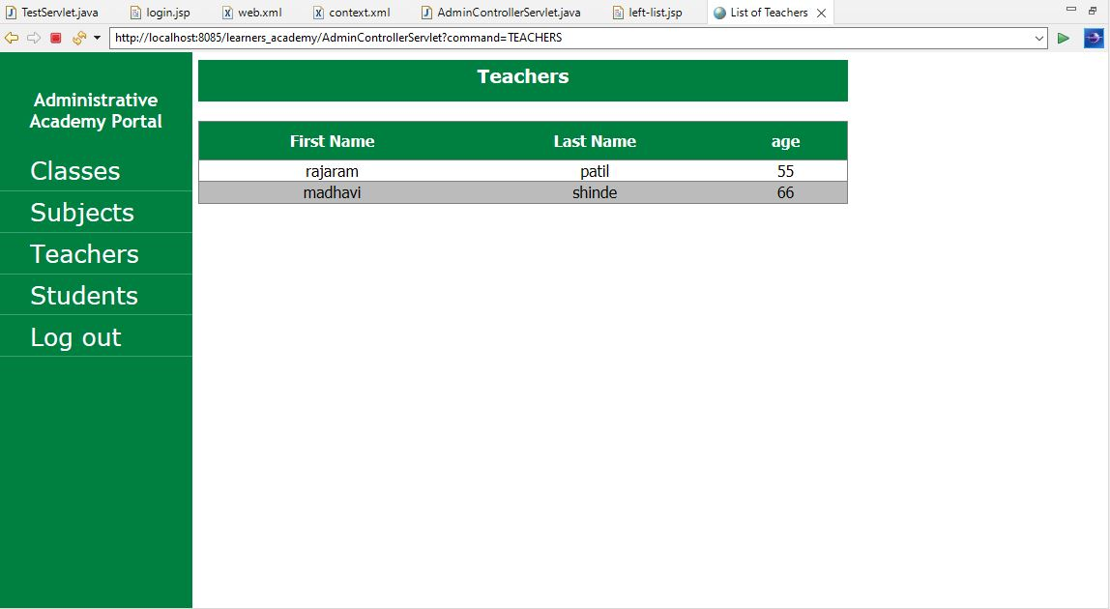List of teachers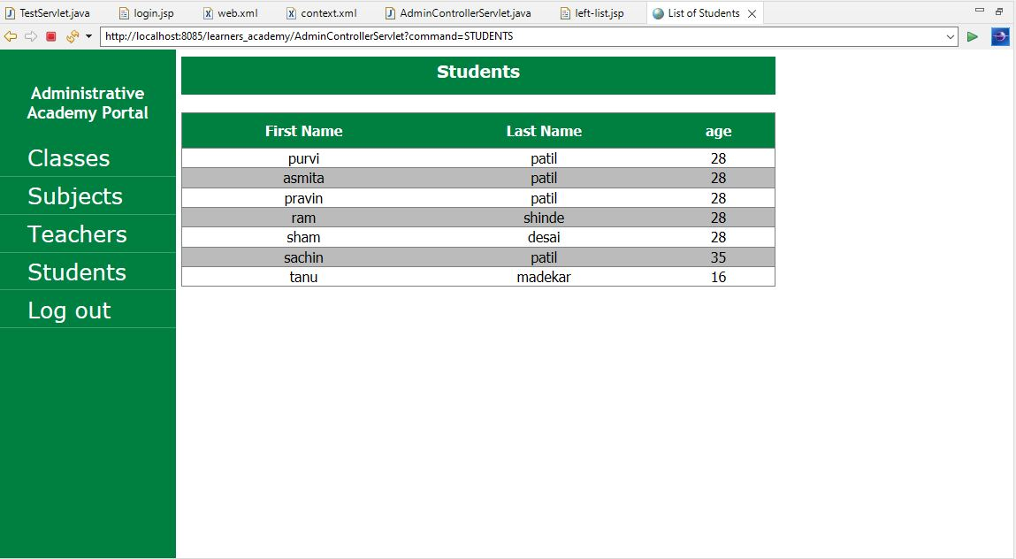

List of students

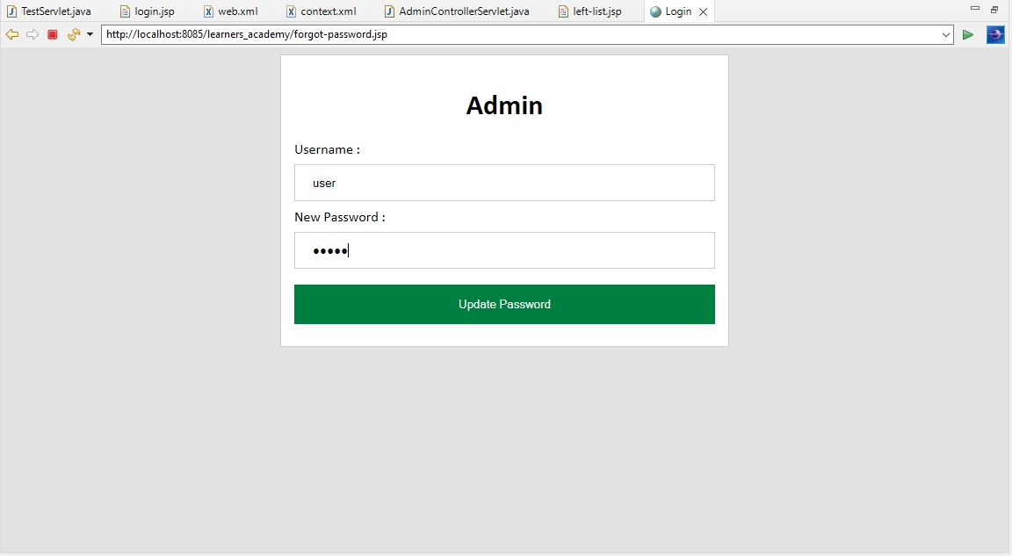

Forgot password (update password)