String in java

1. A Java string is a sequence of characters that as an object of the class java.

2. Java strings are created and manipulated through the string class.

3. Once created, a string is immutable -- its value cannot be changed

What is the string pool?

**1. String pool** is nothing but a storage area in [Java heap](https://www.javatpoint.com/java-heap) where string literals stores. It is also known as **String Intern Pool** or **String Constant Pool**.

2. It is just like object allocation. By default, it is empty and privately maintained by the [Java String](https://www.javatpoint.com/java-string) class.

3. Whenever we create a string the string object occupies some space in the heap memory.

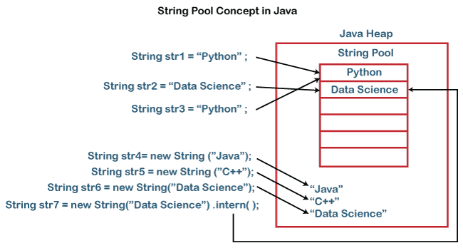

Java wrapper class:

|  |  |
| --- | --- |
|  | Data Type Wrapper Class Memory Range |
|  |  |
|  | byte Byte 1 byte -128 to 127 |
|  | short Short 2 byte -32,768 to 32,767 |
|  | int Integer 4 byte -2^31 to 2^31-1 |
|  | long Long 8 byte -2^63 to 2^63-1 |
|  | float Float 4 byte -3.4e38 to 3.4e38 |
|  | double Double 8 byte -1.7e308 to 1.7e308 |
|  | boolean Boolean 1 bit true or false |
|  | char Character 2 byte '\u0000' to '\uffff' |