|  |  |
| --- | --- |
| **Full Name** | Asmita Shinde |
| **Batch** | **MS FSD DEC 2021 Cohort** |
| **Project Title** | Online Test Application |
| **Project Submission Date** | 05-07-2022 |

|  |
| --- |
| **Screenshots:** |

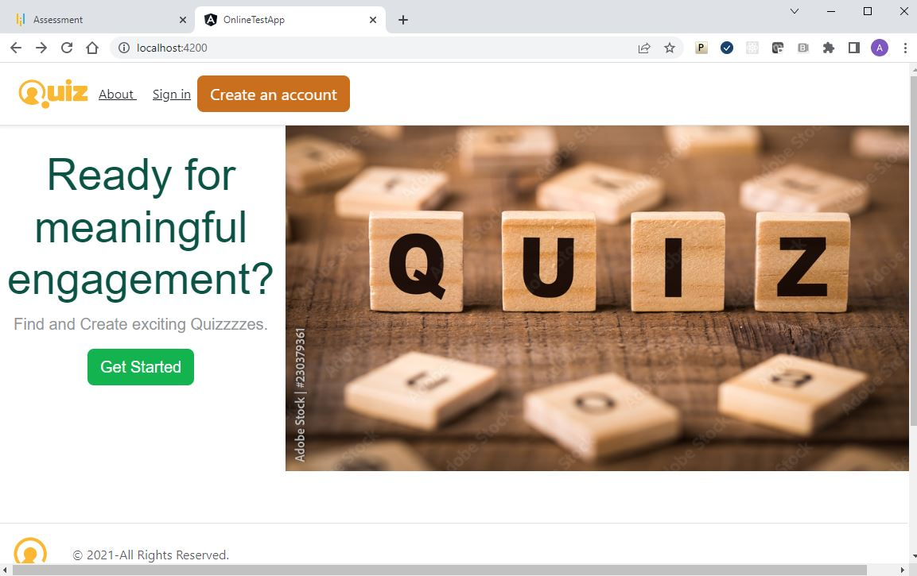Home page

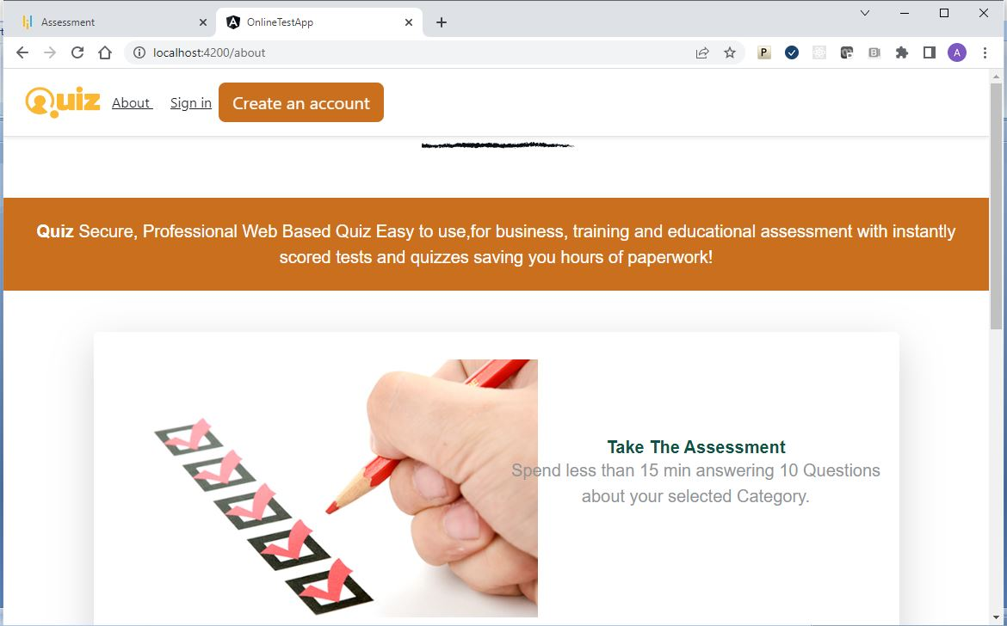

About page

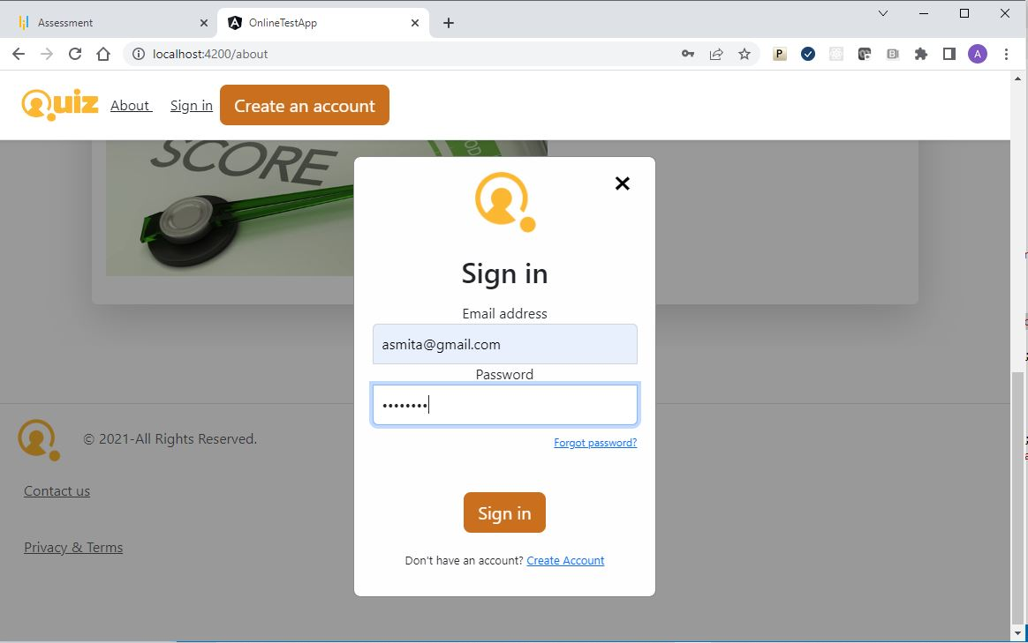Sign in page

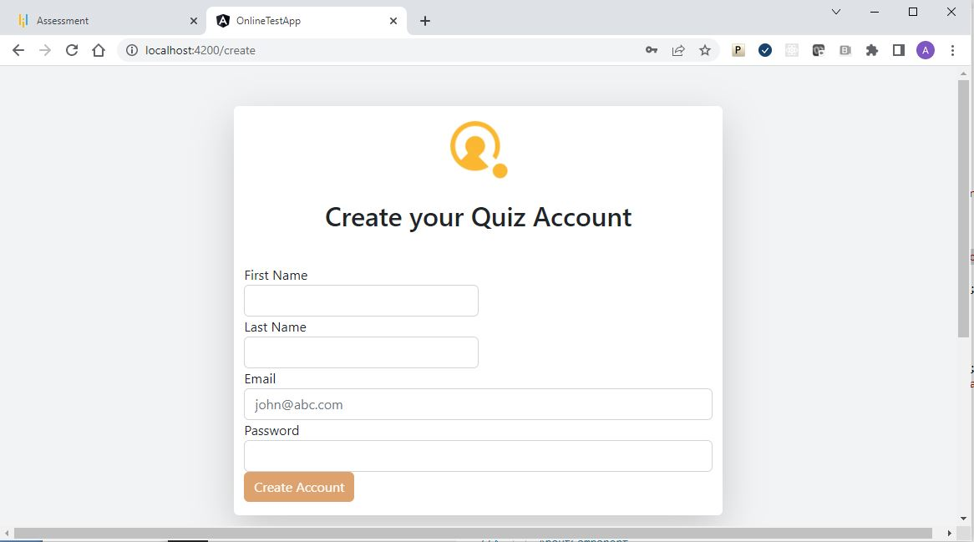Create Account page

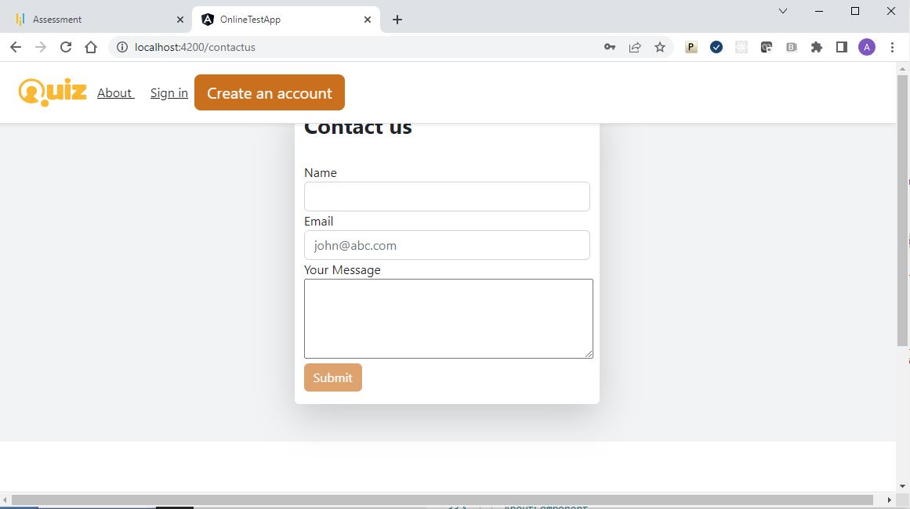Contact Us Page

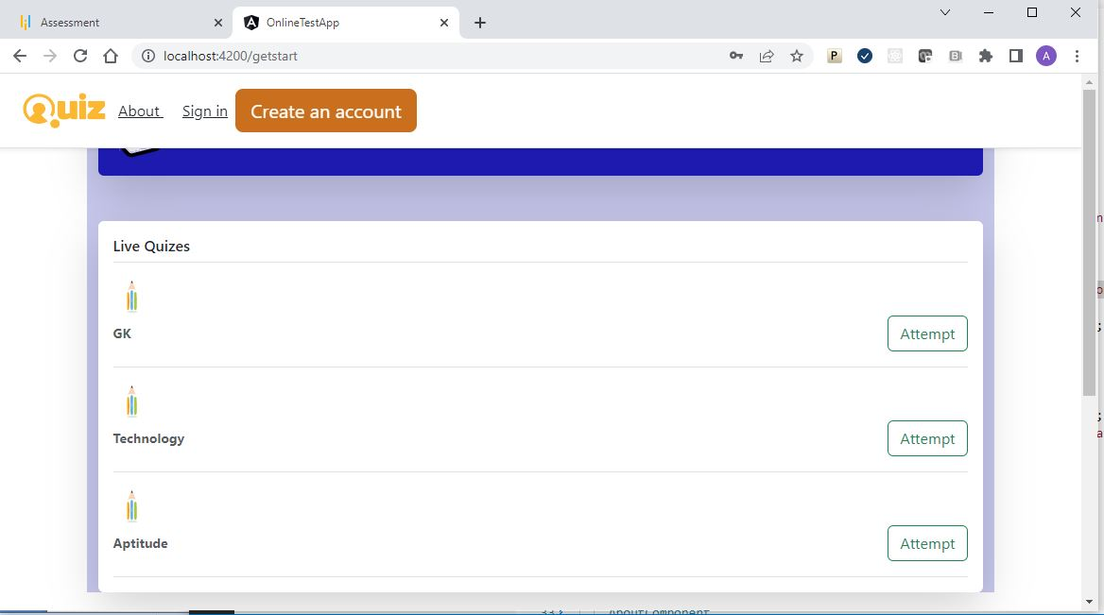Get Start Page

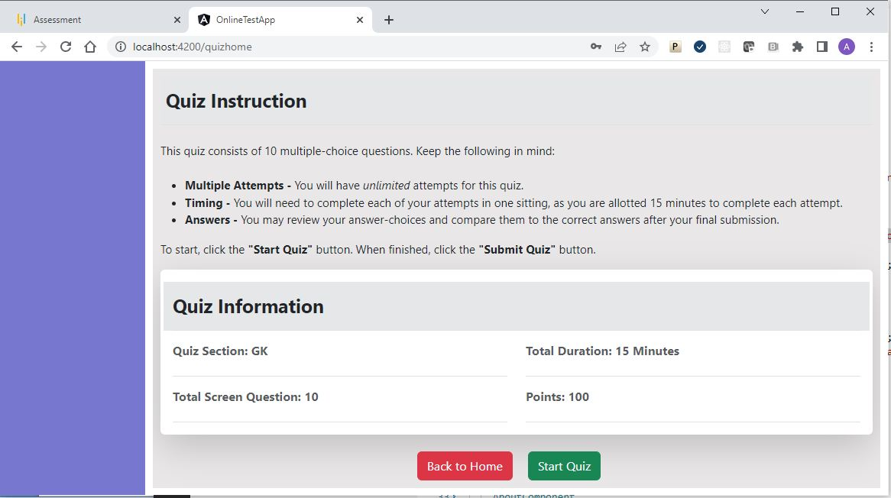QuizHome page

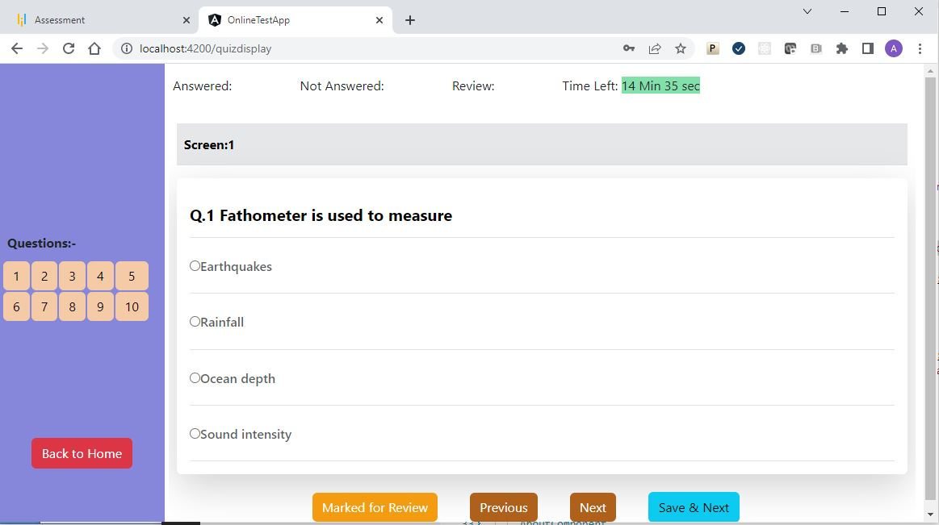QuizDisplay Page