**Deaths of Despair: A comparison of suicides per 100,000 amongst age groups based on Kaggle suicide data (1985 – 2016)**

|  |  |  |  |
| --- | --- | --- | --- |
| Assignment submission for 7COM1079 - [Team Research and Development Project](https://herts.instructure.com/courses/76820) by **GROUP 49** | | | |
| Purvish Himanshukumar Jariwala | | Z Mohammed Ayyaz Khan | |
| Diwakar Ranjan | Vikrant Sharma | | Rahul Soni  M.Sc. Artificial Intelligence & Robotics  rs20acs@herts.ac.uk |

**Abstract**

Stories about suicide that appear in the news tend to focus on celebrities who have t`aken their own lives and on clusters of deaths among students. They miss the bigger picture: that, at a global level, suicide has declined by just 8% since its peak in 2009 (139211 suicides in absolute terms) almost returning to its previous low 127156 suicides of in 2006, for our dataset.

**Objective**

This study aims to assess if there is a difference in the suicides per 100,000 amongst age groups.

**Method**

Data from Kaggle [1] was examined using R programming language to create visualisations and understand the suicides per 100,000 amongst age groups and genders. Plots were created to further aid in examining the suicides per 100,000 trends over demographics.

We further used chi-square test to further answer our hypothesis.

**Results**

Nearly 129776 people took their own lives in 2015 up 27 percentage points from 1985, and suicide is an important part of the rising number of “deaths of despair” described by Anne Case and Angus Deaton, economists [2]. This cause of death has increased the overall mortality rate amongst male over female. Both absolute levels of suicide per 100,000 people and recent increases are particularly high amongst those aged 75 years and over. The male suicide rate remains almost four times that for women.

**Implications**

**Research Question**

Is there a difference in proportion of suicide rate/100k amongst the age groups?

INTRODUCTION:

Describe the dataset

Research Question

Null & Alternative Hypothesis

Visualization:

Explain data visualization

Explain what it shows (in our case explain every plot)

Visualizations should be imported into your document as images created by R script; do NOT import screenshots!

Analysis:

describing the statistical analysis used to test your hypotheses, and

what it means.

Conclusion:

Describe what analysis means

# **PROJECT OVERVIEW**

# Summary of Research:

In a brief statement describe the research to be performed and the data to be developed. This could include a statement on the source of funding; research design and context; project history; aims and objectives; hypotheses; related publications and research outputs; etc.

**INTRODUCTION:**

Suicide regularly gets from profound sensations of sadness. Casualties ordinarily have the powerlessness to see answers for issues or to adapt to testing life conditions which at that point drives them to consider suicide to be the lone arrangement. As indicated by World Health Organization Suicide is a significant medical condition worldwide and is a main source of death. More than 800,000 individuals die consistently from suicides which is assessed to be at a pace of one individual like clockwork. However, suicide is preventable when ideal, powerful intercessions are actualized at public, civil and individual levels. With regards to a nation's pay level, suicide does not simply happen in major league salary nations, however it is a worldwide marvel in all locales of the world. Truth be told, over 79% of worldwide suicides happened in low-and centre pay nations in 2016. (are we able to explain this assetion?)

This research will be focused on Is there a difference in a suicide rate/100k among the age groups and supporting hypothesis as:

H0: There is no difference in the proportion of suicide rate/100k amongst age groups.

H1: There is a difference in the proportion of suicide rate/100k amongst age groups.

**DATA:**

The information to be utilized in this task was gathered by extracting data from an online information base (Kaggle.com).

There are sum of 27,820 cases where each case speaks to a nation and the suicide rate inside an age-group gathering of males or females for the year somewhere in the range of 1987 and 2016 alongside the nation's GDP at that point. As referenced before, the research will be focused about finding any connection between Suicide rate/100k and age-group, in this way these are the two factors which will be the fundamental concentration in which suicide is a dependent variable and age-group is an independent variable

This research is an observational investigation since the members are seen with no sort of interference. Therefore, the objective is to check whether is there any difference in the Suicide rate/100k among age-group. The number of inhabitants in interest is all people ages 5 and up who ended it all. The socioeconomics from this data comes from nations around the globe so we can sum up our decisions to the population internationally. In any case, since the Research is observational the discoveries cannot be utilized to set up causal connections, just **Comparison of proportions**. For likely inclination, we need to accept that each nation similarly revealed all Suicide occasions, in any case our decisions might be inaccurate. Suicide is viewed as a negative fascination for a nation's economy so on the off chance that numbers go unreported, at that point the outcomes will reflect error.

**Restrictions or Limitations and Assumptions**

1. The data in this Research depends on reports up to 2015 excluding 2016
2. Outliers are distinguished however stayed to be remembered for the report as these are the real announced insights from the source (where are the outliers? Do we scatter plot to justify this statement?)
3. The Significance level is set to 0.05 and is expected that there is a homogeneity of fluctuation in the data

# **PROJECT MANAGEMENT AND ORGANIZATION PLAN**

* 1. Folders and Files:

Outline the project folder structures and location of files by type and/or stage of development (raw, processed, master, etc.). Set standards for folder or file naming conventions, including for versioning or modifications. Provide guidance on selecting file formats.

* 1. Storage and Backup:

Explain the storage infrastructure and protocols for saving and backup (e.g., scheduling, testing, disposal, etc.). Detail how to handle security considerations, including access rights.

# **DATA COLLECTION AND PROCESSING DOCUMENTATION**

# Data Collection Methods:

Describe the protocols, procedures, and workflows. List information about tools used such as instruments, hardware, and software. Give details of quality assurance procedures; information recorded about the data collection process itself; use of structured data entry documents (if any).

Every team member brought their own interests and their chosen dataset for team discussions. After much deliberation suicide_dataset was finalised by the team members downloaded from Kaggle as it fulfils all the criteria [3] we set out in our almost daily meeting using *Microsoft Teams*. We explain these criteria as

1. Dataset should be easy to *understand* i.e. individual/team should not spend a long time (more than 2 days) to investigate terminology/column name/data in a column
2. It should to *feasible* for the team to implement given limited understanding of the course/R and help in framing a research question and hypothesis
3. Dataset should help in understanding the *concept* of Correlation, Comparison of means, or comparison of proportion and draw visualisation
4. The answer to the RQ can be easily *summarised* in a report
   1. Data Processing Methods:

Detail the protocols and procedures to clean the data and prepare it for analysis. List the hardware and software used; quality assurance procedures; information to be recorded about the data processing procedure itself.

* 1. Metadata:

Provide contextual information about the data needed to discover, understand, and make use of it. Describe alignment with disciplinary standards (if any). Detail how to create or link to codebook or data dictionary which includes variables. Explain coding practices.

* 1. Sensitive Data Considerations:

Explain how to adhere to requirements such as anonymization; special storage protections and permissions; disposal regulations. Include IRB considerations and link to/append compliance documents.

1. **DATA ANALYSIS DOCUMENTATION**
   1. Data Analysis Methods:

Describe the protocols, procedures, and workflows. List information about tools used such as hardware and software. Give details of quality assurance and quality control procedures; information recorded about the data analysis process itself (e.g., techniques, etc.).

* 1. Dataset Versioning:

Outline how to provide clear identification and definition of versions; including distinction between versions.

* 1. Master Dataset Rules:

Explain the designation of the master dataset. Describe protocols for using the master dataset.

1. **VISUALISATION**
   1. Global Analysis
      1. Global Trend

The dashed line is the **global average suicide rate** from 1985 - 2015: **11.5 suicides** (per 100k, per year). There was a spike in suicide rate per 100k in 2009 that is the largest in the dataset. This could be related to the global slowdown of 2009, but we cannot be certain as the dataset does not list the cause of suicides.

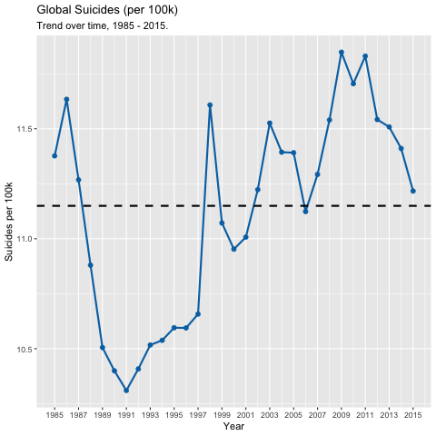

* + 1. Top 20% highest risk between 1985 – 2016

We were interested to understand how suicide rate per 100k has changed every 5 years. There are 30 country data in our filtered data set [see section ] and we were interested in the 20% highest risk suicides per 100k and compare the demographics between 1985 and 2015.

We define a demographic as a year in a particular country for some combination of sex and age.

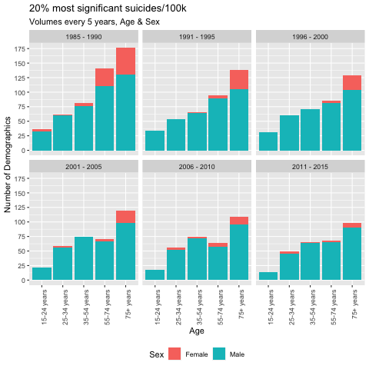

**We observe suicides per 100k for the 35 – 54 years age group has largely remained flat since 1991 at about 70 suicides per year. Although the suicides per 100k has decreased for 75+ years age group we remain concerned it being high throughout 30-year period.**

* + 1. By Age Group

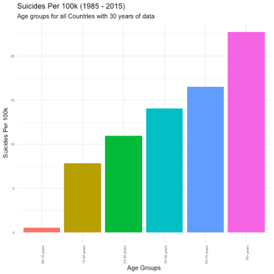

* + 1. 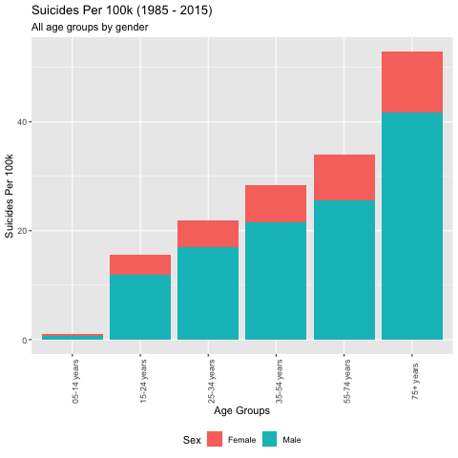By Age Group and Gender

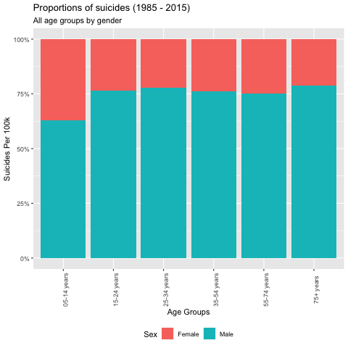

* 1. Trend Plots
     1. By Country

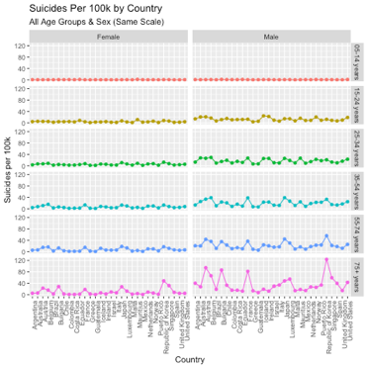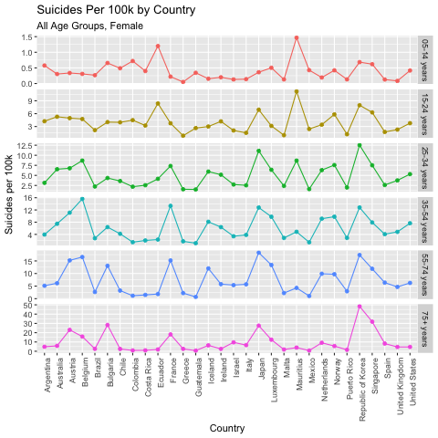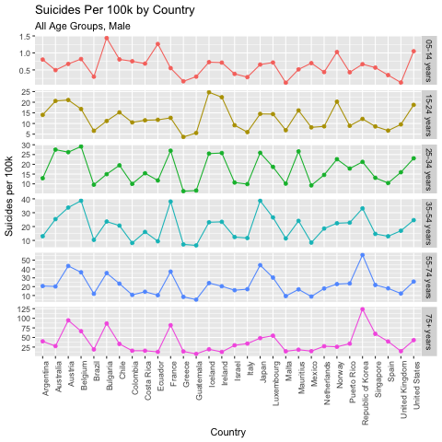

* + 1. By Age Group & Gender

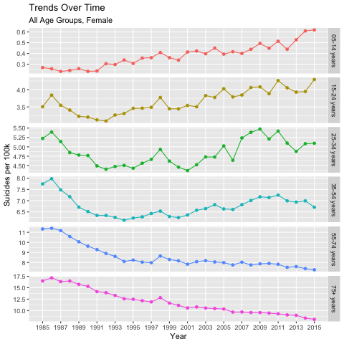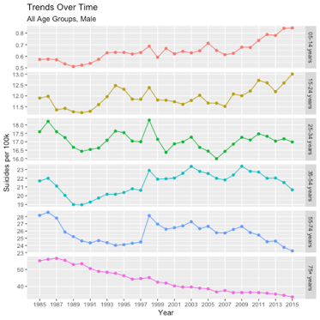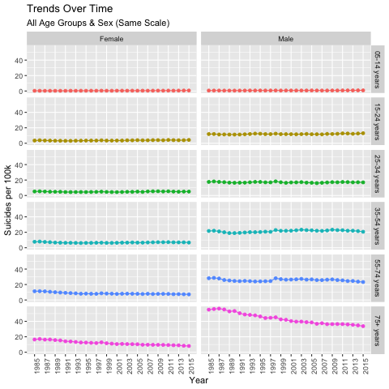

We share the following insights:

* + - * + Globally the likelihood of suicide increases with age
        + Although the suicide rate in 5 – 14 years remains small and it has doubled in the past 30 years for our filtered dataset for both males and females
        + Suicide rate per 100k for 75+ year age group for both genders is linearly decreasing and has dropped by about 83% since 1988
        + Suicide rate per 100k for 15 – 24 years age group for both genders is highest in 2015 than any time in the 30 years of history

1. **ANALYSIS**
2. **CONCLUSION**
3. **REFERENCES**

[1] <https://www.kaggle.com/russellyates88/suicide-rates-overview-1985-to-2016>

[2] Anne Case and Angus Deaton, ‘Deaths of Despair and the Future of Capitalism’

[Online] <https://press.princeton.edu/books/hardcover/9780691190785/deaths-of-despair-and-the-future-of-capitalism> [Accessed: 03 Jan 2021]

[3] <https://trello.com/c/0uYp2wZC>