./

Report – XOX

Course Code: <CODE>



Version Number:

Team Members :

Team No:

Module: Model Based System Engineering

|  |  |  |  |  |  |
| --- | --- | --- | --- | --- | --- |
| **Ver. Rel. No.** | **Release Date** | **Prepared. By** | **Reviewed By** | **Approved By** | **Remarks/Revision Details** |
|  |  |  |  |  |  |
|  |  |  |  |  |  |
|  |  |  |  |  |  |
|  |  |  |  |  |  |
|  |  |  |  |  |  |

**Document History**

# 

Contents

1. Introduction 5

1.1 Advantages: 5

1.2 Disadvantages: 5

1.3 SWOT analysis 6

1.4 4W's and 1H 7

2. Detail requirements 8

2.1 High level requirements: 8

2.2 Low level requirements: 8

3. Architecture 9

3.2 Use case diagram: 10

4. Test Plan and Output 11

4.1 High level test plan: 11

4.2 Low level test plan: 11

# Introduction

Game/Games is an extracurricular activity, or fun, entertainment, mind booster, crazy tool where everyone enjoys playing. It empowers every individual to make their own active decisions and help them to gain an accurate experience, skills, and confidence to lead them on the path of their future. It is truly considered that through participation in sports and different games, one learns cooperation, teamwork, leadership methods and time management. It is not only applied to humans but also for an animal's where a dog plays a ball game with its owner and cat playing a hide n seek game with its owner. Just an example depending upon how owner treats their pets. There are some types of games like billiards, board games and golf etc. which are considered recreational activities and they increase our mental, physical skills while enjoying the excitement of our shots.

XOX is a logical game played by two players in 3×3 square board using X and O tokens. Alternatively, the two players are going to enter their tokens of their choice in the box. The player who gets three of the same tokens in a row or column or diagonal is the winner otherwise the match is draw.

## 1.1 Advantages:

* Enhance the logical thinking
* Provides relaxation
* Handy and friendly
* Not necessary of writing and playing

## 1.2 Disadvantages:

* Children can easily get addicted to the game
* It can be yeah played only when there is a device

## 1.3 SWOT analysis

Strengths:

* Improves logical thinking
* Empowering active decision
* Increases mental, physical skills
* Healthy booster
* Fun creator

Weakness:

* Addictions
* No data management of winning and losing
* Maximum and minimum number of players is two.

Opportunity:

* Empowering to online players
* Implementing Bluetooth connections for players
* Buddy requests and connections in a server

Threats:

* Negative impact on psychology of the users
* Continuous play effects on health and time management

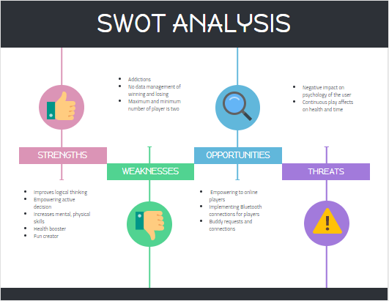

## 1.4 4W's and 1H

* Who:

Mobile, laptop, tabs applications are used by people very often for various purposes.

* What:

XOX is a game application played by human.

* When:

When a human wants refreshments, children for playing and for entertainment and fun.

* Where:

User can use this app anywhere with stable battery in their device.

* How:

Mobile, laptop, tabs users can access in any of these devices.

# Detail requirements

## 2.1 High level requirements:

|  |  |  |
| --- | --- | --- |
| ID | Description | Implementation status |
| HR.01 | System should be able to display the 3×3 square board. | Yes |
| HR.02 | Players should be able to enter inputs. | Yes |
| HR.03 | System should provide the output. | Yes |
| HR.04 | System should access to other players in the server | No |

## 2.2 Low level requirements:

|  |  |  |
| --- | --- | --- |
| ID | Description | Implementation status |
| LR.01 | According to players choice, they should be able to enter X and O in the 3×3 square board. | Yes |
| LR.02 | System should be able to print the player winner and draw of the match. | Yes |
| LR.03 | System should print if the place as already occupied. | Yes |
| LR.04 | System should print next game or exit | No |
| LR.05 | System should allow the player to choose its opponent in the server | No |

# Architecture

3.1 Flow chart

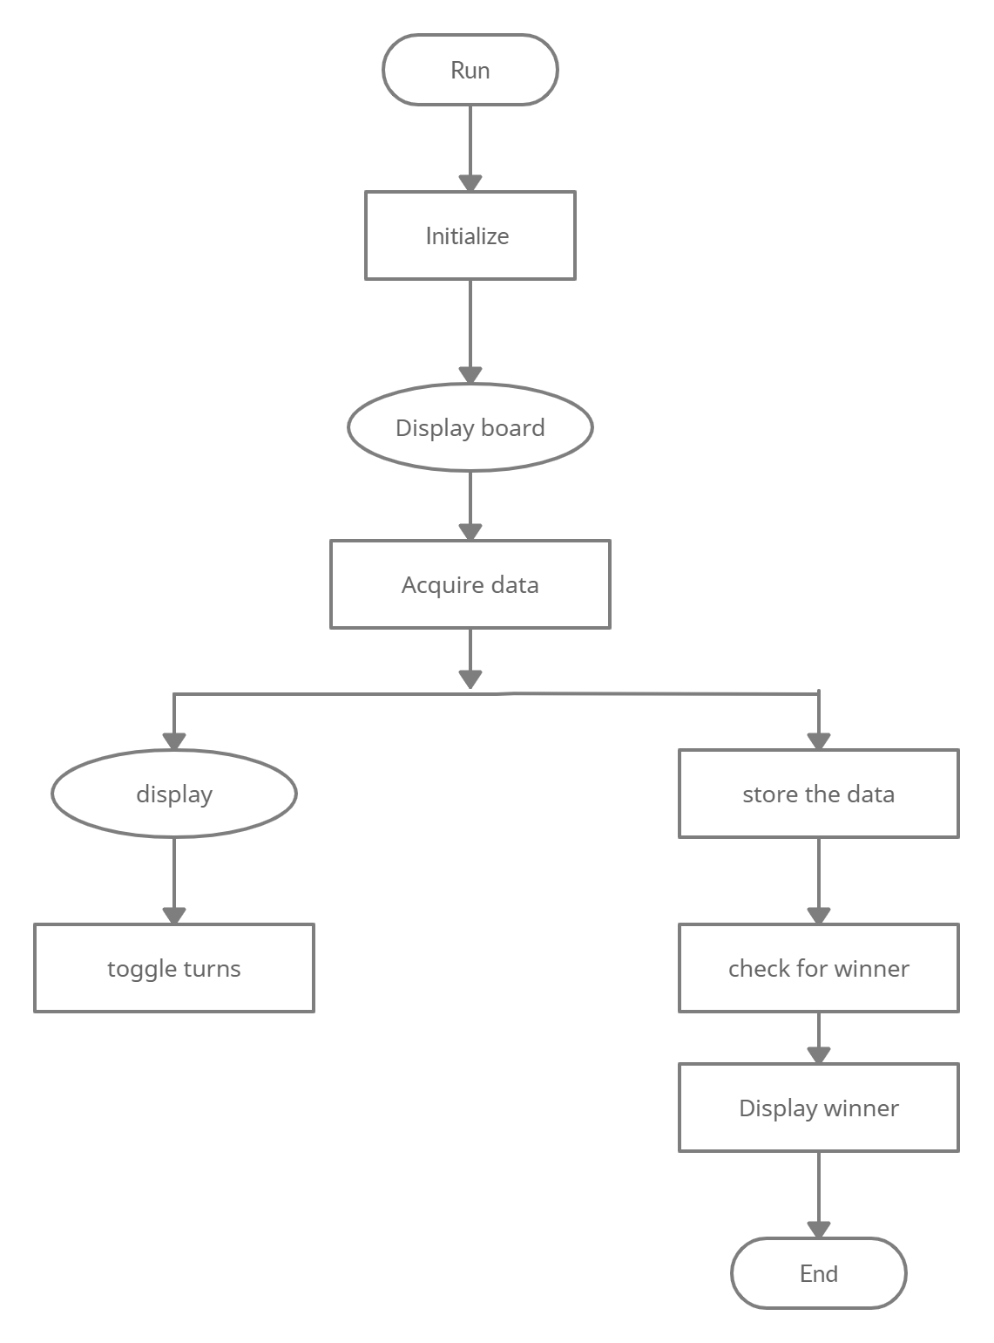

## 3.2 Use case diagram:

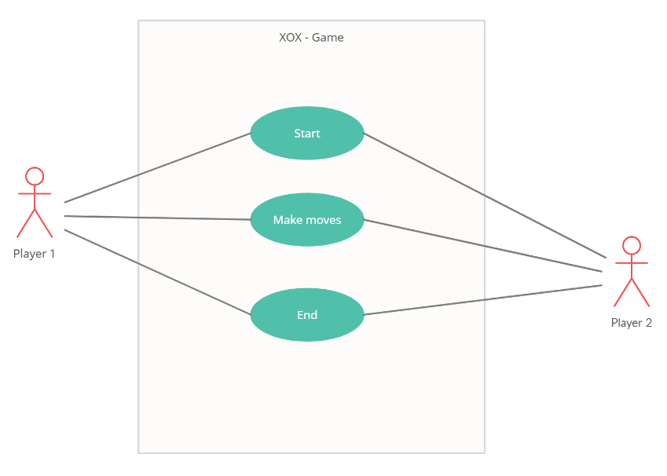

# Test Plan and Output

## 4.1 High level test plan:

|  |  |  |  |  |
| --- | --- | --- | --- | --- |
| ID | Description | Exp I/P | Exp O/P | Actual O/P |
| HR.01 | System should be able to display the 3×3 square board. | Run | 3×3 square board display | 3×3 square board display |
| HR.02 | Players should be able to enter inputs. | Numbers of their choice | Tokens occupy cell for the entered number | Tokens occupy cell for the entered number |
| HR.03 | System should provide the output. | Player’s winner | Winner or draw | Winner or draw |

## 4.2 Low level test plan:

|  |  |  |  |  |
| --- | --- | --- | --- | --- |
| ID | Description | Expected I/O | Expected O/P | Actual O/P |
| LR.01 | According to players choice, they should be able to enter X and O in the 3×3 square board. | Numbers of their choice | Tokens occupy cell for the entered number | Tokens occupy cell for the entered number |
| LR.02 | System should print if the place as already occupied. | Toggle turn | Display place has already occupied | Display place has already occupied |
| LR.03 | System should be able to print the player winner and draw of the match. | Store player1 winner / player2 winner/  Game draw | Display player1 winner / player2 winner/  Game draw | Display player1 winner / player2 winner/  Game draw |