Dockerized .NET Core Web Api with SQL Server

Prerequisites

To follow along with this tutorial, you need to have:

1. A Windows, Linux, or Mac machine
2. [Docker Desktop](https://www.docker.com/products/docker-desktop/)
3. [.NET 7 SDK](https://dotnet.microsoft.com/en-us/download/dotnet/7.0) (or newer)
4. [Visual Studio 2022](https://visualstudio.microsoft.com/vs/)
5. [SQL Server Management Studio](https://learn.microsoft.com/en-us/sql/ssms/download-sql-server-management-studio-ssms?view=sql-server-ver16)
6. Some experience with [Docker commands](https://docs.docker.com/engine/reference/commandline/docker/)
7. Some experience with ASP.NET Core Web API and EF Core

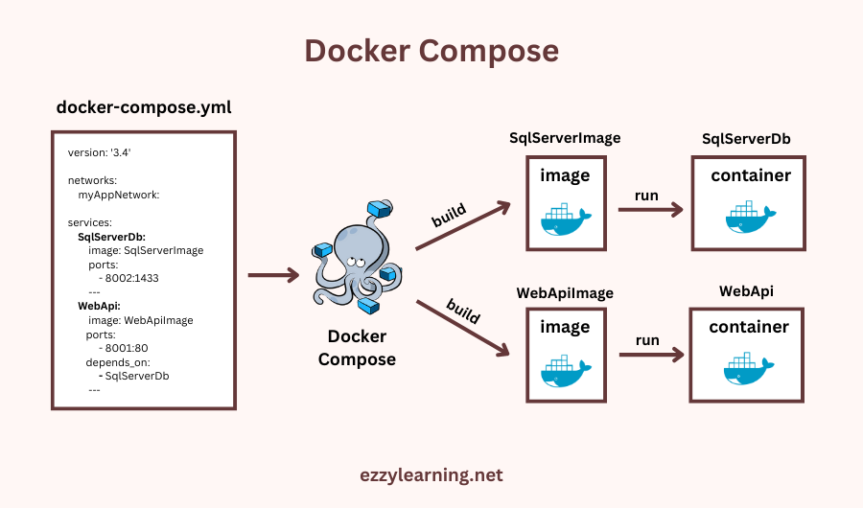

Adding Docker Compose Support in Visual Studio

To add Docker compose support in Visual Studio, right-click on the Web API project in the solution explorer and choose and choose **Add > Container Orchestrator Support…** option from the menu.

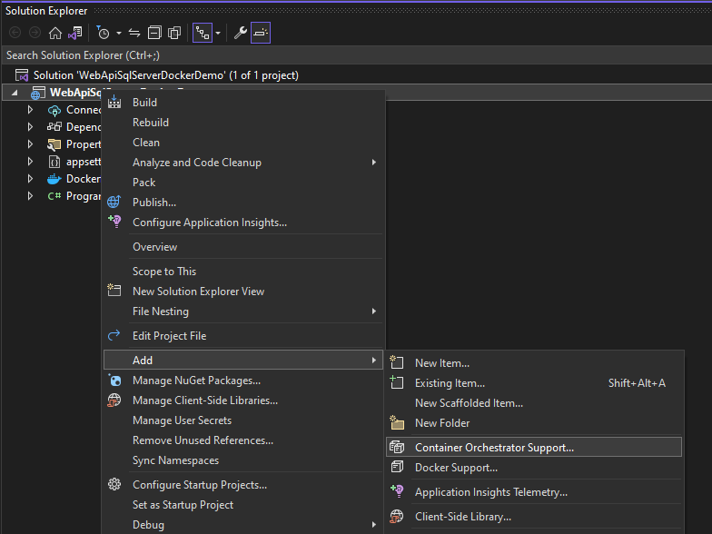

You will see the following dialog where you need to choose the **Container orchestrator**. Currently, there is only one option so choose **Docker Compose** and click the OK button.

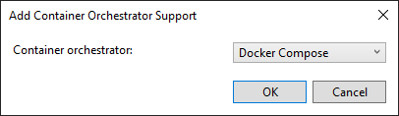

Next, You will see the following dialog where you can choose the **Target OS**. Choose **Linux** and press the OK button.

**[READ ALSO:  A Step by Step Guide to Bundling and Minification in ASP.NET Core](https://www.ezzylearning.net/tutorial/a-step-by-step-guide-to-bundling-and-minification-in-asp-net-core" \t "_self)**

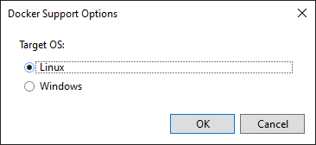

You will see the **docker-compose** project and **docker-compose.yml** file added in the Visual Studio Solution Explorer.

