PRACTICAL: 01
Aim: To implementation and Time analysis of sorting algorithms. Bubble sort, Selection sort, Insertion sort, Merge sort and Quicksort.
BUBBLE SORT
Algorithm:

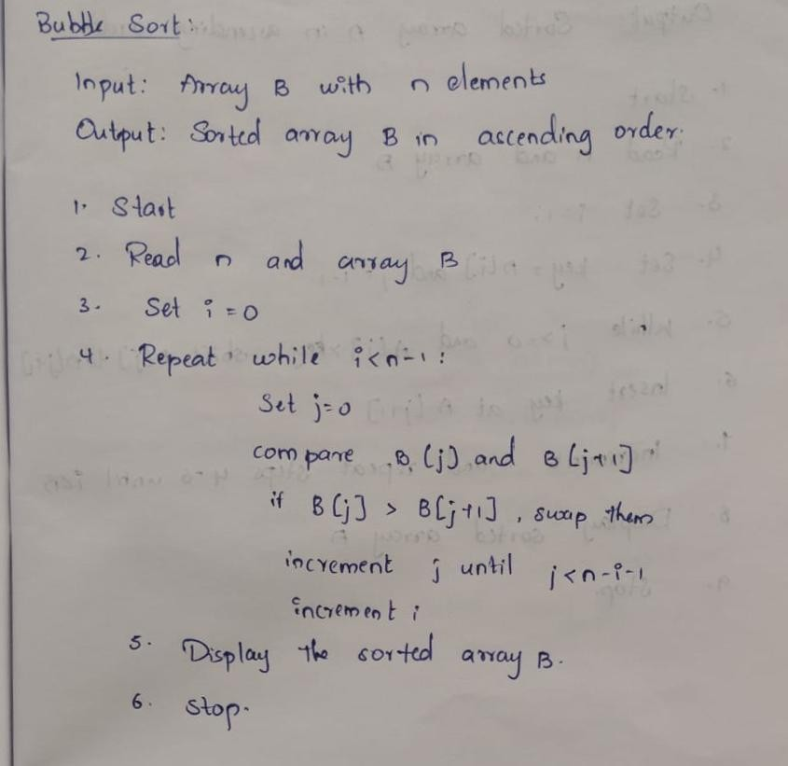
Program / Code:
#include <iostream> #include <vector> using namespace std;

void bubbleSort(vector<int> &arr)
{
int n = arr.size();
for(inti=0;i<n-1;i++)
for(int j=0;j<n-i-1;j++)
if(arr[j]>arr[j+1]) swap(arr[j],arr[j+1]);
}

int main() {
vector<int> numbers = {64, 34, 25, 12, 22, 11, 90};
bubbleSort(numbers);

for (int value : numbers)
cout << value << ' ';

cout << '\n';
return 0;
}

Output:
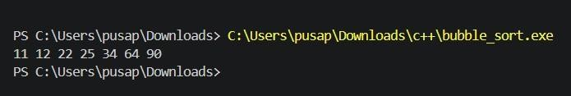
Time Complexity:
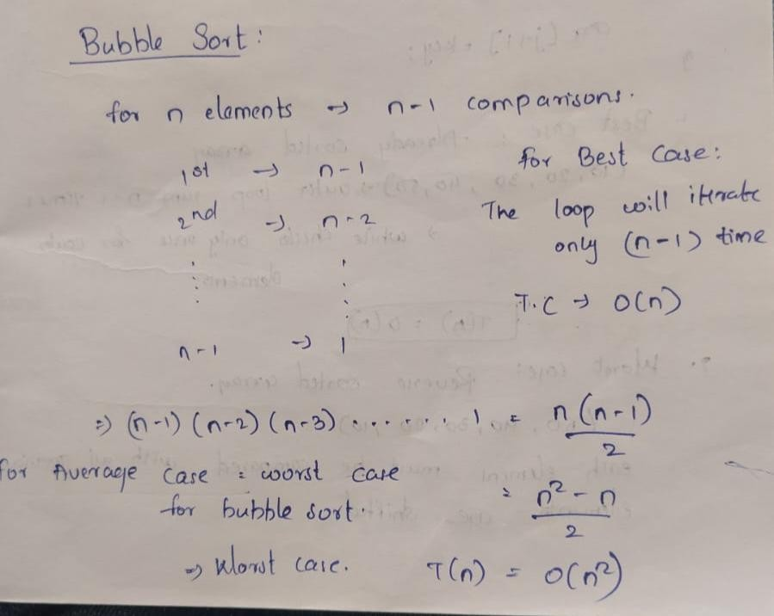

SELECTION SORT
Algorithm:
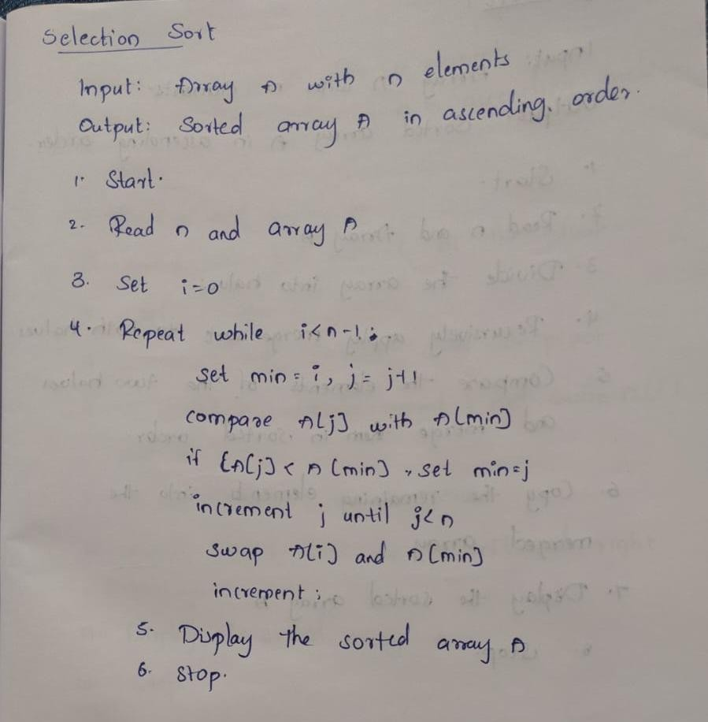

Program / Code:
#include <iostream> #include <vector> using namespace std;

void selectionSort(vector<int> &arr)
{ int n=arr.size();

for(int i=0;i<n-1;i++)
{ intmin=i;

for(int j=i+1;j<n;j++)
if(arr[j]<arr[min])
min=j;

swap(arr[i],arr[min]);
}
}

int main() {
vector<int> numbers = {64, 34, 25, 12, 22, 11, 90}; selectionSort(numbers);
cout<<"Sorted array using selection sort: \n";
for (int value : numbers)
cout << value << ' ';

cout << '\n';
return 0;
}

Output:
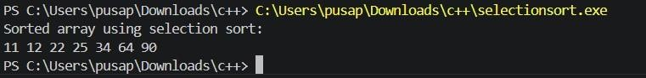

Time Complexity:
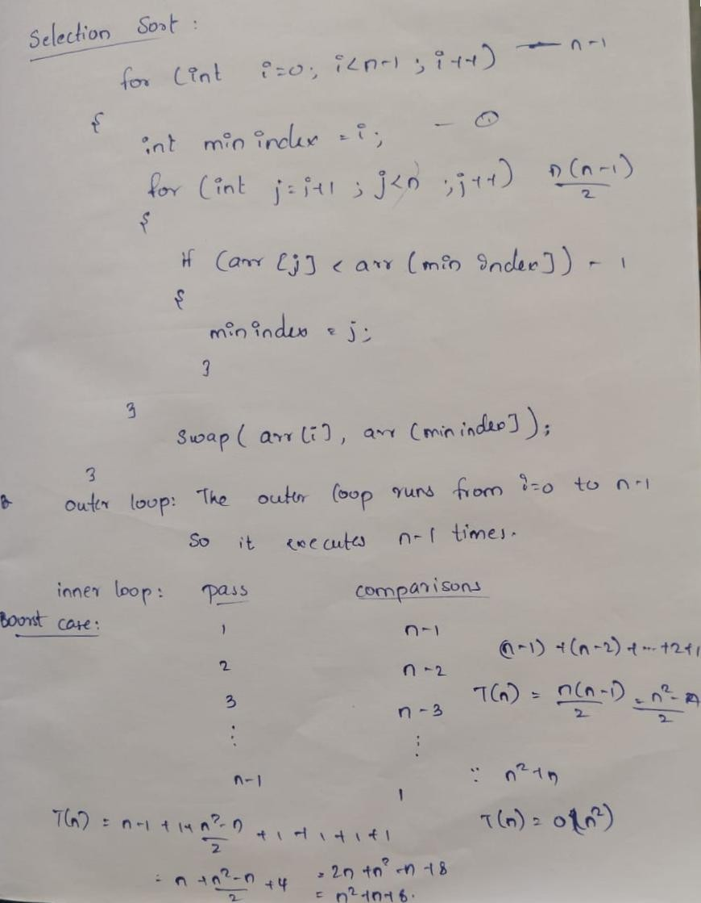
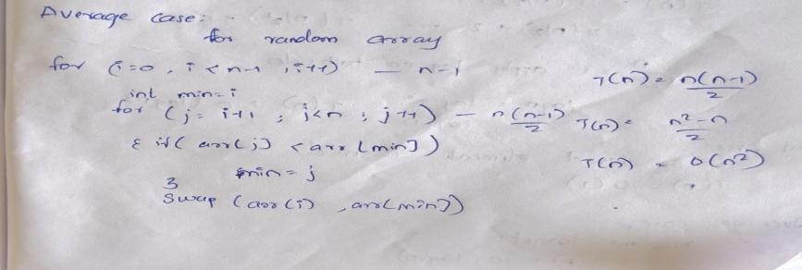
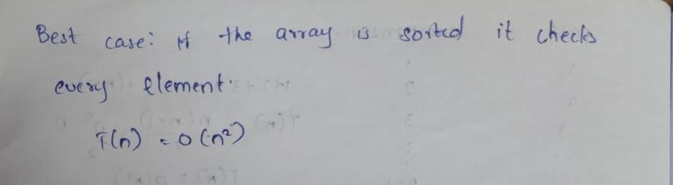

INSERTION SORT
Algorithm:
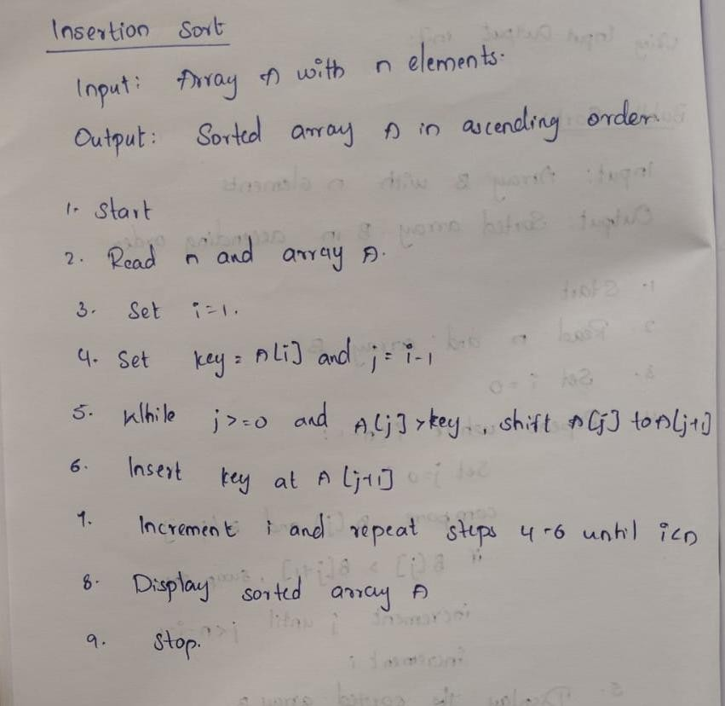
Program / Code:
#include <iostream> #include <vector> using namespace std;

void insertionSort(vector<int> &arr)
{ int n=arr.size();

for(int i=1;i<n;i++)
{
int key=arr[i]; int j=i-1;

while(j>=0 && arr[j]>key)
{ arr[j+1]=arr[j];
j--;
}

arr[j+1]=key;
}
};

int main(){
vector<int> numbers = {64, 34, 25, 12, 22, 11, 90};
insertionSort(numbers);

cout << "Sorted array using insertion sort: \n"; for (int value : numbers)
cout << value << ' ';

cout << '\n';
return 0;
}

Output:
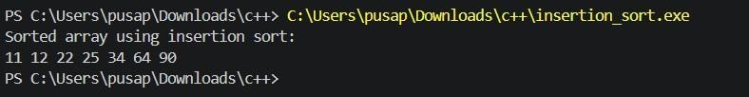
Time Complexity:
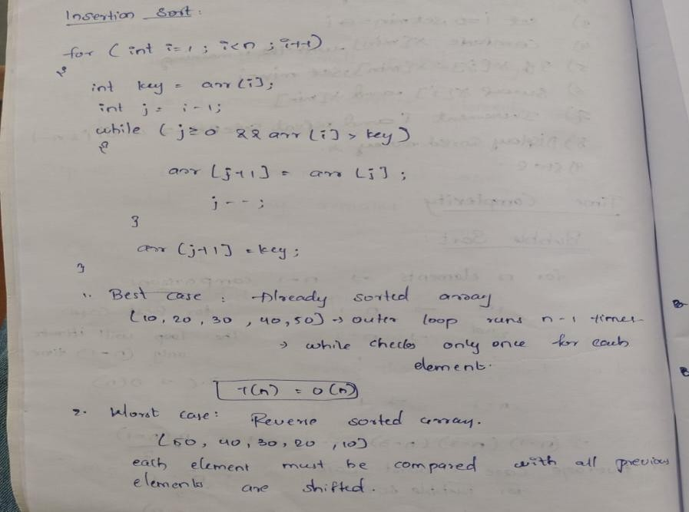

QUICK SORT Algorithm:
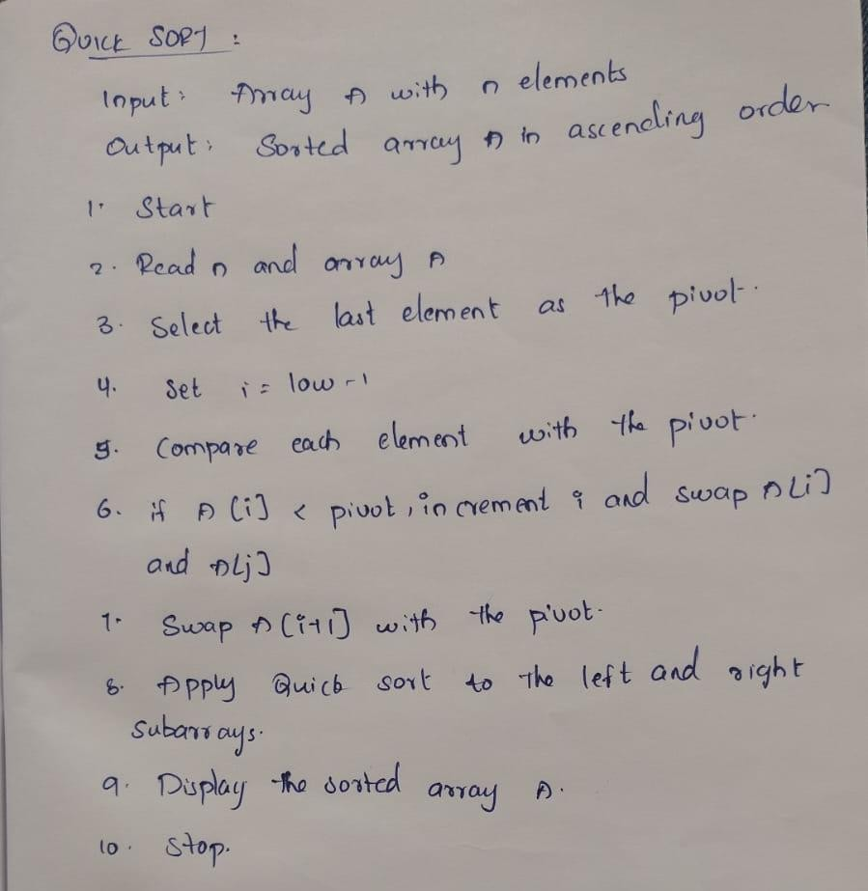

Program / Code:
#include <iostream>
#include <vector> #include <algorithm> using namespace std;

int partition(vector<int> &arr, int low, int high)
{ int pivot = arr[high]; int i = low - 1;

for (int j = low; j < high; j++)
{ if (arr[j] < pivot)
{ i++;
swap(arr[i], arr[j]); }
}

swap(arr[i + 1], arr[high]);
return i + 1;
}

void quickSort(vector<int> &arr, int low, int high)
{ if (low < high)
{
int pi = partition(arr, low,high);
quickSort(arr, low, pi - 1); quickSort(arr, pi + 1, high);
}
}

int main() {
vector<int> arr = {64, 34, 25, 12, 22, 11, 90};
int n = static_cast<int>(arr.size());

quickSort(arr, 0, n - 1);

cout << "Sorted array using quick sort:\n";
for (int value : arr)
cout << value << ' ';

cout << '\n';
return 0;
}

Output:
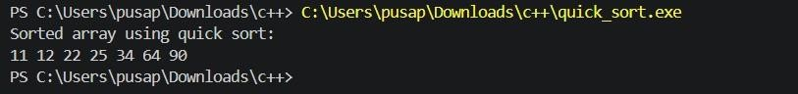
Time Complexity:

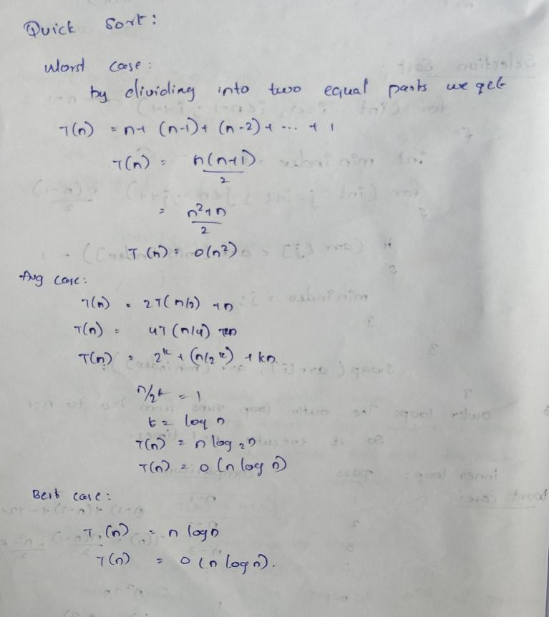

MERGE SORT

Algorithm:
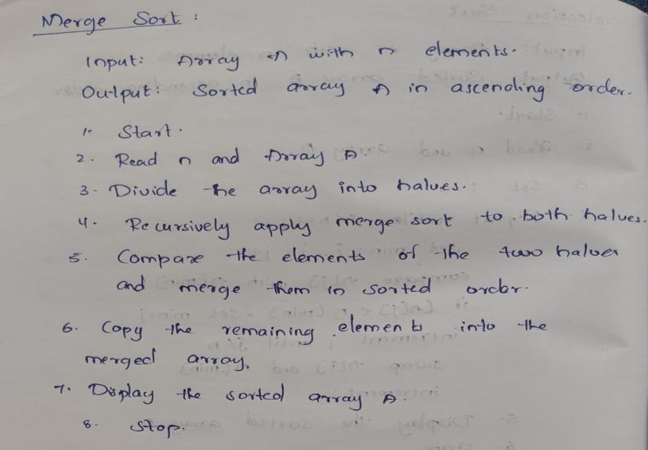

Program/code:
#include <iostream> #include <vector> using namespace std;

void merge(vector<int> &arr,int l,int m,int r)
{ int n1=ml+1; int n2=rm;

vector<int> L(n1),R(n2);

for(int i=0;i<n1;i++)
L[i]=arr[l+i];

for(int j=0;j<n2;j++)
R[j]=arr[m+1+j];

int i=0,j=0,k=l;

while(i<n1 && j<n2)
{ if(L[i]<=R[j]) arr[k++]=L[i++];
else
arr[k++]=R[j++];
}

while(i<n1)
arr[k++]=L[i++];

while(j<n2)
arr[k++]=R[j++];
}

void mergeSort(vector<int> &arr,int l,int r)
{ if(l<r)
{ int m=(l+r)/2;

mergeSort(arr,l,m);
mergeSort(arr,m+1,r);

merge(arr,l,m,r);
}
}

int main() {
vector<int> numbers = {64, 34, 25, 12, 22, 11, 90}; mergeSort(numbers, 0, numbers.size()
- 1);

cout << "Sorted array using merge sort: \n";
for (int value : numbers)
cout << value << ' ';

cout << '\n';
return 0;
}

Output:

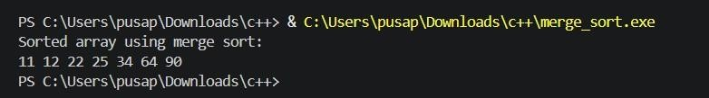
Time Complexity:
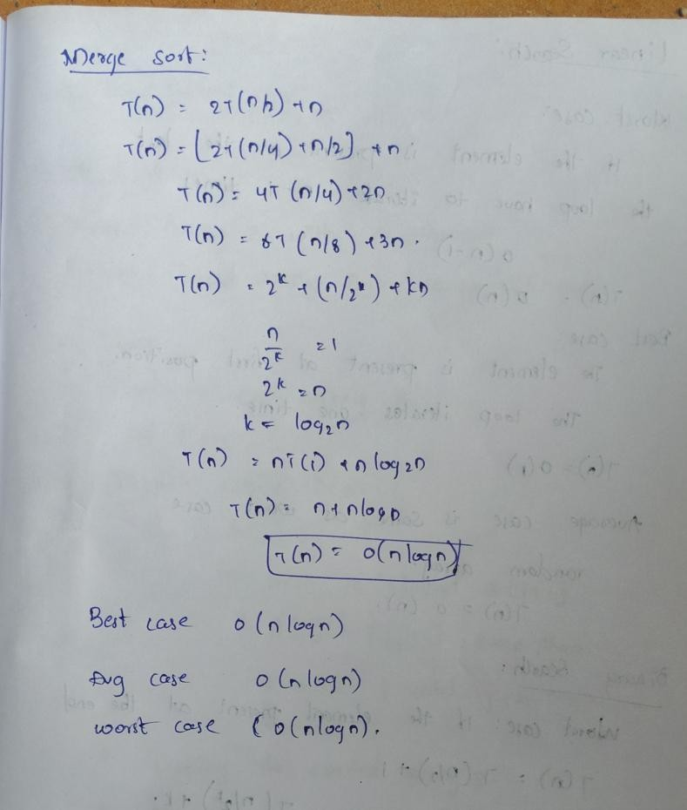

Conclusion:
Merge Sort and Quick Sort are efficient divide-and-conquer sorting algorithms. Merge Sort provides a consistent O(n log n) time complexity and is stable, while Quick Sort is generally faster in practice with an average O(n log n) complexity but can take O(n²) in the worst case. Both algorithms are useful for efficiently sorting large datasets.

