PRACTICAL: 06
Aim: Implementation of chain matrix multiplication of using dynamic programming.
Algorithm:
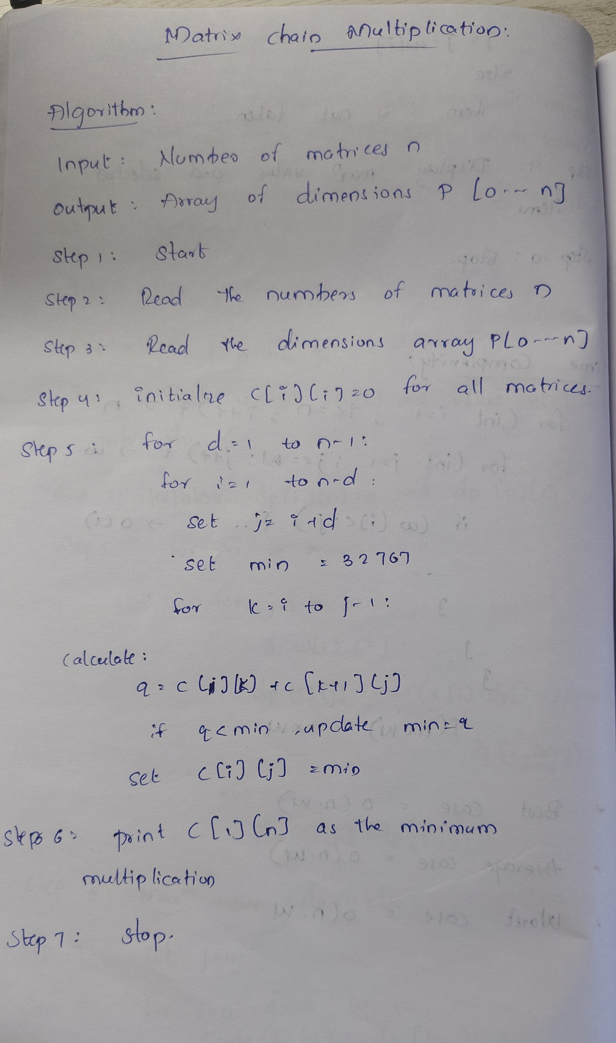

Program / Code:
#include <iostream>
using namespace std;

class MatrixChain{
private:
int p[20];
int c[20][20];
int n;

public:
void getInput()
{
cout << "Enter number of matrices: ";
cin >> n;

cout << "Enter dimensions: ";
for (int i = 0; i <= n; i++)
{
cin >> p[i];
}
}

void matrixChain()
{
// Cost of multiplying one matrix is 0
for (int i = 1; i <= n; i++)
{
c[i][i] = 0;
}

// d = chain length - 1
for (int d = 1; d < n; d++)
{
for (int i = 1; i <= n - d; i++)
{
int j = i + d;
int min = 32767;

for (int k = i; k <= j - 1; k++)
{
int q = c[i][k]
+ c[k + 1][j]
+ p[i - 1] * p[k] * p[j];

if (q < min)
{
min = q;
}
}

c[i][j] = min;
}
}

cout << "Minimum number of multiplications: "
<< c[1][n] << endl;
}
};

int main()
{
MatrixChain obj;

obj.getInput();
obj.matrixChain();

return 0;
}

Output:
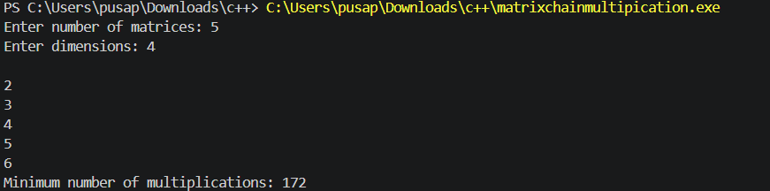

Time Complexity:
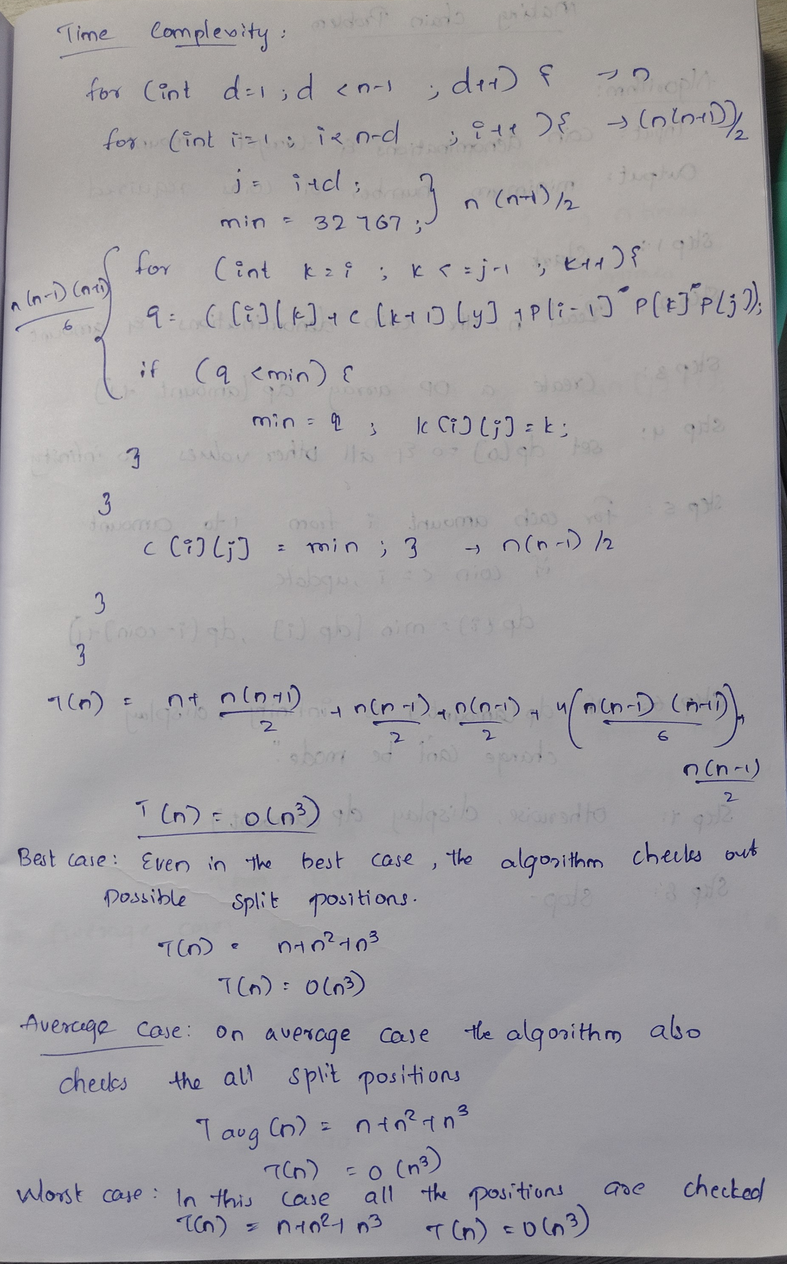

Conclusion:
The Matrix Chain Multiplication problem was successfully implemented using Dynamic Programming. The algorithm determines the optimal order of multiplying matrices while minimizing the total number of scalar multiplications. By storing the results of smaller subproblems in a DP table, the overall problem can be solved efficiently and systematically.

