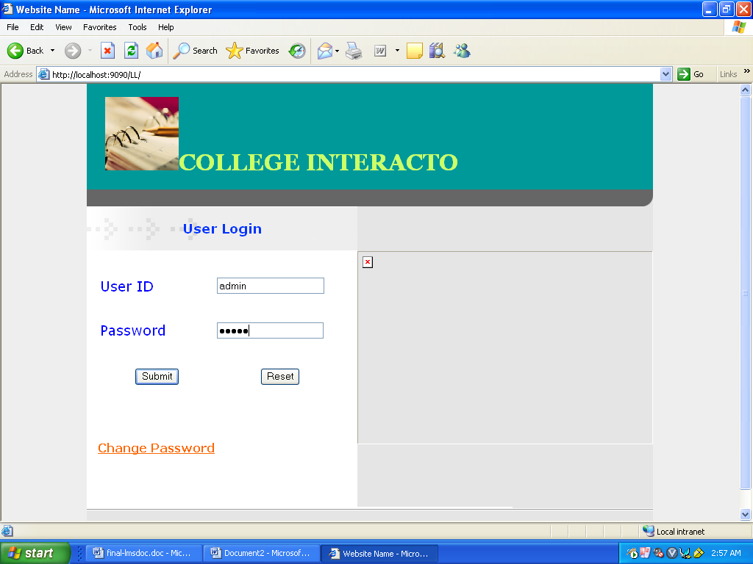

Fig: Login form
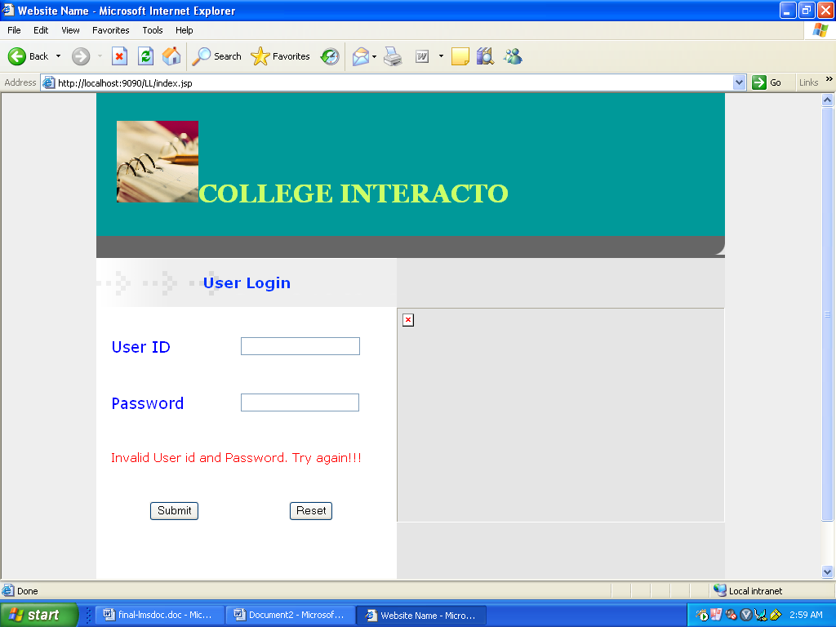

Fig: Screen displaying message “invalid User ID and password” when wrong password is entered.

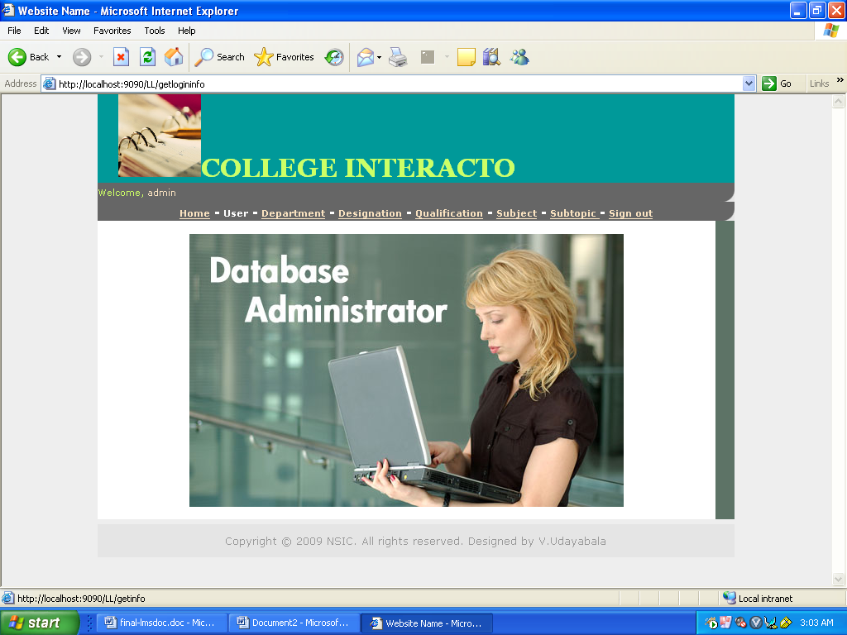

Fig: Administrator home page
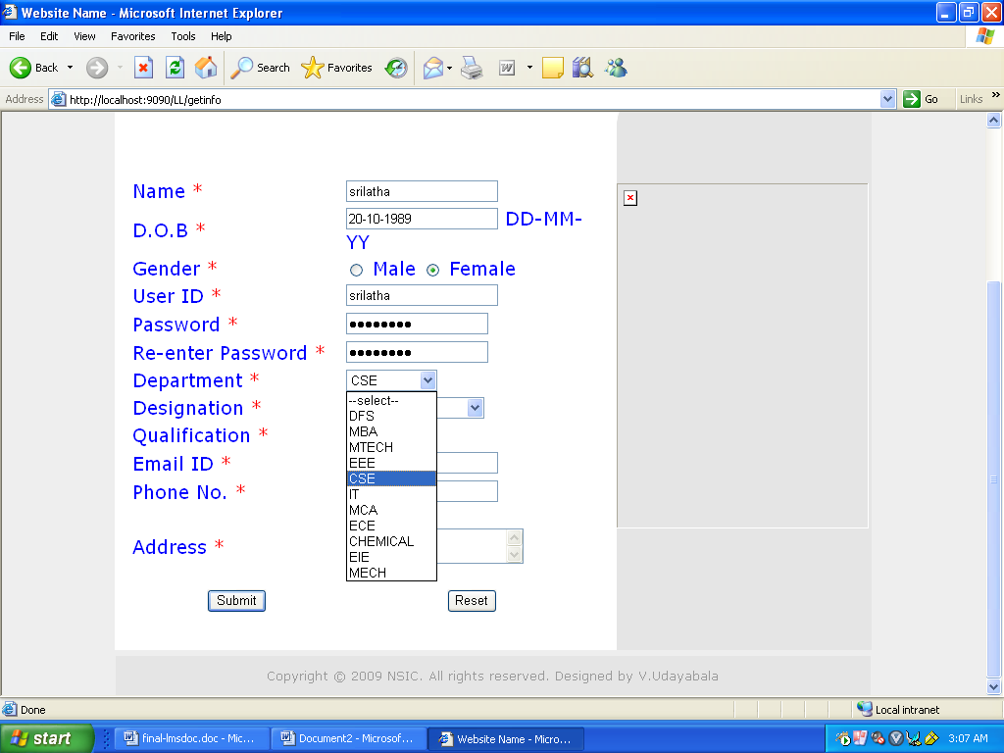

Fig: User Registration form
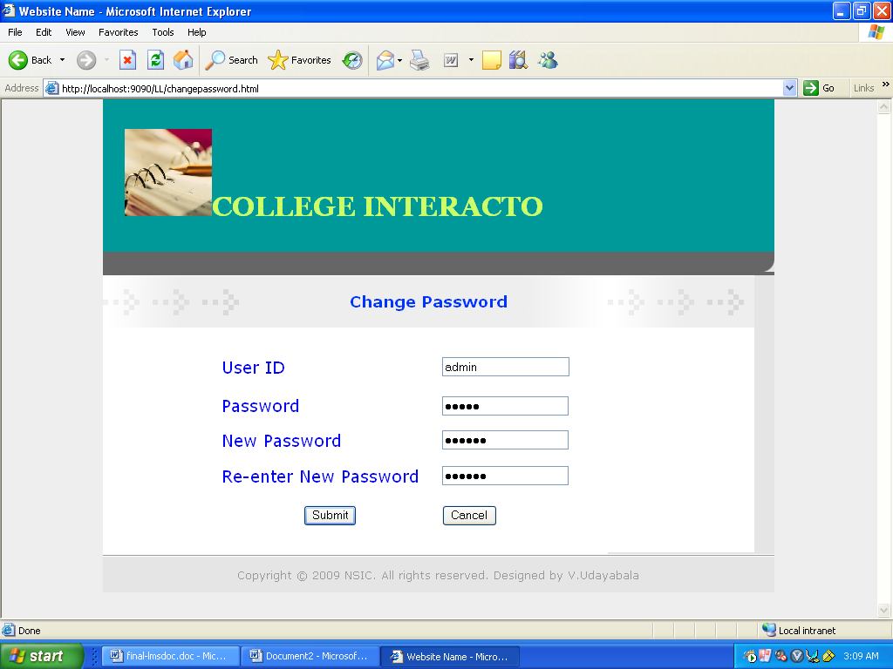
Fig: Screen for changing the password of the user.

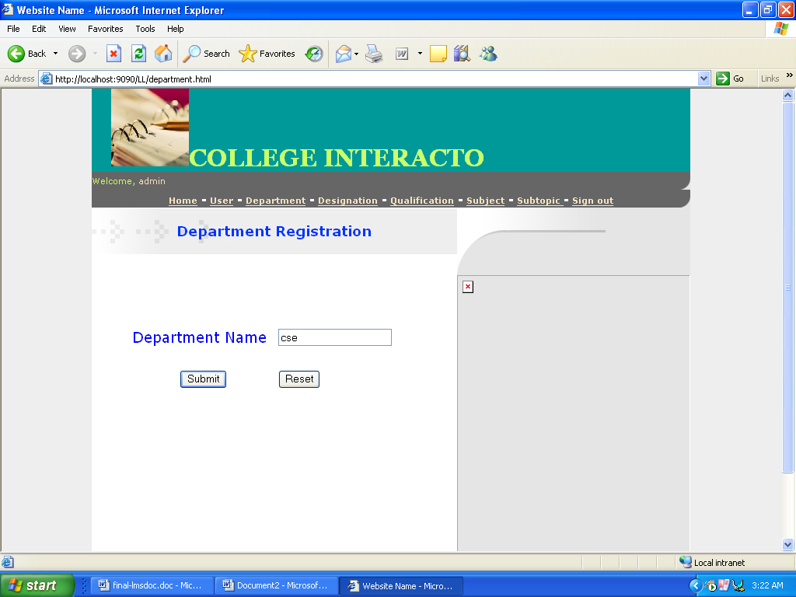

Fig: Screen to select department
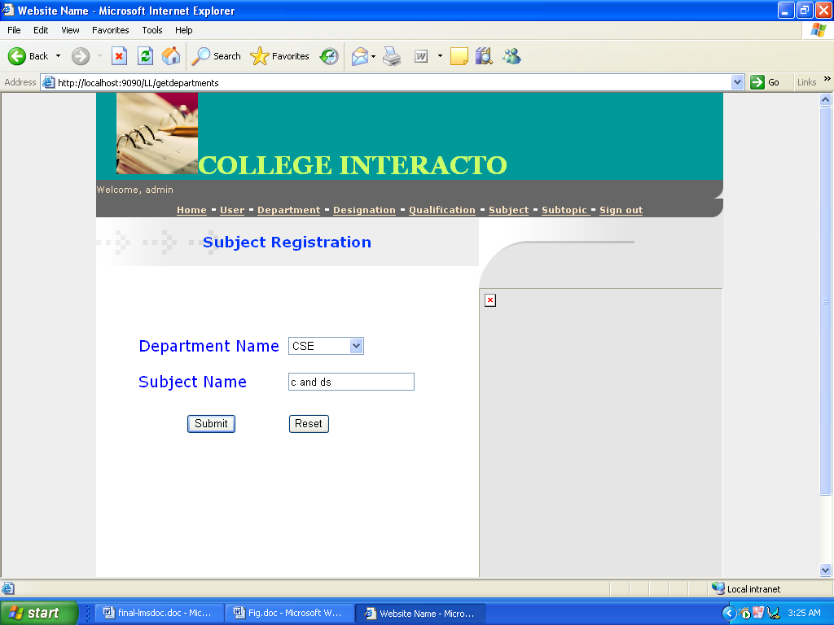
Fig: Screen to select subject of the selected department
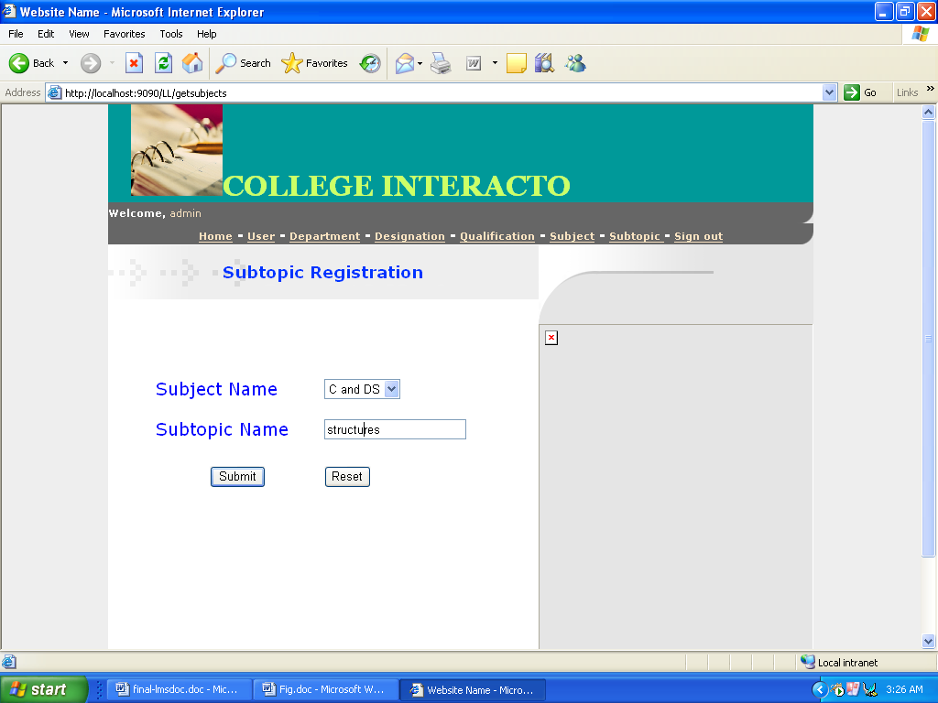
Fig: Screen to select subtopic of the selected subject

