React tutorial-

React is a declarative, efficient, and flexible JavaScript library for building user interfaces. It lets you compose complex UIs from small and isolated pieces of code called “components”.

Installing creat app things

npm install -g create-react-app npm - > node package manager

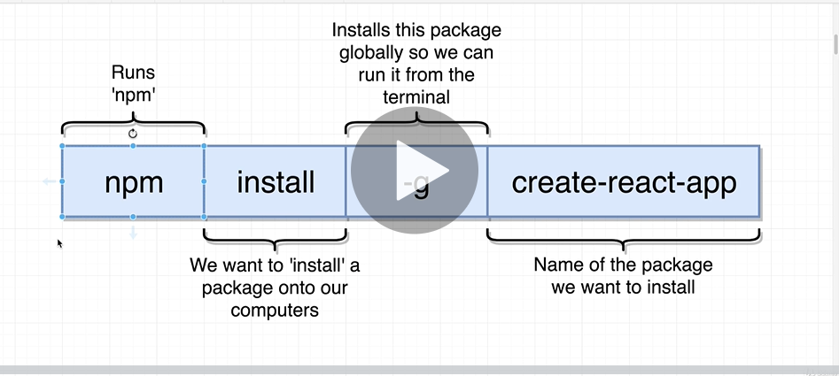

Creating project

Create-react-app “project-name” alternate -- > npx create-react-app <name of project>

npm start

Starts the development server.

npm run build

Bundles the app into static files for production.

npm test

Starts the test runner.

npm run eject

Removes this tool and copies build dependencies, configuration files

and scripts into the app directory. If you do this, you can’t go back!

We suggest that you begin by typing:

cd learnjsx

npm start

Happy hacking!

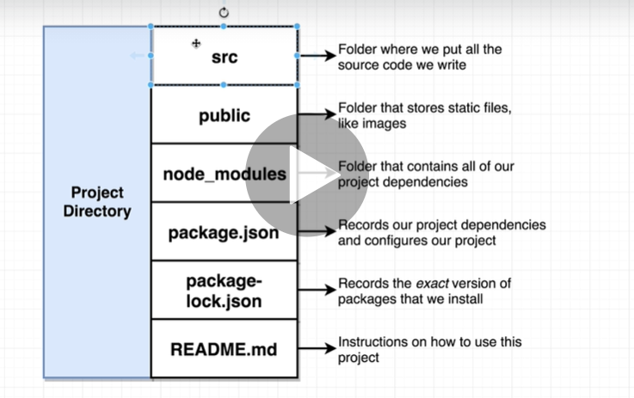

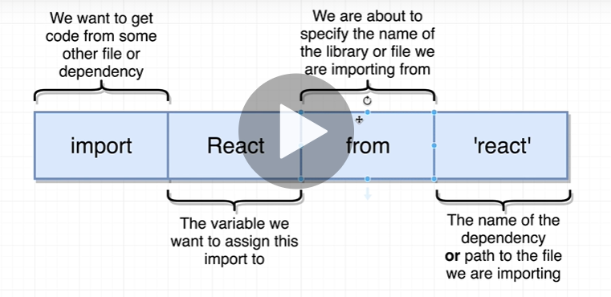

The components

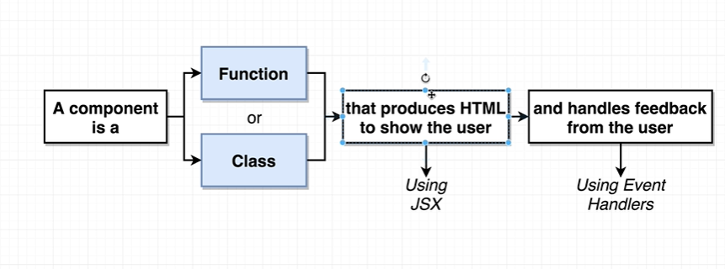

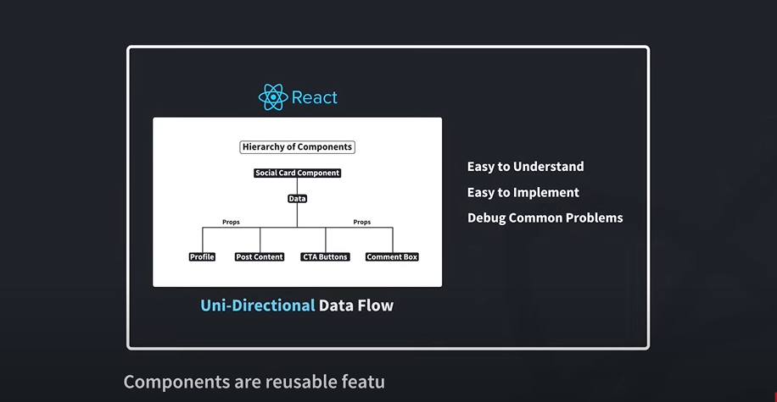

Two types of components

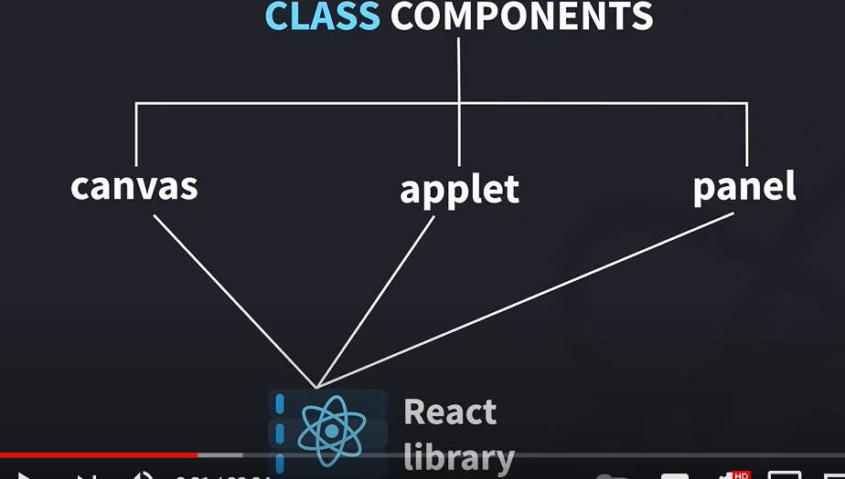

Render is main, focus on this.

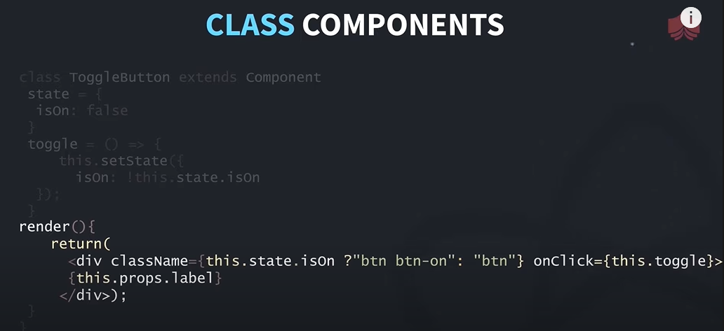

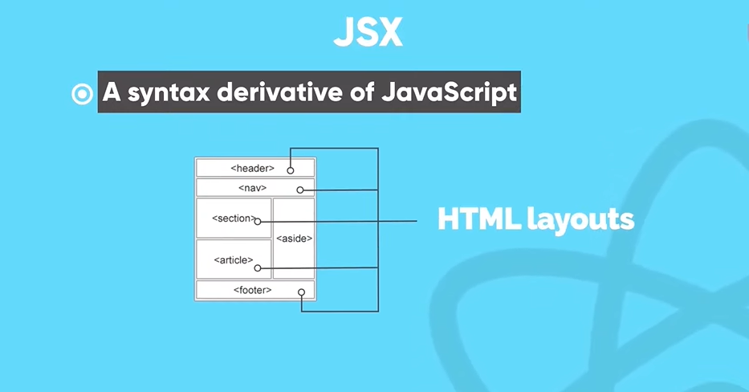

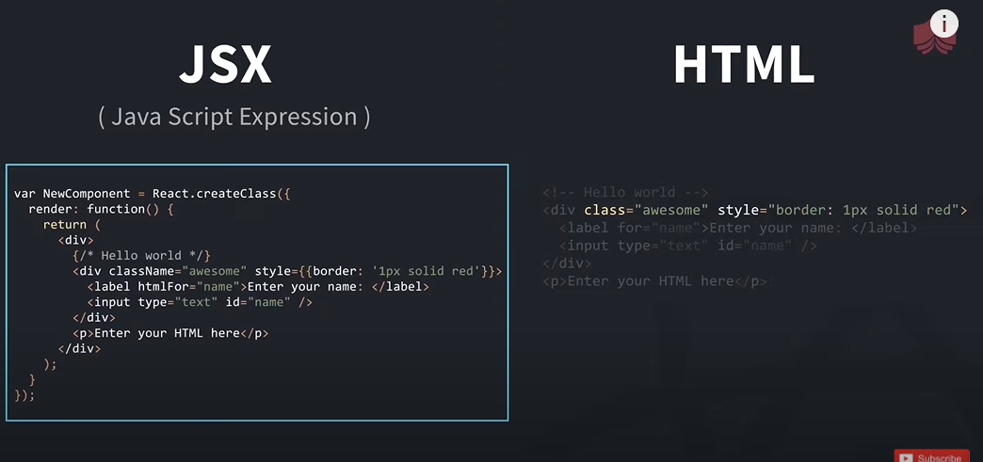

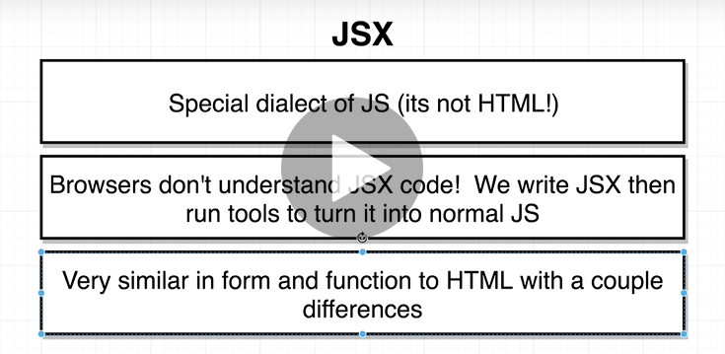

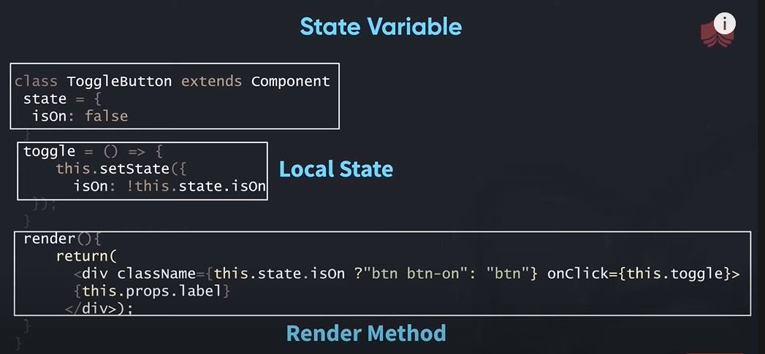

Coding convention-

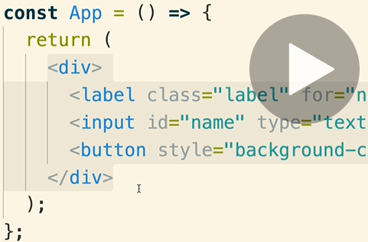

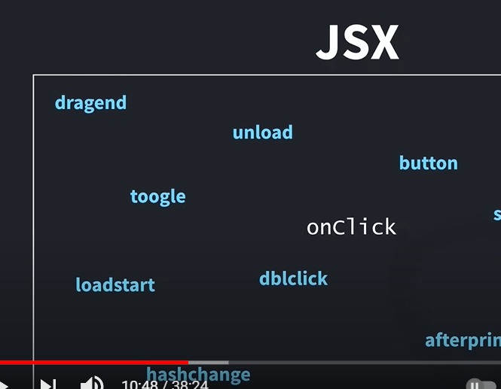

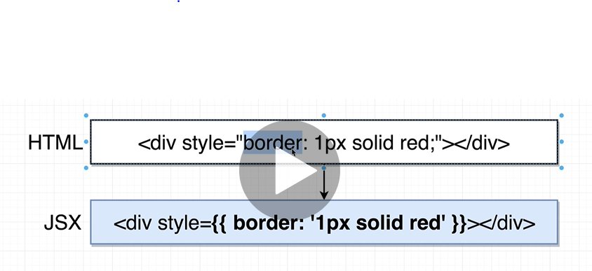 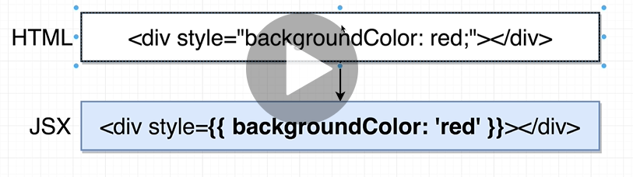

// Import react and react dom libraries

import React from 'react';

import ReactDom from 'react-dom';

// create a react components

const App = function () {

    return <div>

        <label class="label" for="name">

            Enter Name:

        </label >

        <input id="name" type="text" />

        <button style={{ backgroundColor: 'blue',colour:'white'}}>

            Submit

        </button>

        </div>;

};

// Take the react component and show it on the screen

ReactDom.render(

    <App />,

    document.querySelector('#root')

);

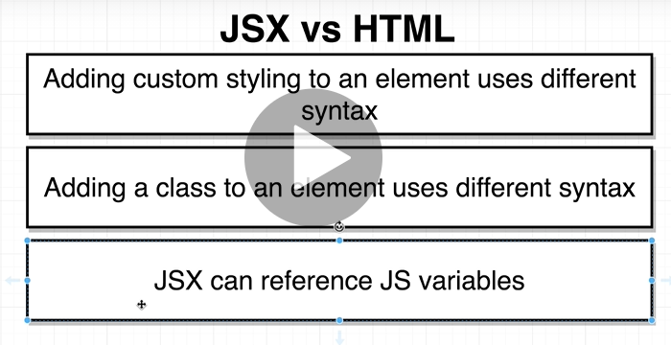

Start new project

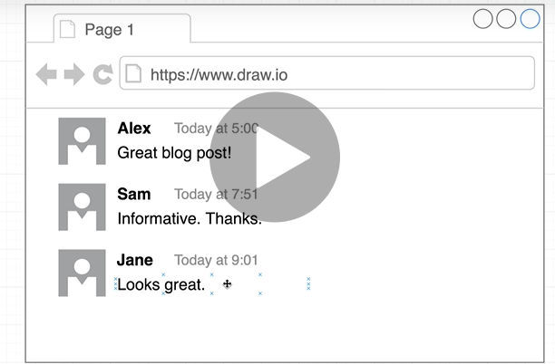

<https://cdnjs.com/libraries/semantic-ui> libraries…

<https://semantic-ui.com/views/comment.html> semantic UI

saving the faker by npm install –save faker

import  faker from 'faker';

then calling the function by faker.image.avatar

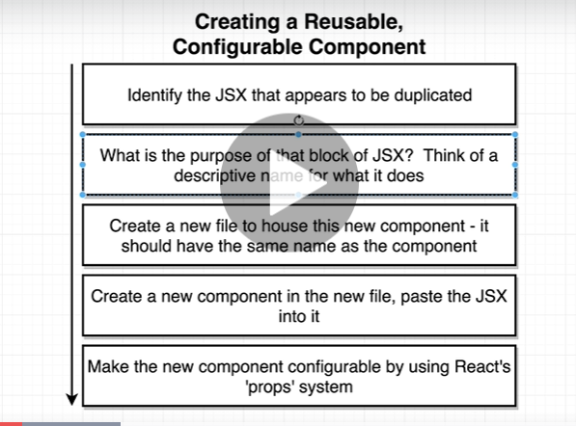

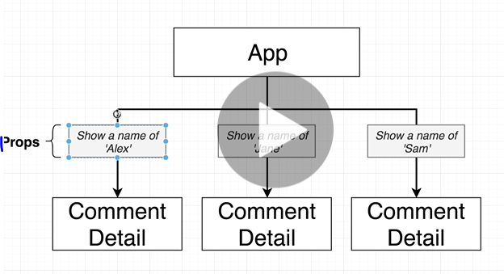

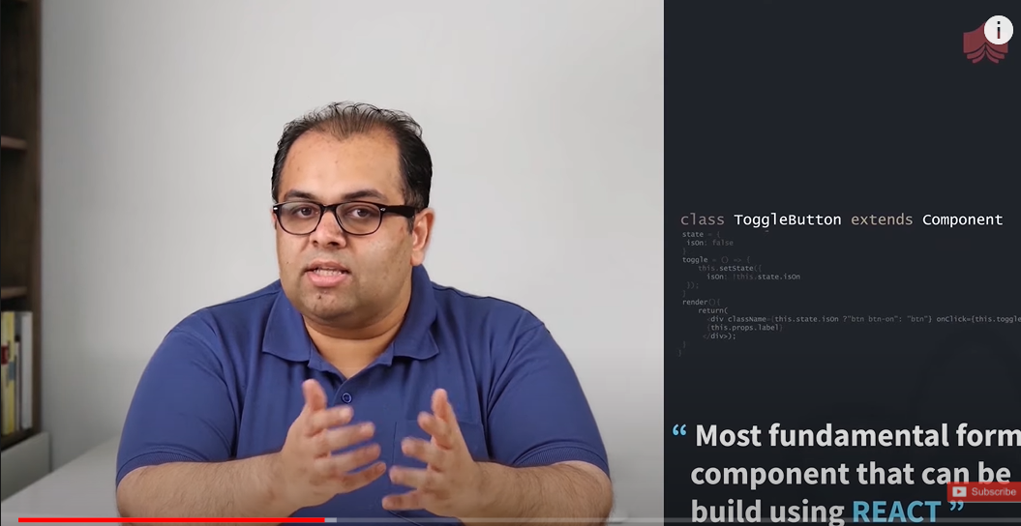

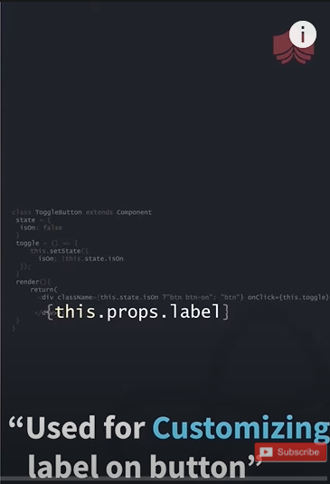

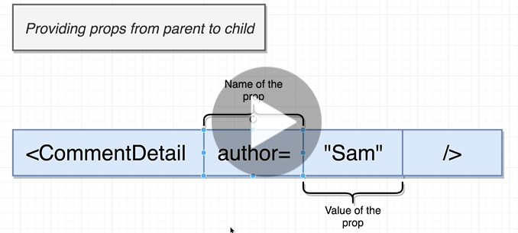

Second type of component is function component

Are a simple function that return a JSX template

