Problem statement 1: Gaming

* Code involves 3 players - User (X), Computer 1 (O), Computer 2 (T)
* It is assumed that Computer 1 and Computer 2 players are playing against user (X) but they are not playing against each other.
* Draw board function draws 6X6 board
* Endofgame function checks for column or row or diagonal win
* Alpha Beta (max and min) functions are created to check alpha – beta values for each position
* Static Evaluation is considered as below: -
  + If User (X) wins – Static Evaluation is -1
  + If User (O or T) wins – Static Evaluation is +1
  + If User (no one) wins – Static Evaluation is 0

Output

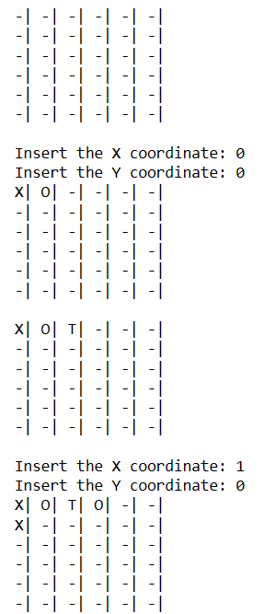

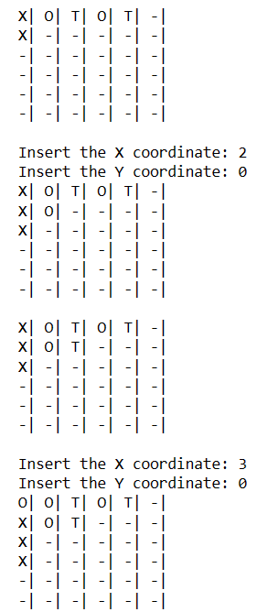

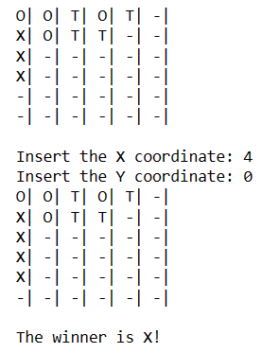

Problem Statement 2 - Logic

* Code is developed to derive decision tree. Code file is shared as “ACI_Assignment-2_Group-107-prolog_assignment.pl”. It is run and below is screen shot of results.

