**❌ What is a Query Antipattern in Cosmos DB for PostgreSQL (Citus)?**

A **query antipattern** refers to an inefficient or suboptimal way of querying distributed data, leading to poor performance, high latency, or excessive resource consumption. These typically arise when queries violate the principles of distributed computing—particularly **colocation** and **distribution-awareness**.

**🧠 Analogy: "Asking the Wrong People"**

Imagine you’re in a company where data is stored in filing cabinets by department:

* Sales → Cabinet A
* Marketing → Cabinet B
* HR → Cabinet C

Now suppose you want employee sales records. Instead of asking only Cabinet A, you shout:  
“Everyone give me anything related to employees!”  
Now all departments start searching, even when they don’t have relevant data.

➡️ This is a query antipattern: **you didn’t target the right data sources**, so the system **broadcasts the query** everywhere, causing inefficiency.

**💥 Common Query Antipatterns**

| **Antipattern** | **Description** | **Fix** |
| --- | --- | --- |
| 🔁 **Cross-Shard Joins without Colocation** | Joining two distributed tables not colocated causes full data movement across nodes. | Use colocate_with during table distribution. |
| 📦 **Querying without WHERE on Distribution Column** | Causes data scatter to all shards. | Always include a filter on the distribution column. |
| 🧮 **ORDER BY / LIMIT on distributed table without index** | Sorting globally across shards is expensive. | Use indexed fields or sort after coalescing. |
| 🧊 **Too many small shards (shard bloat)** | Too many shards make metadata overhead unbearable. | Use appropriate shard count. |
| 📢 **SELECT * over massive distributed table** | Returns excessive data and causes bottlenecks. | Project only necessary columns. |

**🧪 Demo Example: Cross-Shard Join (Antipattern)**

sql

-- Assume both tables are distributed on different keys

SELECT u.login, e.event_type

FROM payment_users u

JOIN payment_events e ON u.user_id = e.user_id;

**Problem**: If payment_users is distributed on user_id but payment_events is on event_id, this join will result in **data movement between shards**.

**✅ Better Version: Use Colocation**

-- Ensure both tables are distributed on 'user_id' and colocated

SELECT create_distributed_table('payment_users', 'user_id');

SELECT create_distributed_table('payment_events', 'user_id', colocate_with := 'payment_users');

-- Now the same query becomes efficient

SELECT u.login, e.event_type

FROM payment_users u

JOIN payment_events e ON u.user_id = e.user_id;

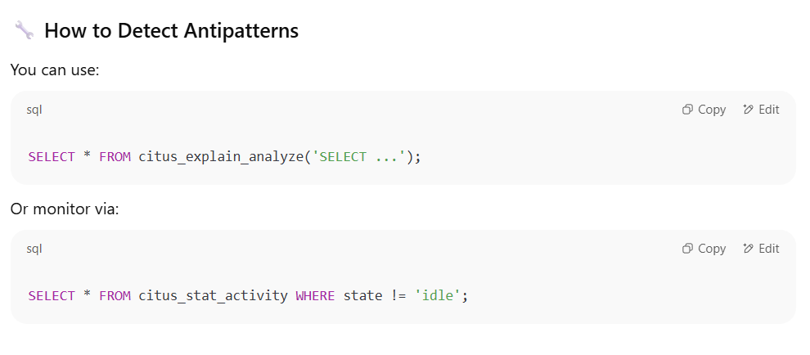

More AP Exmaples

**⚠️ Query Antipatterns (Based on Our Schema)**

**🔁 1. Cross-Shard Join Without Colocation**

*SELECT u.login, m.name*

*FROM payment_users u*

*JOIN payment_merchants m ON u.user_id = m.merchant_id;*

**Why it's bad**:

* payment_users is distributed on user_id, and payment_merchants on merchant_id.
* Join happens **on unrelated keys**, triggering **full data shuffle** across all shards.

**Fix**:

* Use reference tables for small lookup tables like payment_merchants.
* Or **colocate** on the same key if meaningful.

**🔍 2. Full Table Scan Without WHERE on Distribution Column**

*SELECT * FROM payment_events WHERE event_type = 'purchase';*

**Why it's bad**:

* No filter on user_id (the distribution key).
* Triggers **query on all shards**.

**Fix**:

SELECT * FROM payment_events

WHERE user_id = 123 AND event_type = 'purchase';

**🔁 3. Group By Without Filtering**

sql

CopyEdit

SELECT user_id, COUNT(*) FROM payment_events GROUP BY user_id;

**Why it's bad**:

* Though user_id is the distribution column, **no filtering** leads to **all-shards aggregation**.

**Fix**:

* Use WHERE user_id = ... if scoped to user
* Or optimize with materialized rollup tables or pre-aggregations.

**❌ 4. Non-Colocated Join on Distributed Tables**

sql

CopyEdit

SELECT e.event_type, m.name

FROM payment_events e

JOIN payment_merchants m ON e.merchant_id = m.merchant_id;

**Why it's bad**:

* payment_merchants is **reference or differently distributed**
* Join on merchant_id, which is not the distribution key of payment_events.

**Fix**:

sql

CopyEdit

-- Make `payment_merchants` a reference table

SELECT create_reference_table('payment_merchants');

**⚖️ 5. Overusing SELECT * in Distributed Tables**

sql

CopyEdit

SELECT * FROM payment_events WHERE user_id = 123;

**Why it's bad**:

* Returns unnecessary columns (event_details, created_at, etc.)
* Wasteful in distributed context.

**Fix**:

sql

CopyEdit

SELECT event_type FROM payment_events WHERE user_id = 123;

**🧱 6. Too Many Small Shards**

sql

CopyEdit

-- Implicitly creating with too many shards

SELECT create_distributed_table('payment_users', 'user_id', shards_count := 10000);

**Why it's bad**:

* Overhead in metadata, query planning, and shard management.

**Fix**:

* Use a **sensible shard count** (e.g., 32, 64) based on data volume and node count.