
INDIAN INSTITUTE OF TECHNOLOGY INDORE
Department of Mechanical Engineering
FINITE ELEMENT ANALYSIS OF A 2-D GRID STRUCTURE
Effect of Different Loading and Structural Conditions
A Project Report
Submitted in partial fulfillment of the requirements for the degree of
Master of Technology
(Mechanical System Design)
by
Pushkar Bharad
Roll No. 2502103016
Academic Year 2025–27

Abstract
This report presents a numerical finite element investigation of a two-dimensional braced grid structure.
The model contains 30 nodes connected through horizontal, vertical and diagonal members. A linear elastic
two-dimensional truss formulation is used to determine nodal displacement under static loading. The reference
configuration uses a 500 N downward point load at Node 7, Young's modulus of 210 GPa and a member cross-sectional
area of 5×10⁻³ m². Node 30 is restrained in both translational directions and Node 29 is restrained vertically
to remove rigid-body rotation. The reference calculation gives a maximum physical displacement of approximately
6.805×10⁻⁴ m at Node 7. The deformation shown in the figure is graphically magnified only to make the structural
response clearly visible.

1. Introduction
Finite Element Analysis (FEA) is a numerical method used to predict the response of engineering structures
subjected to external loading. A complex structure is divided into a finite number of interconnected elements.
The stiffness behavior of each element is formulated mathematically, and all element contributions are assembled
to form a global structural system. The resulting equations are solved to obtain nodal displacements and other
structural response quantities.

2. Objectives
The objectives of this project are to develop a two-dimensional grid/truss finite element model, formulate
and assemble element stiffness matrices, apply loading and boundary conditions, calculate nodal displacements,
identify the maximum displacement location, visualize the deformed structure, and investigate the effect of
different loading and structural stiffness conditions.

3. Geometry and Structural Model
The structure consists of 30 nodes. The lower grid extends from x = 0 m to x = 12 m and contains
two horizontal levels at y = 0 m and y = 1 m. The upper portion forms a tower-like braced grid extending to
y = 9 m. Horizontal and vertical members are connected with diagonal braces to create a triangulated structural
network. The horizontal nodal spacing is 2 m and the vertical spacing is 1 m.

4. Finite Element Theory
Each member is represented as a two-dimensional truss element with two translational degrees of freedom at
each node. For an element of length L, Young's modulus E, area A and direction cosines c and s, the standard
2-D truss stiffness matrix is formed in global coordinates. Assembly of all element matrices gives the global
equilibrium equation KU = F, where K is the global stiffness matrix, U is the nodal displacement vector and F
is the global load vector.

5. Material, Loading and Boundary Conditions
The members are assigned a steel-like Young's modulus of 210 GPa and a constant cross-sectional area of
5×10⁻³ m². A 500 N downward point load is applied at Node 7 for the reference condition. Node 30 is fixed in
both X and Y directions. Node 29 is restrained in the Y direction to remove rigid-body rotation and provide a
stable two-dimensional truss solution.

6. Computational Procedure
The analysis begins with the definition of nodal coordinates and element connectivity. For every element,
the length and direction cosines are calculated and the element stiffness matrix is generated. These matrices
are assembled into the global stiffness matrix. The load vector and support conditions are then applied. The
reduced system is solved for unknown nodal displacements. Finally, displacement magnitudes are calculated and
the original and deformed configurations are plotted for interpretation.

7. Reference Analysis Result
For the reference 500 N loading condition, the maximum physical displacement is 6.805×10⁻⁴ m
(approximately 0.681 mm) at Node 7. Since the physical deformation is very small compared with the 9 m overall
height of the structure, a visualization scale of 500 is used in the plotted result. This scale is only a
graphical magnification and does not change the calculated FEM displacement.
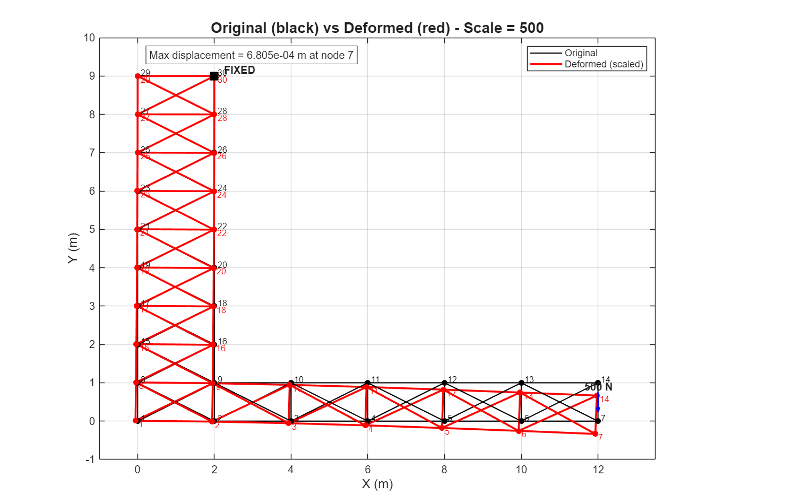
Figure 1. Reference FEA output showing the original grid in black and the magnified deformed grid in red.

8. Analysis Under Different Conditions
A parametric study is performed to examine the effect of load and structural stiffness. The first four
cases vary the applied load while maintaining the reference material and area. The remaining cases investigate
the effect of reducing Young's modulus and member cross-sectional area.
Case | Load | E (GPa) | Area (m²) | Max Disp. (m) | Node
Case 1 | 250 | 210 | 5.00e-03 | 3.402e-04 | 7
Case 2 | 500 | 210 | 5.00e-03 | 6.804e-04 | 7
Case 3 | 750 | 210 | 5.00e-03 | 1.021e-03 | 7
Case 4 | 1000 | 210 | 5.00e-03 | 1.361e-03 | 7
Case 5 | 500 | 105 | 5.00e-03 | 1.361e-03 | 7
Case 6 | 500 | 210 | 2.50e-03 | 1.361e-03 | 7

8.1 Case-by-Case Discussion
Case 1 – 250 N load: The lower 250 N load produces approximately half the reference displacement, as expected for a linear elastic structure.
Case 2 – 500 N reference: This is the reference condition shown in Figure 1, with a maximum displacement of approximately 0.681 mm at Node 7.
Case 3 – 750 N load: Increasing the load to 750 N increases the maximum displacement by approximately 50% relative to the reference condition.
Case 4 – 1000 N load: At 1000 N, the maximum displacement is approximately twice the 500 N reference value, consistent with linear elastic behavior.
Case 5 – E = 105 GPa: Reducing Young's modulus from 210 GPa to 105 GPa approximately doubles the displacement because stiffness is proportional to E.
Case 6 – A = 2.5×10⁻³ m²: This is the reference condition shown in Figure 1, with a maximum displacement of approximately 0.681 mm at Node 7.
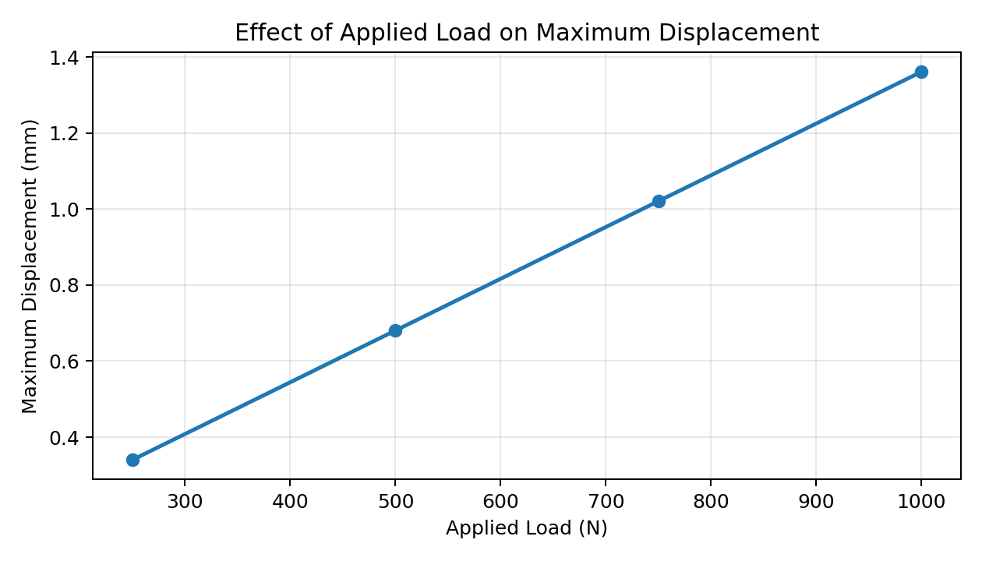
Figure 2. Effect of applied load on maximum displacement.

9. Results and Engineering Interpretation
The numerical results show the expected behavior of a linear elastic truss system. Increasing the applied
load increases displacement in direct proportion. Reducing Young's modulus or cross-sectional area reduces
member stiffness and therefore increases deformation. Node 7 remains the critical displacement location because
the load is applied there and the node is relatively far from the principal restraint.
- The black geometry represents the original undeformed structure.
- The red geometry represents the deformed configuration after graphical magnification.
- The displacement stated in metres or millimetres is the physical FEM result.
- The deformation scale shown in the figure is a visualization aid only.
- The diagonal bracing provides load paths and contributes to the overall structural stiffness.
- The parametric trends provide a useful consistency check for the numerical implementation.

10. Assumptions and Limitations
- Members are idealized as two-dimensional truss elements carrying axial force.
- Material behavior is assumed linear elastic and isotropic.
- Young's modulus and cross-sectional area are constant within each analysis case.
- Connections are idealized as pin joints.
- Geometric nonlinearities and large-deformation effects are neglected.
- The analysis is static and does not include dynamic or time-dependent effects.
- The displayed deformation is magnified for visualization and is not the physical scale of the structure.

11. Conclusion
A complete finite element model of a 30-node two-dimensional braced grid structure was developed and
evaluated. The study demonstrates the complete FEM workflow, including element formulation, global stiffness
assembly, application of loads and boundary conditions, solution of nodal displacements, and graphical
interpretation of the deformed structure. For the 500 N reference condition, the maximum physical displacement
is approximately 6.805×10⁻⁴ m at Node 7. The additional loading and stiffness cases demonstrate consistent
linear relationships between displacement, applied load and structural stiffness. The study therefore provides
a clear and practical demonstration of finite element structural analysis.

12. Future Scope
- Calculate member axial forces, stresses and strains.
- Introduce multiple load combinations and support configurations.
- Perform sensitivity studies for member size and material properties.
- Extend the model to beam and frame elements including bending stiffness.
- Include geometric and material nonlinear analysis.
- Compare the results with a commercial finite element package.

Appendix – Main Analysis Parameters
Young's modulus, E = 210 GPa
Cross-sectional area, A = 5×10⁻³ m²
Reference load, P = 500 N
Load location = Node 7
Fixed node = Node 30 (X and Y)
Additional restraint = Node 29 (Y)
Visualization scale = 500×

