
REPORT
OF
FULL-STACK WEB DEVELOPMENT INTERNSHIP

Submitted To
School of Computer Science and Engineering
IILM University, Greater Noida, U.P.
In partial fulfilment of the requirement for the degree of
B.Tech CSE
By
Name of Student: PUSHKAR NARAYAN
Roll No. of Student: 25SCS1003005607
Batch: 2025 – 2029
Academic Year: 2026 – 2027
Prodigy InfoTech
Internship Period: 01 August 2026 – 01 September 2026

1. CANDIDATE’S DECLARATION
I, PUSHKAR NARAYAN, do hereby declare that the internship report titled “FULL-STACK WEB DEVELOPMENT INTERNSHIP” has been prepared by me to fulfil the requirement for the award of the degree of Bachelor of Technology in Computer Science and Engineering. The work presented in this report is based on my learning and practical work carried out during the Full-Stack Web Development Internship at Prodigy InfoTech. I affirm that the report has not been submitted to any other institute for any degree or diploma requirement.
Signature: __________________________
Student Name: PUSHKAR NARAYAN
Roll No.: 25SCS1003005607

2. ACKNOWLEDGEMENT
I would like to express my sincere gratitude to everyone who supported and guided me throughout my Web Development Internship at Prodigy InfoTech. The internship provided me with an opportunity to gain practical exposure to web application development and to apply programming concepts while working on assigned technical tasks.
I am thankful to IILM University, the faculty members, and Prodigy InfoTech for providing this learning opportunity. I am also grateful to my parents and well-wishers for their continuous support and encouragement.
The practical work helped me improve my understanding of web application development, database connectivity, authentication, validation, debugging, and project organization. It also strengthened my problem-solving skills and confidence in developing and testing web-based applications.
Signature: _________________________
Student Name: PUSHKAR NARAYAN
Roll No.: 25SCS1003005607

3. INTERNSHIP COMPLETION CERTIFICATE

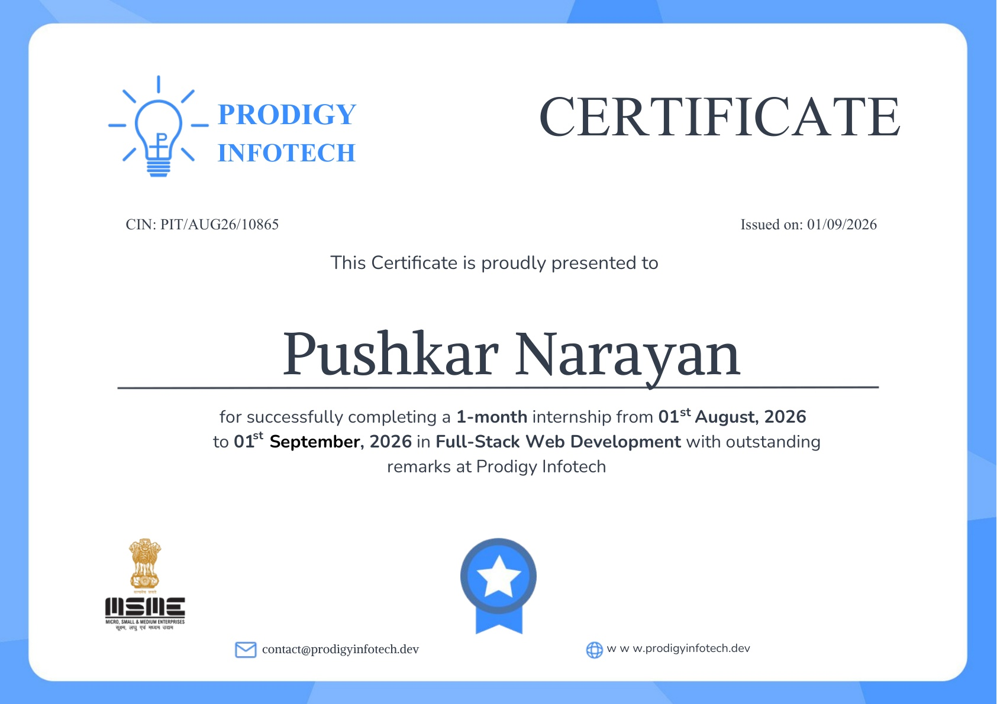

4. PROJECT DESCRIPTION

4.1 INTRODUCTION
The Full-Stack Web Development Internship at Prodigy InfoTech provided practical exposure to building web applications across the client, server, database, authentication and real-time communication layers. The work involved designing user-facing interfaces with HTML5, CSS3 and JavaScript, developing backend services with Node.js and Express.js, working with MongoDB and Mongoose for persistent data, implementing authentication mechanisms, creating CRUD APIs, and testing/debugging web application workflows.
The internship task track covered five application-oriented tasks: Secure User Authentication, Employee Management System, Local Store E-commerce Platform, Real-Time Chat Application, and Social Media Platform. The supplied project archive contains implementation files for Tasks 1–4, while Task 5 is documented in the report through its social-media UI demonstration. Together, the tasks provided a progressive understanding of full-stack application structure, API integration, database operations, security, real-time communication and user experience design.

4.2 ORGANIZATION PROFILE
Prodigy InfoTech provided the opportunity through a practical, project-based internship program. The internship emphasized learning by implementing assigned web-development tasks, understanding client-server interaction, working with databases and APIs, debugging application issues, and documenting the resulting work.

4.3 PROBLEM STATEMENT
Modern web applications require a coordinated frontend, backend, database and deployment-ready architecture. The internship tasks were designed to build practical skills in secure authentication, data validation, REST-style APIs, CRUD operations, persistent storage, real-time communication, responsive interfaces, debugging and documentation.

4.4 PROJECT OBJECTIVES
- To gain practical experience in full-stack web application development.
- To strengthen HTML5, CSS3 and JavaScript skills for responsive and interactive interfaces.
- To develop backend services and REST-style API routes using Node.js and Express.js.
- To work with MongoDB and Mongoose for schemas, queries and persistent data storage.
- To implement secure registration, login, password hashing and JWT-based protected routes.
- To understand and implement CRUD operations for employee and product records.
- To integrate frontend interfaces with backend APIs and database services.
- To implement real-time communication concepts using Socket.IO/WebSocket technology.
- To practice validation, error handling, testing, debugging and technical documentation.
To improve version-control and professional software-development practices using Git and GitHub.

4.5 SCOPE OF THE PROJECT
The scope of the internship work covers full-stack web application development from interface design to backend logic and database interaction. The implemented project archive demonstrates authentication, employee CRUD workflows, e-commerce product APIs, MongoDB persistence and real-time chat infrastructure. The Task 5 social-media interface demonstrates profile, posting and interaction concepts. The work forms a foundation for future deployment, stronger security controls, payment integration, notifications and production-grade services.

4.6 TECHNOLOGIES AND TOOLS USED
- HTML5 – structure of web pages, forms, navigation and content.
- CSS3 – responsive layouts, styling, cards, buttons and visual presentation.
- JavaScript – client-side interaction, DOM handling, form logic and API integration.
- Node.js – server-side JavaScript runtime used to build backend applications.
- Express.js – backend framework used for HTTP servers, middleware and API routes.
- MongoDB – NoSQL database used for persistent application data.
- Mongoose – ODM used for schemas, models, validation and database operations.
- bcryptjs – password hashing used in the authentication implementation.
- JSON Web Token (JWT) – token-based authentication and protected-route access in Task 1.
- Socket.IO – real-time client-server communication and room-based messaging in Task 4.
- CORS – cross-origin request handling for frontend/backend integration.
- dotenv – environment-variable management for configuration such as database connection settings and server configuration.
- Nodemon – development utility used to automatically restart the Node.js server during development.
- Git – version-control system used to track project changes and maintain development history.
- GitHub – remote repository and collaboration platform used to store and submit the internship project work.

4.7 SYSTEM ARCHITECTURE
The applications use a client-server architecture: the browser presents the interface, Node.js/Express handles HTTP requests and application logic, and MongoDB/Mongoose provides persistent storage. Task 1 adds bcryptjs and JWT for authentication, while Task 4 uses Socket.IO for real-time communication and message delivery.
- Visual Studio Code – development environment and code editor.

4.8 METHODOLOGY
- Understanding the assigned task requirements and expected user workflow.
- Planning page structure, components, data fields and API requirements.
- Developing frontend interfaces using HTML5, CSS3 and JavaScript.
- Creating Node.js/Express backend servers and REST-style API routes.
- Designing MongoDB/Mongoose schemas and implementing database queries.
- Applying input validation, error handling and authentication/security mechanisms.
- Integrating frontend requests with backend APIs and persistent data.
- Implementing real-time communication with Socket.IO for the chat task.
- Testing application flows in the browser, checking API responses and debugging issues.
- Using Git/GitHub for version control and preparing screenshots/documentation for submission.

5. TASKS ASSIGNED
The internship task track documented in this report consists of the following five tasks:
Task | Project
Task 1 | Secure User Authentication
Task 2 | Employee Management System
Task 3 | Local Store E-commerce Platform
Task 4 | Real-Time Chat Application
Task 5 | Social Media Platform
The following pages document the five assigned tasks and their demonstrated outputs.

Task 1 – Secure User Authentication
Task Objective: Implement a secure user authentication system with registration, login and protected-route access. The application validates required fields, checks for existing users, hashes passwords with bcryptjs, stores users in MongoDB, issues JWTs after successful login and verifies tokens before allowing access to protected resources.
Output Screenshot
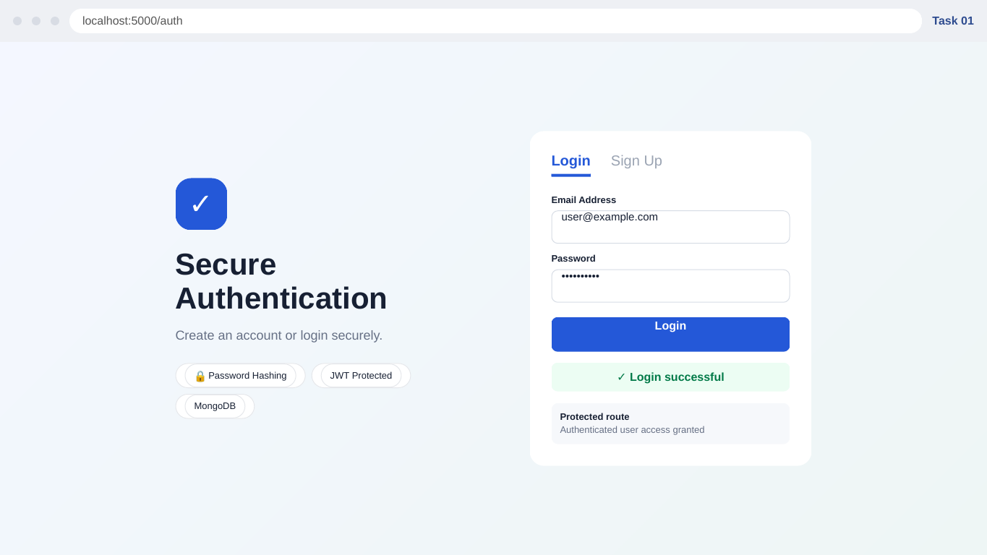
Figure 1:working-interface output for Task 1 – Secure User Authentication.
Key features demonstrated:
- Built the login and registration interface and connected it to backend authentication endpoints.
- Implemented password validation, duplicate-user checks and bcryptjs password hashing.
- Generated JWT access tokens after successful authentication and verified tokens in middleware.
- Created and tested a protected API route that requires a valid authentication token.
- Used MongoDB/Mongoose for persistent user records and handled success/error responses.

Task 2 – Employee Management System
Task Objective: Develop an Employee Management System that allows administrators to create, view, update and delete employee records. The backend defines an Employee model with name, email, position and department fields and exposes API routes for record management with validation and error handling.
Output Screenshot
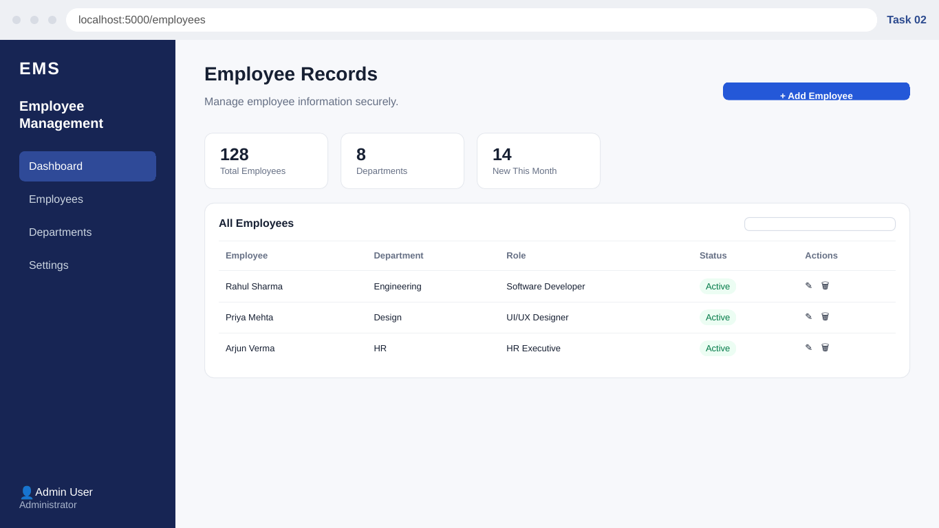
Figure 2: working-interface output for Task 2 – Employee Management System.
Key features demonstrated:
- Designed the employee dashboard and responsive record-management interface.
- Implemented GET, POST, PUT and DELETE API operations for employee records.
- Added field validation and duplicate-email checks before creating employee records.
- Connected the frontend to the backend API for retrieving and updating employee data.
- Practiced authenticated administrative workflows, record search and structured error handling.

Task 3 – Local Store E-commerce Platform
Task Objective: Develop a local e-commerce web application where customers can browse products through a practical shopping interface. The backend provides product retrieval, product creation and deletion routes backed by MongoDB/Mongoose, while the frontend presents catalogue cards, categories and shopping interactions.
Output Screenshot
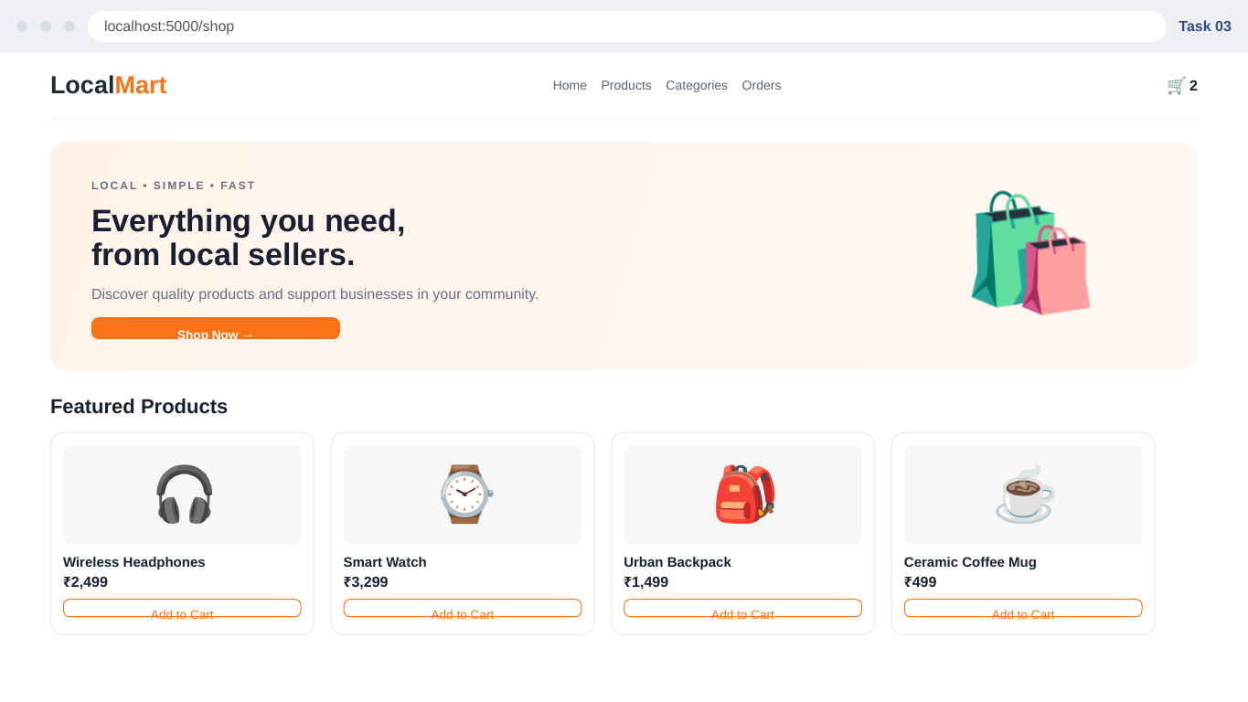
Figure 3: working-interface output for Task 3 – Local Store E-commerce Platform.
Key features demonstrated:
- Designed product cards, catalogue presentation, navigation and responsive styling.
- Implemented product data retrieval through Express API routes.
- Created a Mongoose Product model and practiced storing product name, description, price, category and image data.
- Added product creation and deletion API workflows with validation and error handling.
- Implemented frontend add-to-cart interaction and shopping-interface behaviour.

Task 4 – Real-Time Chat Application
Task Objective: Develop a real-time chat application using Socket.IO/WebSocket technology for instant messaging. The application uses Express for HTTP services, MongoDB/Mongoose for user and message data, and Socket.IO rooms/events for joining conversations, loading message history and broadcasting new messages.
Output Screenshot
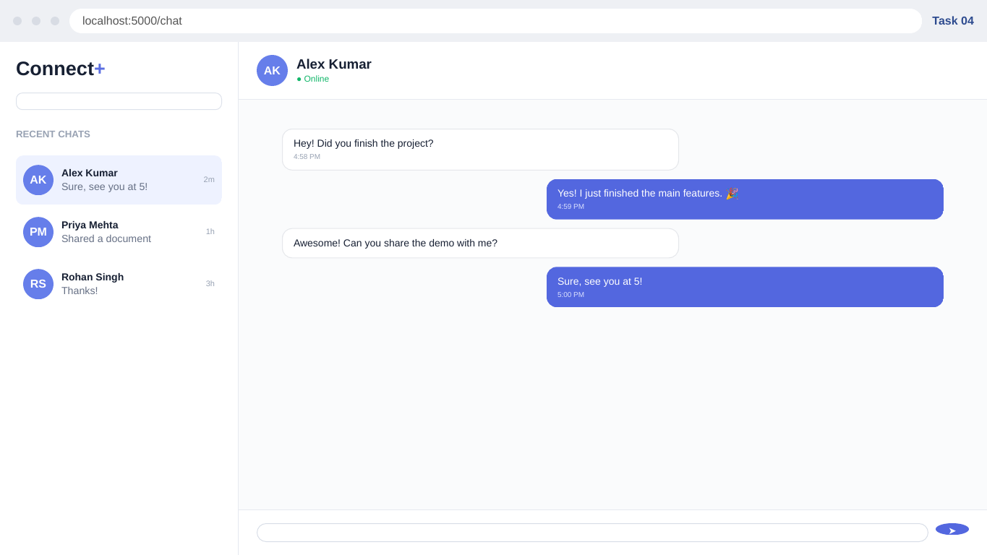
Figure 4:working-interface output for Task 4 – Real-Time Chat Application.
Key features demonstrated:
- Designed the conversation interface with contact list, online status and message areas.
- Implemented Socket.IO connection and room-joining logic for real-time communication.
- Loaded recent message history from MongoDB when a user joins a room.
- Saved outgoing messages to MongoDB and broadcast them to users in the same room.
- Implemented message composition, sender/receiver styling and connection/disconnection handling.

Task 5 – Social Media Platform
Task Objective: Build a social media application interface where users can create profiles, share posts and interact with other users. The demonstrated interface focuses on the user experience layer, including profile information, post composition, feed presentation and social interaction controls.
Output Screenshot
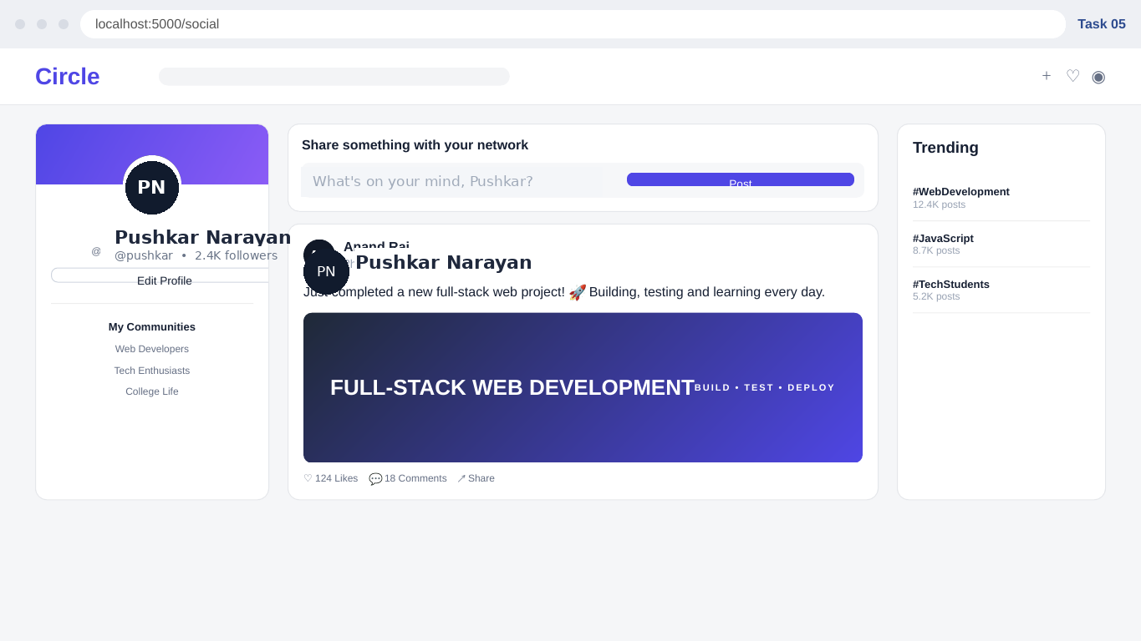
Figure 5: working-interface output for Task 5 – Social Media Platform.
Key features demonstrated:
- Designed the user profile section with avatar, name, handle and follower information.
- Created a post-composer interface for preparing user-generated content.
- Designed a feed-style post layout with readable content hierarchy and media presentation.
- Included likes, comments and sharing controls to represent social interaction workflows.
- Added a trending-topics area and community-oriented navigation elements.

6. RESULTS AND OUTCOMES
The internship provided hands-on exposure to the complete flow of a web application: understanding requirements, designing interfaces, writing frontend logic, building backend APIs, connecting databases, applying authentication, implementing real-time communication, testing and documenting results. The project archive demonstrates implementation work for Tasks 1–4, while the Task 5 report output documents the social-media interface. The experience strengthened my ability to translate requirements into working application components and understand how frontend, backend and database layers interact.

6.1 LEARNING OUTCOMES
- Understood the structure of a full-stack web application and the relationship between frontend, backend and database layers.
- Improved practical proficiency in HTML5, CSS3 and JavaScript for responsive and interactive interfaces.
- Learned to build Node.js and Express.js servers, middleware and API routes.
- Learned MongoDB and Mongoose concepts including schemas, models, queries and persistent storage.
- Implemented secure authentication concepts using bcryptjs password hashing and JWT protected routes.
- Practiced CRUD operations, request validation, duplicate checks and structured API error handling.
- Integrated frontend interfaces with backend APIs and database-backed application workflows.
- Implemented real-time communication concepts using Socket.IO rooms, events and message persistence.
- Improved browser testing, debugging, troubleshooting and problem-solving skills.

6.2 SOFT SKILLS AND PROFESSIONAL DEVELOPMENT
- Teamwork – learned to approach development tasks systematically and communicate progress and issues clearly.
- Communication – improved the ability to explain technical concepts, application workflows and implementation choices.
- Problem Solving – practiced breaking requirements into smaller development and debugging tasks.
- Time Management – organized multiple internship tasks, testing activities and documentation within the internship period.
- Attention to Detail – improved checking of UI alignment, validation rules, API responses and data flow.
- Professional Documentation – developed structured reporting habits using screenshots, descriptions and technical references.

6.3 FUTURE ENHANCEMENTS
Deploy applications to a cloud hosting environment and configure production environment variables.
Add stronger validation, rate limiting, security headers and role-based access control.
- Expand the e-commerce project with complete order processing and payment integration.
- Use production-grade Socket.IO infrastructure and stronger authentication for real-time chat.
- Extend the social platform with backend services, moderation, notifications and privacy controls.
- Improve automated testing and CI/CD practices for reliable deployment.

6.4 PROJECT REPOSITORY AND VERSION CONTROL
GitHub Repository: https://github.com/pushkarcse-tech/25-29_Pushkar-Narayan_25SCS1003005607_3rdSem_2CSE32-
The repository was used as the central project submission and version-control reference. It contains the source folders for Task 1 Secure User Authentication, Task 2 Employee Management System, Task 3 E-Commerce and Task 4 Real-Time Chat, together with the internship certificate and presentation. The technical descriptions in this report have been aligned with the repository structure and package dependencies.
Version-control learning: organizing repositories, maintaining project folders, tracking source files, preparing submissions, and using GitHub as a professional code-hosting and collaboration platform.

7. CERTIFICATE / SUPPORTING DOCUMENTS


SUPPORTING DOCUMENTS / OFFER LETTER
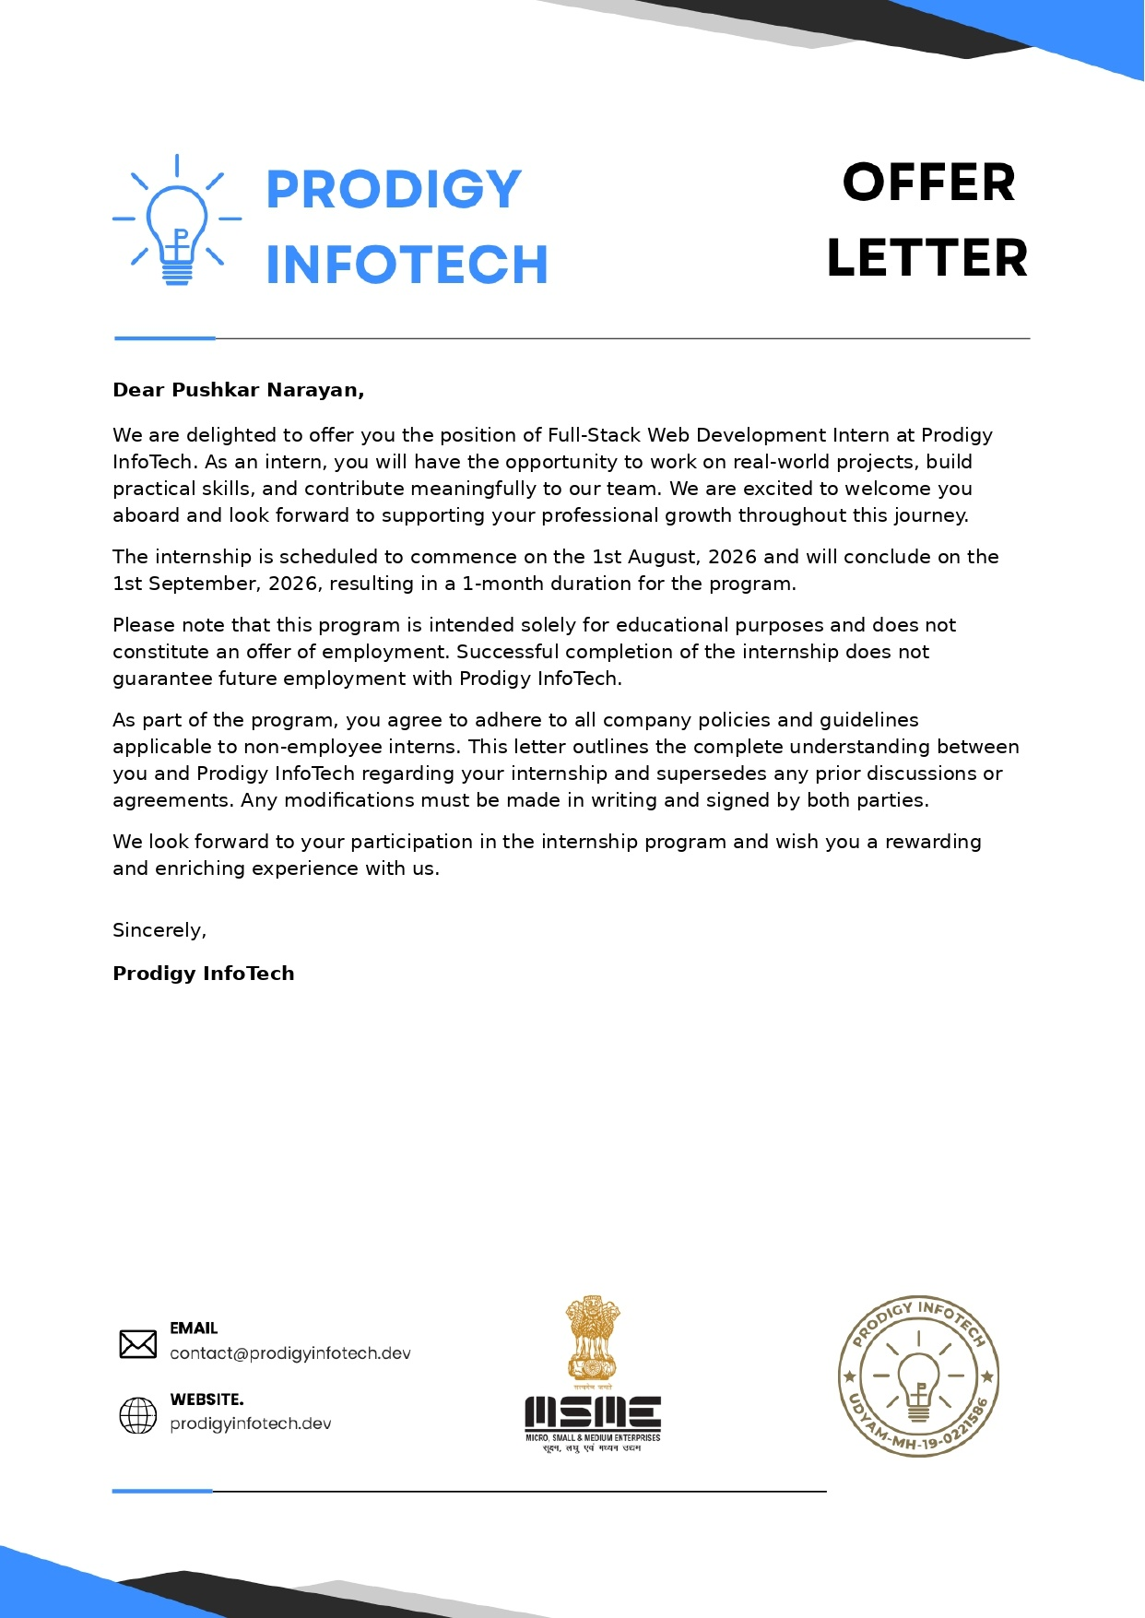

8. BIBLIOGRAPHY / REFERENCES

1. Prodigy InfoTech, Internship Offer Letter and Internship Task Materials, 2026.
2. MDN Web Docs, HTML, CSS, JavaScript and Web API documentation.
3. Node.js Documentation.
4. Express.js Documentation.
5. MongoDB Documentation.
6. Mongoose Documentation.
7. bcrypt package documentation.
8. JSON Web Token (JWT) documentation.
9. Project Repository – Pushkar Narayan, Full-Stack Internship Project Repository.

