Work Instruction
Registering On-Premises (Offline) SQL Server Instances in Azure Arc and Activating Extended Security Updates (ESUs) Using a Purchase Order (PO) Number
Applies to: SQL Server 2014 and SQL Server 2016 (disconnected / manually registered instances)
Field | Details
Document Title | Register On-Prem Offline SQL Servers in Azure Arc and Activate ESU via PO Number
Purpose | Step-by-step procedure to manually register disconnected SQL Server instances in the Azure portal (Azure Arc) and link the ESU volume-licensing invoice using the Purchase Order Number
Reference | Microsoft Learn – “Register SQL Server instances for ESUs” (extended-security-updates-disconnected-instances)
Prepared By | __________________________
Date | __________________________
Version | 1.0

1. Overview
Extended Security Updates (ESUs) provide critical security patches for SQL Server versions that have reached end of support. Servers that cannot be connected to Azure Arc directly (offline / disconnected environments) must be manually registered in the Azure portal so that ESUs purchased through volume licensing can be activated and downloaded.
Manual registration is required in the following scenarios:
- The SQL Server instance cannot be connected to Azure Arc directly (e.g., air-gapped or restricted network environments).
- The SQL Server on Azure VM is in a region that does not currently support ESUs for Azure VMs.
Note: If neither scenario applies, Microsoft recommends connecting the server to Azure Arc directly (connected mode) instead of manual registration, to take advantage of the full flexibility of Arc-enabled ESUs.
About the figures: The figures in this document are illustrative representations of the Azure portal screens, created to guide the reader through each step. Actual portal layout and labels may differ slightly. Refer to the Microsoft Learn source article for original screenshots.

2. Prerequisites
Complete all items below before starting the registration procedure.
- Azure subscription. An active Azure subscription is required (Microsoft Customer Agreement, Enterprise Agreement, pay-as-you-go, or free account).
- Azure RBAC permissions. The user performing the registration must have the following permissions:
  - Microsoft.AzureArcData/sqlServerInstances/read
  - Microsoft.AzureArcData/sqlServerInstances/write
  - These can be granted via the Azure Connected SQL Server Onboarding role, or via built-in roles such as Contributor or Owner.
- Register the resource provider. The Microsoft.AzureArcData resource provider must be registered in the subscription:
  - Sign in to the Azure portal.
  - Navigate to the subscription and select Resource providers.
  - If Microsoft.AzureArcData is not listed as Registered, select it and click Register.
- Azure Policy check. If Azure policies restrict resource creation to specific resource types, ensure the Microsoft.AzureArcData/sqlServerInstances resource type is allowed. Otherwise, the SQLServerInstances_Update operation fails with a 'deny' Policy action entry in the subscription activity log.
- Information to collect per server. For every SQL Server instance to be registered, collect: instance name (output of SELECT @@SERVERNAME), SQL Server version, edition, number of cores, and host type.
- ESU purchase details. The Purchase Order (PO) Number from the Microsoft ESU invoice (found under Invoice Summary on the invoice) is required to activate ESUs.

3. Procedure A – Register a Single SQL Server Instance
- In the Azure portal, go to Azure Arc > SQL Server instances.
- Select Add in the navigation bar.
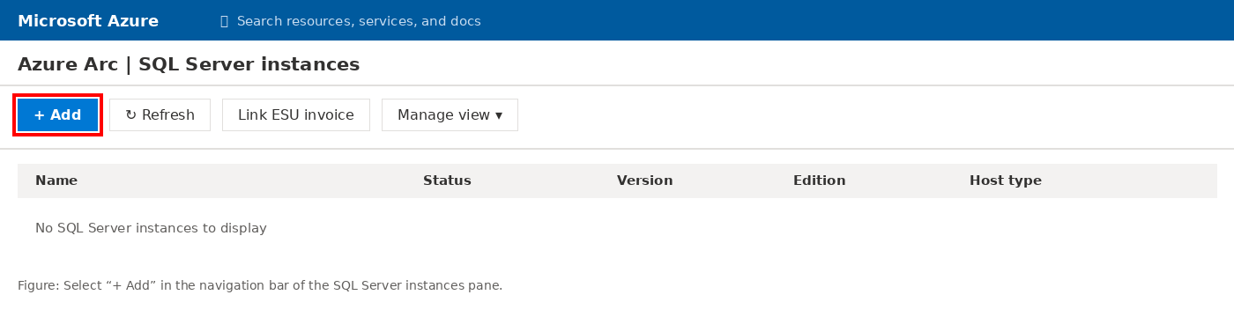
Figure 1: The “+ Add” button on the Azure Arc > SQL Server instances pane (illustrative representation of the Azure portal)
- Select Register SQL Server instances.
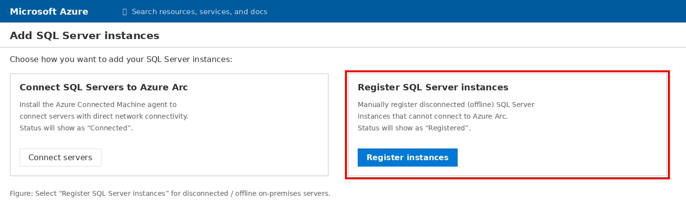
Figure 2: Choosing “Register SQL Server instances” for disconnected servers (illustrative representation of the Azure portal)
- Choose Single SQL Server Instance (this is the default option).
- Select the Subscription and Resource group where the registered instance will be created.
- Enter the instance details as per the table below, then select Next.

Field | What to Enter | Notes
Instance Name | Output of the T-SQL command SELECT @@SERVERNAME | For a named instance, replace the backslash (\) with a hyphen (-). Example: MyServer\Instance01 becomes MyServer-Instance01
SQL Server Version | Select the version from the dropdown (e.g., SQL Server 2014 / 2016)
Edition | Select from: Datacenter, Developer, Enterprise, Standard, Web, Workgroup | Developer edition is free to deploy if ESUs were purchased
Cores | Number of cores for the instance
Host Type | Virtual machine (on-premises), Physical Server (on-premises), Azure Virtual Machine, Amazon EC2, Google Compute Engine, Other | For on-prem offline servers, select the applicable on-premises option

- Confirm the entitlement checkbox to declare that your organization has the rights to receive ESUs, then complete the registration.
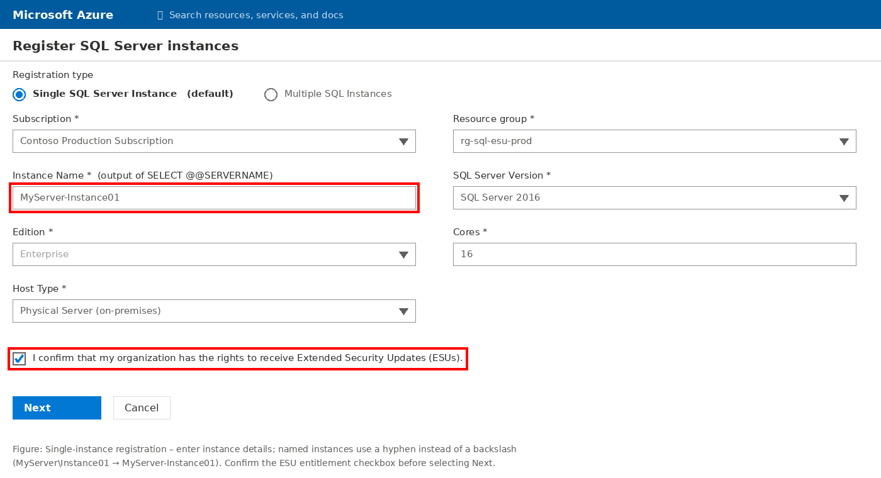
Figure 3: Single-instance registration form with entitlement confirmation (illustrative representation of the Azure portal)

4. Procedure B – Register Multiple SQL Server Instances in Bulk (CSV Upload)

4.1 Prepare the CSV File
- Separate values with commas; do not use single or double quotes around values.
- Values may contain letters, numbers, hyphens (-), and underscores (_) only – no other special characters.
- For named instances, replace the backslash (\) with a hyphen (-). Example: MyServer\Instance01 becomes MyServer-Instance01.
- Column names are case-sensitive and must be exactly: name, version, edition, cores, hostType
Example CSV content:
name,version,edition,cores,hostType
Server1-SQL2014,SQL Server 2014,Enterprise,12,Other Physical Server
Server2-SQL2014,SQL Server 2014,Enterprise,24,Other Physical Server
Server3-SQL2014,SQL Server 2014,Enterprise,12,Azure Virtual Machine
Server4-SQL2014,SQL Server 2014,Standard,8,Azure VMware Solution

4.2 Upload and Register
- In the Azure portal, go to Azure Arc > SQL Server instances.
- Select Add in the navigation bar.
- Select Register SQL Server instances.
- Select the option for Multiple SQL Instances.
- Select the Browse icon and upload the prepared CSV file.
- Confirm the entitlement checkbox to declare that your organization has the rights to receive ESUs, then complete the registration.
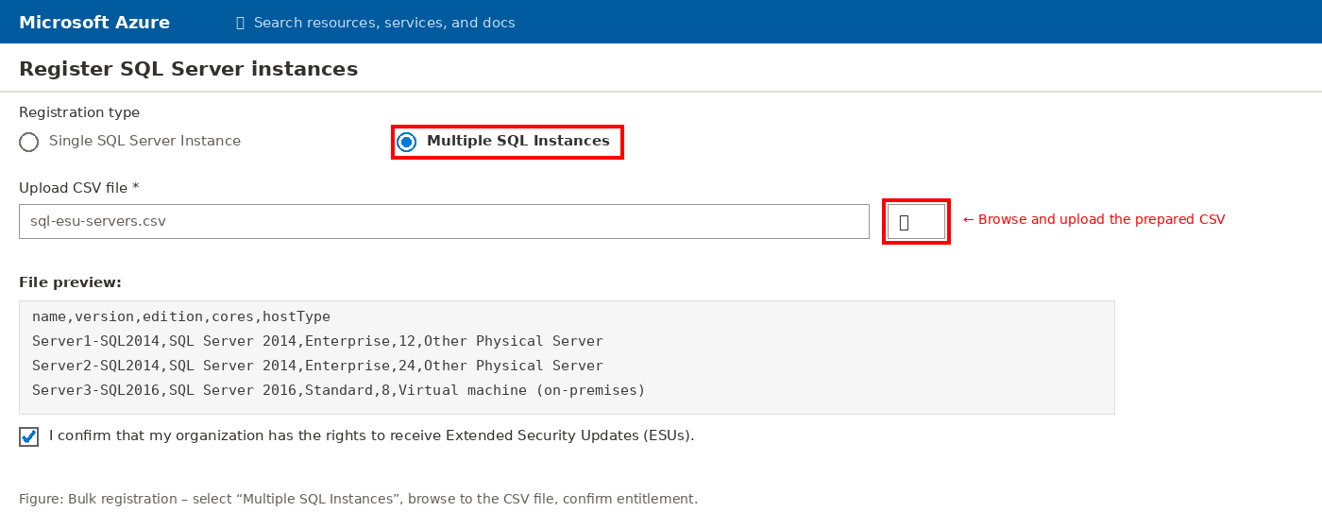
Figure 4: Bulk registration – uploading the CSV file for multiple instances (illustrative representation of the Azure portal)
Verification: Registered instances appear in the SQL Server instances pane within a few minutes. Because they were added manually, their status always shows as “Registered” (as opposed to “Connected” for Arc-connected servers).
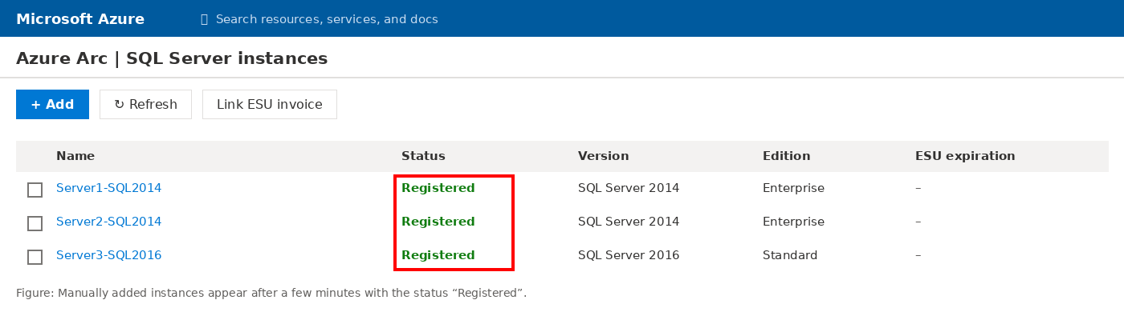
Figure 5: Registered instances shown with the status “Registered” (illustrative representation of the Azure portal)

5. Procedure C – Activate ESUs by Linking the Invoice (PO Number)
ESUs are activated by linking the ESU volume-licensing purchase to the registered SQL Server instances. The value used as the Invoice ID is the Purchase Order Number shown under the Invoice Summary section of the Microsoft invoice.
- Locate the Purchase Order Number under the Invoice Summary section of your Microsoft ESU invoice.
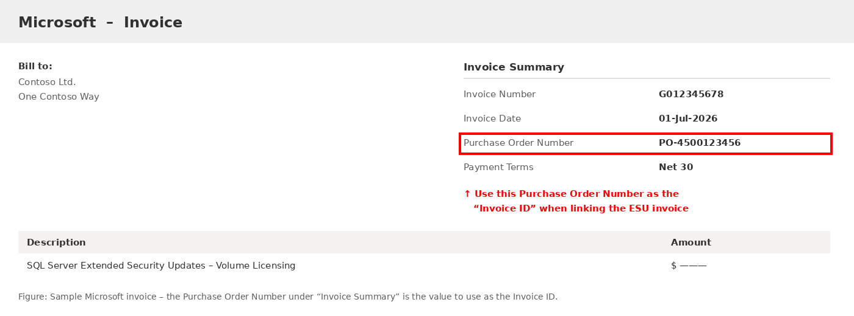
Figure 6: Sample Microsoft invoice with the Purchase Order Number under Invoice Summary (illustrative representation of the Azure portal)
- In the Azure portal, go to Azure Arc > SQL Server instances.
- Select the checkboxes next to each SQL Server instance to be linked, then select Link ESU invoice.
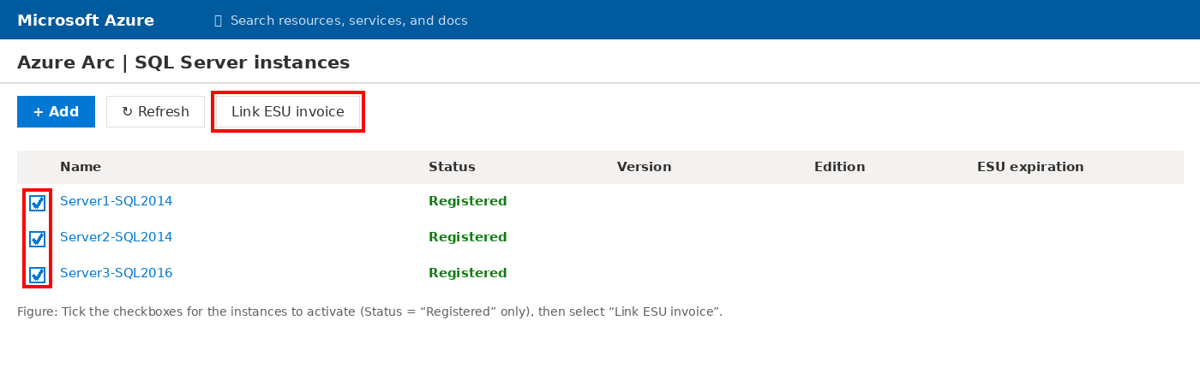
Figure 7: Selecting registered instances and choosing “Link ESU invoice” (illustrative representation of the Azure portal)
- Enter the PO number in the Invoice ID field, then select Link invoice.
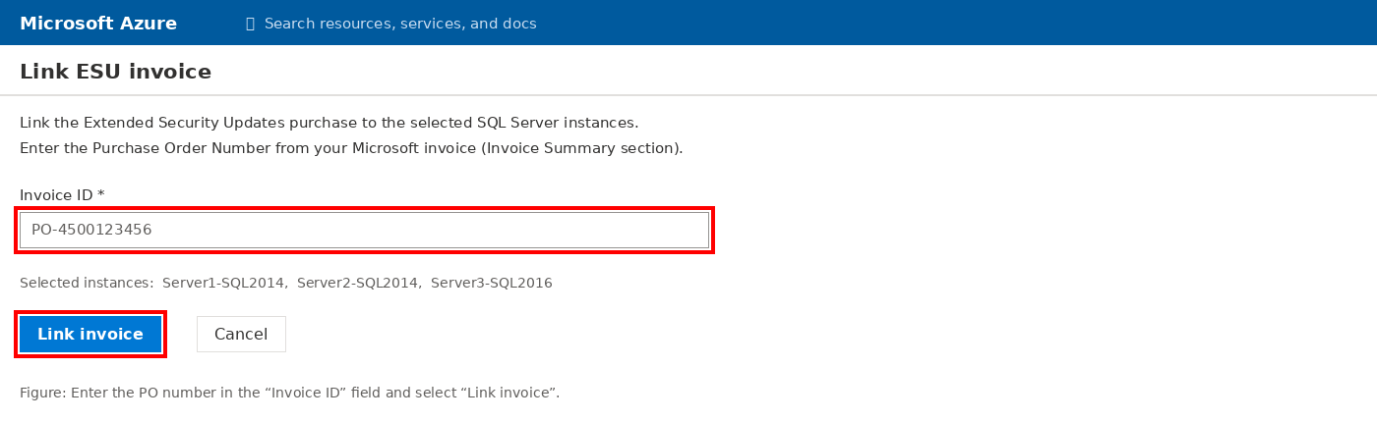
Figure 8: Entering the PO number as the Invoice ID and linking the invoice (illustrative representation of the Azure portal)
- Verify activation: the linked servers now display a valid ESU expiration date in the portal.
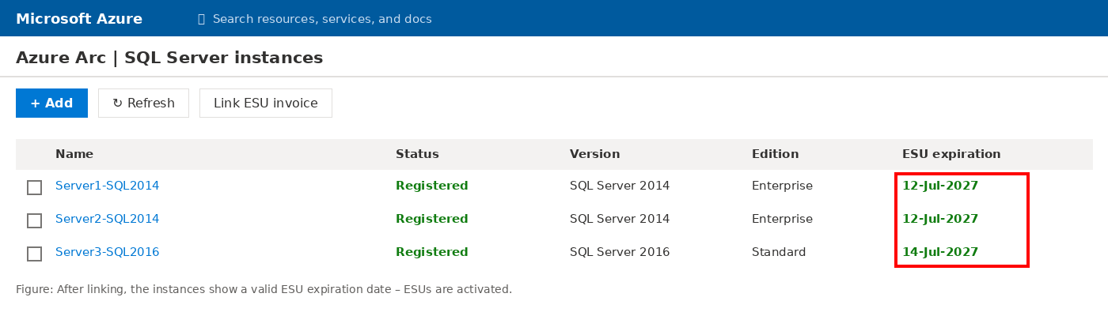
Figure 9: Linked instances showing a valid ESU expiration date (illustrative representation of the Azure portal)
Important: When registering an ESU volume-licensing product for disconnected SQL Server servers, select only the instances with a Status of “Registered”.

6. Procedure D – Download ESUs
- After the ESU invoice is linked, open the relevant SQL Server instance resource in the Azure portal.
- Go to the Extended Security Updates pane.
- Manually download the available ESU packages and apply them to the offline SQL Server(s) using your standard offline patching process.

7. Quick Reference Checklist
# | Task | Done (✓)
1 | Azure subscription available and Microsoft.AzureArcData resource provider registered
2 | User has Azure Connected SQL Server Onboarding role (or Contributor/Owner)
3 | Azure Policy allows Microsoft.AzureArcData/sqlServerInstances resource type
4 | Server details collected (instance name, version, edition, cores, host type)
5 | Instances registered in Azure Arc (single or bulk CSV)
6 | Instances visible in portal with status “Registered”
7 | PO Number obtained from Microsoft invoice (Invoice Summary section)
8 | ESU invoice linked to registered instances (Invoice ID = PO Number)
9 | Valid ESU expiration date visible on linked instances
10 | ESU packages downloaded from Extended Security Updates pane and applied

Source: Microsoft Learn – Register SQL Server instances for ESUs: https://learn.microsoft.com/en-us/sql/sql-server/end-of-support/extended-security-updates-disconnected-instances

