**Cab booking application using springboot and kafaka.**

Database “eventstore” and “readdb” has created .

Empty tables has created after both vehicleloc-app and cab-book-app microserice started.

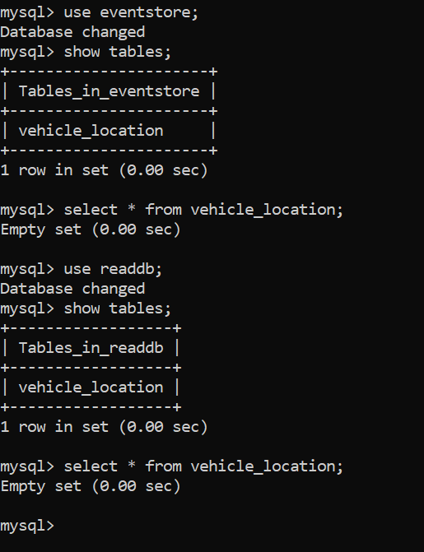

Topic: “Vehicle_location” has created in kafka as message broker

Creating two vehicle record with different latitude and longitude:

URL POST: http://localhost:9002/vehicle

Fetch all vehicle details from vehicleloc-app microservice

URL GET: http://localhost:9002/vehicle

Database entry into eventstore and readdb databases.

User send a cab booking request and based on latitude and longitude vehicle is getting assigned.

-Here the latitude and longitude of the user are 25.77 and 80.12 respectively, whereas the cab details are 25.7811 and 80.1311. As per our find close vehicle location logic, close vehicle can be assigned as the variation in decimal places is +/- 0.01 for rounding of 2 digits.

POST URL: http://localhost:9001/book

If user location is not nearby vehicle then it will below message to the user.

