**Room Reservation System:**

‘rrs’ database has created with create-drop ddl property.

Eureka service registry with api-gateway, config-server, property-app, booking-app, payment-app

HTTP Request using api-gateway(port:9013):-

1. POST URL: to create the property record into the database from property-app microservice.

2. GET URL: to fetch the all properties details from database.

3. GET Request : to fetch the property detail based on ID

URL: http://localhost:9013/property/1

4. HTTP GET: to fetch the property by location.

URL: <http://localhost:9013/property/location/bangalore>

5. Booking property from booking-app microservice.

HTTP POST request: to book the properties

URL: http://localhost:9013/book

* **Circuit breaker Failure Case into Booking-app microservice:**

If any downsteam api are down or having any error then while making api call from the booking microservices it will automatically open the circuit breaker to handle this fall back scenario.

Currently there is not issue and circuit breakers state is closed.

HTTP GET Request: <http://localhost:9110/actuator/circuitbreakers>

Make the 5 consecutive failed request with wrong property id. It will open the circuit breaker. From open to half open automatically transition will take place after 5 sec(as per config)

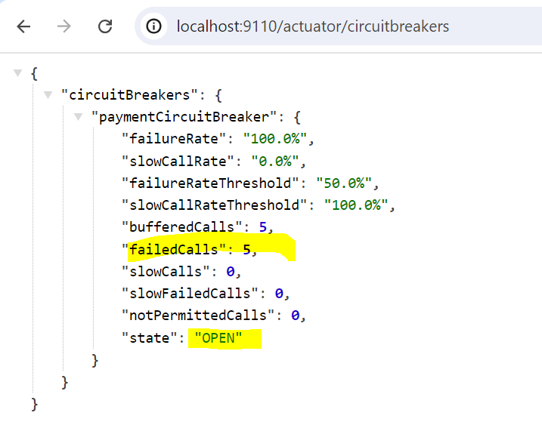

Automatically circuit breaker state will transition from OPEN to Half-open within 5sec.

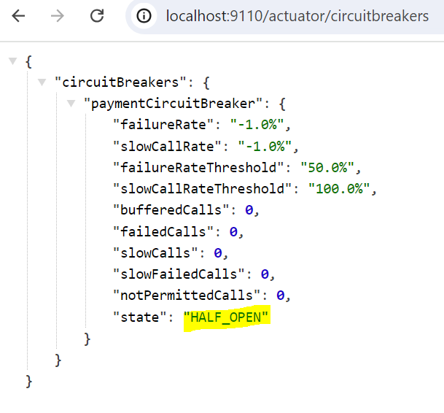

**Zipkin:**

We can use zipkin for Distributed tracing.

As shown below, for the post request of booking a property, these are the internal calls that are being made to other microservices and we can trace them and their respective timings using zipkin.

Steps to download and run the zipkin in local system.

1. Download the zipkin <https://zipkin.io/pages/quickstart.html>
2. Run using - java -jar zipkin-server-3.4.0-exec.jar

Zipkin is running on default port 9411

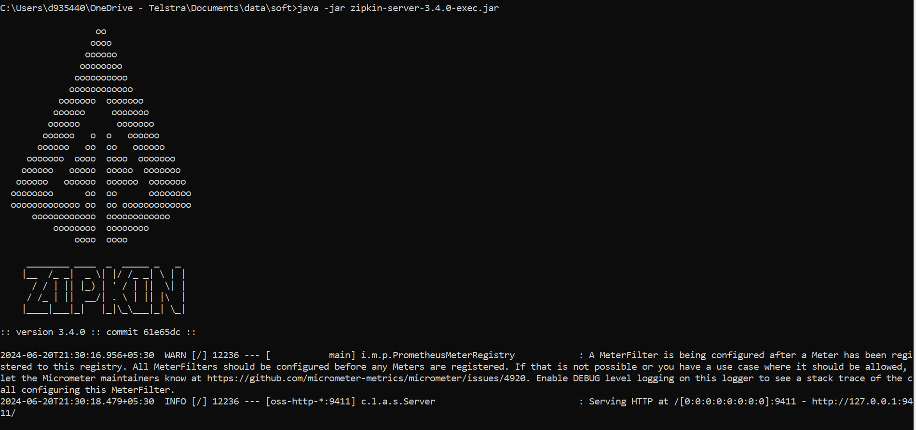

**Prometheus:**

An open-source monitoring system with a dimensional data model, flexible query language, efficient time series database and modern alerting approach

We are using Prometheus for Monitoring using Prometheus:

Number of calls made per microservice, and their response status etc can be monitored by Prometheus which can be configured using prometheus.yml as show below.

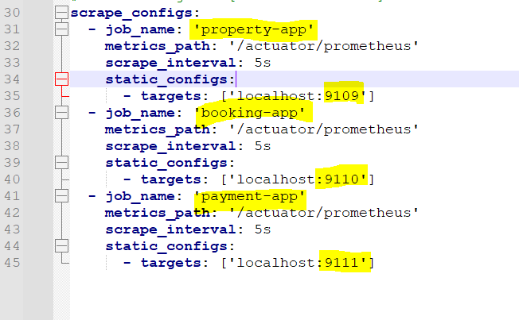

Download and run the Prometheus into local system:

1. Download from <https://prometheus.io/download/>

2. extract the zip file and run the Prometheus.exe

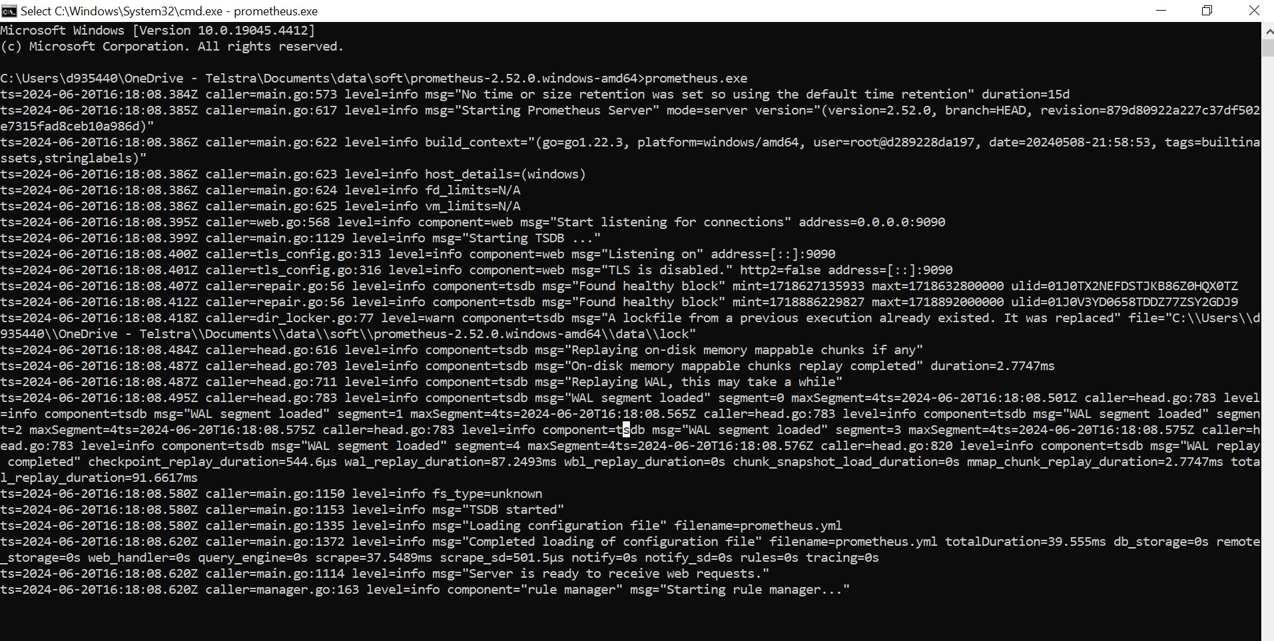

**Swagger documentation:**

Documentation using Swagger api

All the api’s exposed and its features can be viewed in swagger documentation and even we can try out testing the rest api from here.

We need to add the dependency into the pom.xml to use the swagger api.

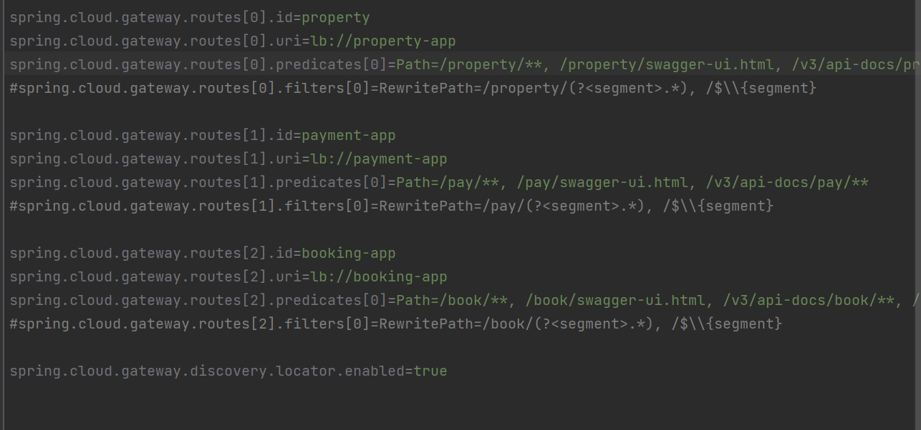

**UNIT TEST CASES:**

Test cases are included for microservices at the controller level as shown below:

