Spring cloud applications with user and bank account applications:

Bank Database has created with user and bank_account table;

Eureka server with registered client instance.

Create user with bank_account data

Post request: http://localhost:9013/user

Fetch user details using api gateway:

GET url: http://localhost:9013/user

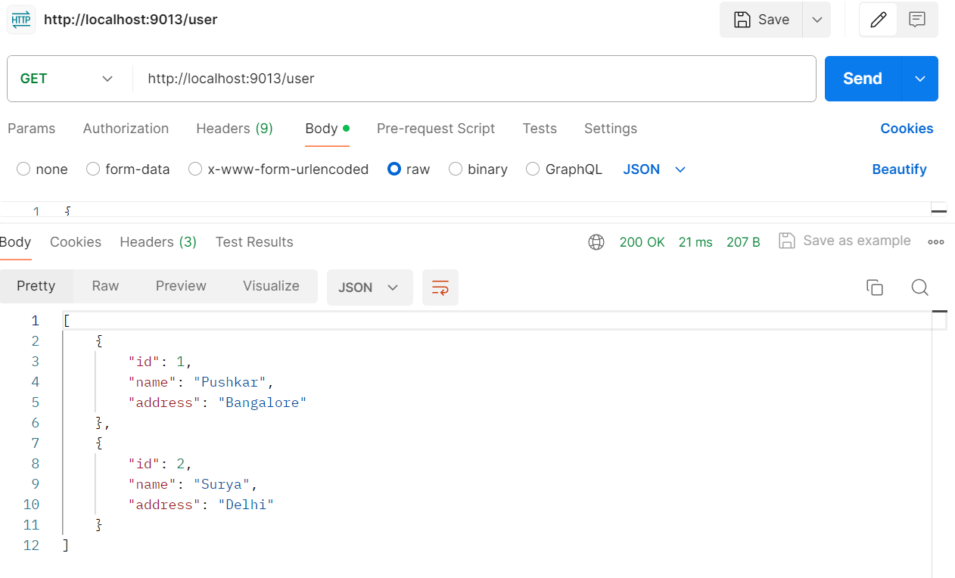

Database after creating the user and bank account details:

Read user by id :

GET url: http://localhost:9013/user/1

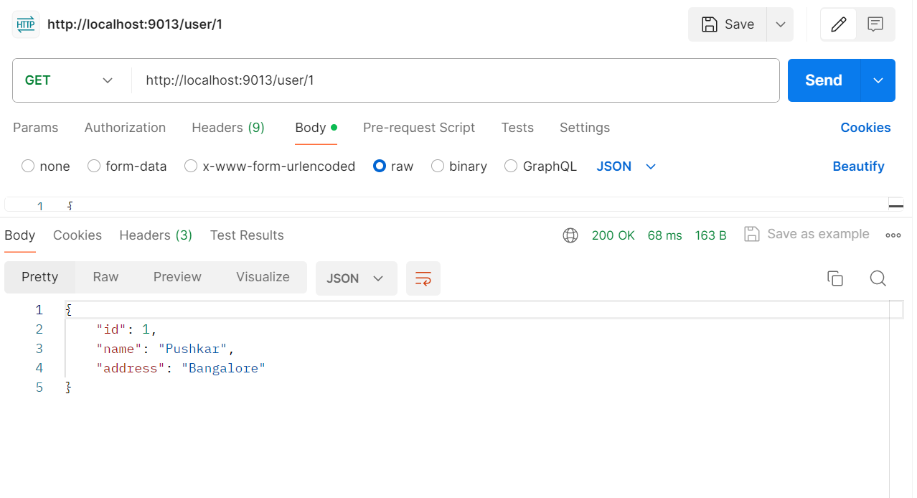

Read account data by id.

GET url: http://localhost:9013/account/1

Update account data:

PUT url: http://localhost:9013/account

Delete user data:

Delete url: http://localhost:9013/user/2

