**Name: Pushkar Sutar**

**Roll No.: 2019110060**

**Batch: A**

**Course Code:**

**Experiment No.:1**

**Name of the Experiment : Creating own profile using HTML and CSS.**

**Theory :**

1. **What was your thought process while creating your profile?**I wanted to make an interactive and responsive portfolio website that highlighted the major projects and experiences done. I decided to make a full portfolio that supported my resume using HTML and CSS for styling. I divided each section of my portfolio with appropriate tags and separated individual sections to make it more comprehensible. I selected the font and color palette to use for better look and readability. I added descriptions of each project with supporting links. The most essential part was to write a compelling section and contact section.
2. **List the tags used in html file along with its meaning in 2-3 lines.**- html : The <html> tag represents the root of an HTML document. The <html> tag is the container for all other HTML element.- head : The <head> element is a container for metadata (data about data) and is placed between the <html> tag and the <body> tag.  
   - link : The <link> tag defines the relationship between the current document and an external resource.  
   - title : The <title> tag defines the title of the document. The title must be text-only, and it is shown in the browser's title bar or in the page's tab.  
   - meta : The <meta> tag defines metadata about an HTML document. Metadata is data (information) about data.  
   - body : The <body> element contains all the contents of an HTML document, such as headings, paragraphs, images, hyperlinks, tables, lists, etc.  
   - div : The <div> tag defines a division or a section in an HTML document.  
   - nav : The <nav> tag defines a set of navigation links.  
   - img : The <img> tag is used to embed an image in an HTML page.  
   - ul : The <ul> tag defines an unordered (bulleted) list.  
   - li : The <li> tag is used inside ordered lists, unordered lists, and in menu lists.  
   - h1 : The <h1> to <h6> tags are used to define HTML headings.<h1> defines the most important heading. <h6> defines the least important heading.  
   - p : The <p> tag defines a paragraph.  
   - span : The <span> tag is an inline container used to mark up a part of a text, or a part of a document.  
   - hr : The <hr> element is most often displayed as a horizontal rule that is used to separate content (or define a change) in an HTML page.  
   - I : The <i> tag defines a part of text in an alternate voice or mood. The content inside is typically displayed in *italic*.  
   - script : The <script> tag is used to embed a client-side script (JavaScript).
3. **Benefits of HTML5 and CSS3**1. *Cost effective Multi-Platform Development*

A single line of code can be used on multiple platforms and devices, and this is an advantage because it reduces the development and maintenance costs over the website or web app’s lifetime.  
2. *Offline browsing*

Applications can be used offline, without the need of an internet connection. Similarly, the HTML5 supports local storage of web application code and content via the offline application cache.

3. *Expansion of Video to an ample range of platforms*

HTML5 has a native video support and can be directly developed into the supporting browsers that enable quicker, high-quality videos distribution.

4.*A good user experience*

HTML5 provides a broader range of designing and presentation tools across media types with an objective to give the developers greater scope to create a perfect site and web applications.

5. *Compatible with multiple browsers*

It is not necessary that all browsers support all the web pages or web applications. But the implementation of HTML5 CSS3 allows the designer to craft a compatible site or app within all the browsers.

1. **Code of HTML and CSS**

<!DOCTYPE html>

<html lang="en">

<head>

    <meta charset="UTF-8">

    <meta http-equiv="X-UA-Compatible" content="IE=edge">

    <meta name="viewport" content="width=device-width, initial-scale=1.0">

    <title>Pushkar Sutar</title>

    <link rel="stylesheet" href="style.css">

    <link rel="icon" href="images/ico.png">

    <script src="https://kit.fontawesome.com/055b42c6da.js" crossorigin="anonymous"></script>

</head>

<body>

    <div id="header">

        <div class="container">

            <nav>

                <img src="images/logo.png" alt="logo" class="logo">

                <ul>

                    <li><a href="#header">Home</a></li>

                    <li><a href="#about">About</a></li>

                    <li><a href="#experience">Experience</a></li>

                    <li><a href="#portfolio">Work</a></li>

                    <li><a href="#contact">Contact</a></li>

                </ul>

            </nav>

            <div class="header-text">

                <p>Software Developer</p>

                <h1>Hi, I am <span>Pushkar Sutar</span><br> from SPIT.</h1>

            </div>

        </div>

    </div>

<!-- -----------about-------------->

    <div id="about">

        <div class="container">

            <div class="row">

                <div class="about-col-1">

                    <img src="images/user.jpg" alt="profile-pic">

                </div>

                <div class="about-col-2">

                    <h1 class="subtitle">About Me</h1>

                    <p>Enthusiastic learner with the ability to quickly pick up new languages, tools and software applications.<br>

                    Dedicated team member who is known for organizational skills and commitment to excellence.</p>

                    <div class="tab-titles">

                        <p class="tab-links active-link" onclick="opentab('education')">Education</p>

                        <p class="tab-links" onclick="opentab('skills')">Skills</p>

                        <p class="tab-links" onclick="opentab('hobbies')">Hobbies</p>

                    </div>

                    <div class="tab-contents active-tab" id="education">

                        <ul>

                            <li><span>Sardar Patel Institute of Technology</span><br>BTech in Electronics Engineering with Minors in CS.<br>CGPI: 9.55</li>

                            <li><span>Shiravane Vidyalaya and Junior College</span><br>HSC: 84.60%</li>

                            <li><span>St.Joseph's High School</span><br>SSC: 94%</li>

                        </ul>

                    </div>

                    <div class="tab-contents" id="skills">

                        <ul>

                            <li><span>Computer Languages</span><br>C, C++, Java, Python, C#.</li>

                            <li><span>Libraries & APIs</span><br>Scikit, Sklearn, Librosa, OpenCV.</li>

                            <li><span>Tools</span><br>Unity3D, Unreal Engine, MATLAB, Android Studio.</li>

                            <li><span>Other Skills</span><br>Machine Learning, AI, image and audio processing, music composition.</li>

                        </ul>

                    </div>

                    <div class="tab-contents" id="hobbies">

                        <ul>

                            <li><span>Guitar and Harmonica</span></li>

                            <li><span>Singing</span></li>

                            <li><span>Competitive Programming</span></li>

                            <li><span>Cricket</span></li>

                            <li><span>Chess</span></li>

                            <li><span>Cooking</span></li>

                        </ul>

                    </div>

                </div>

            </div>

        </div>

    </div>

<!-- ----------------experience---------------- -->

    <div id="experience">

        <div class="container">

            <h1 class="subtitle">My Experience</h1>

            <div class="services-list">

                <div>

                    <i class="fa-solid fa-book"></i>

                    <h2>Research Intern</h2>

                    <h3>Bhabha Atomic Research Centre</h3>

                    <p>· Analysing the data obtained from the gamma radiations in order to detect leaks in heat exchangers. <br>

                        · Developing an easy to use solution for leak detection based on the analysed data</p>

                    <a href="https://drive.google.com/file/d/1iw9vgDxs2MtmwrymnbAesMXqwbafuHYn/view?usp=sharing">Learn more</a>

                </div>

                <div>

                    <i class="fa-solid fa-robot"></i>

                    <h2>Programming Intern</h2>

                    <h3>The Innovation Story</h3>

                    <p>· Responsibility for designing/selecting robotic systems, run simulation, implementation, and programming.<br>

                        · NI Roborio advanced robotics controller for commanding joysticks, motor controllers and other FRC

                        control system components.<br>

                        · Working to develop programs using Java WPILib and FRC Tools for Moving Ball Shooter robot control

                        and automation.</p>

                    <a href="https://drive.google.com/file/d/1_Ud18ADYIYv4FS7lVXYiJEYsnGOXl-eD/view?usp=sharing">Learn more</a>

                </div>

                <div>

                    <i class="fa-sharp fa-solid fa-shield-halved"></i>

                    <h2>Engineering Virtual Internship</h2>

                    <h3>Goldman Sachs</h3>

                    <p>· Identifying and reporting the cyber security issues from a database.<br>

                        · Suggesting and developing effective hashing techniques to maintain security of the database</p>

                    <a href="https://drive.google.com/file/d/1HcVCr_FXMlg2i792tIopVXYXWfljYEhb/view?usp=sharing">Learn more</a>

                </div>

            </div>

        </div>

    </div>

    <!-- ---------------------portfolio----------- -->

    <div id="portfolio">

        <div class="container">

            <h1 class="subtitle">My Work</h1>

            <div class="work-list">

                <div class="work">

                    <img src="images/work-1.jpg" alt="w1">

                    <div class="layer">

                        <h3>Speech Emotion Recognition</h3>

                        <p>· Implemented MLP-classification model with scikit-learn from Python open-source library.<br>

                            · Used Librosa python package for audio analysis and extraction of features and RAVDESS dataset for training</p>

                        <a href="https://github.com/pushkarr999/Speech-Emotion-Recognition"><i class="fa-sharp fa-solid fa-arrow-up-right-from-square"></i></a>

                    </div>

                </div>

                <div class="work">

                    <img src="images/work-2.jpg" alt="w1">

                    <div class="layer">

                        <h3>Music Generation using 8051</h3>

                        <p>· Low-cost device for musicians designed to work in different modes of applications like metronome, manual keypad

                            based composition of music, tuner and, song library</p>

                        <a href="https://github.com/pushkarr999/Music-Generator-8051uC"><i class="fa-sharp fa-solid fa-arrow-up-right-from-square"></i></a>

                    </div>

                </div>

                <div class="work">

                    <img src="images/work-3.png" alt="w1">

                    <div class="layer">

                        <h3>Realtime Sudoku Solver</h3>

                        <p>· Sudoku grid detection using OpenCV Python and backtracking algorithm to solve sudoku in realtime. Uses Keras

                            for digit recognition</p>

                        <a href="https://github.com/pushkarr999/SudokuSolver"><i class="fa-sharp fa-solid fa-arrow-up-right-from-square"></i></a>

                    </div>

                </div>

            </div>

            <a href="#" class="btn">See more</a>

        </div>

    </div>

    <!-- ------------contact me------------------ -->

    <div id="contact">

        <div class="container">

            <h1 class="subtitle2">Connect With Me</h1>

            <div class="contact-list">

                <div>

                    <h3>Address</h3>

                    <hr>

                    <p>Amarante, Navi Mumbai <br> Maharshtra, 410218.</p>

                </div>

                <div>

                    <h3>Contact</h3>

                    <hr>

                    <p>+91 8828245848 <br>pushkarsutar999@gmail.com</p>

                </div>

                <div>

                    <h3>Socials</h3>

                    <hr>

                    <div class="grid">

                        <div class="socials">

                            <a href="https://www.linkedin.com/in/pushkar-sutar/"><i class="fa-brands fa-linkedin"></i></a>

                        </div>

                        <div class="socials">

                            <a href="https://www.instagram.com/pushkar_999_/?hl=en"><i class="fa-brands fa-instagram"></i></a>

                        </div>

                        <div class="socials">

                            <a href="https://twitter.com/i/flow/login"><i class="fa-brands fa-twitter"></i></a>

                        </div>

                        <div class="socials">

                            <a href="https://github.com/pushkarr999"><i class="fa-brands fa-github"></i></a>

                        </div>

                    </div>

                </div>

            </div>

        </div>

    </div>

    <script>

        var tablinks = document.getElementsByClassName("tab-links");

        var tabcontents = document.getElementsByClassName("tab-contents");

        function opentab(tabname){

            for(tablink of tablinks){

                tablink.classList.remove("active-link");

            }

            for(tabcontent of tabcontents){

                tabcontent.classList.remove("active-tab");

            }

            event.currentTarget.classList.add("active-link");

            document.getElementById(tabname).classList.add("active-tab");

        }

    </script>

</body>

</html>

*{

    margin: 0;

    padding: 0;

    font-family: 'Poppins', sans-serif;

    box-sizing: border-box;

}

body{

    background-color: #080808;

    color: floralwhite;

}

#header{

    width: 100%;

    height: 100vh;

    background-image: url(images/bg.jpg);

    background-size: cover;

    background-position: center;

}

.container{

    padding: 10px 10%;

}

nav{

    display: flex;

    align-items: center;

    justify-content: space-between;

    flex-wrap: wrap;

}

.logo{

    width: 140px;

}

nav ul li{

    display: inline-block;

    list-style: none;

    margin: 10px 20px;

}

nav ul li a{

    color: floralwhite;

    text-decoration: none;

    font-size: 18px;

    position: relative;

}

nav ul li a::after{

    content: '';

    width: 0;

    height: 3px;

    background: #ff004f;

    position: absolute;

    left: 0;

    bottom: -6px;

    transition: 0.5s;

}

nav ul li a:hover::after{

    width: 100%;

}

.header-text{

    margin-top: 20%;

    font-size: 30px;

}

.header-text h1{

    font-size: 60px;

    margin-top: 20px;

}

.header-text h1 span{

    color: #ff004f;

}

/* -------------about------------ */

#about{

    padding: 80px 0;

    color: #ababab;

}

.row{

    display: flex;

    justify-content: space-between;

    flex-wrap: wrap;

}

.about-col-1{

    flex-basis: 35%;

}

.about-col-1 img{

    width: 100%;

    border-radius: 15px;

}

.about-col-2{

    flex-basis: 60%;

}

.subtitle{

    font-size: 60px;

    font-weight: 600;

    color: white;

}

.tab-titles{

    display: flex;

    margin: 20px 0 40px;

}

.tab-links{

    margin-right: 50px;

    font-size: 18px;

    font-weight: 500;

    cursor: pointer;

    position: relative;

}

.tab-links::after{

    content: '';

    width: 0;

    height: 3px;

    background: #ff004f;

    position: absolute;

    left: 0;

    bottom: -8px;

    transition: 0.5s;

}

.tab-links.active-link::after{

    width: 50%;

}

.tab-contents ul li{

    list-style: none;

    margin: 10px 0;

}

.tab-contents ul li span{

    color: #b54769;

    font-size: 14px;

}

.tab-contents{

    display: none;

}

.tab-contents.active-tab{

    display: block;

}

/* -------------------experience-------------- */

#experience{

    padding: 30px 0;

}

.services-list{

    display: grid;

    grid-template-columns: repeat(auto-fit,minmax(250px,1fr));

    grid-gap: 40px;

    margin-top: 50px;

}

.services-list div{

    background: #262626;

    padding: 40px;

    font-size: 13px;

    font-weight: 300;

    border-radius: 10px;

    transition: background 0.5s, transform 0.5s;

}

.services-list div i{

    font-size: 50px;

    margin-bottom: 30px;

}

.services-list div h2{

    font-size: 30px;

    font-weight: 500;

}

.services-list div h3{

    margin-bottom: 15px;

}

.services-list div a{

    text-decoration: none;

    color: white;

    font-size: 12px;

    margin-top: 20px;

    display: inline-block;

}

.services-list div:hover{

    background: #ff004f;

    transform: translateY(-10px);

}

/* ---------------portfolio--------------- */

#portfolio{

    padding: 50px 0;

}

.work-list{

    display: grid;

    grid-template-columns: repeat(auto-fit,minmax(250px,1fr));

    grid-gap: 40px;

    margin-top: 50px;

}

.work{

    border-radius: 10px;

    position: relative;

    overflow: hidden;

}

.work img{

    width: 100%;

    border-radius: 10px;

    display: block;

    transition: transform 0.5s;

}

.layer{

    width: 100%;

    height: 0;

    background: linear-gradient(rgba(0,0,0,0.6),#ff004f);

    border-radius: 10px;

    position: absolute;

    left: 0;

    bottom: 0;

    overflow: hidden;

    display: flex;

    align-items: center;

    justify-content: center;

    flex-direction: column;

    padding: 0 40px;

    text-align: center;

    font-size: 14px;

    transition: height 0.5s;

}

.layer h3{

    font-weight: 300;

    margin-bottom: 20px;

}

.layer a{

    margin-top: 20px;

    color: #ff004f;

    text-decoration: none;

    font-size: 18px;

    line-height: 60px;

    background: white;

    width: 60px;

    height: 60px;

    border-radius: 50%;

    text-align: center;

}

.work:hover img{

    transform: scale(1.1);

}

.work:hover .layer{

    height: 100%;

}

.btn{

    display: block;

    margin: 50px auto;

    width: fit-content;

    border: 1px solid #ff004f;

    padding: 14px 50px;

    border-radius: 6px;

    text-decoration: none;

    color: white;

    transition: background 0.5s;

}

.btn:hover{

    background-color: #ff004f;

}

/* ----------contact me---------- */

#contact{

    padding: 50px 0;

    background: whitesmoke;

}

.contact-list{

    display: grid;

    grid-template-columns: repeat(auto-fit,minmax(250px,1fr));

    grid-gap: 40px;

    margin-top: 50px;

}

.contact-list div{

    background: #262626;

    padding: 10px;

    font-size: 13px;

    font-weight: 300;

    border-radius: 5px;

}

.subtitle2{

    font-size: 60px;

    font-weight: 600;

    color: #080808;

}

.contact-list div h3{

    padding: 15px 15px 0 15px;

    font-size: 20px;

    font-weight: 500;

}

.contact-list div hr{

    margin: 15px;

    width: 70%;

}

.contact-list div p{

    padding: 15px;

}

.contact-list div i{

    font-size: 40px;

}

.contact-list div a{

    color: aliceblue;

    text-decoration: none;

}

.grid {

    display: flex;

    flex-direction: row;

}

.socials:hover i{

    transform: scale(1.1);

}

1. **Screenshots of UI.**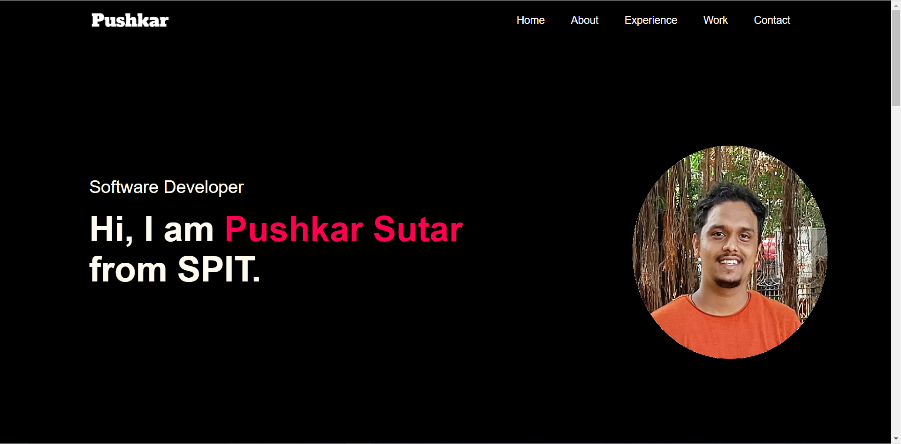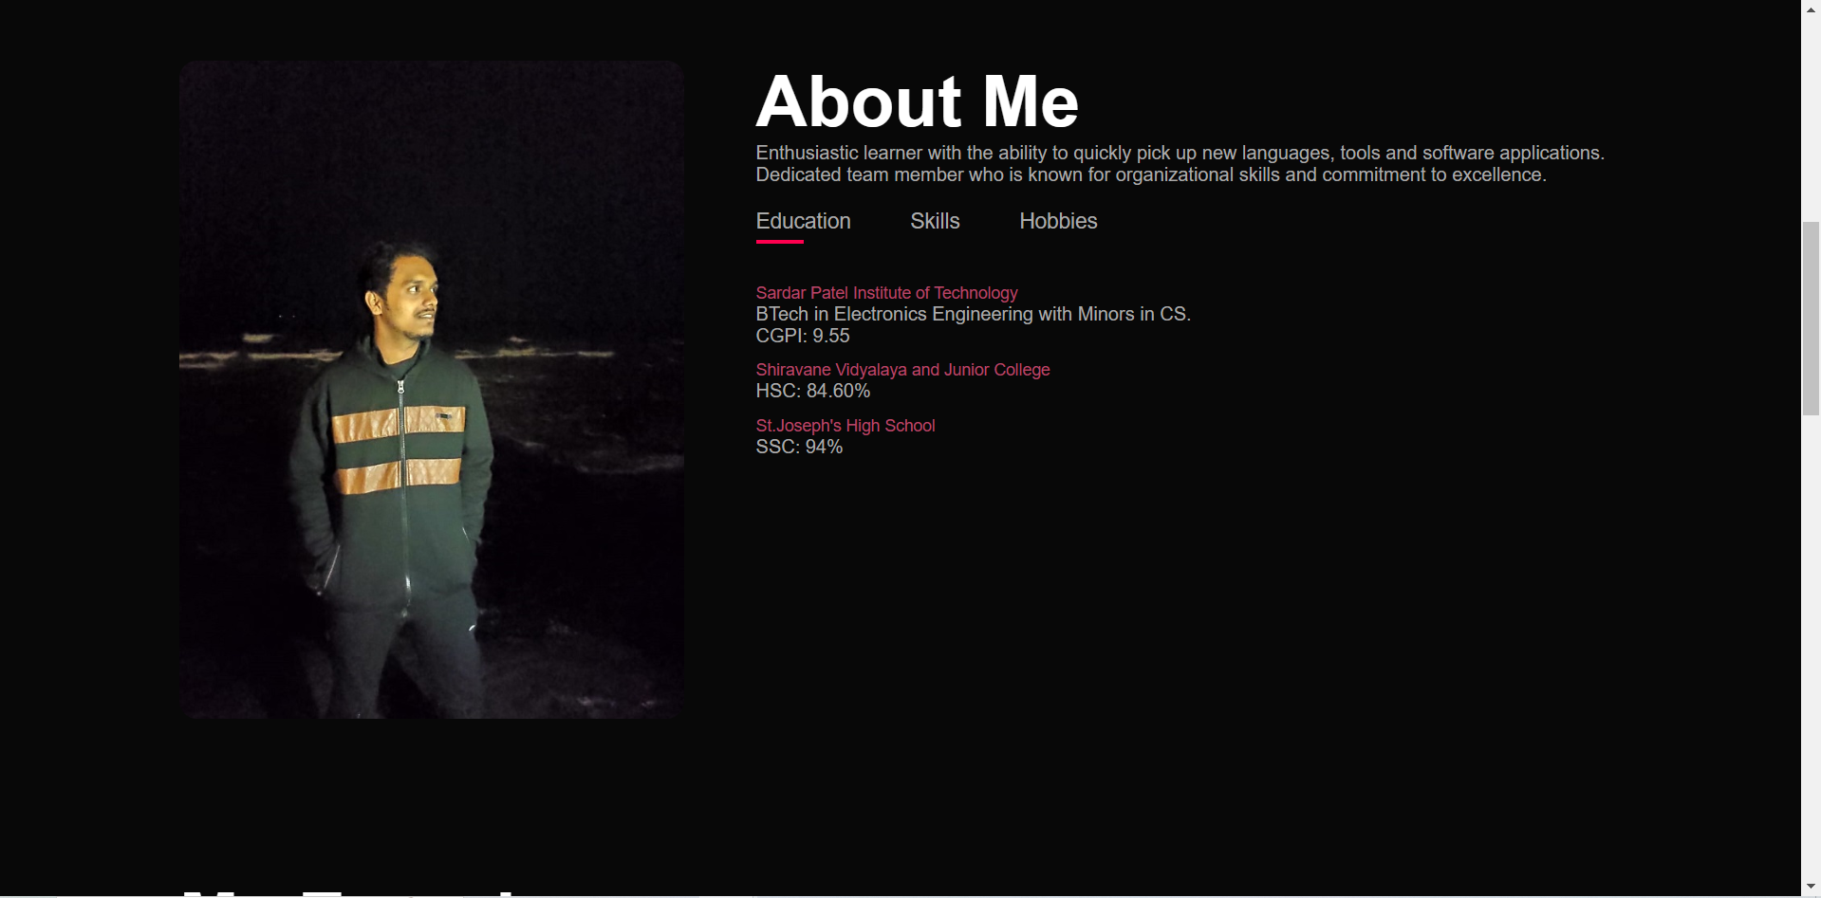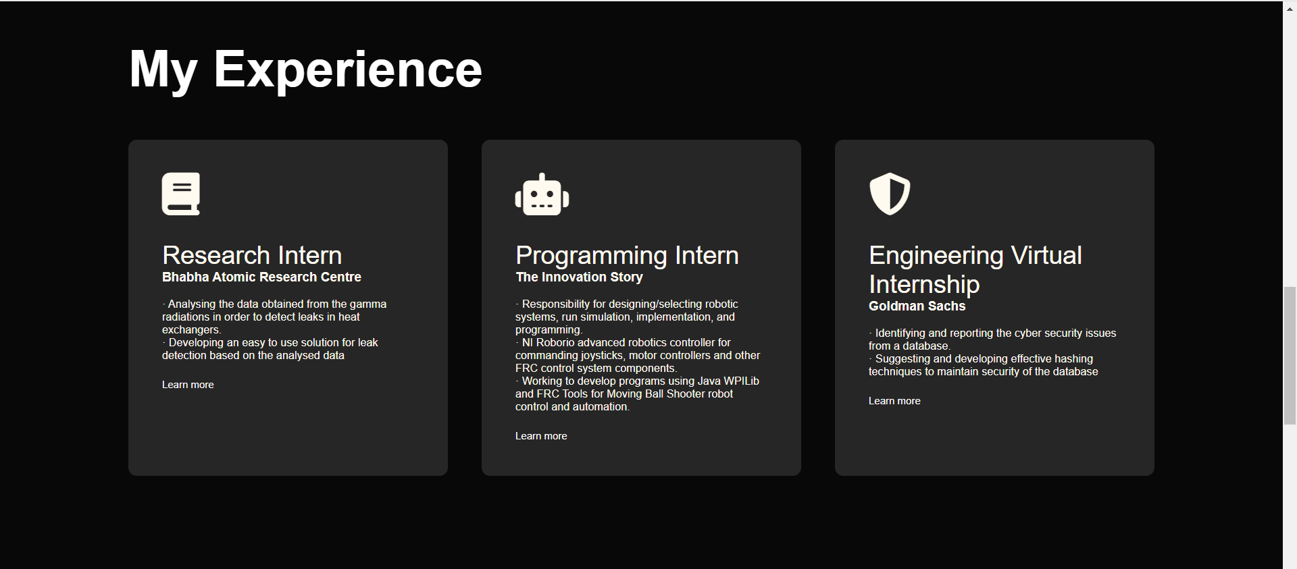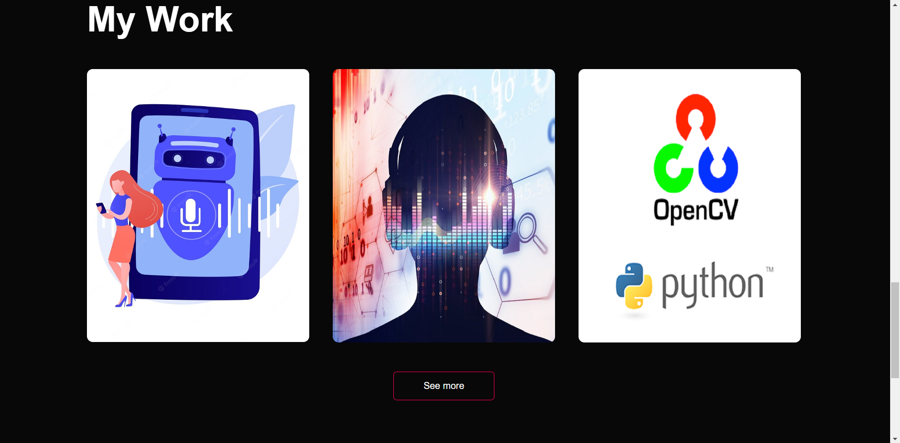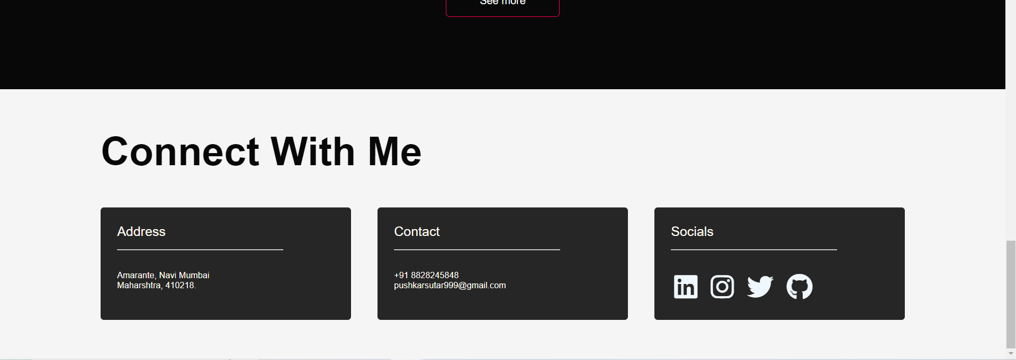

[**https://pushkarr999.github.io/portfolio/**](https://pushkarr999.github.io/portfolio/)

**Conclusion :**

* **It is really simple to make portfolio website with HTML and style it using CSS.**
* **HTML positioning can be tricky and proper layout arrangement can be difficult so it is necessary to understand the difference between static, absolute, relative, etc.**
* **All the different sections should be under div tags to style them using CSS separately.**
* **We can add hover effects such as increasing the size by transform property or changing the color for better interactive experience.**
* **Sizing and positioning is really important to make websites responsive.**