ScamGuard AI: Protecting Trust with Generative Intelligence

This tutorial guides you through building a complete AI-powered scam detection system from scratch, progressively integrating key GenAI concepts from your curriculum. We will start with a minimal working system and gradually enhance it, learning essential production techniques along the way.

What You'll Build

By the end of this tutorial, you'll have created:

- AI-Powered Detection Pipeline using Google Gemini with multiple reasoning strategies
- Interactive Web Interface with Streamlit for real-time analysis
- Batch Processing system for analyzing datasets
- Evaluation Framework with accuracy metrics and performance analysis
- Production-Ready Architecture with robust error handling and logging

Note to Instructor
Rather than copying explanations directly from the document, take a moment to read and internalize the content. Then, explain it in your own words, tailored to your learners' level and context.

Part 1: System Architecture & Design

Understanding the Architecture
Our scam detection system follows a layered architecture. This modular design is crucial for building a system that is easy to maintain, scale, and improve over time.

Note to Instructors:
When explaining the architecture, emphasize why we are choosing a modular design. Highlight the benefits such as:
- Separation of concerns: part has one specific responsibility.
- Testability: We can test components individually.
- Flexibility: We can replace a component (like the LLM) without changing everything else
This helps learners understand that architecture is a set of deliberate choices.

The diagram below illustrates the end-to-end control flow for both single message and batch scam detection, tracing how input flows from the UI or evaluation script through the prompt builder, LLM executor, output parser, and finally to the result display or storage.

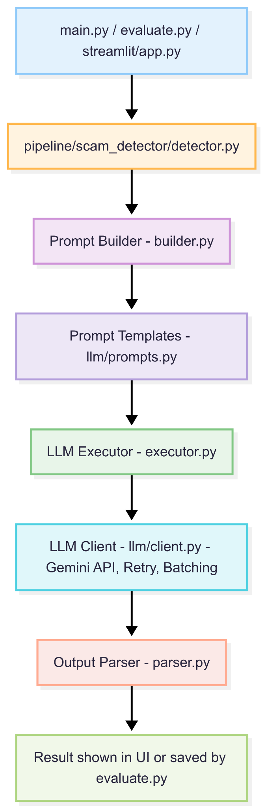

High-Level Architecture: The Full Picture

The high-level architecture gives a big-picture view of how information flows through the system from user interaction all the way to AI-powered analysis and back. It includes the main components and entry points that make up the system.

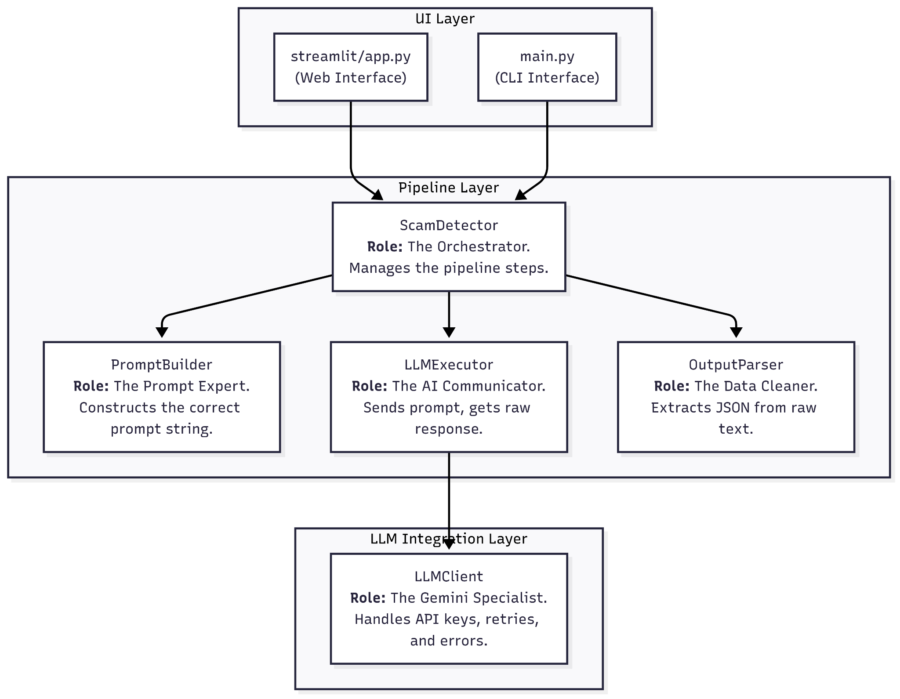
Key Components

Entry Points
User interacts through:
- Streamlit Web App for a graphical interface
- Command Line Interface for terminal usage

Learner modifies system behavior through
- Configuration Files

Data Processor uses:
- evaluate script, which consumes datasets for batch analysis and performance evaluation

Core Engine: The Scam Detector Pipeline
- This is the heart of the system
- It receives a message and orchestrates the analysis through several stages.

Pipeline Components
Prompt Builder
- Constructs the final prompt using templates
- Loads templates from prompt files

LLM Executor
- Sends the final prompt to the AI

Output Parser
- Receives raw text from the LLM and processes it into a clean, structured format.
- Uses the Output Validator to clean and validate the result

“Before diving into the low-level architecture that explains how each component functions and interacts, let’s first look at the directory structure to understand how the system is organized.”

scam-detection-system/
├── config.py # Central configuration
├── main.py # CLI interface
├── requirements.txt # Dependencies
├── .env # Environment variables
├── utils.py # Common helper function
|
├── llm/ # LLM integration layer
│ ├── client.py # Gemini API client
│ ├── prompts.py # Prompt management
│ ├── validator.py # Response validation
│ └── prompts/ # Prompt templates
|
├── pipeline/ # Core detection pipeline
│ └── scam_detector/
│ ├── detector.py # Main orchestrator
│ ├── builder.py # Prompt building
│ ├── executor.py # LLM execution
│ └── parser.py # Result parsing
|
├── streamlit/ # Web interface
└── app.py

Low-Level Architecture: The Three Layers

The low-level architecture breaks the system down into three core layers, each with clearly defined responsibilities. This allows us to understand how each part interacts with the rest.
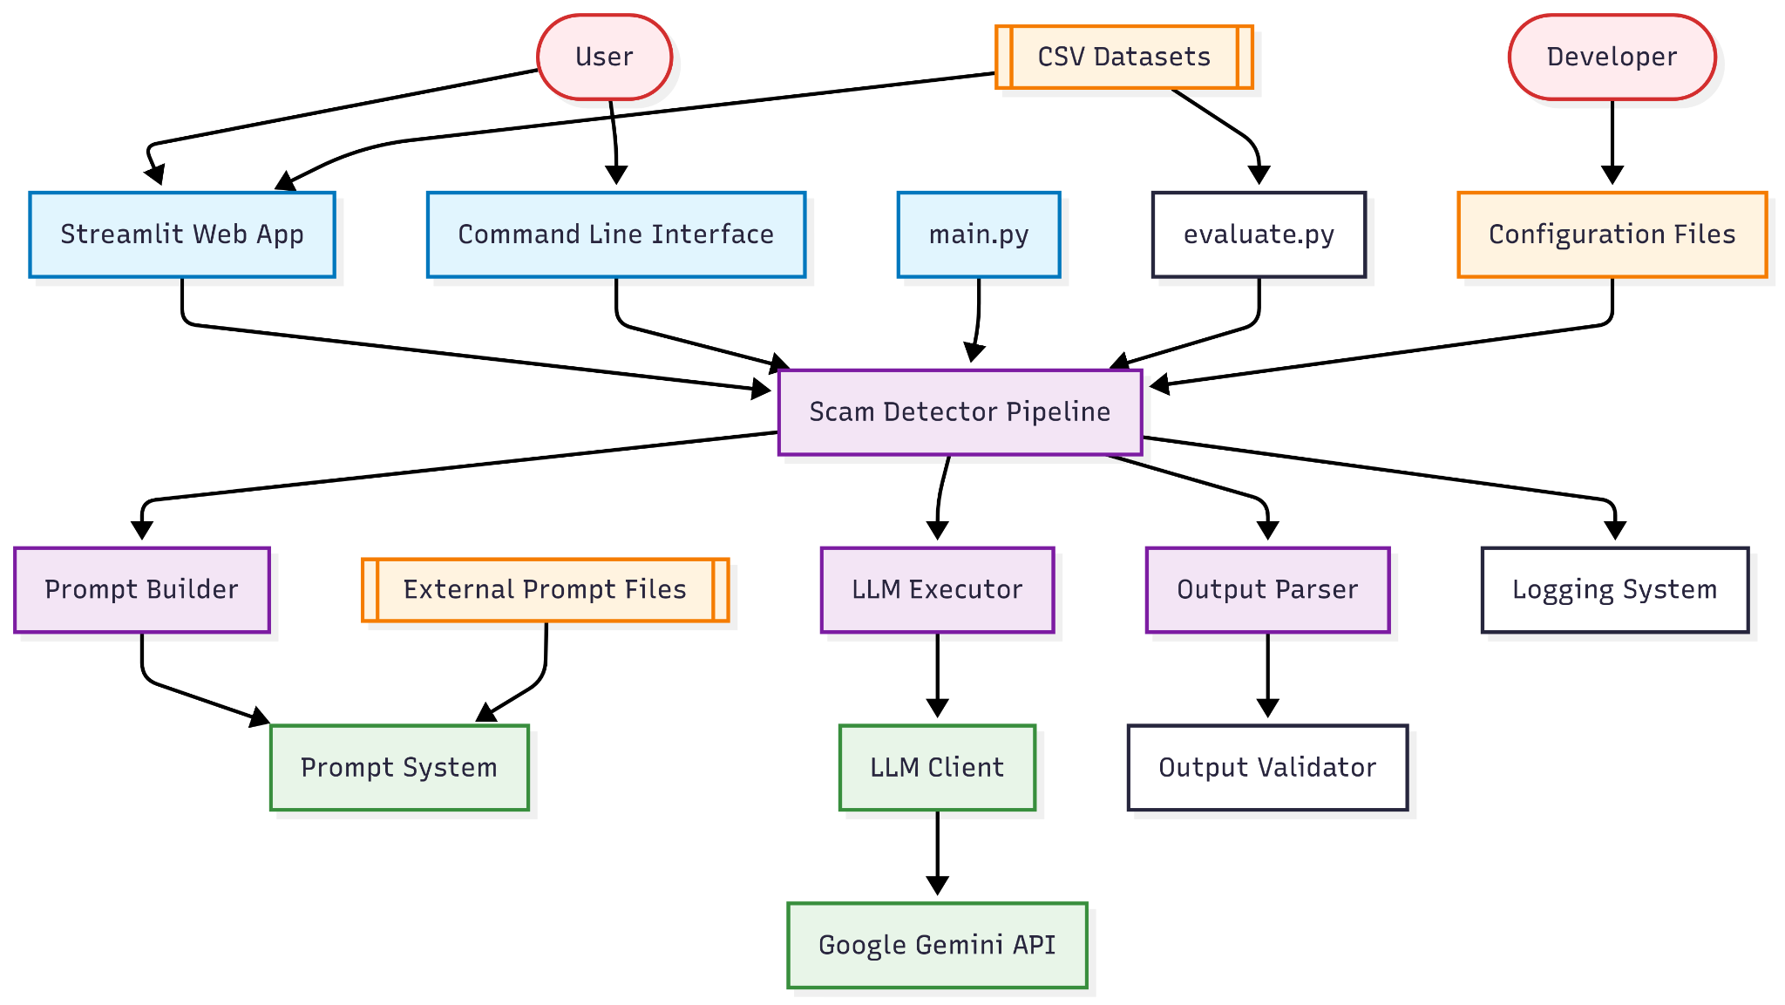

Layer-by-Layer Breakdown

1. UI Layer (User Interface)
Role: Entry points for the user to interact with the system

Files:

- streamlit/app.py: Provides a simple web interface for analyzing individual messages
- main.py: A command-line tool to analyze messages directly from the terminal or through automation

2. Pipeline Layer (Core Logic)
Role: Coordinates the entire scam detection process. This layer defines how the detection works.

Main Components:

ScamDetector (detector.py)

- Acts as the orchestrator of the entire pipeline
- Calls each step of the detection process in sequence

PromptBuilder (builder.py)

- Specializes in generating well-structured prompts
- Uses prompt templates and fills them with dynamic message content

LLMExecutor (executor.py)

- Sends prompts to the LLM and returns the raw results

OutputParser (parser.py)

- Transforms raw AI output into a clean, structured format like JSON
- Cleans and validates the result to ensure reliability

3. LLM Integration Layer (External Communication)
Role: Manages all direct interactions with the AI (LLM) - in this case, Google Gemini

Component:

LLMClient (llm/client.py)
- Handles Gemini API requests and responses
- Manages API keys, retries, and error handling
- Abstracts away Gemini-specific details so other parts of the system stay decoupled

Note to instructor
This design makes it easy to switch between AI providers (e.g., OpenAI, Gemini) by modifying only this module, allowing learners to experiment with different models based on their preferences or project needs.
Briefly needs to be introduced about this idea.

Part 2: Project Setup and Configuration

Step 2.1: Project Setup
First, let's set up the project structure:
# Create project directory
mkdir scam-detection
cd scam-detection
# Create the modular structure
mkdir -p llm/prompts pipeline/scam_detector streamlit
# Create essential files
touch config.py utils.py main.py evaluate.py requirements.txt .env
touch llm/__init__.py llm/client.py llm/prompts.py
touch pipeline/__init__.py pipeline/scam_detector/__init__.py
touch pipeline/scam_detector/detector.py pipeline/scam_detector/builder.py
touch pipeline/scam_detector/executor.py pipeline/scam_detector/parser.py
touch streamlit/app.py

Note to Instructor
While commands like mkdir and touch can be used to create directories and files, many learners, especially those new to programming - may not be familiar or comfortable with using the terminal. It is recommended to guide them through creating files and folders directly using the Visual Studio Code interface, as it offers a more accessible and visual approach.

Step 2.2: Dependencies and Configuration
- Create requirements.txt
What are we doing?
We are listing all the external Python libraries our project needs to run. The `pip` tool will use this file to install them automatically.
Why is this important?
This ensures that anyone can set up the exact same environment with a single command, making the project reproducible and easy to share.

google-genai==1.27.0
pandas==2.3.1
python-dotenv==1.1.1
streamlit==1.47.1
tqdm==4.67.1

To install the dependencies run the following command:
pip install -r requirements.txt

- Create .env for API credentials
What are we doing?
We are creating a special file to hold our secret API key. This file is kept private and should never be shared or committed to version control (like Git).

Note to Instructor
Although Git and version control haven’t been introduced yet, this is a good opportunity to help learners understand the importance of using a .env file. Emphasize that it is a best practice to keep sensitive information like API keys separate from the main codebase, and explain that .env files are designed to keep such secrets private and secure

GEMINI_API_KEY=your_google_api_key_here

Note to instructor
You may also demonstrate how to generate a fresh API key from Google AI Studio

- Create config.py for centralized settings
Rather than waiting for complexity to build up, we're proactively starting with a centralized configuration file - config.py.
This ensures that all critical settings (like model choice, API retry limits, and secret keys) are managed from one place right from the beginning. It lays the foundation for clean, maintainable, and scalable code as the project grows.
Why is this important?
Centralized configuration greatly simplifies system maintenance. If you want to switch to a different model or adjust a setting, you only need to update it in a single location—making experimentation and updates faster and less error-prone.
Code
import os
from pathlib import Path
from dotenv import load_dotenv
# Load environment variables
PROJECT_ROOT = Path(__file__).parent
load_dotenv(PROJECT_ROOT / ".env")
# API Configuration
GEMINI_API_KEY = os.getenv("GEMINI_API_KEY")
# LLM Settings
DEFAULT_MODEL = "gemini-2.5-flash"
MAX_RETRIES = 3
RETRY_DELAY = 2
# Processing Settings
DEFAULT_BATCH_SIZE = 10
STREAMLIT_BATCH_SIZE = 5

Code Walkthrough
1. import os, Path, load_dotenv: We import the necessary libraries. os helps us interact with the operating system, Path from pathlib lets us handle file paths in a modern way, and load_dotenv is the function that reads our secret keys.
2. PROJECT_ROOT = Path(__file__).parent: This line is a robust way to find the project's root directory, no matter where you run the script from. __file__ is a special variable that holds the path to the current file (config.py), and .parent gets the directory that contains it.
3. load_dotenv(...): This command finds the .env file located in our project root and loads the variables inside it into the environment.
4. GEMINI_API_KEY = os.getenv(...): This securely reads the GEMINI_API_KEY value from the loaded environment. The key now exists as a variable in our script, but it's not hardcoded, which is great for security.
5. DEFAULT_MODEL, MAX_RETRIES, etc.: We define our application's settings as global variables. Now, any other file in our project can simply from config import DEFAULT_MODEL to use this value, ensuring consistency.

Note to the Instructor:
In this project, we will be using Python’s pathlib module frequently to manage file and directory paths in a clean, cross-platform way. Take a moment to introduce learners to key pathlib concepts and patterns, such as:
- __file__: A special variable that gives the path of the current file. Often used with pathlib.Path(__file__) to build relative paths.
- .parent: Used to navigate to a parent directory from a file or folder path.
- .resolve(): Returns the absolute version of a path.
- .exists(): Checks if a path actually exists.

- Create utils.py for common helper functions
This file contains reusable helper functions that make your codebase cleaner and more modular. Instead of rewriting common logic like logging setup or extracting JSON from LLM output, you define them here once and use them wherever needed.
These utility functions are lightweight but powerful, designed to streamline common tasks.

Code
import logging
import re
import json
from pathlib import Path
def get_logger(name: str) -> logging.Logger:
"""Get a simple logger for the given name."""
logging.basicConfig(
level=logging.INFO,
format='[%(asctime)s] %(levelname)s: %(message)s'
)
return logging.getLogger(name)
def extract_json_from_text(text: str) -> dict:
"""Extract JSON from text string. Returns empty dict if not found."""
try:
match = re.search(r"\{.*\}", text, re.DOTALL)
if match:
return json.loads(match.group())
return {}
except json.JSONDecodeError:
return {}
def load_file(file_path: str) -> str:
"""Load and return file contents as string."""
return Path(file_path).read_text().strip()

Code Walkthrough
- import logging, re, json, Path:
We start by importing the standard libraries we'll need. logging helps us track what the app is doing, re allows us to search inside text using patterns, json lets us handle structured data, and Path gives us a clean, modern way to work with file paths.
- get_logger(name: str):
This function sets up a basic logger with a consistent format that includes the time, log level, and message. Instead of repeating this setup everywhere, we create it once here. Now, in any other file, we can just write logger = get_logger(__name__) and start logging right away.
- extract_json_from_text(text: str):
Sometimes an LLM mixes JSON with normal text. This function tries to find the first {...} block in the given string using a regular expression. If it finds one, it tries to turn it into a Python dictionary using json.loads(). If it doesn’t find anything or fails to parse, it safely returns an empty dictionary—no crashes.
- load_file(file_path: str):
This utility reads the contents of any file (like a prompt template or config snippet) and returns it as a clean string. Using Path().read_text() makes this simple and readable. It also trims off any accidental leading/trailing spaces.

Considerations
Before we write our first prompt, it's critical to think about the real-world impact of the AI we're building. A scam detector seems purely beneficial, but like any AI, it has potential risks that we, as responsible developers, must consider.
The Cost of Being Wrong: False Positives vs. False Negatives
- False Positive (Type I Error): Our model flags a legitimate message as a scam.
Real-World Harm: Imagine an urgent message from a family member about an emergency being incorrectly blocked. The user might miss critical information. This erodes trust in the system.
- False Negative (Type II Error): Our model fails to detect a real scam.
Real-World Harm: The user falls victim to the scam, potentially losing money or personal information. This means our application failed at its primary job.
For a safety-critical application like this, we must often decide which error is worse. It's usually better to have a slightly higher rate of false positives (and perhaps let the user review flagged messages) than to miss a dangerous scam.
For this we chose the ReAct prompt format to promote transparency. By forcing the model to explain its reasoning step-by-step, we make its decision-making process less of a "black box." If it makes a mistake, we can examine its reasoning to understand *why* and use that insight to improve the prompt of the system.

Part 3: Prompt Engineering Strategies
Learning Objectives
- Understand different prompting approaches (zero-shot, few-shot, ReAct)
- Implement the Strategy Pattern for prompt management
- Learn when to use each technique

Step 3.1: Understanding Prompt Strategies
Our system implements four distinct strategies:
- ReAct (Reasoning and Acting): Step-by-step reasoning with structured output
- Few-shot Learning: Learning from examples with pattern recognition
- Strict JSON: Direct classification with minimal explanation
- Simplified: Quick, streamlined analysis

Note to the Instructor
As part of this project, we will guide learners through a progression of prompting strategies, starting with simple methods and gradually introducing more advanced techniques. This scaffolding helps them build both intuition and technical skill.
Explain to learners that we’re not using just one approach to prompt design—instead, we’re exploring multiple strategies that each offer different levels of structure, control, and complexity:
1. Simplified Natural Language Prompts
Our starting point—basic instruction-based prompts written in plain English to see how the LLM interprets intent.
2. Structured Output with JSON
We introduce the idea of formatting outputs consistently using JSON. This makes it easier for downstream components (like parsers) to process responses.
3. ReAct (Reasoning + Acting)
Next, we enhance the prompt using the ReAct pattern. This lets the model break its thinking into steps, improving both transparency and reasoning quality.
4. Few-Shot Prompting
Finally, we include few-shot examples. These examples show the model exactly how to respond, which increases reliability and reduces hallucinations.
(We will be initiating with React prompting followed by few shot but all the other ways can be shown for learner to better understand the choice and limitations)

Step 3.2: Implementing the Prompt Management System
Create llm/prompts.py - Strategy Loader:
We will create a simple system to load prompt templates from external .md or .txt files. This will keep our prompts neatly separated from our Python code.

Why is this important?
Prompt engineering is an iterative and experimental process. By storing prompts in external files, you can modify and refine them using a simple text editor - without changing the application’s core code. This approach also makes it easier to organize and maintain a library of prompts, enabling efficient A/B testing and quick experimentation with different prompt strategies.

Note to Instructor
Inform Learners in brief about what is A/B testing

Code
from pathlib import Path
from utils import load_file
# Directory paths
PROMPTS_DIR = Path(__file__).parent / "prompts"
# Load prompt templates from external files
def load_prompt(filename: str) -> str:
"""Load a prompt template from file."""
return load_file(PROMPTS_DIR / filename)
# Available prompt templates
PROMPT = load_prompt("react.md") # <-- Edit this to use different prompts
def generate_prompt(user_input: str) -> str:
template = PROMPT
return f"{template}\n\nUser Message:\n{user_input.strip()}"

Code Walkthrough
- from pathlib import Path
We import Path to handle file paths cleanly and portably across operating systems.
- PROMPTS_DIR = Path(file).parent / "prompts"
This sets the directory where all prompt templates are stored. It dynamically resolves the absolute path relative to the file's location.
- def load_prompt(filename: str) -> str
This function takes the name of a prompt template file and:
  - Uses PROMPTS_DIR / filename to construct the full path.
  - Calls the load_file utility (from utils.py) to read and return the file's content as a string.
- PROMPT = load_prompt("react.md")
This loads the ReAct prompt template from disk and stores it in a global variable.
To switch strategies, the user only needs to change "react.md" to another filename like "fewshot.md" or "strict.json".
- def generate_prompt(user_input: str) -> str
This function combines the loaded prompt template with the user's input:
  - template = PROMPT assigns the currently active template.
  - The final string is composed by appending the user's message to the prompt with clear sectioning.
Step 2.3: ReAct Strategy Implementation
Create llm/prompts/react.md - ReAct Reasoning:
We are creating our first prompt template using the ReAct (Reason + Act) framework. This provides the LLM with a clear role, a task, and a strict output format.
Why is this important?
ReAct is an advanced prompting technique that forces the LLM to "show its work." By instructing it to first write down its Thought, then an Action, and finally an Observation, we get a much more transparent and reliable reasoning process. It helps the model produce consistent structured output (like JSON), which is critical for programmatic use.

Prompt
You are a highly reliable and safety-focused AI system trained to identify potentially scammy, manipulative, or deceptive intent in text-based communication.
Follow this exact structured reasoning format for each message:
1. **Thought**: Analyze the tone, language, urgency, and phrasing patterns
2. **Action**: Classify if this is likely a scam or not based on evidence
3. **Observation**: Justify your classification with specific details
4. **Final Answer**: Output a structured JSON with the following fields:
```json
{
"label": "Scam | Not Scam | Uncertain",
"reasoning": "<step-by-step analysis>",
"intent": "<short description of user intent>",
"risk_factors": ["<e.g., urgency, financial request, impersonation>"]
}
```
**Key Analysis Points:**
- Urgency tactics (limited time offers, immediate action required)
- Financial requests (money, bank details, card info)
- Impersonation (claiming to be from legitimate organizations)
- Suspicious links or attachments
- Grammar and spelling quality
- Emotional manipulation tactics
Be cautious when unsure. Do not make up details beyond the input.

Note to the Instructor:
Once you've completed building the ReAct-style prompt, take a moment to reflect with the learners on the limitations they might have observed - such as inconsistency in responses, lack of clarity in reasoning steps, or edge cases where the model's behavior becomes unpredictable.
Use this as a natural transition to introduce Few-Shot prompting. Explain that by providing concrete examples within the prompt, we help the model better understand the expected format, tone, and reasoning approach. This not only increases consistency but also reduces hallucinations and improves reliability - especially in more complex or ambiguous scenarios.

Step 2.4: Few-Shot Strategy Implementation
Create llm/prompts/fewshot.md - Example-Based Learning:
The Current Limitation:
Our ReAct prompt tells the model the rules, but it doesn't show it any examples. For some tasks, providing concrete examples is a more effective way for the model to learn the desired pattern.
The Enhancement: We are creating a second prompt template that uses Few-Shot Learning. We will provide a handful of high-quality examples of inputs and their corresponding correct outputs.
Why is this important?
LLMs are excellent pattern matchers. Providing a few examples (or "shots") can significantly improve the accuracy and format of their responses, especially for classification tasks, as the model can infer the pattern more easily than by reading abstract rules.

Prompt
# Scam Detection - Few-Shot Learning
You are an expert at identifying scams in text messages. Learn from these examples and apply the same reasoning to new messages.
## Example 1:
**Message:** "Congratulations! You've won a free iPhone. Click this link and enter your bank details to claim."
**Analysis:**
```json
{
"label": "Scam",
"reasoning": "This message uses classic scam tactics: unexpected reward, request for sensitive financial information, and urgency through a link click requirement.",
"intent": "Trick user into sharing banking information",
"risk_factors": ["Unexpected reward", "Link click", "Bank details request"]
}
```
## Example 2
**Message:** "Dear customer, your bill is due. Please visit our portal and pay by 5th."
**Analysis:**
```json
{
"label": "Not Scam",
"reasoning": "This is a standard billing reminder with no threatening or suspicious tone. No request for sensitive info outside normal billing process.",
"intent": "Inform about billing and prompt payment",
"risk_factors": []
}
```
## Example 3
**Message:** "URGENT: Your account will be suspended! Call 555-FAKE immediately or lose access forever!"
**Analysis:**
```json
{
"label": "Scam",
"reasoning": "Uses high urgency, threatens account suspension, and provides suspicious phone number. Legitimate companies rarely use such aggressive tactics.",
"intent": "Create panic to force immediate action",
"risk_factors": ["High urgency", "Threats", "Suspicious phone number", "Fear tactics"]
}
```
## Your Task
Analyze the following message using the same structured approach. Output only the JSON response.

Step 2.5: Prompt Builder Implementation
Create pipeline/scam_detector/builder.py:
Once we have prompt templates in place, it’s important to establish a clean and reusable method for loading and formatting them. If each part of the codebase were to handle prompt logic independently, the system would quickly become disorganized and difficult to maintain. By introducing a centralized prompt-building function early in the architecture, we enforce consistency, modularity, and ease of extension as we incorporate additional prompt strategies or templates over time.
The Enhancement:
We are building the first official component of our detection pipeline: the build_prompt function. This function is responsible for taking a user's message and constructing the full, formatted prompt based on the selected prompting strategy.
Why is this important?
By introducing a dedicated prompt builder function, we keep the prompt construction logic separate from the main detection workflow. This ensures:
- Consistent formatting across the system
- Clean extensibility when adding new strategies (like "few-shot" or "chain-of-thought")
- Maintainable and testable architecture

from llm.prompts import generate_prompt
def build_prompt(message: str, strategy: str = "react") -> str:
if strategy == "react":
return generate_prompt(message)
else:
raise NotImplementedError(f"Strategy '{strategy}' is not supported yet.")

Code Walkthrough
- from llm.prompts import generate_prompt
We import the core formatting logic that generates a ReAct-style prompt for scam detection.
- def build_prompt(...):
This is the main function that wraps prompt creation.
- if strategy == "react":
Checks if the strategy is supported. If yes, we use generate_prompt to produce a well-structured prompt.
- return generate_prompt(message)
Delegates the formatting task to the generate_prompt helper function.
- raise NotImplementedError(...)
Raises an explicit error to ensure developers know that this strategy hasn't been implemented yet. This avoids silent failures and improves maintainability.

Note to the Instructor:
You can optionally introduce a small challenge to reinforce learning and spark curiosity. After covering the ReAct and Few-Shot ReAct strategies, ask learners to create a third prompt strategy of their own.
Challenge (Optional):
Can you design a simpler, zero-shot prompt?
- Create a new file: llm/prompts/new_prompt.md
- Write a plain prompt that asks the model to classify a message and return the result in JSON format—without using the ReAct structure or reasoning steps
- To test it, modify llm/prompts.py to use this strategy by setting:
PROMPT = load_prompt("new_prompt")
Try These Changes with Learner
Experiment with the following prompt modifications to see how they affect scam detection:
- Add More Examples: Expand the few-shot prompt with additional scam and non-scam messages.
- Change Output Format: Ask for a different JSON structure, or request a summary in plain English.
- Require Step-by-Step Reasoning: Instruct the model to explain its thought process before giving a final answer.
- Emphasize Caution: Add instructions to be more conservative (or aggressive) in labeling uncertain cases.
- Highlight Key Features: Direct the model to focus on specific risk factors (e.g., urgency, financial requests).
- Vary the Tone: Try making the prompt more formal or more conversational.
- Limit Output: Ask the model to only output the label, or to always include a confidence score.
Educational Note: This demonstrates the Strategy Pattern – we can easily switch between different prompting approaches by changing one line in llm/prompts.py. This is crucial for experimentation and optimization.

Part 3: LLM API Integration

Learning Objectives
- Implement robust API client with error handling
- Understand retry strategies and rate limiting
- Handle authentication and API responses

Step 3.1: Understanding API Integration Challenges
When working with LLM APIs, you need to handle:
- Authentication: API keys and security
- Rate Limiting: API usage quotas and delays
- Network Issues: Transient failures and timeouts
- Response Validation: Ensuring valid responses

Step 3.2: Implementing the Gemini API Client
Create llm/client.py – Robust API Client
To communicate effectively with the Google Gemini API, we need more than just a basic API call. Production-grade systems must handle authentication, network failures, rate limits, and response parsing, cleanly and consistently.
Instead of spreading this logic across multiple components, we encapsulate it in a dedicated LLMClient. This component manages all the technical details of API communication, including robust error handling and retry logic.
This separation of concerns ensures that our pipeline remains clean and maintainable. Components like the LLMExecutor can focus purely on what needs to be done (sending and receiving prompts), while the LLMClient handles how it gets done behind the scenes.
Or simply put:
Now that we have prompt management in place, we need a way to send those prompts to Google Gemini and receive responses. The LLMClient is our communication layer—it takes care of all the background work like authentication, retries, and error handling, so the rest of our system stays focused and reliable.
Note for Instructor
Before diving into the LLMClient implementation, take a moment to explain why we’re using a class and what the constructor is doing, especially for learners who may not be familiar with object-oriented programming (OOP).
- Why a class?
We're grouping together all the logic related to communicating with the Gemini API—authentication, retries, error handling—into one organized component. Using a class helps us keep the code clean, modular, and reusable.
- What does the constructor (__init__) do?
The constructor sets up everything needed for the client to work:
  - It stores configuration like the model name and retry settings.
  - It initializes the actual Gemini client using the API key.
By explaining this early, learners can better understand how this component fits into the overall system and why it’s structured this way.

Code
import time
from google import genai
from config import GEMINI_API_KEY, DEFAULT_MODEL, MAX_RETRIES, RETRY_DELAY
from utils import get_logger
logger = get_logger(__name__)
class LLMClient:
"""Gemini API client"""
def __init__(self, model_name=DEFAULT_MODEL, max_retries=MAX_RETRIES, retry_delay=RETRY_DELAY):
self.model_name = model_name
self.max_retries = max_retries
self.retry_delay = retry_delay
self.client = genai.Client(api_key=GEMINI_API_KEY)
def call(self, prompt: str, **kwargs) -> str:
"""Send prompt to Gemini API"""
for attempt in range(self.max_retries + 1):
try:
response = self.client.models.generate_content(
contents=prompt,
model=self.model_name,
**kwargs
)
if response and response.text:
return response.text.strip()
else:
raise Exception("Empty response received")
except Exception as e:
if attempt == self.max_retries:
raise Exception(f"API call failed after {self.max_retries + 1} attempts: {e}")
time.sleep(self.retry_delay * (2 ** attempt))
Code Walkthrough
- import time, from google import genai
We begin by importing the necessary libraries. time is used for implementing retry delays, and genai is the Gemini SDK we use to talk to the LLM.
- from config import ...
Instead of hardcoding things like API keys or model names, we pull them from a centralized config file. This keeps our setup clean and allows us to tweak settings from a single place.
- from utils import get_logger
We reuse our logging setup from utils.py to make sure all logs in this file follow the same format.
- logger = get_logger(name)
This sets up a logger for this module. It’s useful for debugging and tracking issues during LLM interaction.
- class LLMClient:
We wrap all Gemini API logic inside a dedicated class. This makes the code modular and reusable, and we can use this class anywhere we need to send prompts.
- def init(...):
The constructor lets us customize the model name, number of retries, and retry delay—though all of them default to the config values.
Inside it, we initialize genai.Client using the API key, which sets up a ready-to-use connection to Gemini.
- def call(self, prompt: str, kwargs):
This is the method that actually sends prompts to the Gemini model and returns the generated text.
- for attempt in range(self.max_retries + 1):
We use a retry loop here to make the client more reliable. If the first attempt fails, it will try again (up to the limit).
- response = self.client.models.generate_content(...):
This line makes the actual API call using the Gemini SDK. It passes in the prompt, model name, and any extra arguments.
- if response and response.text:
Once we get the response, we check if it contains valid text. If yes, we return the cleaned-up version of that text.
- raise Exception("Empty response received")
If Gemini doesn’t return anything useful, we raise an exception. This ensures we don’t proceed with blank output.
- except Exception as e:
If any error occurs—API issue, network problem, or bad response—we catch it here.
- time.sleep(self.retry_delay * (2 ** attempt))
Before retrying, we wait using exponential backoff. This helps reduce load on the API and gives it time to recover. So the wait increases like: 2s, 4s, 8s...
- raise Exception(...)
If we’ve exhausted all retry attempts, we raise a final error. It includes the original exception message to help with debugging.
a clear message indicating failure and includes the root exception for debugging.

Note for Instructor
Use this for a smooth transition between the different files here

From API Client to Prompt Execution: Why We Need the Executor
Now that we’ve built a reliable LLMClient, we have a solid foundation for communicating with the Gemini API. The client knows how to handle retries, errors, and authentication, and it gives us a clean call(prompt) interface to send a prompt and get a response.
But here's the current limitation:
- The LLMClient is focused on how to talk to the API: managing credentials, retrying on failure, handling API errors.
- However, the rest of our pipeline shouldn’t need to know any of those internal details.
- We now need a clean, focused interface that the main detection logic can use to execute prompts and receive LLM outputs without worrying about how it happens.
That’s where the Executor comes in.

Create pipeline/scam_detector/executor.py
The Current Limitation:
Our PromptBuilder can create a ready-to-send prompt, but there is no component in our pipeline to do anything with it. The main application logic would have to directly import and use the LLMClient, making it less modular.
The Enhancement:
We are creating the LLMExecutor, the second component of our pipeline. Its single, clear job is to take a prompt from the builder, use the client to get a response from the LLM, and pass that response on.
Why is this important?
This class acts as a clean adapter. The main ScamDetector doesn't need to know about the LLMClient's retry logic or system prompts; it just needs a component that can "execute" a prompt. This separation keeps our core pipeline logic simple and focused.

Code
from typing import Optional
from llm.client import LLMClient
from utils import get_logger
logger = get_logger(__name__)
class LLMExecutor:
"""Executes prompts using the LLM client."""
def __init__(self, model: Optional[str] = None) -> None:
self.llm: LLMClient = LLMClient(model) if model else LLMClient()
logger.info("Initialized LLMExecutor")
def execute(self, prompt: str) -> str:
logger.info(f"Executing LLM with prompt length: {len(prompt)}")
try:
response = self.llm.call(prompt)
logger.info(f"LLM execution successful, response length: {len(response)}")
return response
except Exception as e:
logger.error(f"LLM execution failed: {str(e)}")
raise

Code Walkthrough
- from llm.client import LLMClient: We import the LLMClient we just built.
- class LLMExecutor: We define our executor class.
- def __init__(...): The constructor's primary job is to create an instance of our LLMClient.
  - self.llm: LLMClient = LLMClient(...): It creates the client object and stores it as self.llm. Notice how simple this is. All the complexity of API keys and retry logic is hidden away inside the LLMClient itself.
- def execute(self, prompt: str)
This method is also very simple, by design.
  - response = self.llm.call(prompt): It calls the call method on the client instance, passing along the prompt.
  - return response: It returns the raw text response it receives from the client.
  - The try...except block here is a secondary safety net. While the client handles retries, this block will catch the final exception if the client gives up, allowing us to log that the execution step failed.

Educational Note
The retry logic with exponential backoff is crucial for production systems. It prevents overwhelming the API during temporary outages while ensuring eventual success for transient failures.

Part 4: Output Handling & Reliability

Learning Objectives
- Parse and validate LLM responses
- Implement fallback mechanisms
- Handle malformed outputs gracefully
Step 4.1: Understanding Output Challenges
LLM outputs can be unpredictable:
- Format Variations – JSON might be embedded in text
- Malformed Responses – Invalid JSON or missing fields
- Inconsistent Structure – Different field names or types
- Error Conditions – Empty responses or API failures

Step 4.2: Implementing Robust Output Parser
Create pipeline/scam_detector/parser.py
The Current Limitation
The LLMExecutor gives us a raw text response from the API. This string might contain the JSON object we want, but it could also include extra conversational text (e.g., "Sure, here is the JSON...") or the JSON itself could have syntax errors. Our application cannot reliably work with this unpredictable string data.
The Enhancement
We are building the OutputParser, the final component of our core pipeline. Its job is to take the raw text, intelligently find and extract the JSON part, and parse it into a clean Python dictionary.
Why is this important?
A robust parser is essential for production reliability. Our parser uses a regular expression to find the JSON and, most importantly, includes a try...except block with fallback logic. If the LLM output is malformed and cannot be parsed, our application won't crash. Instead, it will gracefully handle the error and return a default "Uncertain" result.
The reason we need such a robust parser is that LLMs can hallucinate. This means they can "make things up" or add extra, conversational text that we didn't ask for (e.g., "Of course, here is the JSON you requested..."). Our regex search is a direct technique to combat this and find the structured data within the noise.
Code
from typing import Dict, Any
from utils import get_logger, extract_json_from_text
logger = get_logger(__name__)
class OutputParser:
"""Parses LLM output into structured format."""
def parse_llm_output(self, llm_output: str) -> Dict[str, Any]:
logger.info(f"Parsing LLM output of length: {len(llm_output)}")
# Try to extract JSON using utils function
parsed_json = extract_json_from_text(llm_output)
if parsed_json:
logger.info("Successfully parsed LLM output to JSON.")
return parsed_json
else:
logger.warning("No JSON found in LLM output.")
# Return fallback result
fallback_result = {
"label": "Uncertain",
"reasoning": "Failed to parse response: No JSON found",
"intent": "Could not determine",
"risk_factors": []
}
return fallback_result

- import json, re, ...
We import json for parsing JSON strings, and re for using regular expressions.
- class OutputParser: We define our parser class.
- def parse_llm_output(self, llm_output: str) This method takes the raw string output from the LLM.
- try: We wrap the entire parsing process in a try...except block because parsing is a common point of failure.
- json_match = re.search(r"\{.*\}", ...)
This is the core of our extraction logic.
  - re.search scans the llm_output string.
  - The pattern r"\{.*\}" looks for a literal opening brace {, followed by any character (.) repeated zero or more times (*), followed by a literal closing brace }.
  - re.DOTALL is a flag that allows . to match newline characters, so our search works even if the JSON is spread across multiple lines.
- if json_match:
This checks if our regular expression found a match.
  - parsed_json = json.loads(json_match.group()): If a match was found, json_match.group() gets the matched text (our JSON string). json.loads() then parses this string into a true Python dictionary.
  - return parsed_json: We return the clean dictionary.
- except (json.JSONDecodeError, ValueError) as e:
This block catches two types of errors: JSONDecodeError if the string isn't valid JSON, and ValueError if our regex found no match.
- fallback_result = { ... }
If an error occurs, we create a default "error" dictionary. This ensures our application receives a predictable structure even when things go wrong.
- return fallback_result
We return the safe fallback dictionary instead of crashing.

Note to the Instructor
As we introduce this code, this is a great point to teach learners about regular expressions (regex) especially since many may be unfamiliar with the concept.

What is Regex?
Regex stands for regular expressions, a powerful way to search for patterns in text. In Python, it's handled using the re module. Regex can match email addresses, phone numbers, or in our case JSON blocks inside a larger text.

How is Regex Used Here?
json_match = re.search(r"\{.*\}", llm_output, re.DOTALL)
We’re telling Python to look for anything that starts with { and ends with }, which is how JSON objects are structured.
- \{.*\} is the regex pattern:
  - \{ and \} match the literal curly braces.
  - .* means "match any character (.) any number of times (*)".
- re.DOTALL allows the . character to match newlines as well, so it works even if the JSON spans multiple lines.
This helps us extract the JSON part from a messy or verbose LLM output.
Challenge (Optional)
The current parser is good, but what happens if the LLM returns valid JSON, but is missing a required field like "label"?
- Think about how you could check for the existence of required keys ("label", "reasoning") after successfully parsing the JSON.
- Modify the parse_llm_output method to return the fallback_result if a required key is missing. This makes the parser even more reliable.
Educational Note
The fallback mechanism ensures the system never crashes due to parsing errors. This is essential for production reliability.

Part 5: Pipeline Integration & Chat Interfaces

Learning Objectives
- Orchestrate all components into a cohesive pipeline
- Implement single message vs batch processing
- Build user interfaces for different use cases

Step 5.1: Main Pipeline Orchestrator
Create pipeline/scam_detector/detector.py
The Current Limitation
We have built three powerful, independent pipeline components: a PromptBuilder, an LLMExecutor, and an OutputParser. However, they are just separate tools in a toolbox. We have no "master craftsman" to use them together in the correct sequence.
The Enhancement
We are building the ScamDetector class, the "brain" of our application. This class orchestrates the entire process, managing and calling the three components in the right order.
Why is this important?
This is the culmination of our modular design. The ScamDetector provides a single, clean entry point (the detect method) that hides all the underlying complexity. Any user interface we build can now use this simple method without needing to know about prompt building, API calls, or parsing. This makes our system incredibly easy to use and maintain.
Data Flow Diagram
This diagram shows how data moves through the ScamDetector when the detect() method is called.
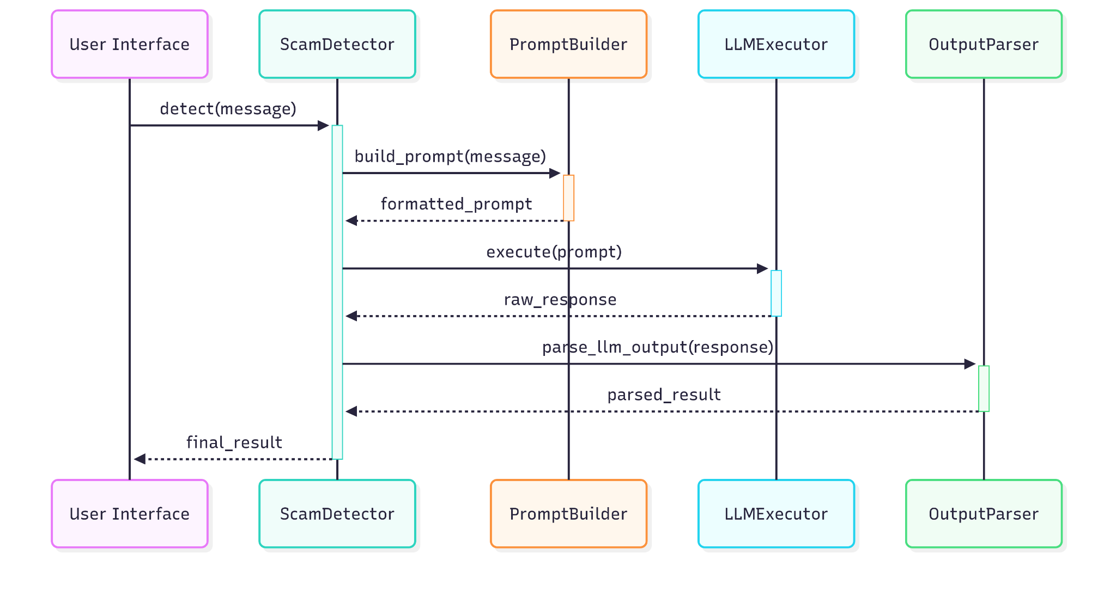
Explanation:
- User Interface sends a message to be checked.
- ScamDetector receives the message and coordinates the full detection process.
- It first calls PromptBuilder to format the message into a proper LLM prompt.
- The formatted prompt is passed to LLMExecutor, which sends it to the LLM (like Gemini).
- LLMExecutor returns the raw LLM response.
- PromptBuilder calls OutputParser to extract useful information from that raw response.
- The parsed result is sent back to ScamDetector, which passes the final result to the User Interface.

Key Roles:
- PromptBuilder: Prepares and interprets the prompt.
- LLMExecutor: Talks to the actual LLM.
- OutputParser: Extracts structured info from the LLM’s text.

Note to the Instructor
Even though the user interface isn’t built yet, introducing this component at this stage is intentional. It allows both you and the learners to:
- Understand the backend flow and sequence of interactions between components like prompt builders, LLM clients, and output parsers.
- Recognize what they’ve implemented so far, reinforcing their understanding of how the pieces fit together.
- Identify what's still missing—such as how the interface will trigger requests, display results, or manage inputs, which creates a natural path forward in the development process.
By visualizing the system before the UI is introduced, learners gain clarity on both the data flow and the responsibilities of each module, which ultimately makes front-end integration much smoother and more purposeful.
Code
from typing import List, Dict, Any
from .builder import build_prompt
from .executor import LLMExecutor
from .parser import OutputParser
from utils import get_logger
logger = get_logger(__name__)
class ScamDetector:
"""Orchestrates the scam detection pipeline."""
def __init__(self, strategy: str = "react") -> None:
"""Initializes the pipeline components."""
self.executor = LLMExecutor()
self.parser = OutputParser()
self.strategy = strategy
logger.info(f"Initialized ScamDetector with strategy: {self.strategy}")
def detect(self, message: str) -> Dict[str, Any]:
"""Runs scam detection on a single message."""
logger.info(f"Starting detection for message length: {len(message)}")
try:
# The 3-step pipeline
prompt = build_prompt(message, self.strategy)
raw_response = self.executor.execute(prompt)
parsed_result = self.parser.parse_llm_output(raw_response)
logger.info(f"Detection successful. Result: {parsed_result.get('label', 'Unknown')}")
return parsed_result
except Exception as e:
logger.error(f"Detection pipeline failed: {e}")
# Re-raise the exception to be handled by the caller (UI layer)
raise
def detect_batch(self, messages: List[str]) -> List[Dict[str, Any]]:
"""Runs scam detection on a list of messages."""
total_messages = len(messages)
logger.info(f"Starting batch detection for {total_messages} messages.")
results: List[Dict[str, Any]] = []
for i, message in enumerate(messages):
try:
result = self.detect(message)
results.append(result)
except Exception as e:
logger.warning(f"Failed to process message {i+1}/{total_messages}: {e}")
# Append a fallback error result for the failed message
error_result = {
"label": "Uncertain",
"reasoning": f"Error processing message: {e}",
"intent": "Could not determine",
"risk_factors": ["processing_error"]
}
results.append(error_result)
successful = sum(1 for r in results if r.get("label") != "Uncertain" or "processing_error" not in r.get("risk_factors", []))
logger.info(f"Batch processing complete. {successful}/{total_messages} succeeded.")
return results

Code Walkthrough
- __init__ method
- When we create a ScamDetector, the __init__ method runs.
- It creates and stores an instance of each of our three pipeline components: PromptBuilder, LLMExecutor, and OutputParser. T
- detect method
- This method is the heart of the application. It takes a single message string.
- try: – It wraps the core logic in a try...except block to gracefully handle any potential failures within the pipeline.
- Step 1: Build
prompt = self.builder.build_prompt(message)
  - It calls the build_prompt method on its PromptBuilder instance.
  - This returns the fully formatted prompt string, ready for the LLM.
- Step 2: Execute
raw_response = self.executor.execute(prompt)
  - It passes the generated prompt to its LLMExecutor instance.
  - The executor handles the API call and returns the LLM's raw text response.
- Step 3: Parse
parsed_result = self.parser.parse_llm_output(raw_response)
  - It sends this raw_response to its OutputParser instance.
  - The parser finds and validates the JSON, returning a clean Python dictionary.
- return parsed_result – The final, structured dictionary is returned.
- except Exception as e: – If any step fails, this block catches the error, logs it for debugging, and then raises it so the calling interface (like the Streamlit app) knows there was a problem.
detect_batch method
- This method shows how to process many messages efficiently.
- for i in range(0, len(messages), batch_size): – This loop iterates through the list of messages in chunks (or "batches") of size batch_size.
- for j, message in enumerate(batch): – An inner loop processes each message within the current batch.
- result: Dict[str, Any] = self.detect(message) – For each message, it simply calls the same detect method we just analyzed. This is a great example of code reuse.
- If any individual detect call fails, the try...except block inside this loop prevents the entire batch from failing. It logs a warning and appends a structured error message to the results.
Note for Instructor
Now that we’ve introduced batching, it’s a good opportunity to explain to learners why batching is useful in LLM-based systems and when it's necessary.

Why Batching?
Batching helps when:
- You want to send multiple messages or prompts to the LLM at once, especially during evaluation or bulk classification.
- You’re running integration tests or processing datasets where multiple prompts need to be evaluated efficiently.
It allows the system to handle more work with fewer API calls, improving performance and clarity in output handling.

Talk About Rate Limiting
Introduce the idea of rate limits:
- Most LLM providers (like Google Gemini or OpenAI) limit how many requests you can make per minute or per day.
- Batching helps reduce the number of calls and stay within usage quotas.
- It also reduces the chance of errors like 429 Too Many Requests.
You might also touch on:
- Retry logic when rate limits are exceeded.
- The trade-off between latency (waiting for a batch to finish) and throughput (handling many requests efficiently).

Create main.py – CLI Interface
The Current Limitation
We have a powerful ScamDetector "engine," but no steering wheel or dashboard. There is currently no way for a human user to interact with our system to get a prediction.
The Enhancement
We are creating a simple command-line interface (CLI). This will allow a user to run our script, type in a message directly into their terminal, and see the result printed out.
Why is this important?
A CLI is a powerful and essential tool for developers. It's perfect for quick tests, debugging, and integrating the application into automated scripts. It's often the very first interface built for a new system because of its simplicity and utility.

Code
from pathlib import Path
import sys
from pipeline.scam_detector.detector import ScamDetector
from utils import get_logger
# Add project root to path
project_root = Path(__file__).parent
sys.path.append(str(project_root))
logger = get_logger(__name__)
def main():
"""Test the scam detection system with dynamic message."""
detector = ScamDetector()
test_msg = str(input("Enter your Message: "))
try:
logger.info("Running scam detection")
result = detector.detect(test_msg)
print(f"Test Message: {test_msg}")
print(f"Detection Result: {result}")
except Exception as e:
logger.error(f"Detection failed: {e}")
print(f"Error: {e}")
if __name__ == "__main__":
main()
Code Walkthrough
- import ...: We import our ScamDetector class and the sys and pathlib modules to help Python find our other files.
- def main():: We define the main function that holds our script's logic.
- detector = ScamDetector(): We create an instance of the detector.
- test_msg = str(input("Enter your Message: ")): We prompt the user to type a message.
- detector.detect(test_msg): We pass the user's input to our pipeline and get the result.
- if __name__ == "__main__":: This is a standard Python construct that ensures the main() function only runs when the script is executed directly (not when it's imported by another file).
Note for Instructor
Once the CLI interface is ready, encourage learners to run the system using different prompt strategies (e.g., ReAct, Few-Shot ReAct etc) to observe and compare the outcomes.
This activity helps learners:
- See the impact of each prompt style on the quality and structure of the LLM’s response.
- Understand how prompt strategy affects intent detection, reasoning, and classification accuracy.
- Get comfortable switching strategies using the centralized prompt configuration.
Sample run
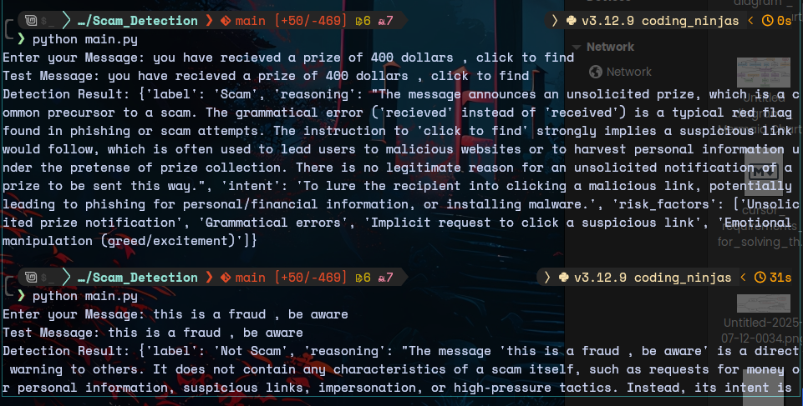

Step 5.3: Web Interface with Streamlit
Create streamlit/app.py – Web Interface
The Current Limitation
Our CLI is great for developers, but it's not very user-friendly for a non-technical audience. To make our tool truly accessible, we need a graphical user interface (GUI).
The Enhancement
We will use the Streamlit library to build an interactive, browser-based web application for our scam detector. This will provide a visual and intuitive way for anyone to use our system.
Why is this important?
A GUI makes an application accessible to a much wider audience. We are demonstrating a key software engineering principle: a well-designed backend (our ScamDetector class) can support many different frontends (a CLI, a web app, or even a mobile app) without any changes to its own code.
Code
import sys
from pathlib import Path
# Add the project root directory to Python path
project_root = Path(__file__).parent.parent
sys.path.append(str(project_root))
import streamlit as st
import pandas as pd
from pipeline.scam_detector.detector import ScamDetector
st.set_page_config(page_title="Scam Detection App", layout="wide")
st.title(" Scam Detection System")
# Initialize detector
detector = ScamDetector()
# Tab layout
tab1, tab2 = st.tabs(["Single Message", "Dataset Evaluation"])
# ----------- Single Message Analysis ----------
with tab1:
st.header("Analyze a Single Message")
user_input = st.text_area("Enter the message to analyze:", height=150,
placeholder="Example: Congratulations! You've won $1000. Click here to claim...")
if st.button("Analyze Message", type="primary"):
if user_input.strip():
with st.spinner("Analyzing message..."):
try:
result = detector.detect(user_input)
# Display results
col1, col2 = st.columns(2)
with col1:
st.subheader("Classification Result")
label = result.get("label", "Unknown")
if label == "Scam":
st.error(f"🚨 **{label}**")
elif label == "Not Scam":
st.success(f"✅ **{label}**")
else:
st.warning(f"⚠️ **{label}**")
with col2:
st.subheader("Intent")
st.write(result.get("intent", "Could not determine"))
st.subheader("Reasoning")
st.write(result.get("reasoning", "No reasoning provided"))
st.subheader("Risk Factors")
risk_factors = result.get("risk_factors", [])
if risk_factors:
for factor in risk_factors:
st.write(f"• {factor}")
else:
st.write("No specific risk factors identified.")
except Exception as e:
st.error(f"Error during analysis: {str(e)}")
else:
st.warning("Please enter a message to analyze.")
# ----------- Dataset Evaluation ----------
with tab2:
st.header("Dataset Evaluation")
uploaded_file = st.file_uploader("Upload a CSV file for batch analysis", type="csv")
if uploaded_file is not None:
try:
df = pd.read_csv(uploaded_file)
st.write(f"Loaded dataset with {len(df)} rows")
st.write("Sample data:")
st.dataframe(df.head())
# Find text column
text_columns = ["text", "message_text", "message"]
text_col = None
for col in text_columns:
if col in df.columns:
text_col = col
break
if text_col:
st.write(f"Using '{text_col}' as text column")
# Limit for demo purposes
max_rows = min(len(df), 10)
if st.button(f"Analyze First {max_rows} Messages"):
with st.spinner(f"Analyzing {max_rows} messages..."):
messages = df[text_col].head(max_rows).tolist()
results = detector.detect_batch(messages)
# Create results dataframe
results_df = pd.DataFrame(results)
st.subheader("Analysis Results")
st.dataframe(results_df)
# Summary statistics
label_counts = results_df['label'].value_counts()
st.subheader("Summary")
st.bar_chart(label_counts)
else:
st.error(f"Could not find text column. Expected one of: {text_columns}")
except Exception as e:
st.error(f"Error processing file: {str(e)}")

Code Walkthrough
- import streamlit as st: We import the library, giving it the conventional short name st.
- st.set_page_config(...), st.title(...): These commands set the title of the browser tab and the main title visible on the page.
- detector = ScamDetector(): Just like in our CLI, we create a single instance of our entire pipeline.
- tab1, tab2 = st.tabs(...): This creates the tabbed layout for our app.
- with tab1:: The code inside this block will only appear in the "Single Message" tab.
- user_input = st.text_area(...): This creates the large text box for user input. The text the user types is stored in the user_input variable.
- if st.button(...): This is the event handler. The code inside this if block only runs when the "Analyze Message" button is clicked.
- with st.spinner(...): This helpful command displays an "Analyzing message..." loading animation while the code inside the block is running. This provides great user feedback during the API call.
- result = detector.detect(user_input): This is the exact same pipeline call we used in the CLI. The Streamlit app is just another "frontend" for our powerful backend ScamDetector.
- st.subheader(...), st.write(...), st.error(...): After getting the result dictionary, we use various Streamlit commands to display the information in a nicely formatted way. We can even use st.error or st.success to add colors and icons based on the classification label.
- with tab2:: The code inside this block populates the "Dataset Evaluation" tab.
- uploaded_file = st.file_uploader(...): This single line creates a powerful file upload widget.
- df = pd.read_csv(uploaded_file): If a file is uploaded, we use the pandas library to read the CSV into a DataFrame, which is like a spreadsheet in Python.
- results = detector.detect_batch(messages): Here we call the detect_batch method to process multiple rows from the uploaded file.
- st.dataframe(results_df), st.bar_chart(...): Streamlit has built-in support for pandas DataFrames, allowing us to easily display the results in a table and create a summary bar chart with just one line of code each.
Expected GUI
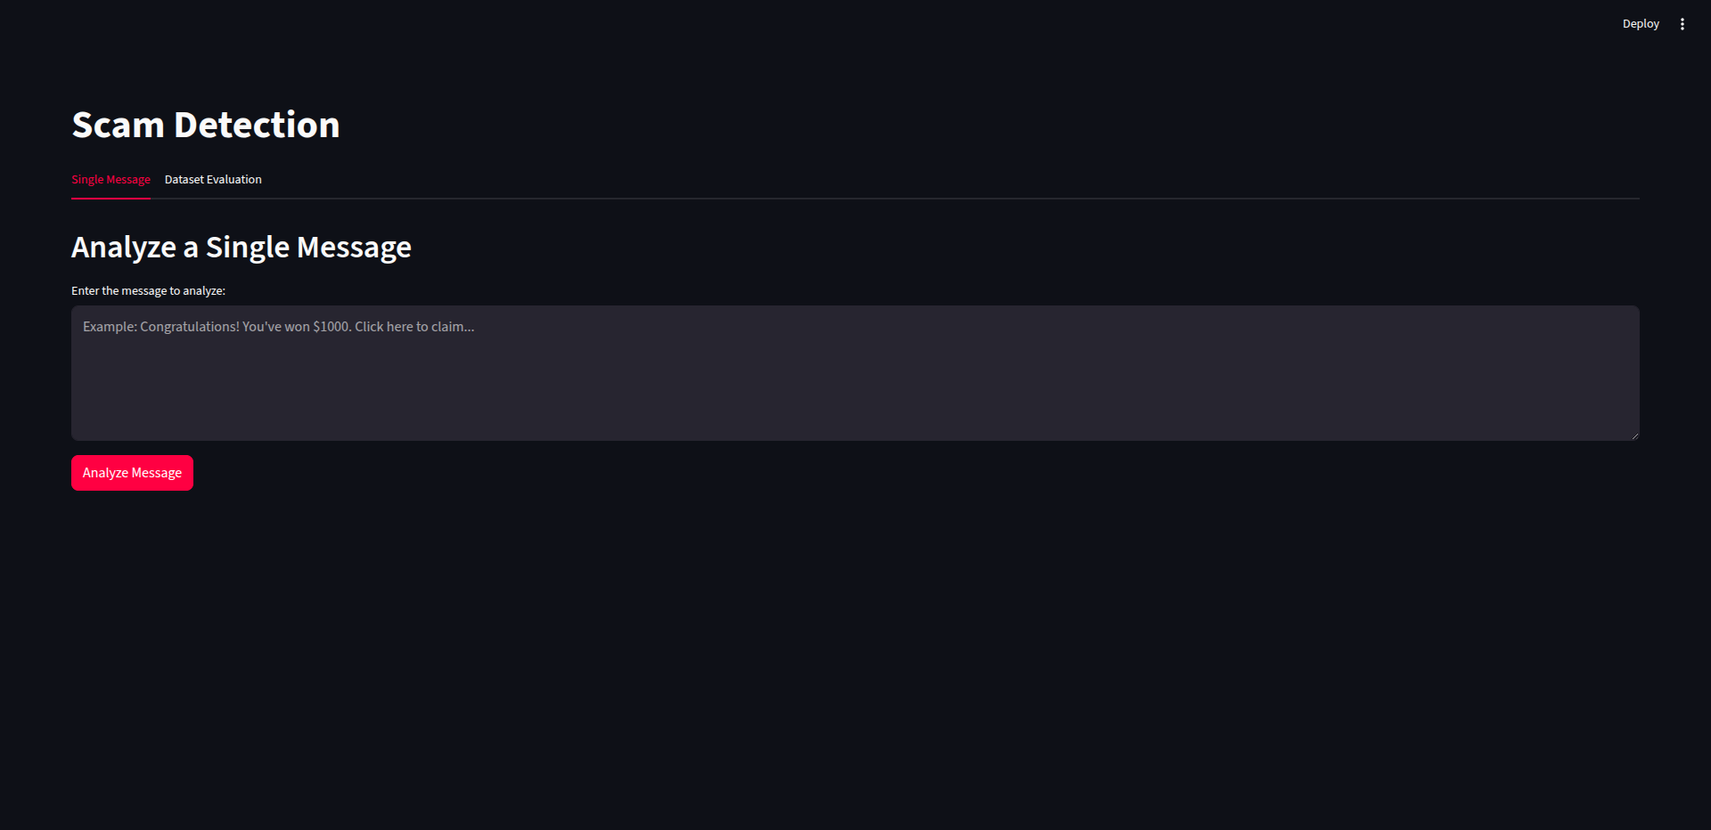
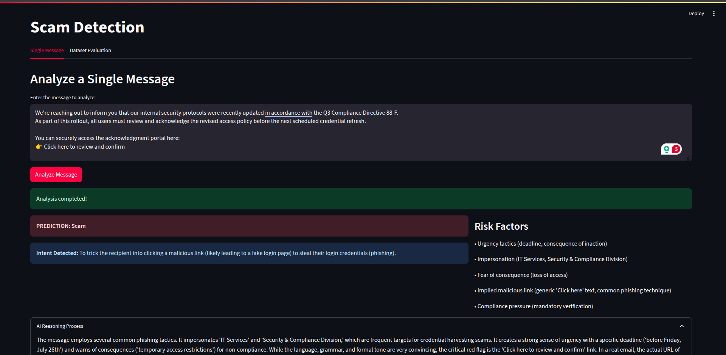
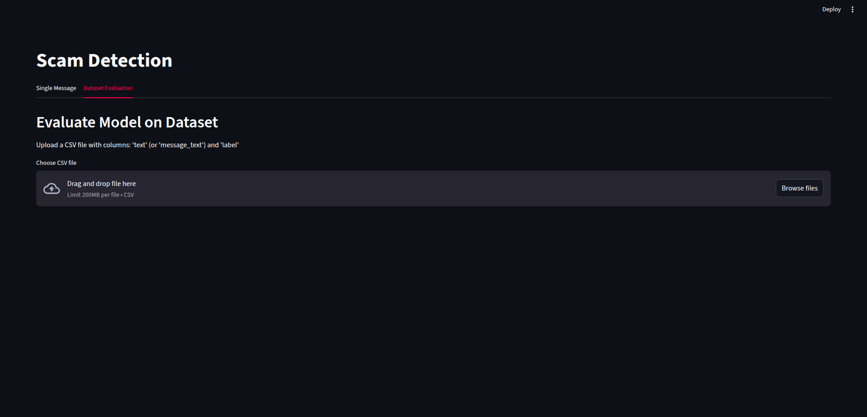

Educational Note
This demonstrates the difference between single completion calls and batch processing — crucial concepts in production LLM applications.
Note for Instructor
The Streamlit-based UI will be entirely new for most learners, so it must be introduced during a live session with a hands-on walkthrough.
All the necessary code and implementation flow is already provided here for your reference. However, if needed, feel free to consult the official Streamlit documentation for deeper insights or clarifications:
Streamlit Documentation
This walkthrough will help learners connect their backend pipeline to a user-facing interface - a crucial step in understanding how LLM-driven applications work end-to-end.

Part 6: Evaluation & Performance Assessment
Aligns with Module 6: Output Evaluation & Projects

Learning Objectives
- Implement evaluation metrics for classification tasks
- Understand model performance assessment
- Learn to iterate and improve prompt strategies

Step 6.1: Creating Evaluation Framework
Create evaluate.py – Evaluation System
The Current Limitation
Our system works, and we can test it manually with a few messages. But is it good? Is it 80% accurate or 95% accurate? If we change a prompt, how do we know if we made things better or worse? We are "flying blind" without any objective performance metrics.
The Enhancement
We are building an evaluation script. This will take a dataset of messages with known correct labels and run them through our pipeline. It will then compare our model's predictions to the true labels and calculate a precise accuracy score.
Why is this important?
You can't improve what you can't measure. An evaluation framework is the most critical tool for iterating on an AI system. It provides the feedback loop necessary to make data-driven decisions, test new ideas, and systematically improve the performance of your application.
This iterative, data-driven cycle is how modern AI applications are refined.
import pandas as pd
from tqdm import tqdm
import argparse
from pipeline.scam_detector.detector import ScamDetector
def calculate_metrics(actual_labels, predicted_labels):
"""Calculate accuracy, recall, and F1-score for scam detection."""
total = len(actual_labels)
if total == 0:
return {"total": 0, "correct": 0, "accuracy": 0.0, "class_metrics": {}}
# Clean up labels (remove spaces, make lowercase)
actual_clean = [label.lower().strip() for label in actual_labels]
predicted_clean = [label.lower().strip() for label in predicted_labels]
# Calculate overall accuracy
correct = 0
for actual, pred in zip(actual_clean, predicted_clean):
if actual == pred:
correct += 1
accuracy = (correct / total) * 100
# Calculate metrics for each class
class_metrics = {}
unique_labels = set(actual_clean)
for label in unique_labels:
# Count correct and incorrect predictions for this class
true_positives = 0
false_negatives = 0
false_positives = 0
for actual, pred in zip(actual_clean, predicted_clean):
if actual == label and pred == label:
true_positives += 1
elif actual == label and pred != label:
false_negatives += 1
elif actual != label and pred == label:
false_positives += 1
# Calculate metrics
if true_positives + false_negatives > 0:
recall = (true_positives / (true_positives + false_negatives)) * 100
else:
recall = 0
if true_positives + false_positives > 0:
precision = (true_positives / (true_positives + false_positives)) * 100
else:
precision = 0
if precision + recall > 0:
f1_score = (2 * precision * recall) / (precision + recall)
else:
f1_score = 0
class_metrics[label] = {
"recall": round(recall, 2),
"f1_score": round(f1_score, 2)
}
return {
"total": total,
"correct": correct,
"accuracy": round(accuracy, 2),
"class_metrics": class_metrics
}
def evaluate_model(dataset_path, limit=None, verbose=False, batch_size=10):
"""Load dataset, run predictions, and evaluate performance."""
# Load the dataset
try:
df = pd.read_csv(dataset_path)
print(f"Loaded dataset with {len(df)} rows")
except FileNotFoundError:
print(f"Error: Dataset file not found at {dataset_path}")
return
if limit:
df = df.head(limit)
print(f"Limiting evaluation to the first {limit} messages.")
# Initialize detector
detector = ScamDetector()
# Prepare data for batch processing
messages = df['message_text'].tolist()
actual_labels = df['label'].tolist()
print(f"\nEvaluating {len(messages)} messages in batches of {batch_size}...")
# Process messages in batches
predicted_labels = []
total_batches = (len(messages) + batch_size - 1) // batch_size
for i in tqdm(range(0, len(messages), batch_size), desc="Processing batches", total=total_batches):
batch_messages = messages[i:i + batch_size]
batch_actual = actual_labels[i:i + batch_size]
try:
# Process batch
batch_results = detector.detect_batch(batch_messages)
batch_predicted = [result.get("label", "Uncertain") for result in batch_results]
if verbose:
for j, (msg, true_label, pred_label) in enumerate(zip(batch_messages, batch_actual, batch_predicted)):
print(f"\nMessage {i+j+1}: {msg[:50]}...")
print(f" True: {true_label}")
print(f" Predicted: {pred_label}")
predicted_labels.extend(batch_predicted)
except Exception as e:
print(f"Error processing batch {i//batch_size + 1}: {e}")
# Add fallback predictions for failed batch
predicted_labels.extend(["Uncertain"] * len(batch_messages))
print("\nEvaluation complete.")
# Calculate and print the final metrics
metrics = calculate_metrics(actual_labels, predicted_labels)
print("\n" + "="*50)
print(" MODEL EVALUATION RESULTS")
print("="*50)
print(f" Total Messages: {metrics['total']}")
print(f" Correct Predictions: {metrics['correct']}")
print(f" Overall Accuracy: {metrics['accuracy']}%")
print()
print(" PER-CLASS METRICS:")
for label, class_metrics in metrics['class_metrics'].items():
print(f" {label.upper()}:")
print(f" Recall: {class_metrics['recall']}%")
print(f" F1-Score: {class_metrics['f1_score']}%")
print()
print("="*50)
if __name__ == "__main__":
parser = argparse.ArgumentParser(description="Evaluate the Scam Detection System.")
parser.add_argument("dataset", help="Path to the labeled dataset (CSV file).")
parser.add_argument("--limit", type=int, help="Limit evaluation to the first N messages.")
parser.add_argument("--verbose", action="store_true", help="Print detailed results for each message.")
parser.add_argument("--batch-size", type=int, default=10, help="Batch size for processing (default: 10).")
args = parser.parse_args()
evaluate_model(args.dataset, args.limit, args.verbose, args.batch_size)

Code Walkthrough
- calculate_metrics(...)
This function evaluates model predictions using standard classification metrics like accuracy, recall, and F1-score.
actual_clean = [label.lower().strip() for label in actual_labels]
Cleans all labels by converting them to lowercase and stripping whitespace for fair comparison.

Accuracy Calculation
correct = sum(1 for a, p in zip(actual_clean, predicted_clean) if a == p)

accuracy = (correct / total) * 100
Compares predicted vs actual labels element-wise and calculates overall accuracy.

Per-Class Metrics
For each unique label, it calculates:
- Recall: TP / (TP + FN)
- F1 Score: Harmonic mean of precision and recall
All metrics are returned as a dictionary rounded to two decimals.
- evaluate_model(...)
This is the core evaluation function that loads the dataset, runs predictions using the scam detector pipeline, and prints performance metrics.
df = pd.read_csv(dataset_path)
Uses pandas to load the dataset containing labeled messages.
detector = ScamDetector()
Initializes the scam detection pipeline for batch inference.
messages = df['message_text'].tolist()
Extracts message texts and labels as Python lists.

Batch Processing Loop
for i in tqdm(range(0, len(messages), batch_size), desc="Processing batches"):
Processes the messages in configurable batches using a tqdm progress bar for visualization.
batch_results = detector.detect_batch(batch_messages)
Calls the pipeline on each batch and extracts predicted labels.

Verbose Mode
if verbose:
print(...) # Print message, true label, and prediction
If enabled, it shows detailed information per message for manual inspection.

Error Handling
If any exception occurs in a batch, it logs the error and assigns "Uncertain" as a fallback prediction for that batch.
metrics = calculate_metrics(actual_labels, predicted_labels)
After all batches are processed, it calculates evaluation metrics.

Print Summary
Prints total samples, correct predictions, accuracy, and per-class recall & F1-score in a formatted report.
if __name__ == "__main__"
Makes this script executable from the command line.
argparse.ArgumentParser(...)
Sets up CLI arguments to customize:
- Dataset path (required)
- Number of messages to evaluate (--limit)
- Verbose output (--verbose)
- Batch size (--batch-size)
args = parser.parse_args()
Parses command-line inputs.
evaluate_model(...)
Invokes the main evaluation function using parsed arguments.

Note for Instructor
As part of the evaluation module, we introduce two external libraries that may be new to learners:
- tqdm:
This library adds a progress bar to Python loops, helping learners visualize the progress during batch evaluations. It’s especially helpful when working with large datasets or slow LLM calls.
- pandas:
A widely-used library for working with tabular data. In our context, it helps organize model outputs and evaluation results for easy display, comparison, and optional export (e.g., to CSV).
Teaching Tip:
Briefly walk through:
- Why progress tracking is helpful in batch processing (with tqdm).
- How pandas simplifies viewing and analyzing results, especially if learners want to build dashboards or track metrics over time.
Also, this is a good point in the course to introduce the motivation behind using metrics like F1-score and Recall, instead of relying solely on accuracy.
Why not just use accuracy?
Because in real-world datasets—especially in scam detection—data is often imbalanced (e.g., more non-scams than scams). A model could achieve high accuracy by always predicting "non-scam", but it would completely fail at catching actual scams.
- Recall helps us measure how well we're catching true scams (true positives).
- F1-score balances recall and precision, giving a fair overall performance score, especially in imbalanced datasets.

Addition Setup (Deployment and Github)
Installing Git and Setting Up Version Control
- Install Git:
- Windows:
- Download Git from https://git-scm.com/downloads/win
- Run the installer with default settings
- Verify installation: Open Command Prompt and type git --version
- macOS:
- Using Homebrew (recommended)
- brew install git
- Or download from https://git-scm.com/download/mac

- Configure Git (First Time Setup):
- git config --global user.name "Your Name"
- git config --global user.email "your.email@example.com"

- Initialize Git Repository
In your project directory, run:
- git init

Create .gitignore file
.env
__pycache__/
*.pyc
*.pyo
*.pyd
.Python
logs/
outputs/
.streamlit/
venv/
.venv/
.DS_Store
*.log" > .gitignore

Not for Instructor
Explain, why it is important to to create .gitignorefile and its importance in keeping sensitive and important files away from being committed.

- Add all files to staging
- git add .
- Make initial commit
- git commit -m "Initial commit: ScamGuard"

- Create GitHub Account and Repository
- Create GitHub Account:
- Go to https://github.com

Click "Sign up" and create your account

- Create New Repository:
- Click the "+" icon in top right corner
- Select "New repository"
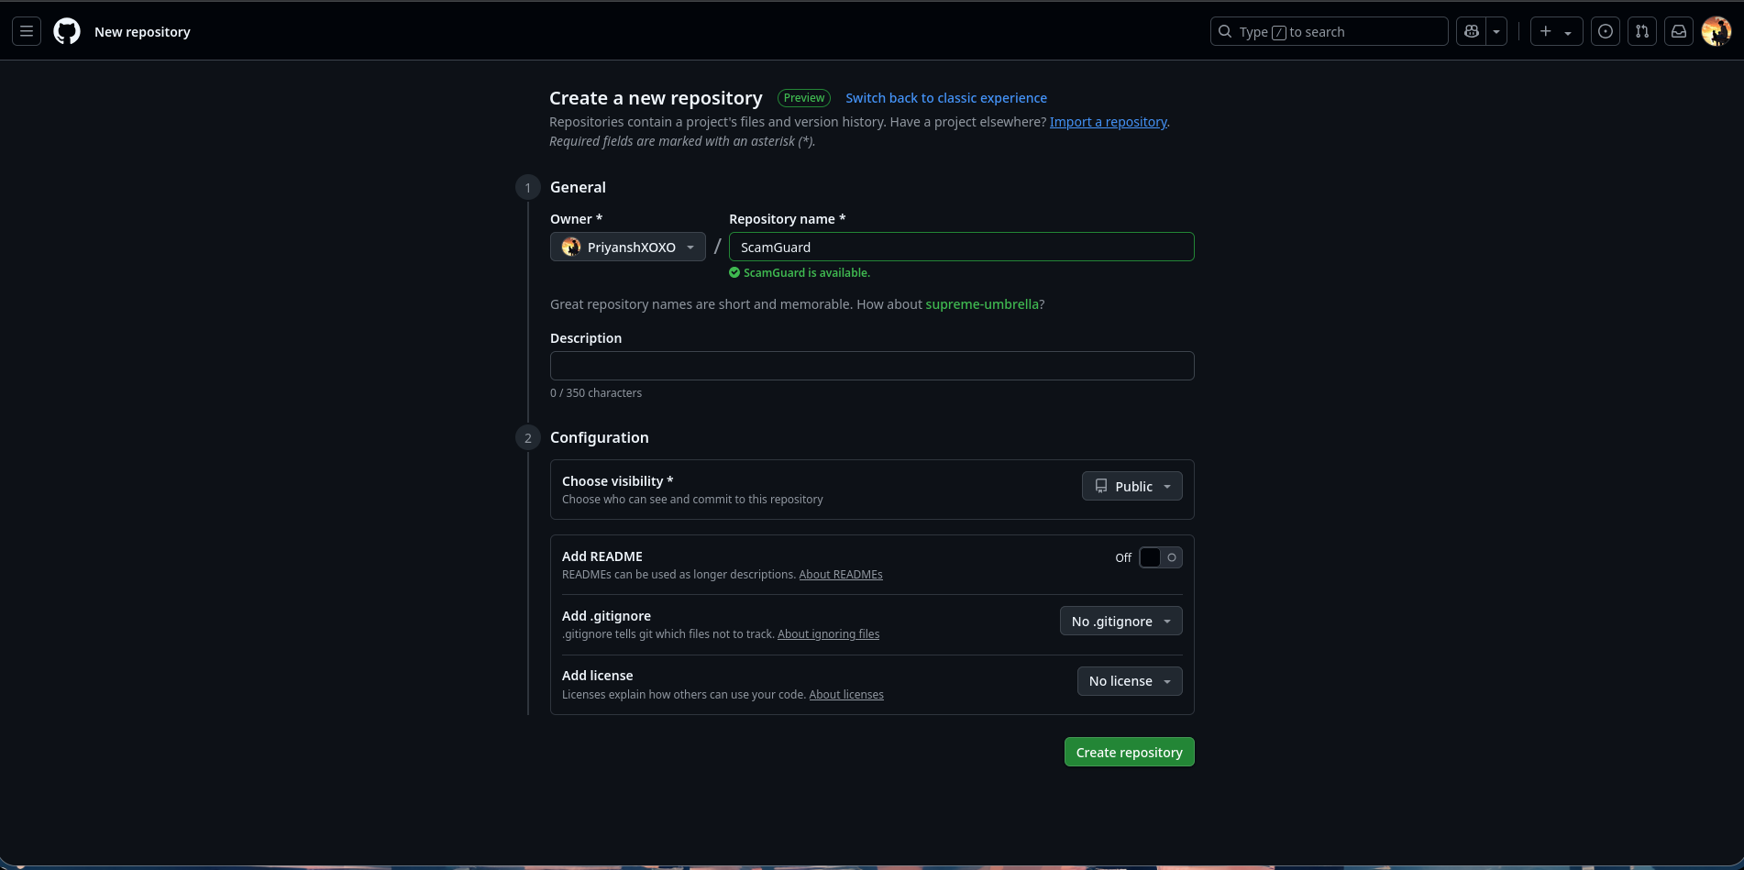

7. Add GitHub remote (replace YOUR_USERNAME with your actual username)
- git remote add origin https://github.com/YOUR_USERNAME/ScamGuard.git

- Push code to GitHub
- git branch -M main
- git push -u origin main

- Deployment to Production
Deploying To streamlit is simple and easy
- Go to https://share.streamlit.io/
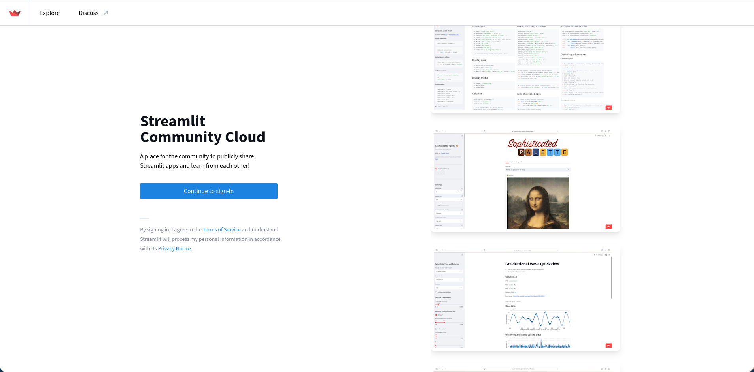
- Create the account
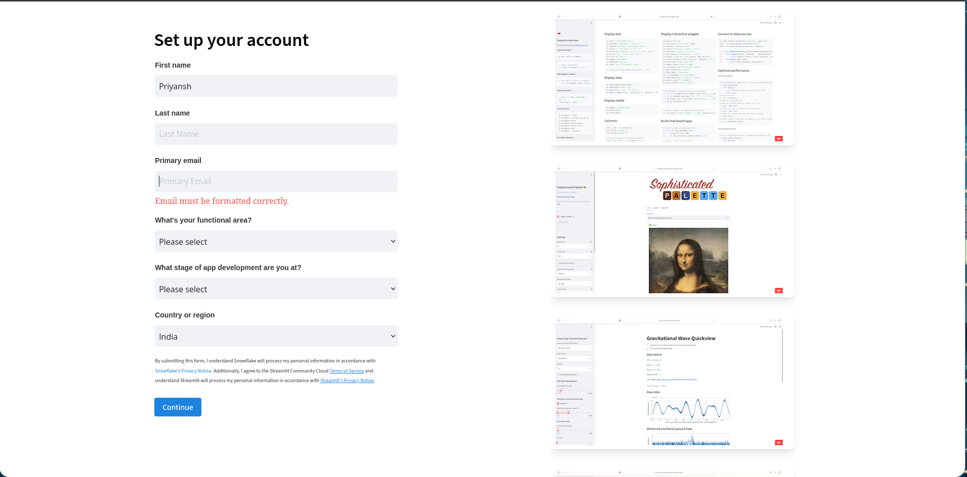

- Create app on the top right corner and select deploy a public app from github
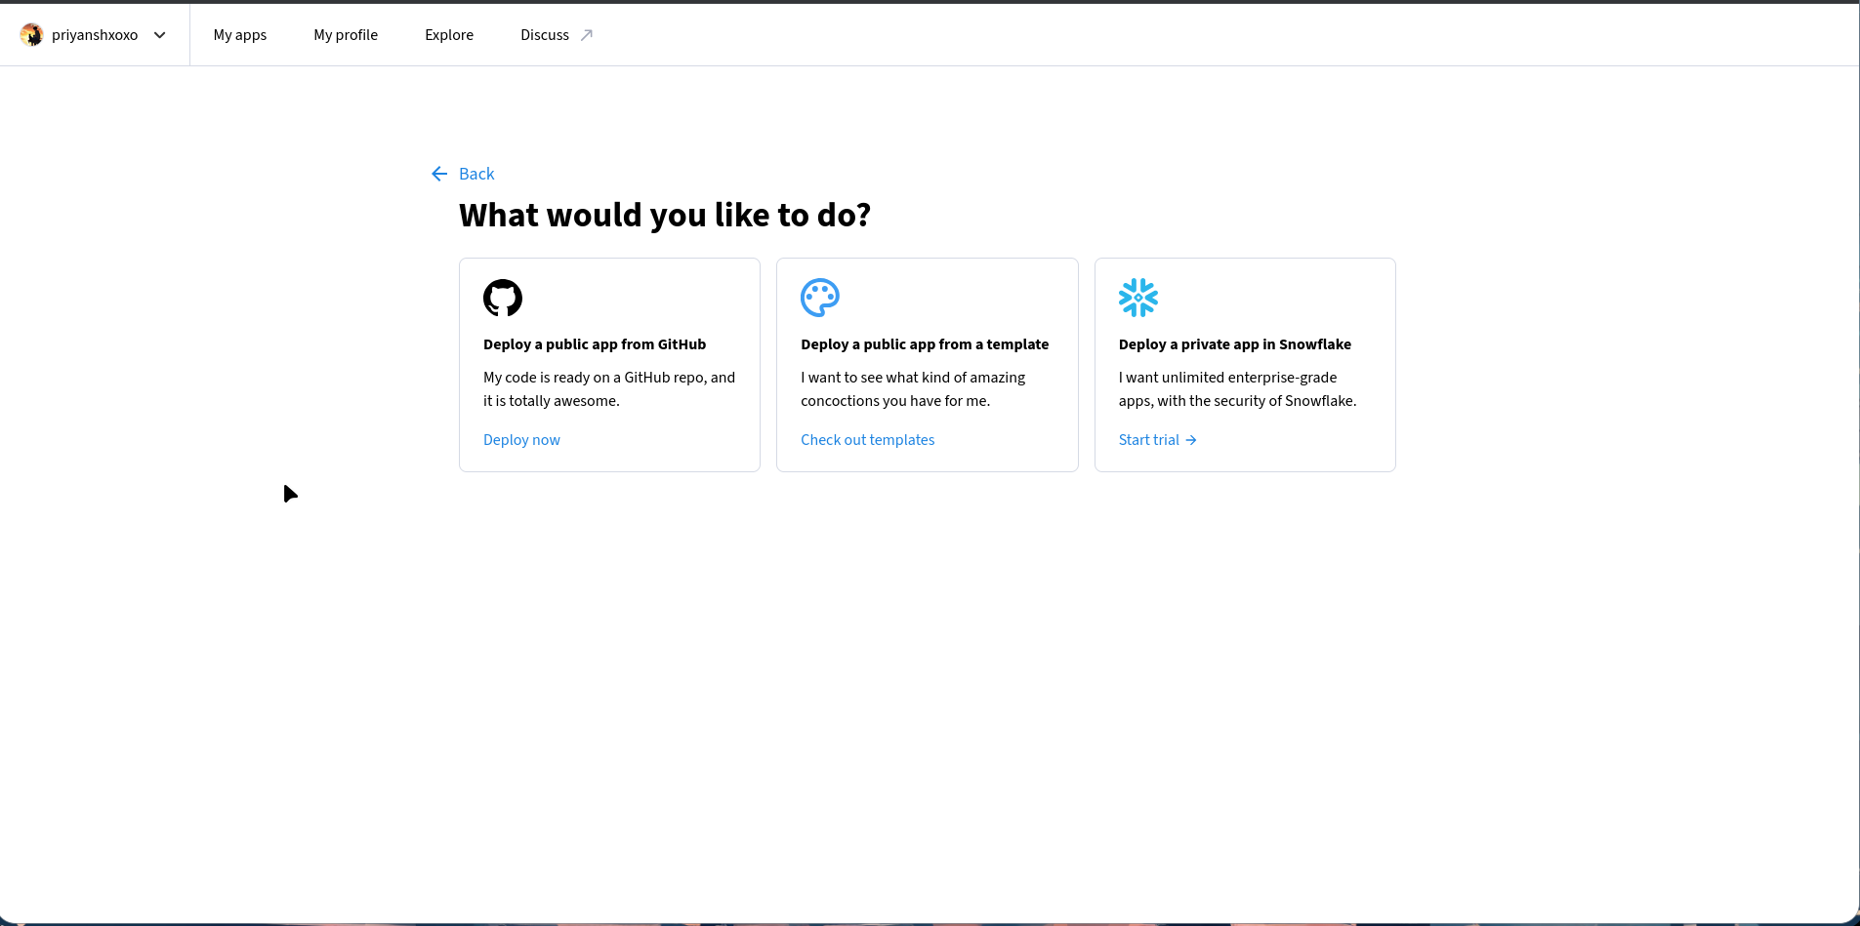
- Deploy an app and create
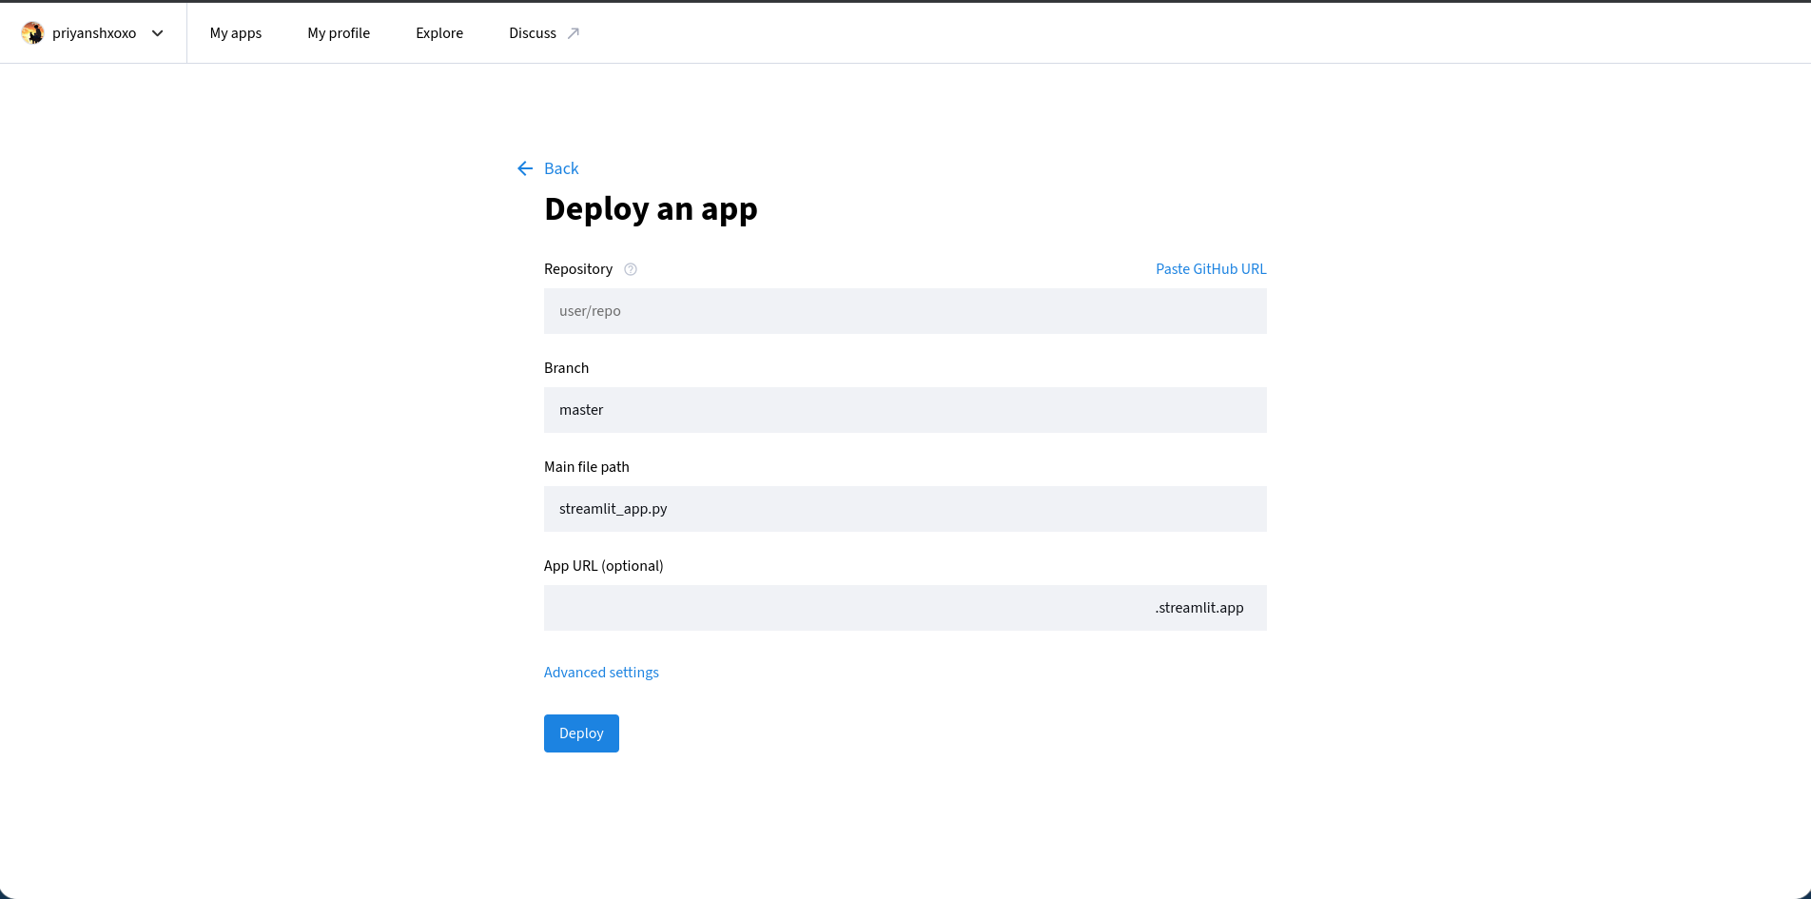
- You app will be deployed and live

