LIBRARY BOOK BROWSER: A ROLE-BASED LIBRARY MANAGEMENT WEB APPLICATION USING REACT, VITE AND REACT ROUTER
A PROJECT REPORT
Submitted by
PUSHKAR (UID: 24BCS10062)
HARMAN (UID: 24BCS10017)
in partial fulfillment for the award of the degree of
BACHELOR OF ENGINEERING
IN
COMPUTER SCIENCE AND ENGINEERING
Subject: Full Stack Development-II | Subject Code: 24CSP304
Chandigarh University
November 2026
BONAFIDE CERTIFICATE
Certified that this project report “LIBRARY BOOK BROWSER: A ROLE-BASED LIBRARY MANAGEMENT WEB APPLICATION USING REACT, VITE AND REACT ROUTER” is the bonafide work of “PUSHKAR (UID: 24BCS10062) and HARMAN (UID: 24BCS10017)” who carried out the project work under my supervision for the subject Full Stack Development-II (Subject Code: 24CSP304).

SIGNATURE  [Name of the Head of the Department]  HEAD OF THE DEPARTMENT  Department of Computer Science and Engineering | SIGNATURE  Prof. Venkatesh K  SUPERVISOR  [Academic Designation]  Department of Computer Science and Engineering, Chandigarh University, Gharuan, Mohali, Punjab – 140413
Submitted for the project viva-voce examination held on ____________________
INTERNAL EXAMINER EXTERNAL EXAMINER
ACKNOWLEDGEMENT
We express our sincere gratitude to our subject teacher and project supervisor, Prof. Venkatesh K, for his valuable guidance, encouragement and constructive suggestions throughout the Full Stack Development-II (24CSP304) course and during the preparation of this project.
We are thankful to the Department of Computer Science and Engineering, Chandigarh University, for providing the learning environment and resources needed to complete this work. We also acknowledge the open-source communities behind React, React Router, Vite and Oxlint, whose tools and documentation made this project possible.
Finally, we thank our families and friends for their constant support and motivation.
PUSHKAR (UID: 24BCS10062)
HARMAN (UID: 24BCS10017)
TABLE OF CONTENTS
ACKNOWLEDGEMENT iii
LIST OF FIGURES vi
LIST OF TABLES vii
ABSTRACT viii
GRAPHICAL ABSTRACT ix
ABBREVIATIONS x
SYMBOLS xi
Chapter 1. Introduction 1
1.1. Client Identification / Need Identification / Identification of Relevant Contemporary Issue 1
1.2. Identification of Problem 2
1.3. Identification of Tasks 2
1.4. Timeline 3
1.5. Organization of the Report 3
Chapter 2. Design flow/process 4
2.1. Evaluation & Selection of Specifications/Features 4
2.2. Design Constraints 5
2.3. Analysis and Feature Finalization Subject to Constraints 5
2.4. Design Flow 6
2.5. Design Selection 6
2.6. Implementation Plan/Methodology 7
Chapter 3. Results analysis and validation 9
3.1. Implementation of Solution 9
3.1.1. Tools used 9
3.1.2. Project structure 9
3.1.3. Data model and central book store 9
3.1.4. Reusable components 10
3.1.5. Search, filter and sort 10
3.1.6. Routing and role-based access 10
3.1.7. Request workflow 10
3.1.8. Admin panel 11
3.1.9. Responsive design and accessibility 11
3.1.10. Report preparation, project management and communication 11
3.2. Testing / Characterization 11
3.3. Validation and Interpretation of Results 14
3.4. Limitations Observed 15
Chapter 4. Conclusion and future work 16
4.1. Conclusion 16
4.2. Future Work 16
REFERENCES 17
APPENDIX-1: USER MANUAL 18
A1.1. Prerequisites 18
A1.2. Running the Project 18
A1.3. Troubleshooting 19
APPENDIX-2: SOURCE CODE 20
ACHIEVEMENTS 23
LIST OF FIGURES
Figure 1.1: Gantt Chart of the Project Timeline 3
Figure 2.1: Layered Architecture of the Library Book Browser (Design A) 6
Figure 2.2: Flowchart of the Book Request Life Cycle 8
Figure 3.1: Login Page (User and Admin Tabs) 13
Figure 3.2: Browse Page with Search, Filters and Results Count 13
Figure 3.3: Book Details Page with Booking Request Form 14
Figure 3.4: Admin / Librarian Panel (Books and Booking Requests) 14
Figure 3.5: Responsive Layout on a Mobile Screen 14
Figure A1.1: Terminal Output of npm run dev 18
Figure A1.2: Login Page 19
Figure A1.3: Sending a Booking Request 19
LIST OF TABLES
Table 1.1: Stakeholders and Their Needs 1
Table 1.2: Project Timeline 3
Table 2.1: Approaches Found in the Literature and Practice 4
Table 2.2: Specifications and Features Selected for the Design 4
Table 2.3: Design Constraints and How They Were Considered 5
Table 2.4: Comparison of the Alternative Designs 6
Table 2.5: Application Routes and Access Rules 7
Table 3.1: Tools and Versions Used 9
Table 3.2: Request Statuses and Their Effect 10
Table 3.3: Test Cases Designed for the Application 11
Table 3.4: Test Execution Record 12
Table A1.1: Common Problems and Solutions 19
ABSTRACT
Libraries need a fast way for members to find books and for librarians to control borrowing; registers and spreadsheets are slow to search and easy to get wrong. This project, Library Book Browser, is a responsive single-page web application built with React, Vite and React Router. A user can log in, search 22 sample books by title or author, filter by category and availability, sort by title, rating or year, open a details page and send a booking request for 1 to 30 days. An admin (librarian) can add, update and delete books, approve or reject requests, issue and receive books and charge a ₹50 fine. The application uses reusable components, lifted state, a central store hook, role-based routes and localStorage persistence, and its mobile-first layout adapts from one to four columns. Nineteen test cases cover login, search, filters, sorting, details, the request workflow, persistence and responsiveness.
Keywords: React, Vite, React Router, Single-Page Application, Library Management
GRAPHICAL ABSTRACT
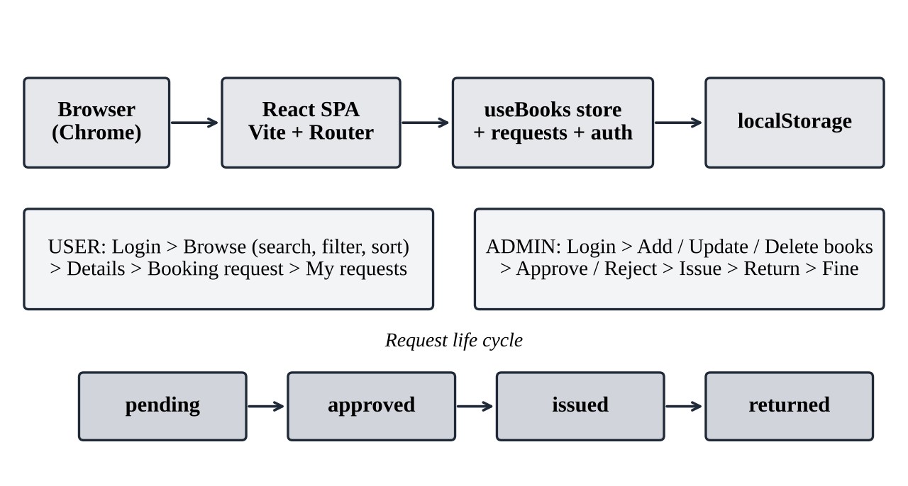
Graphical Abstract of the Library Book Browser Project
ABBREVIATIONS
Abbreviation | Full form
API | Application Programming Interface
CRUD | Create, Read, Update, Delete
CSS | Cascading Style Sheets
DOM | Document Object Model
HTML | HyperText Markup Language
JS / JSX | JavaScript / JavaScript XML
JSON | JavaScript Object Notation
npm | Node Package Manager
SPA | Single-Page Application
SVG | Scalable Vector Graphics
UI / UX | User Interface / User Experience
URL | Uniform Resource Locator
UID | Unique Identification Number
SYMBOLS
Symbol | Meaning
₹ | Indian rupee, the currency of the fine (₹50)
★ | Star symbol that shows the book rating out of 5
/:id | Route parameter that carries the book id
&& | Logical AND used to combine search and filter conditions

CHAPTER 1
INTRODUCTION

1.1. Client Identification / Need Identification / Identification of Relevant Contemporary Issue
The intended client is a college or community library that wants an online catalogue and a simple borrowing process, and, in the academic context of the course Full Stack Development-II (24CSP304), the students and developers who must learn to build a complete React application with routing, shared state and role-based screens. In many small libraries the catalogue is still kept in registers or spreadsheets, searching is slow, the availability of a book is not visible to the member, and issue, return and fine records are maintained by hand. The need was identified by observing this manual practice and through discussion with the course instructor.
Table 1.1 lists the stakeholders and what each of them needs.
Table 1.1: Stakeholders and Their Needs
Stakeholder | Who | Need
Member (user) | Student or reader who borrows books | Find a book quickly, see whether it is available, request it for a chosen period, follow the request status and any fine
Librarian (admin) | Staff who manage the collection | Add, edit and delete books; decide on requests; record issue, return and fines; see the status of every book
Institution | Owner of the library | Accurate records, low cost, use on phones, tablets and desktops without installing software

Relevant contemporary issues. The following issues are documented in the technical literature and practice and are relevant to this work:
- Digital access. Members expect to search a catalogue from a phone, so a responsive interface is essential (Marcotte, 2010).
- Single-page applications. Modern front ends load once and update the screen without page reloads, which needs client-side routing and careful state management (React Router contributors, n.d.).
- Component reuse. Large interfaces become hard to maintain unless they are split into small reusable components that receive data through props (Meta Open Source, n.d.).
- Access control. Different users must see different screens; a member must not reach the librarian’s tools.
- Data persistence. Even a prototype must not lose data on every refresh, which needs some form of storage (MDN Web Docs, n.d.).
- Accessibility and usability. Labels, alternative text and visible feedback help all users, including those using screen readers (W3C, 2023; Nielsen, 1994).

1.2. Identification of Problem
Handling a library by manual methods has four difficulties. First, finding a book requires scanning a list or asking the librarian. Second, a member cannot know in advance whether a book is available. Third, the records of issue, return and fines are kept by hand and are error-prone. Fourth, members and librarians have different responsibilities, but a single common list does not separate what each of them may see and do. These difficulties are felt most by users who access the library from mobile devices.
The broad problem is therefore that members cannot easily discover and request books, and librarians cannot easily control and record borrowing, in a structured way that separates the two roles and works on devices of every screen size.

1.3. Identification of Tasks
The following tasks were identified to study, build and test a solution. They also form the framework of this report.
- Study the requirements of a library catalogue and of the loan life cycle (Chapter 1 and Section 2.1).
- Select the features, list the design constraints and finalise the features (Sections 2.1 to 2.3).
- Generate alternative designs and select the best one (Sections 2.4 and 2.5).
- Create a Vite and React project, add React Router and design the data model (Section 2.6 and Chapter 3).
- Build reusable components: BookCard, BookList, SearchBar, FilterPanel, Navbar and Footer.
- Build the pages: Login, User Panel, Browse, Book Details, Admin Panel and Not Found.
- Implement search, filters, sorting, role-based routing and the request workflow.
- Store books, requests and the session in localStorage and make the layout responsive.
- Test the application, analyse the results and prepare the report, README and user manual (Chapters 3 and 4).

1.4. Timeline
The work was planned in six phases of one week each, as shown in Table 1.2 and in the Gantt chart in Figure 1.1.
Table 1.2: Project Timeline
Phase | Activity | Planned duration
1 | Requirement study, selection of tools, data model | Week 1
2 | Environment set-up (Node.js, Vite, React Router, VS Code) | Week 2
3 | Reusable components, styling and responsive layout | Week 3
4 | Browse page (search, filters, sorting) and Book Details page | Week 4
5 | Login, role-based routes, User and Admin panels, request workflow | Week 5
6 | Testing, debugging, screenshots and preparation of the report | Week 6

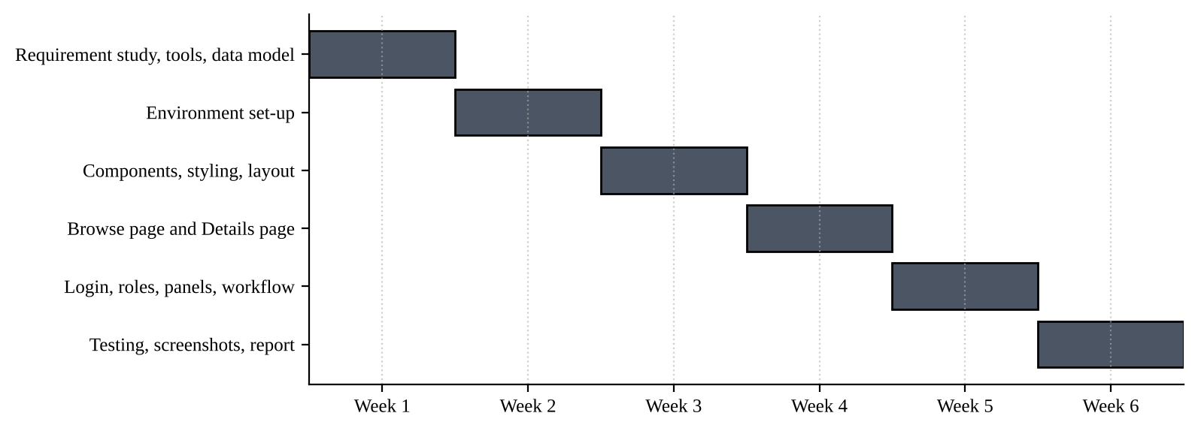
Figure 1.1: Gantt Chart of the Project Timeline

1.5. Organization of the Report
Chapter 1 introduces the client, the need, the problem, the tasks and the timeline. Chapter 2 describes the design flow: evaluation and selection of features, design constraints, feature finalization, alternative designs, selection of the best design and the implementation plan. Chapter 3 presents the implementation using modern engineering tools, the testing and the validation of results. Chapter 4 gives the conclusion, the deviation from expected results and the future work. The references, the user manual (Appendix-1), the source code (Appendix-2) and the achievements follow.

CHAPTER 2
DESIGN FLOW/PROCESS

2.1. Evaluation & Selection of Specifications/Features
Approaches to building a library web application were reviewed from the literature and from practice (Sommerville, 2016; Marcotte, 2010; React and React Router documentation). They are compared in Table 2.1.
Table 2.1: Approaches Found in the Literature and Practice
Approach | Description | Advantage | Limitation
Static HTML pages with plain JavaScript | One HTML file per page; scripts update the DOM | Simple, no build step | Repeated code, no component reuse, hard to maintain
React single-page application | Components, hooks and React Router built with Vite | Reusable components, fast navigation, large ecosystem | Needs a back end for shared and secure data
Full stack (React, Node/Express, database) | Front end calls a REST API backed by a database | Real persistence and authentication, multi-user | More set-up effort and hosting cost
Integrated library systems | Ready-made library software | Complete feature set | Heavy, hard to customise, not suitable for learning
Server-rendered frameworks | Pages rendered on the server | Good search-engine visibility | Extra concepts beyond the course scope

From this review the features ideally required in the solution were listed and given a priority of High (H) or Medium (M), as shown in Table 2.2.
Table 2.2: Specifications and Features Selected for the Design
ID | Feature | Priority | Justification
F1 | Catalogue of 22 sample books with generated SVG covers (works offline) | H | Core content
F2 | Live search by title or author (case-insensitive) | H | Fast discovery
F3 | Category filter, availability filter and sorting (title A-Z, rating, year) | H | Narrowing the list
F4 | Clear filters button, results count and “No books found” message | M | Feedback to the user
F5 | Book details page using the :id route parameter, with Back button | H | Full information
F6 | Login for user and admin with role-based routes | H | Separates member and librarian actions
F7 | Booking request with start date-time and 1 to 30 days | H | Core borrowing workflow
F8 | Admin CRUD: add, update and delete books | H | Collection management
F9 | Approve, reject, issue, return and ₹50 fine | H | Loan life cycle
F10 | Persistence in localStorage | M | Data survives reload
F11 | Responsive mobile-first layout with collapsible navbar | H | Use on any device
F12 | 404 page for unknown routes | M | Graceful error handling

2.2. Design Constraints
Table 2.3 lists the constraints that were considered in the design and how each was addressed.
Table 2.3: Design Constraints and How They Were Considered
Constraint | Consideration in this project
Regulations | No real personal data is collected. Login uses demo credentials only and nothing leaves the browser.
Economic / Cost | React, React Router, Vite, Oxlint, Node.js and VS Code are free, so the licence cost is zero. No hosting is needed during development.
Environmental | A static front end needs no server and little energy; SVG covers avoid image downloads.
Health | Readable font sizes, clear contrast and a collapsible menu reduce strain on small screens.
Manufacturability | Reproducibility through package.json and package-lock.json; set-up is npm install and npm run dev.
Safety | No action affects real data; the Reset books option restores the sample collection.
Professional | Functional components only, descriptive names, comments, lifted state and a linter are used.
Ethical | Only fictional book data is used; open-source tools are acknowledged.
Social | Gives members easy access to a library and teaches students a widely used framework.
Political | No political content. Dependence on third-party open-source packages is noted as a risk.

2.3. Analysis and Feature Finalization Subject to Constraints
All twelve features in Table 2.2 were retained. The economic constraint led to the modification of the data layer: instead of a database, the browser’s localStorage is used. The safety constraint led to the addition of a Reset books option and of a confirmation before a book is deleted. The professional constraint led to the addition of lifted state, a central store hook and a linter. A real back end, secure authentication, e-mail notices and automatic fine calculation were removed from the present scope and are listed as future work.

2.4. Design Flow
Three alternative designs were prepared to complete the project.
Design A: React single-page application (Vite, React Router, localStorage). Pages are routed components; shared book and request state live in the App component through the useBooks hook; the browser stores the data. Its layers are shown in Figure 2.1.
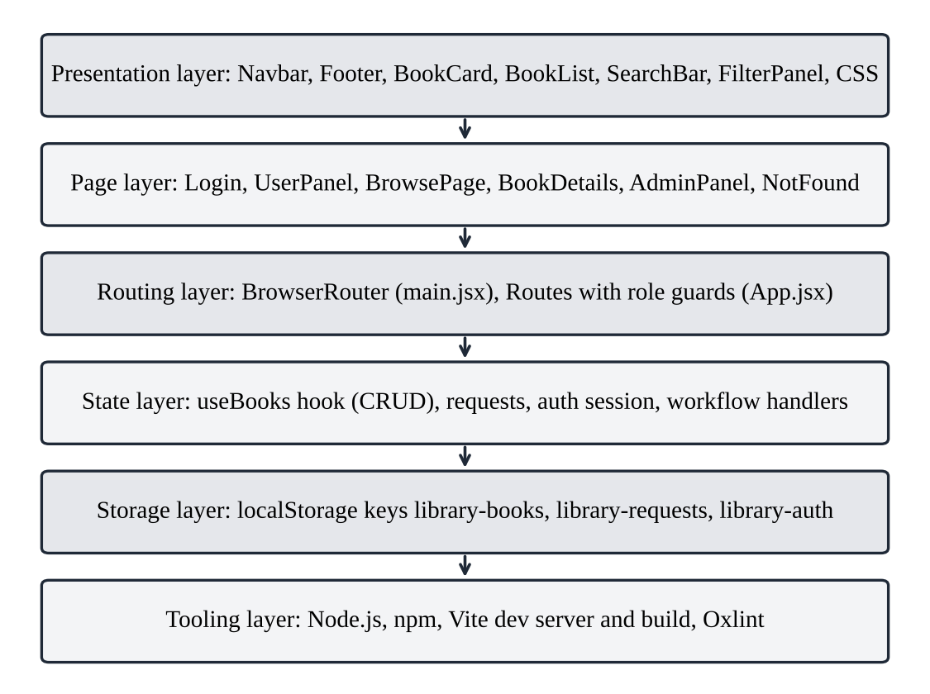
Figure 2.1: Layered Architecture of the Library Book Browser (Design A)
Design B: multi-page website with plain HTML, CSS and JavaScript. Each screen is a separate HTML file and scripts manipulate the DOM. There is no component reuse, so the card markup would be repeated on every page.
Design C: MERN stack. A React front end calls an Express REST API that stores users, books and loans in MongoDB with real authentication. It is the most complete design but needs a server, a database and hosting.

2.5. Design Selection
The designs were scored from 1 (poor) to 5 (best) against seven criteria in Table 2.4. The scores are the authors’ judgement relative to the needs and time frame of this project.
Table 2.4: Comparison of the Alternative Designs
Criterion | Design A | Design B | Design C
Meets functional requirements | 4 | 3 | 5
Development speed | 5 | 3 | 2
Maintainability and component reuse | 5 | 2 | 4
Cost (open source) | 5 | 5 | 4
Set-up effort | 5 | 5 | 2
Industry adoption and ecosystem | 5 | 2 | 5
Alignment with the course | 4 | 3 | 5
Total (out of 35) | 33 | 23 | 27

Design A was selected. It delivers all required screens and workflows with the least set-up, gives the best reuse and maintainability, and can later grow into Design C by replacing localStorage with API calls. Design B was rejected because of repeated code and poor maintainability. Design C was not chosen for this phase because its set-up and hosting needs exceeded the scope of the course project, although it gives better persistence and security.

2.6. Implementation Plan/Methodology
The application routes and their access rules are given in Table 2.5, and the algorithm followed is listed below. The life cycle of a request is shown as a flowchart in Figure 2.2.
Table 2.5: Application Routes and Access Rules
Route | Page | Access rule
/ | Redirect | Logged-in admin to /admin, logged-in user to /user, otherwise /login
/login | Login | Shown when logged out; otherwise redirects to the role’s panel
/user | UserPanel | Role “user” only; others see Login
/books | BrowsePage | Role “user” only; admin is redirected to /admin
/books/:id | BookDetails | Any logged-in person
/admin | AdminPanel | Role “admin” only; others see Login
* | NotFound | Any unknown URL

Algorithm:
- main.jsx renders App inside StrictMode and BrowserRouter.
- App creates the book store with useBooks, loads books, requests and the session from localStorage, and defines the handlers for login, logout, request, approve, reject, issue, return and fine.
- Routes decide which page is shown, using the stored role.
- BrowsePage keeps search, category, availability and sort in state, computes the filtered list with useMemo and passes it to BookList and BookCard.
- A user opens BookDetails and sends a request (status pending) with a start time and a duration; the due date is the start time plus the duration.
- The admin approves or rejects the request. An approved request can be issued, which marks the book unavailable. When the book is returned it is marked available again. An issued loan can be charged a ₹50 fine.
- After every change the data is written to localStorage so that it survives a reload.
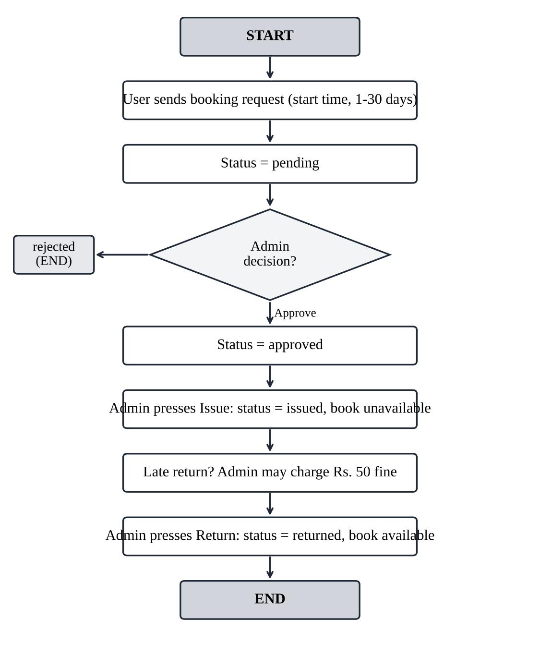
Figure 2.2: Flowchart of the Book Request Life Cycle

CHAPTER 3
RESULTS ANALYSIS AND VALIDATION

3.1. Implementation of Solution

3.1.1. Tools used
The design was implemented with the tools in Table 3.1. The versions are those declared in the project’s package.json.
Table 3.1: Tools and Versions Used
Tool | Version / detail | Purpose
Node.js | 18 or newer | JavaScript runtime for the build tools
React and React DOM | ^19.3.1 | Component-based interface, hooks
React Router DOM | ^7.18.5 | Client-side routing, route parameters, NavLink, Navigate
Vite | ^8.3.5 | Development server with hot module replacement, production build
@vitejs/plugin-react | ^6.1.2 | JSX support in Vite
Oxlint | ^1.89.0 | Linting (rules of hooks, only-export-components)
Browser localStorage | Web Storage API | Persistence of books, requests and session
Visual Studio Code | Editor | Code editing and terminal
Google Chrome | Browser | Running and testing the application

The npm scripts are npm run dev (development server, normally at http://localhost:5173), npm run build (production build in /dist), npm run preview and npm run lint.

3.1.2. Project structure
library-book-browser/
index.html package.json vite.config.js .oxlintrc.json README.md
src/
main.jsx entry point: StrictMode + BrowserRouter
App.jsx book store, session, requests, routes, layout
components/ BookCard, BookList, SearchBar, FilterPanel, Navbar, Footer
pages/ Login, UserPanel, BrowsePage, BookDetails, AdminPanel, Home, NotFound
styles/ global.css, navbar.css, controls.css, bookcard.css, pages.css

3.1.3. Data model and central book store
Each book has an id, title, author, category, year, rating, available flag, description and a generated SVG cover. The 22 sample books span ten categories (Fiction, Science Fiction, Fantasy, Mystery, Romance, History, Science, Technology, Biography and Self-Help). Covers are created by a makeCover function that builds an SVG data URL, so the application works offline. The custom hook useBooks keeps the collection and provides createBook, updateBook, deleteBook and resetBooks; every change is written to localStorage under the key library-books, and the list of categories is derived with useMemo.

3.1.4. Reusable components
- BookCard shows the cover, an Available or Borrowed badge, category, title, author, rating and a View Details link.
- BookList maps an array of books to BookCards in a responsive grid and shows a “No books found” message when the array is empty.
- SearchBar is a controlled input; its state is held by the parent.
- FilterPanel holds the category, availability and sort selects and the Clear filters button; all values come from props.
- Navbar collapses behind a hamburger button on small screens; Footer shows the copyright line.

3.1.5. Search, filter and sort
The state is lifted up into BrowsePage and passed to the child components as props. The three conditions (search, category, availability) are combined with logical AND and the sorter is applied last, inside one useMemo computation, so they always work together. The sort options are title A-Z (localeCompare), rating high to low and year newest first. A results line, “Showing N of M books”, is marked aria-live="polite" so that screen readers announce the change.

3.1.6. Routing and role-based access
main.jsx wraps the application in BrowserRouter. In App.jsx each route checks the stored session: a person who is not logged in is redirected to /login; /user and /books are available to the role “user”; /admin is available to the role “admin” (Table 2.5). The details page reads the book from the :id parameter with useParams and shows “Book not found” for an unknown id; any other URL shows the 404 page. The session is kept under library-auth. For demonstration the logins are user / user123 and admin / admin123.

3.1.7. Request workflow
A request stores the book, the user, the duration in days, the start time, the due date (start time plus duration), the request time, a status and a fine. The statuses move as shown in Table 3.2.
Table 3.2: Request Statuses and Their Effect
Status | Triggered by | Effect on the book
pending | User sends a booking request from the details page | None
approved / rejected | Admin presses Approve or Reject | None
issued | Admin presses Issue book | available = false (shown as Issued / Locked)
returned | Admin presses Return book | available = true
fine | Admin presses Charge ₹50 fine while issued | fine = 50 on the request

The details page hides the request form when the user already has an open request for that title and disables the button when the book is not available. Once a request is approved or issued, the user can open the book through the Read link in the User Panel.

3.1.8. Admin panel
The Admin / Librarian Panel lists all books with a status badge and has its own search, category and availability filters. The admin can add a book through a form, update a book (title, author, category, year, rating, description) and delete a book. Below the books, every request is shown with the requested, start, issued and due times, the status and any fine, together with the buttons that are valid for its current status.

3.1.9. Responsive design and accessibility
The CSS is split into five files (global, navbar, controls, bookcard, pages) and is written mobile-first: one column on mobile, two on tablets and three to four on desktops. Form controls have labels (a screen-reader-only label for the search box), book covers have alternative text, the hamburger button has aria-label and aria-expanded, and the Oxlint rule for the rules of hooks is enabled.

3.1.10. Report preparation, project management and communication
The work was organised according to the phases in Table 1.2 and divided between the two team members by area: components and styling, and routing, panels and the request workflow, with each member reviewing the other’s code. The code uses a standard Vite structure with comments explaining the main ideas, and a README.md records the set-up and commands. Progress was discussed with the course instructor, Prof. Venkatesh K, and this report was prepared in the project-report format of the university.

3.2. Testing / Characterization
The application was tested manually in the browser. The expected counts below follow from the sample data: 22 books, 10 categories, 16 available and 6 issued books at the start. The test cases are given in Table 3.3 and the record of execution in Table 3.4.
Table 3.3: Test Cases Designed for the Application
ID | Feature | Steps | Expected result
TC1 | Login (user) | Open /login, choose User Login, enter user / user123 | Redirected to /user; User Panel shows welcome line and book count
TC2 | Login (admin) | Choose Admin Login, enter admin / admin123 | Redirected to /admin; Admin Panel is shown
TC3 | Invalid login | Enter a wrong password | Message with demo credentials; no login
TC4 | Role guard | Logged in as user, open /admin | Login page is shown; admin tools are not visible
TC5 | Live search | On /books type “clean”, then “Sharma” | One book each: Clean Code in Practice; Data Structures Made Simple
TC6 | Category filter | Select Technology | 3 of 22 books are shown
TC7 | Availability filter | Select Issued, then Available | 6 books, then 16 books
TC8 | Sorting | Sort by Rating, then by Year | First book: Clean Code in Practice (4.8); then Learning React the Right Way (2025)
TC9 | Combined filters and Clear | Apply search, category and sort together; press Clear filters | Results respect all conditions; Clear restores all 22 books
TC10 | Empty result | Search for “zzz” | “No books found” message
TC11 | Book details | Open View Details; then open /books/999 | Full details with Back button; “Book not found” for id 999
TC12 | Booking request | Open an available book, set start time and days, send request | Request appears in My requests with status pending
TC13 | Unavailable book | Open an issued book as a user | Button reads “Book unavailable” and is disabled
TC14 | Approve, issue, return | As admin approve, press Issue book, then Return book | Status approved, issued, returned; book Issued / Locked, then Available
TC15 | Reject and fine | Reject a pending request; charge a fine on an issued request | Status rejected; “Fine ₹50” shown to user and admin
TC16 | Book CRUD | Add a book, update its title, delete it | Collection changes accordingly
TC17 | Persistence | Make changes and reload the page | Books, requests and session unchanged
TC18 | 404 page | Open /unknown | 404 page with Go to Home button
TC19 | Responsive layout | Resize to phone, tablet and desktop widths | 1, 2, then 3 to 4 columns; hamburger menu on phone

Each test case was carried out by hand with npm run dev on Google Chrome and the observed result was entered in Table 3.4. Figures 3.1 to 3.5 show the main screens.
Table 3.4: Test Execution Record
ID | Date | Actual result | Status
TC1
TC2
TC3
TC4
TC5
TC6
TC7
TC8
TC9
TC10
TC11
TC12
TC13
TC14
TC15
TC16
TC17
TC18
TC19

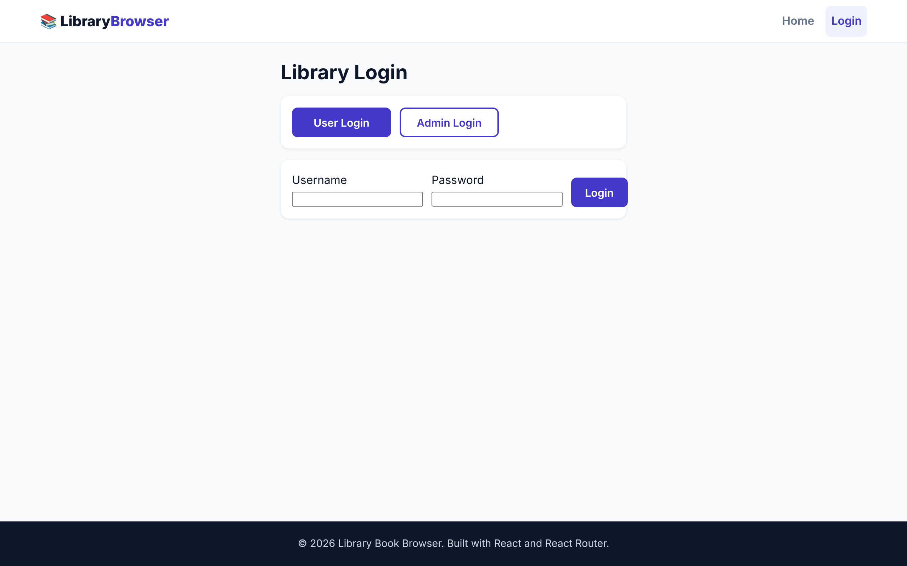
Figure 3.1: Login Page (User and Admin Tabs)
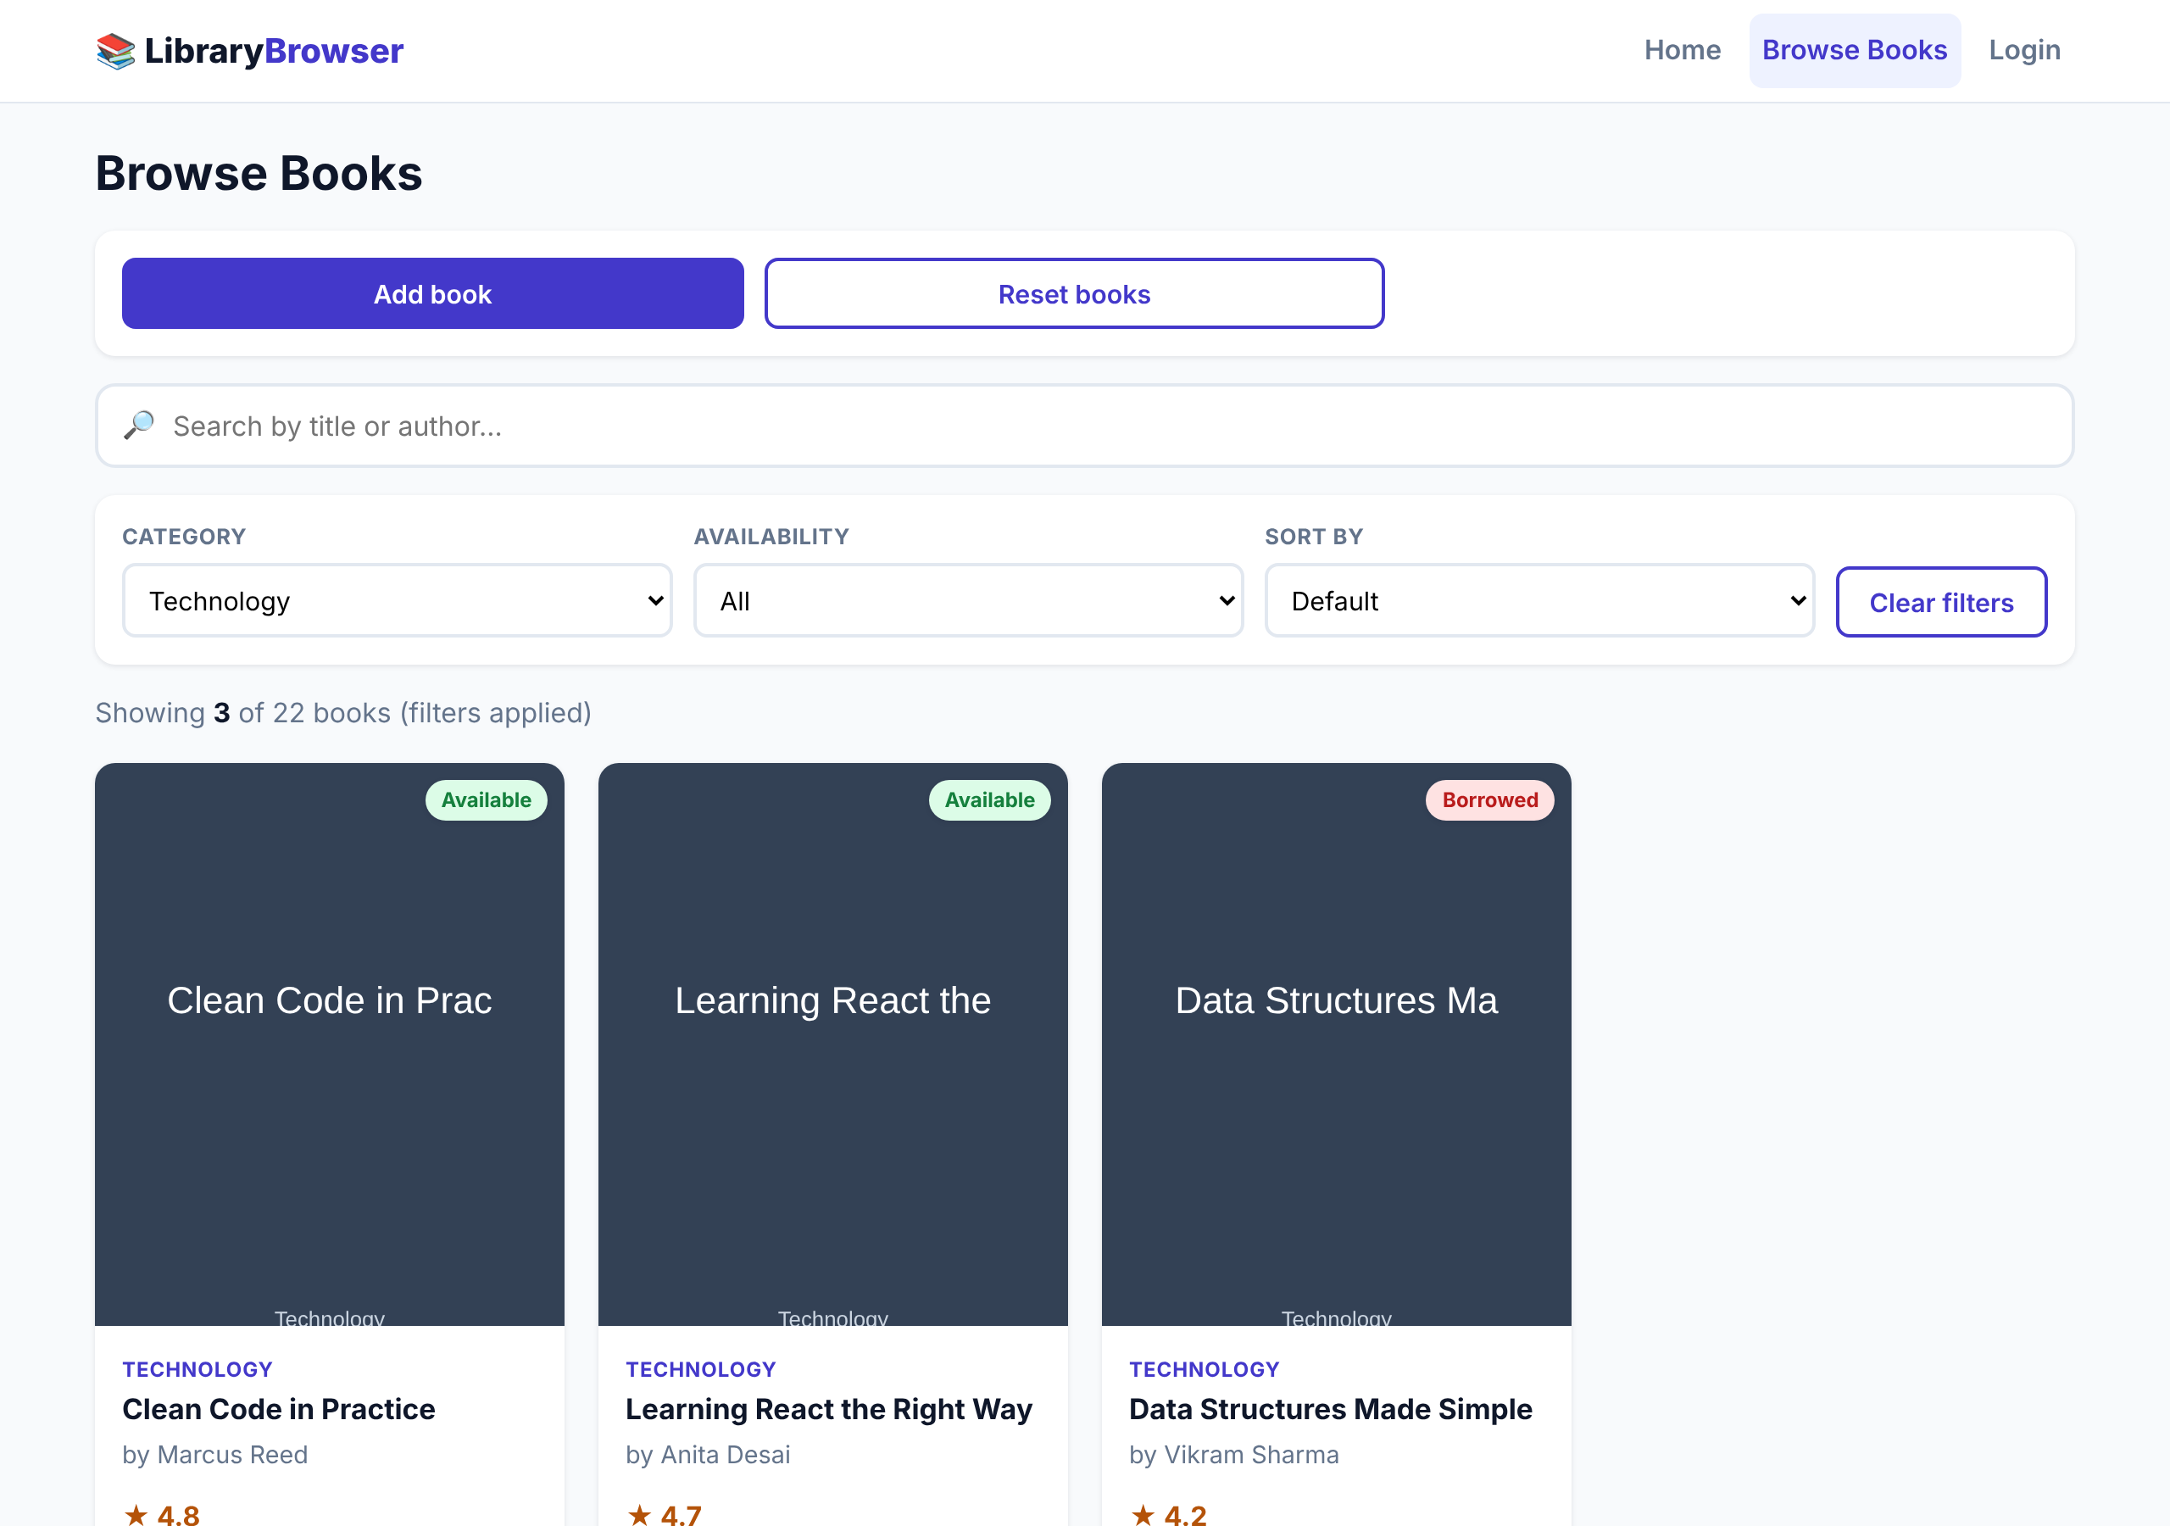
Figure 3.2: Browse Page with Search, Filters and Results Count
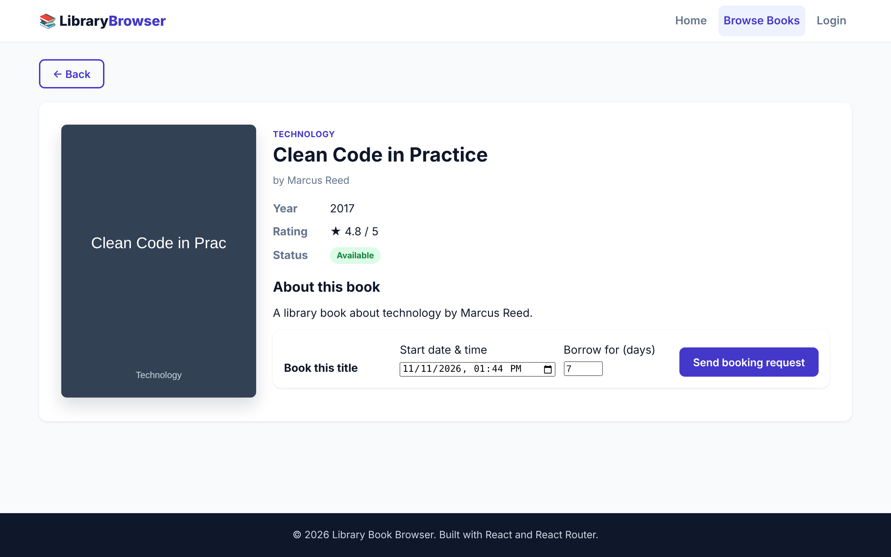
Figure 3.3: Book Details Page with Booking Request Form
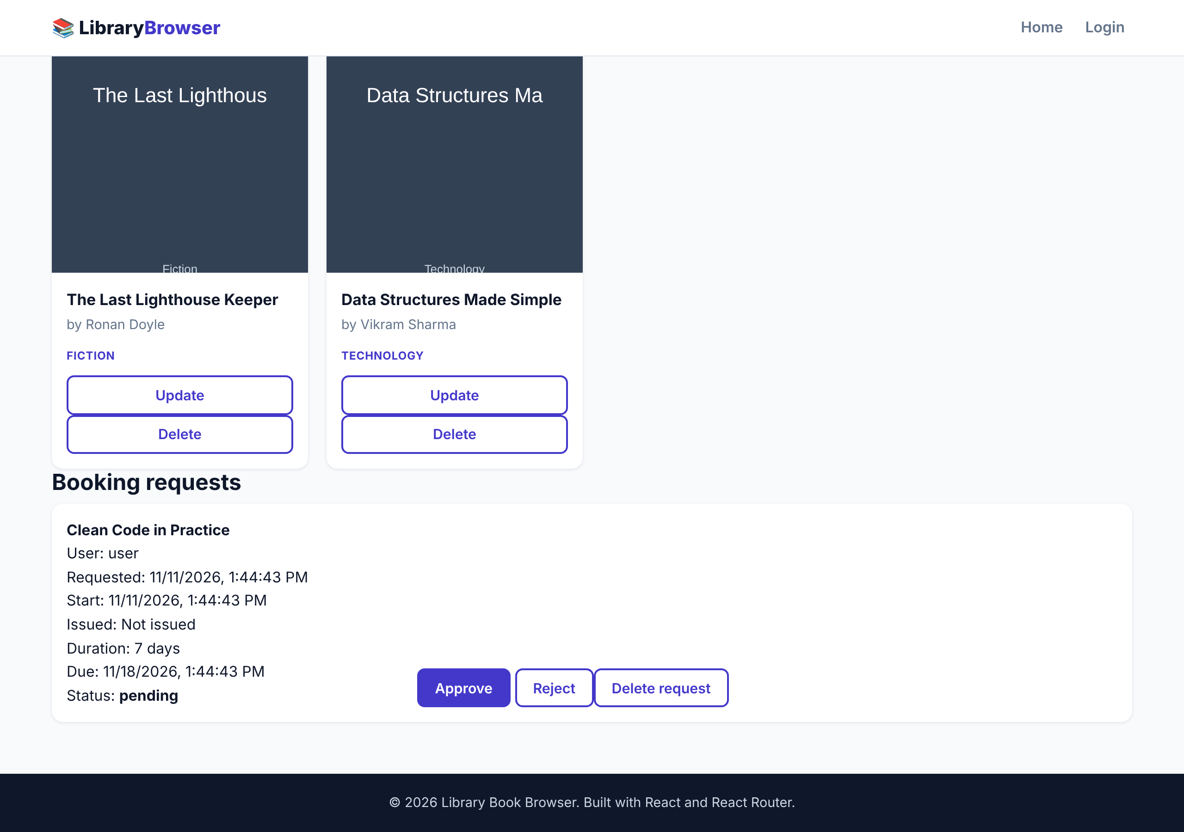
Figure 3.4: Admin / Librarian Panel (Books and Booking Requests)
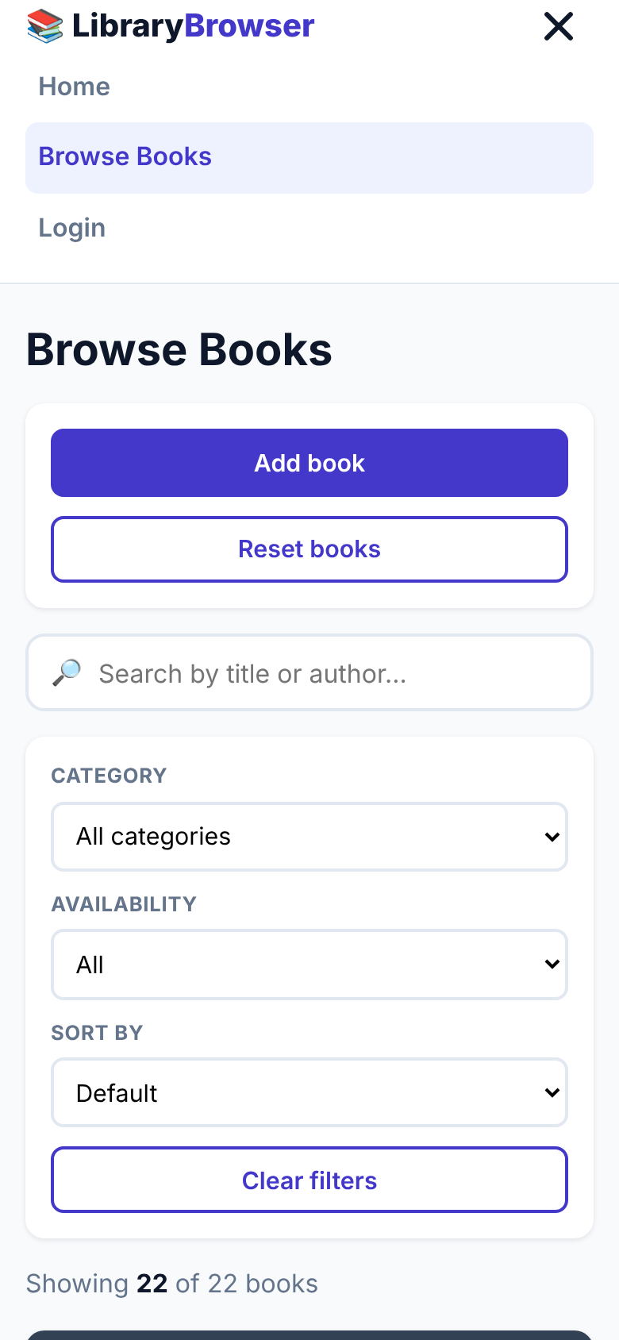
Figure 3.5: Responsive Layout on a Mobile Screen

3.3. Validation and Interpretation of Results
Functional validation. The test cases cover every feature F1 to F12 in Table 2.2. A feature is considered validated when its test case gives the expected result exactly. The expected counts for TC5 to TC8 were worked out independently from the data set (only three books are in the Technology category and six are issued), so a mismatch on screen would point to a defect in the filter logic.
Combined conditions. Search, category, availability and sorting are applied in one computation, so they work together instead of overwriting each other. The results line and the Clear filters button give immediate feedback, following the usability heuristic of visibility of system status (Nielsen, 1994).
Access control. The route guards in App.jsx check the stored role for every protected route, so a member who types /admin in the address bar is sent back to the login screen.
Workflow integrity. The buttons on a request depend on its status (Approve and Reject only for pending, Issue only for approved, Return and Fine only for issued), which prevents invalid steps such as returning a book that was never issued.
Maintainability. Reusable components, lifted state and a single store mean that a change such as a new filter touches only BrowsePage and FilterPanel.

3.4. Limitations Observed
- No back end. All data is in the browser’s localStorage, so it is not shared between devices and is lost if the browser data is cleared. Librarian and member see the same data only in the same browser.
- Demo authentication. The credentials are fixed in the front-end code, which is suitable for a demonstration only and is not secure.
- Fixed fine. The fine is a flat ₹50 charged by the librarian and is not calculated from the due date.
- Points in the code to improve. The useMemo dependency list in BrowsePage does not include books, so the list may not refresh if the collection changes while that page is open; the Home page component exists but the root route redirects to the login or panel; books added by the admin have no cover image; the add-form has no rating field; and some unused code remains in BrowsePage.
- No automated tests. Testing was manual.
- Search state is not kept in the URL, so a filtered view cannot be shared as a link.

CHAPTER 4
CONCLUSION AND FUTURE WORK

4.1. Conclusion
The project built a responsive, role-based library web application with React, Vite and React Router. Expected outcome: members can browse, search, filter, sort and request books, and librarians can manage the collection and the full loan life cycle, including fines. The design uses reusable functional components, lifted state, a central store hook, route guards and localStorage persistence, and it meets the objectives set in Chapter 1.
Deviation from expected results and reason. The functional behaviour matches the features in Table 2.2. The deviations from an ideal library system are the absence of a real back end and secure authentication, the fixed fine amount and the small issues listed in Section 3.4. They exist because the scope was limited to a front-end project that stores data in the browser, in keeping with the time available for the course project.

4.2. Future Work
The way ahead, with the required modifications and suggestions for extending the solution, is:
- Add a Node.js and Express REST API with a MongoDB or MySQL database and replace localStorage with API calls (moving from Design A towards Design C).
- Add real authentication with hashed passwords and JSON Web Tokens, with a separate account for each member.
- Calculate fines automatically from the due date and send reminders by e-mail.
- Fix the points in Section 3.4: the useMemo dependencies, covers for new books and a rating field in the add form.
- Keep search and filters in the URL query string so that views can be bookmarked and shared.
- Add automated tests with Vitest and React Testing Library, and end-to-end tests with Playwright or Selenium.
- Add pagination, wish-lists, member reviews and a dark mode, and deploy on a static host with a CI pipeline for linting and building.

REFERENCES

1. Marcotte, E. (2010) ‘Responsive Web Design’, A List Apart, 25 May. Available at: https://alistapart.com/article/responsive-web-design/ (Accessed: 2 November 2026).
2. MDN Web Docs (n.d.) ‘Window: localStorage property’ and ‘Web Storage API’, Mozilla. Available at: https://developer.mozilla.org/ (Accessed: 2 November 2026).
3. Meta Open Source (n.d.) ‘React Documentation: Hooks, useState, useMemo, useCallback’. Available at: https://react.dev/ (Accessed: 2 November 2026).
4. Nielsen, J. (1994) ‘10 Usability Heuristics for User Interface Design’, Nielsen Norman Group. Available at: https://www.nngroup.com/articles/ten-usability-heuristics/ (Accessed: 2 November 2026).
5. Oxc Project (n.d.) ‘Oxlint Documentation’. Available at: https://oxc.rs/ (Accessed: 2 November 2026).
6. React Router contributors (n.d.) ‘React Router Documentation’. Available at: https://reactrouter.com/ (Accessed: 2 November 2026).
7. Sommerville, I. (2016) Software Engineering, 10th edn, Pearson, Harlow.
8. Vite contributors (n.d.) ‘Vite Documentation’. Available at: https://vite.dev/ (Accessed: 2 November 2026).
9. W3C (2023) ‘Web Content Accessibility Guidelines (WCAG) 2.2’, W3C Recommendation, 5 October. Available at: https://www.w3.org/TR/WCAG22/ (Accessed: 2 November 2026).

APPENDIX-1: USER MANUAL
This manual gives the complete steps needed to set up and run the Library Book Browser project.

A1.1. Prerequisites
- Install Node.js 18 or newer and confirm it with node -v.
- Install npm (it comes with Node.js) and confirm it with npm -v.
- Install Google Chrome and Visual Studio Code.

A1.2. Running the Project
- Extract library-book-browser.zip and open the folder in VS Code using File > Open Folder.
- Open a terminal in the project root (the folder that contains package.json) and run npm install.
- Run npm run dev. The terminal prints a local address, normally http://localhost:5173 (Figure A1.1). Open it in Chrome.
- Log in (Figure A1.2). For a member use user / user123 with User Login; for the librarian use admin / admin123 with Admin Login.
- As a user: open Browse Books, search, filter and sort; open View Details; choose a start date and time and the number of days (1 to 30); press Send booking request (Figure A1.3). Check the status under My requests. When the request is approved or issued, use the Read link.
- As an admin: use + Add new book to add a title; use Update or Delete on a book card; under Booking requests press Approve or Reject, then Issue book, then Return book; press Charge ₹50 fine for a late return.
- Other commands: npm run build creates the production build in /dist; npm run preview previews it; npm run lint checks the code.
- To restore the original data, clear the site’s localStorage in the browser developer tools (keys library-books, library-requests, library-auth).
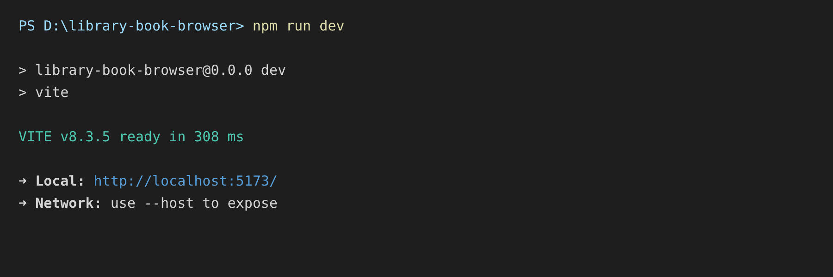
Figure A1.1: Terminal Output of npm run dev
Figure A1.2: Login Page
Figure A1.3: Sending a Booking Request

A1.3. Troubleshooting
Table A1.1: Common Problems and Solutions
Problem | Likely cause | Solution
npm is not recognised | Node.js not installed or not on PATH | Install Node.js 18+ and reopen the terminal
npm install fails | No internet or old Node.js version | Check the connection and update Node.js
Port 5173 already in use | Another dev server is running | Close it, or open the other address that Vite prints
Blank page after build and preview | Wrong URL or build error | Run npm run build again and read the messages
Login rejected | Wrong role tab or credentials | Select the matching tab and use the demo credentials
Changes do not appear | Old data in localStorage | Clear the localStorage keys and reload
Direct link to /books gives 404 on a static host | Host does not fall back to index.html | Configure the host to serve index.html for all routes

APPENDIX-2: SOURCE CODE
The complete source is in the submitted project folder. The main files are reproduced below in shortened form.

main.jsx
import { StrictMode } from 'react';
import { createRoot } from 'react-dom/client';
import { BrowserRouter } from 'react-router-dom';
import App from './App.jsx';
import './styles/global.css';

createRoot(document.getElementById('root')).render(
<StrictMode>
<BrowserRouter>
<App />
</BrowserRouter>
</StrictMode>
);

App.jsx (handlers and routes, shortened)
const login = (account) => { setAuth(account); localStorage.setItem('library-auth', JSON.stringify(account)); };
const logout = () => { setAuth(null); localStorage.removeItem('library-auth'); };
const approve = id => updateRequest(id, { status: 'approved' });
const reject = id => updateRequest(id, { status: 'rejected' });
const issue = id => {
const r = requests.find(x => x.id === id);
updateRequest(id, { status: 'issued', issuedAt: new Date().toISOString() });
bookStore.updateBook(r.bookId, { available: false });
};
const returnBook = id => {
const r = requests.find(x => x.id === id);
updateRequest(id, { status: 'returned' });
bookStore.updateBook(r.bookId, { available: true });
};
const fine = id => updateRequest(id, { fine: 50 });

<Routes>
<Route path="/" element={auth ? <Navigate to={auth.role === 'admin' ? '/admin' : '/user'} replace />
: <Navigate to="/login" replace />} />
<Route path="/books" element={auth?.role === 'user' ? <BrowsePage {...bookStore} user={auth}
requests={requests} onRequest={requestBook} /> : <Navigate to=... />} />
<Route path="/books/:id" element={auth ? <BookDetails ... /> : <Navigate to="/login" replace />} />
<Route path="/login" element={auth ? <Navigate ... /> : <Login onLogin={login} />} />
<Route path="/user" element={auth?.role === 'user' ? <UserPanel ... /> : <Login onLogin={login} />} />
<Route path="/admin" element={auth?.role === 'admin' ? <AdminPanel ... /> : <Login onLogin={login} />} />
<Route path="*" element={<NotFound />} />
</Routes>

BookCard.jsx
import { Link } from 'react-router-dom';
import '../styles/bookcard.css';

// Reusable card for a single book. Props: book
export default function BookCard({ book, onDelete, onToggleAvailability }) {
const { id, title, author, category, rating, available, cover } = book;

return (
<article className="book-card">
<div className="book-cover">
<img src={cover} alt={`Cover of ${title}`} loading="lazy" />
<span className={`badge ${available ? 'badge-available' : 'badge-issued'}`}>
{available ? 'Available' : 'Borrowed'}
</span>
</div>
<div className="book-info">
<span className="book-category">{category}</span>
<h3 className="book-title">{title}</h3>
<p className="book-author">by {author}</p>
<p className="book-rating" aria-label={`Rating ${rating} out of 5`}>
★ {rating.toFixed(1)}
</p>
<Link to={`/books/${id}`} className="btn btn-primary btn-block">
View Details
</Link>
{onToggleAvailability && <button type="button" className="btn btn-outline btn-block" onClick={() => onToggleAvailability(id, !available)}>
{available ? 'Borrow book' : 'Return book'}
</button>}
{onDelete && <button type="button" className="btn btn-outline btn-block" onClick={() => window.confirm('Delete this book?') && onDelete(id)}>
Delete
</button>}
</div>
</article>
);
}

SearchBar.jsx
import '../styles/controls.css';

// Controlled search input (live search, state is held by the parent)
export default function SearchBar({ value, onChange }) {
return (
<div className="search-bar">
<label htmlFor="search" className="sr-only">Search books</label>
<span className="search-icon" aria-hidden="true">🔎</span>
<input
id="search"
type="search"
placeholder="Search by title or author..."
value={value}
onChange={(e) => onChange(e.target.value)}
/>
</div>
);
}

Login.jsx (credential check, shortened)

const submit = (e) => {
e.preventDefault();
const valid = role === 'admin'
? username === 'admin' && password === 'admin123'
: username === 'user' && password === 'user123';
if (!valid) return setError(`Demo ${role} login: ${role === 'admin' ? 'admin / admin123' : 'user / user123'}`);
onLogin({ username, role });
navigate(role === 'admin' ? '/admin' : '/user');
};

The remaining files (BookList.jsx, FilterPanel.jsx, Navbar.jsx, Footer.jsx, BookDetails.jsx, BrowsePage.jsx, UserPanel.jsx, AdminPanel.jsx, NotFound.jsx and the five CSS files) are in the project folder under src/.

ACHIEVEMENTS
- Developed a working React, Vite and React Router single-page application with a user role and an admin (librarian) role.
- Built six reusable components and seven pages, with live search, category and availability filters, sorting, a results count and a Clear filters option that work together.
- Implemented role-based routes, a book details page driven by the :id parameter and a 404 page.
- Implemented the full loan workflow (request, approve or reject, issue, return, ₹50 fine) with admin CRUD on books.
- Persisted books, requests and the session in localStorage and delivered a responsive, accessible layout from mobile to desktop.
- Evaluated three alternative designs and justified the selection of the best one with a scoring comparison.
- Prepared the project report, README and user manual in the prescribed university format.

