Q1. Create Database.
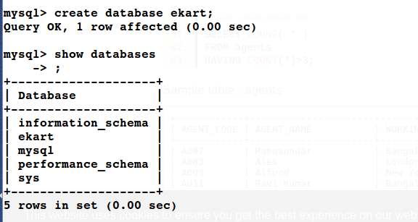
Q2. Create Schema. Q3. Create Tables.
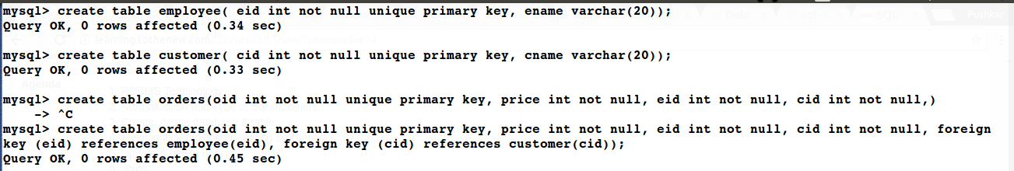
Q4. Insert sample data.
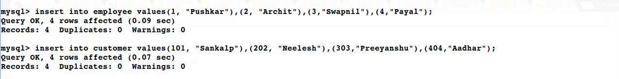
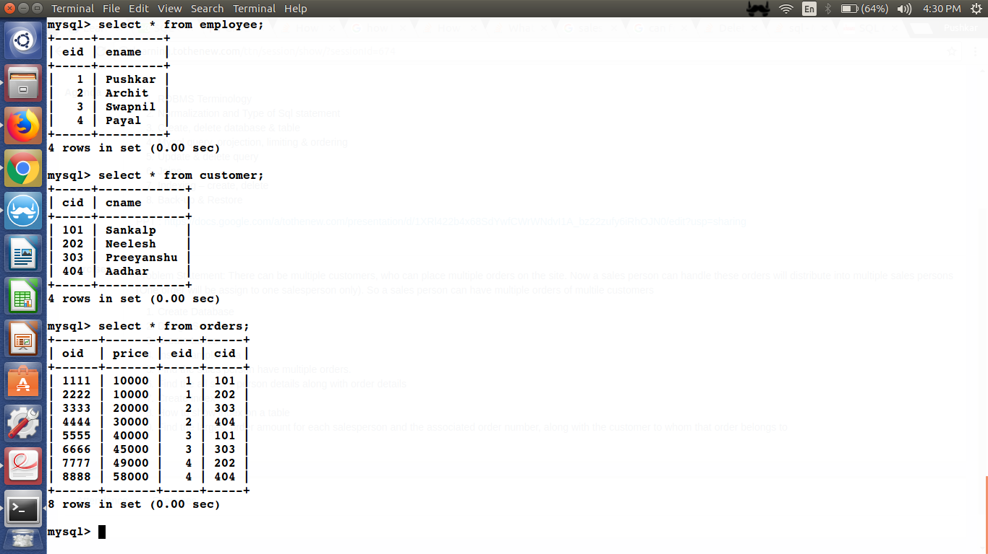
Q5. Find the salesperson have multiple orders.
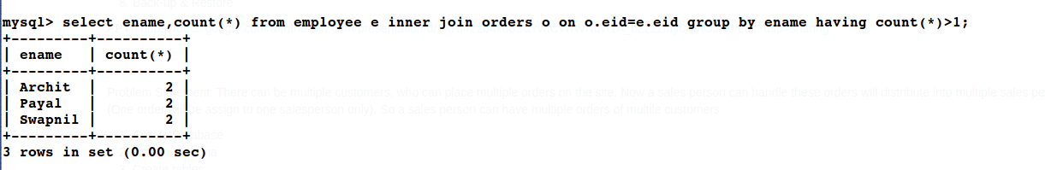
Q6. Find the all sales person details along with order details.
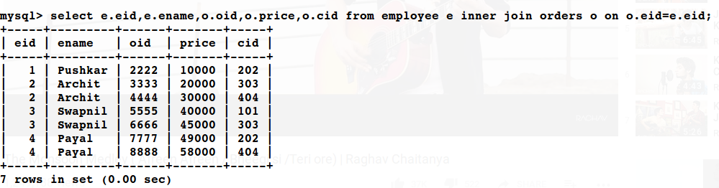
Q7. Create Index.
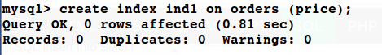

Q8. Show index on a table.
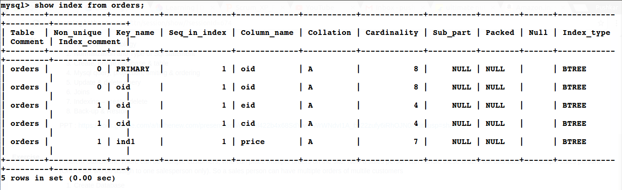
Q9. Find the largest order amount for each salesperson and the associated order number, along with the customer to whom that order belongs to.

select e.name, o.eid, o.oid, o.price,o.cid,c.name
from orders o
inner join employee e on e.eid=o.oid
inner join customer c on o.cid=c.cid
group by o.eid
order by o.price desc limit 1;

